Charlie DEV Environment Setup
Here are the basic steps to create an Eclipse C++ IDE Development environment using the MinGW64 compiler and a Python installation.

Expected Downloads:

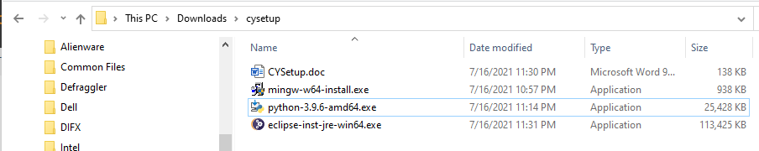

MinGW64 Compiler: https://sourceforge.net/projects/mingw-w64/files/Toolchains%20targetting%20Win32/Personal%20Builds/mingw-builds/installer/mingw-w64-install.exe/download.

Windows Environment Variable Setup:
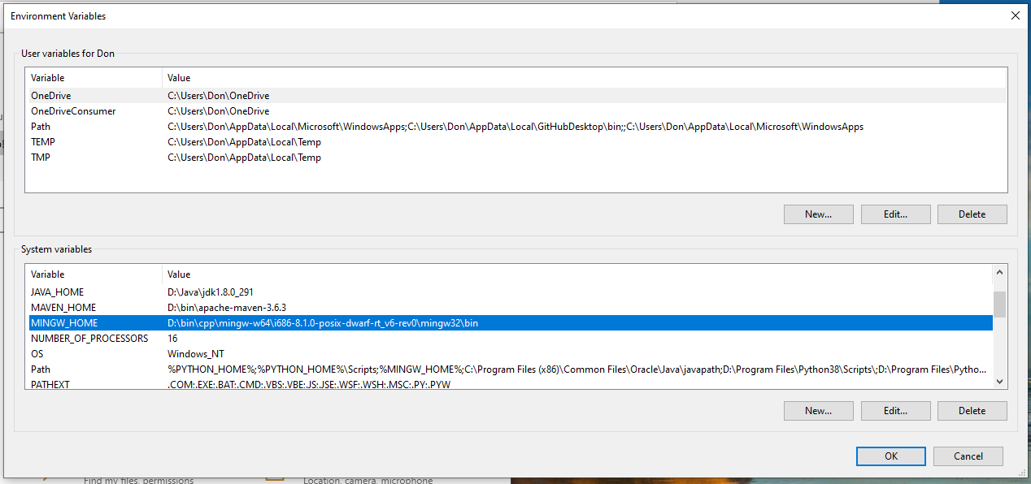

You test from the command prompt:

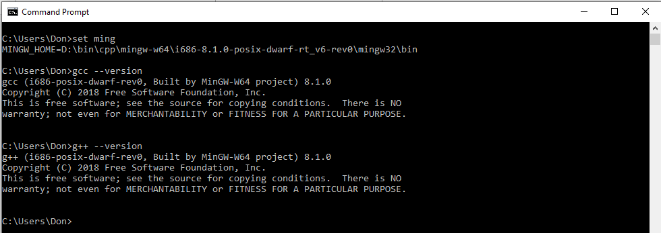
Python Compiler: https://www.python.org/downloads/release/python-396/.

Windows Environment Variable Setup:

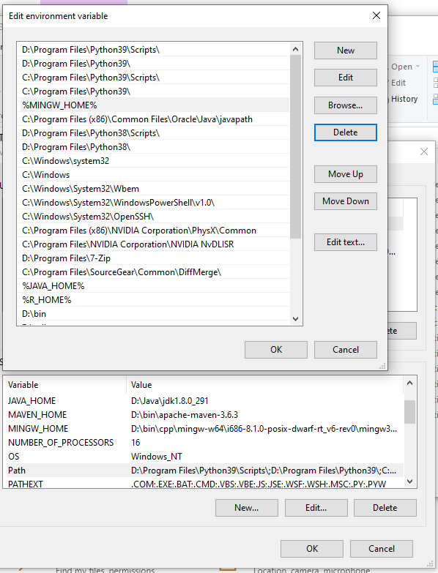

You test from the command prompt:
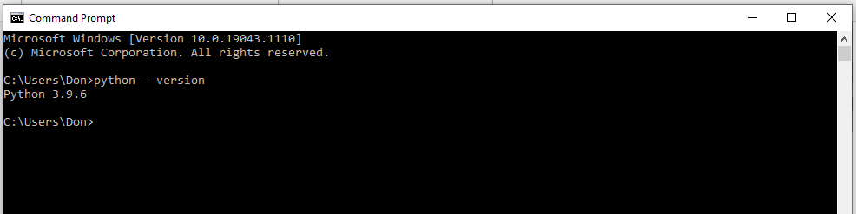

Eclipse C++ Development Environment: https://www.eclipse.org/downloads/.

We will be using the Eclipse installer. This installer will help us select the correct CDT. Select Eclipse IDE for C++ developers. Once selected, you will see something like this:

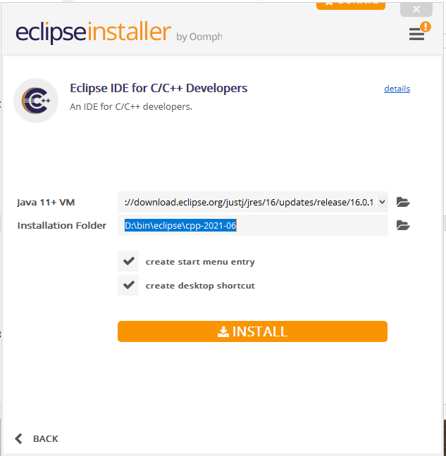

Update the installer by clicking on the box with the red exclamation point (!) in it, located in the upper right corner. Once updated, you should see:

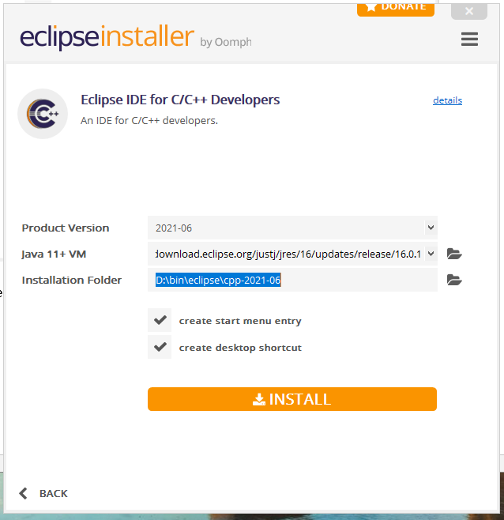

Change your folder to where you want to install CDT and click on INSTALL. When done, you are able to launch the CDT environment. You will be prompted to create an Eclipse work space first, and must enter the directory CDT should user. My workspace location is shown here:
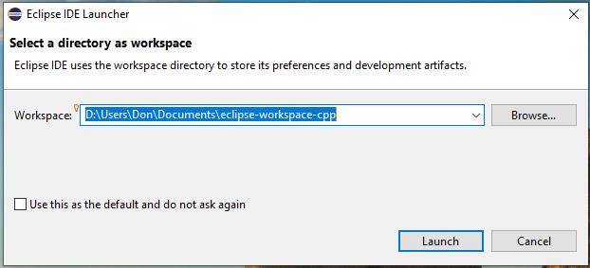

Once you select Launch, you will get the Eclipse Welcome home page:

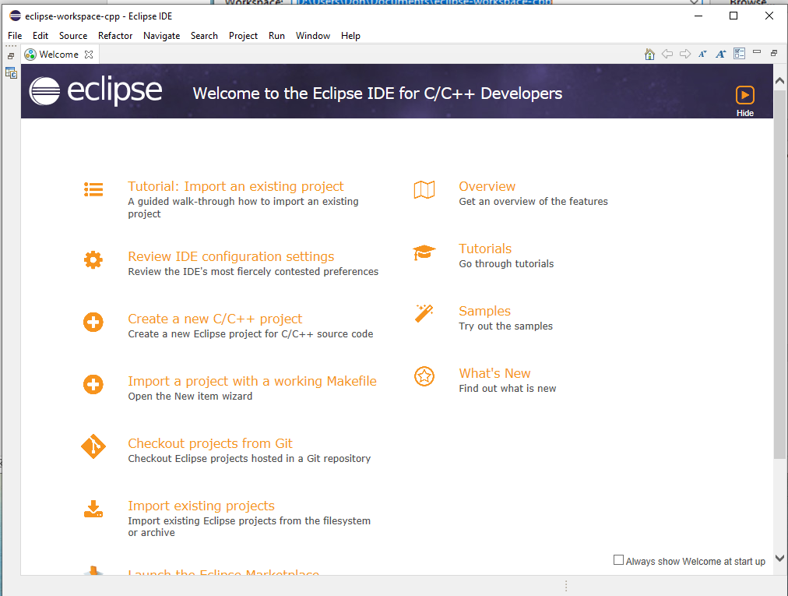

OK, now we have Eclipse running, so let’s make a program. Click on create a new C/C++ project

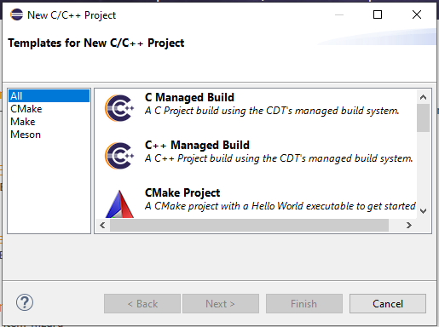

Select a C++ managed build. This will create a version of “Hello Word” to test our compiler:

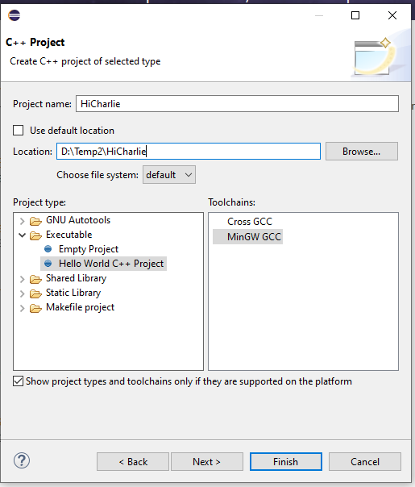

Locate the directory for your first program . . . don’t forget to uncheck “use default location”. Select the “Hello World C++ Project” option and the MinGW compiler, then click finish:

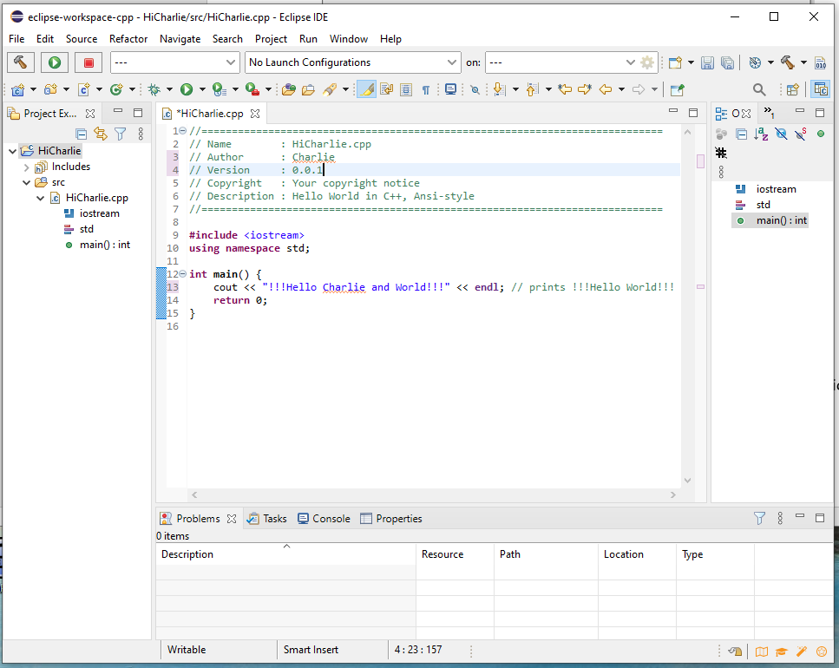

We have a generated program. I have made some minor edits to the generated project. Note the asterisk at the left of the tab with the HiCharlie.cpp program. This indicates the code has not been saved. Use Control-S to save (or File>Save.) From the menu bar, select Project, and then select Clean from the dropdown. You will get this dialog:

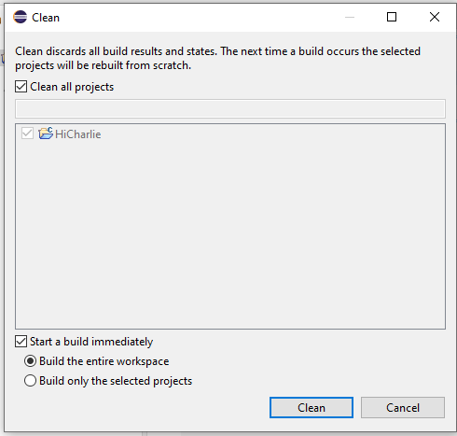

Select Clean. You should see something like this display showing a successful build:

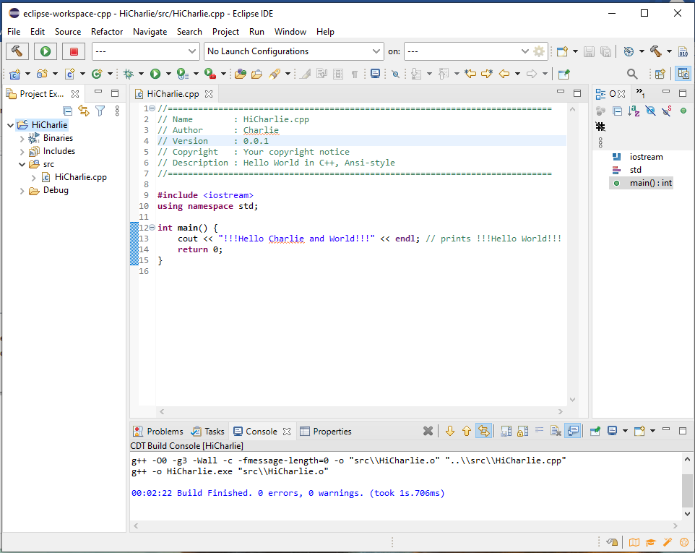

From the menu, select Run > Run as > 2 Local C++ Application. You should see:

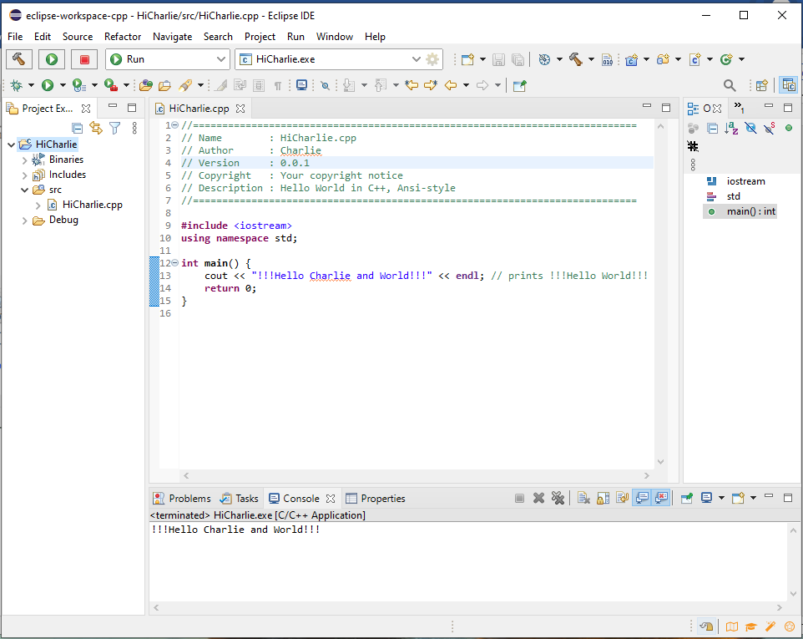

You have correctly installed Eclipse for C++ Developers.
▪

CDT Development Tasks

Select Build Configuration (Debug – Release)

Right-Click on open project, select C/C++ build, you will get:

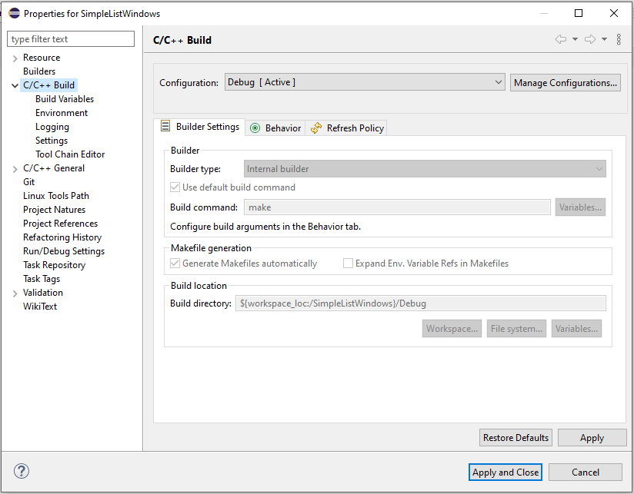

Select manage configurations, then select Release and click the set active button.

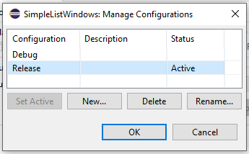

Click on OK, change the configuration to Release (active), click on apply and then apply and close.
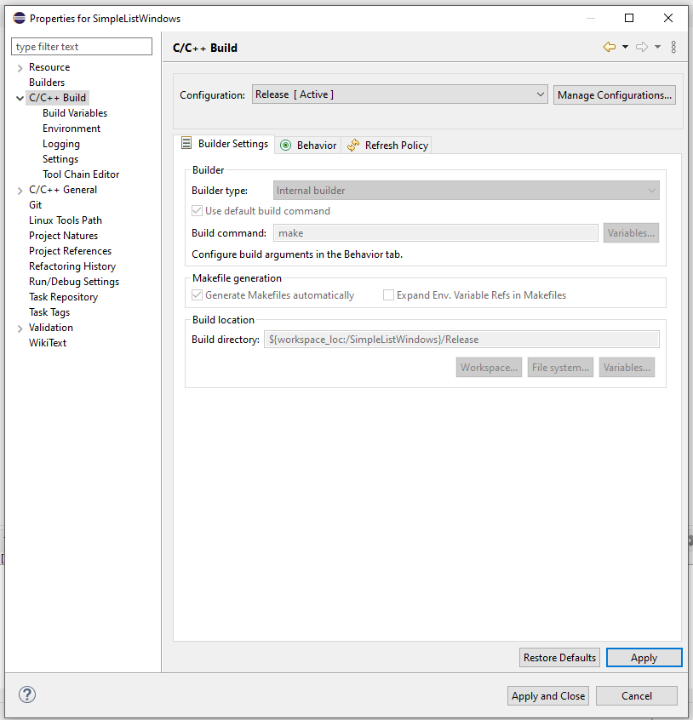

Finally, select Clean from the Eclipse menu bar and you will build in the release directory.

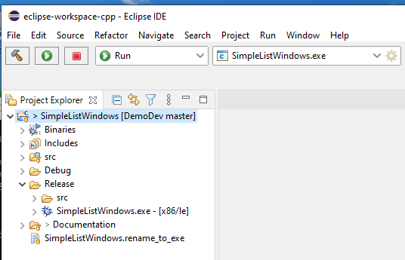

Done

