PySpark Environment Setup

We will install Spark locally on a Windows 10 Laptop, and verify operation with Python using PySpark. These languages are required before Spark is installed:

* Java 8 (e.g., java version "1.8.0_241")
* Python (e.g., Python 3.8.1)
* Scala (e.g., Scala code runner version 2.13.1 -- Copyright 2002-2019, LAMP/EPFL and Lightbend, Inc.)

Each language will have required environment variable that must be defined. Details for Java and Scala are described below.

Once xxxx

Java Related Settings:

Windows 10 Java Environment Variables:

* JAVA_OPTIONS=-Xmx512M -Xms512M
* JAVA_HOME=D:\Java\jdk1.8.0_241

Java Installation Verification:

D:\Temp>java -version

java version "1.8.0_241"

Java(TM) SE Runtime Environment (build 1.8.0_241-b07)

Java HotSpot(TM) 64-Bit Server VM (build 25.241-b07, mixed mode)

Spark Related Settings

Sample spark download URL: <https://www.apache.org/dyn/closer.lua/spark/spark-2.4.5/spark-2.4.5-bin-hadoop2.7.tgz>.

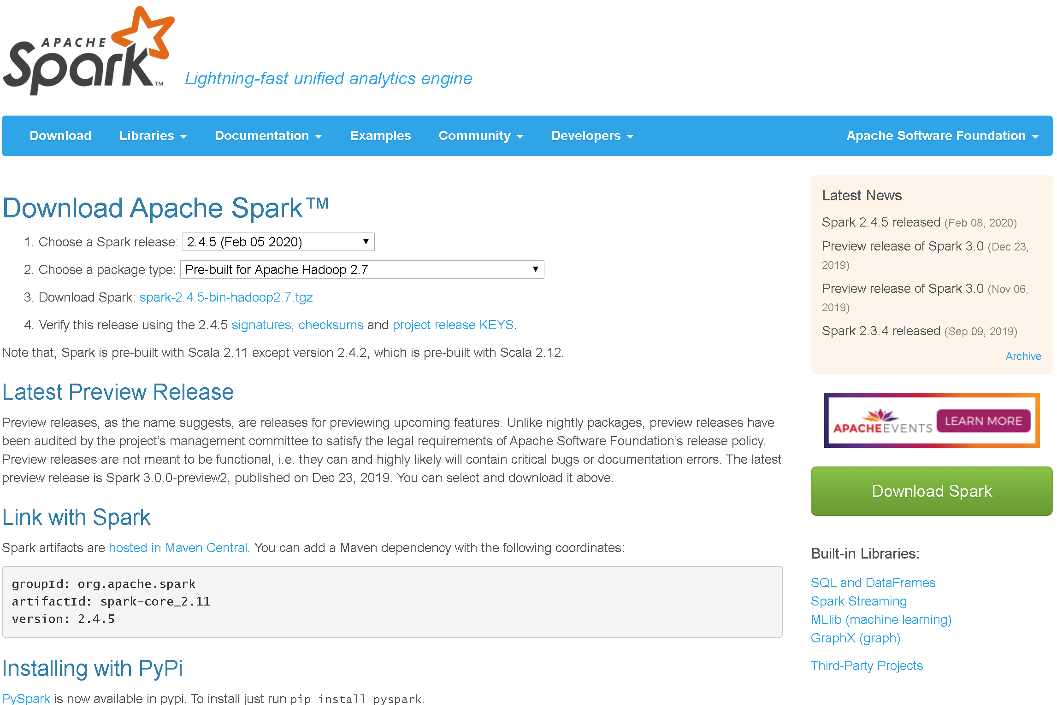

## Resources

1. UCSD instructions (2020): <https://mas-dse.github.io/DSE230/installation/windows/>.
2. Created around 3/2018: <https://medium.com/big-data-engineering/how-to-install-apache-spark-2-x-in-your-pc-e2047246ffc3>.
3. Created around 10/2019: <https://www.knowledgehut.com/blog/big-data/how-to-install-apache-spark-on-windows>.
4. A good overview from 1/2019: <https://medium.com/@naomi.fridman/install-pyspark-to-run-on-jupyter-notebook-on-windows-4ec2009de21f>.
5. Some winutils.exe replacement background: <https://dataintoresults.com/post/apache-spark-on-windows-without-winutils-exe/>.