1. Fooo
2. Barr
3. Distribution Data Generation

We apply a random number generator to create test distributions, and capture a sample from an actual analytic. The analytic, Discount Sensitivity, really has five treatment groups:

* 1. Discount Sensitivity Sample

> source('D:/DemoDevPy/ScorePartition/Evaluate/GenerateDiscountSensitivity.R')

-- Capture Sorted Discount Sensitivity Distribution in:

D:/DemoDevPy/ScorePartition/Evaluate

--- Ingest sampled scores of type DSENS and save into file DS1.csv

--- loaded 800 records from ScorePartition/Evaluate/DS_Sample/SampleBLscoreNonZero.csv

Min. :3.838e-05 1st Qu.:3.592e-03 Median :4.613e-03 Mean :4.389e-03 3rd Qu.:5.503e-03 Max. :6.167e-03

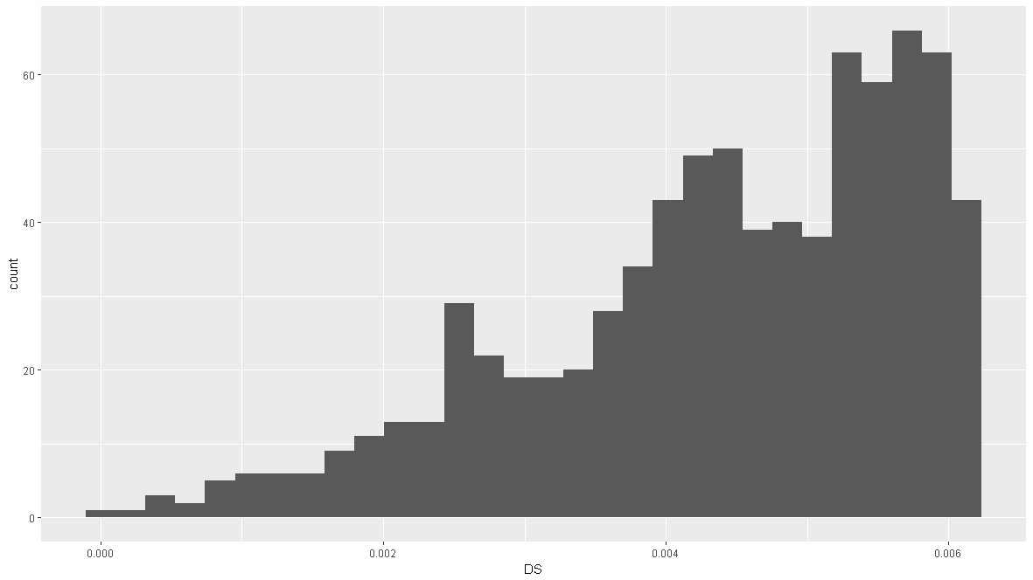

* 1. Beta Distribution (0.5, 0.5)

> source('D:/DemoDevPy/ScorePartition/Evaluate/GenerateBeta.R')

-- Generate Sorted Beta Distribution in:

D:/DemoDevPy/ScorePartition/Evaluate

--- Generate 800 scores of type BETA into file BETA1.csv

--- output BETA to BETA1.csv with alph 0.5 and 0.5

Min. :0.0000052 1st Qu.:0.1599557 Median :0.4830157 Mean :0.5010764 3rd Qu.:0.8580406 Max. :1.0000000

--- Generate 800 scores of type BETA into file BETA2.csv

--- output BETA to BETA2.csv with alph 0.5 and 0.5

Min. :0.0000055 1st Qu.:0.1419850 Median :0.5066811 Mean :0.5013101 3rd Qu.:0.8642576 Max. :0.9999998

--- Generate 800 scores of type BETA into file BETA3.csv

--- output BETA to BETA3.csv with alph 0.5 and 0.5

Min. :0.0000017 1st Qu.:0.1544770 Median :0.5660405 Mean :0.5192361 3rd Qu.:0.8504211 Max. :0.9999981

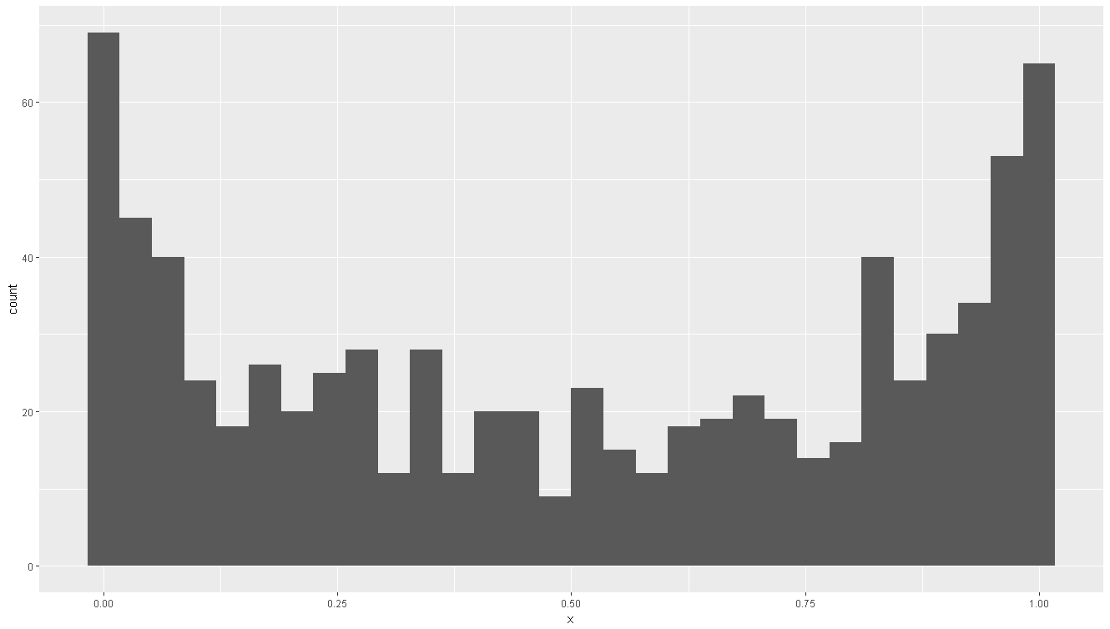

* 1. Uniform Distribution

> source('D:/DemoDevPy/ScorePartition/Evaluate/GenerateUniform.R')

-- Generate Sorted Uniform Distribution in:

D:/DemoDevPy/ScorePartition/Evaluate

--- Generate 800 scores of type UNIFORM into file UNIF1.csv

Min. :0.0000282 1st Qu.:0.2438440 Median :0.5095926 Mean :0.4979379 3rd Qu.:0.7304491 Max. :0.9979542

--- Generate 800 scores of type UNIFORM into file UNIF2.csv

Min. :0.002955 1st Qu.:0.247597 Median :0.511851 Mean :0.500358 3rd Qu.:0.743394 Max. :0.999399

--- Generate 800 scores of type UNIFORM into file UNIF3.csv

Min. :0.001282 1st Qu.:0.248522 Median :0.498183 Mean :0.494757 3rd Qu.:0.736611 Max. :0.996449

* 1. 3 Normal Distributions, Centered Mode

> source('D:/DemoDevPy/ScorePartition/Evaluate/Generate3Normal.R')

-- Generate Sorted 3 Normal Distributions, Centered Modes, in:

D:/DemoDevPy/ScorePartition/Evaluate

--- Generate 800 scores of type 3Normal into file ThreeNorm1.csv

Low 80

Min. 1st Qu. Median Mean 3rd Qu. Max.

0.004572 0.095660 0.179900 0.195500 0.295800 0.399900

Mid 640

Min. 1st Qu. Median Mean 3rd Qu. Max.

0.3504 0.4314 0.5053 0.5027 0.5782 0.6486

Upper 80

Min. 1st Qu. Median Mean 3rd Qu. Max.

0.5038 0.6531 0.7503 0.7523 0.8512 0.9826

Min. :0.004572 1st Qu.:0.410753 Median :0.504902 Mean :0.496910 3rd Qu.:0.586739 Max. :0.982639

--- Generate 800 scores of type 3Normal into file ThreeNorm2.csv

Low 80

Min. 1st Qu. Median Mean 3rd Qu. Max.

0.01685 0.14530 0.21210 0.21340 0.28820 0.39240

Mid 640

Min. 1st Qu. Median Mean 3rd Qu. Max.

0.3510 0.4234 0.4905 0.4957 0.5680 0.6494

Upper 80

Min. 1st Qu. Median Mean 3rd Qu. Max.

0.5199 0.6765 0.7602 0.7656 0.8626 0.9915

Min. :0.01685 1st Qu.:0.40590 Median :0.49052 Mean :0.49443 3rd Qu.:0.58194 Max. :0.99147

--- Generate 800 scores of type 3Normal into file ThreeNorm3.csv

Low 80

Min. 1st Qu. Median Mean 3rd Qu. Max.

0.000892 0.103800 0.207100 0.205400 0.306700 0.397200

Mid 640

Min. 1st Qu. Median Mean 3rd Qu. Max.

0.3508 0.4278 0.4982 0.4984 0.5667 0.6494

Upper 80

Min. 1st Qu. Median Mean 3rd Qu. Max.

0.5022 0.6771 0.7654 0.7613 0.8513 0.9951

Min. :0.000892 1st Qu.:0.406872 Median :0.498215 Mean :0.495396 3rd Qu.:0.579717 Max. :0.995067

* 1. 3 Normal Distributions, Skewed Right Mode

> source('D:/DemoDevPy/ScorePartition/Evaluate/GeneraterTriNormal.R')

-- Generate Sorted Normal Distributions, Skewed Right Mode, in:

D:/DemoDevPy/ScorePartition/Evaluate

--- Generate 800 scores of type TriNormal into file TriNorm1.csv

Low 40

Min. 1st Qu. Median Mean 3rd Qu. Max.

0.007119 0.099190 0.165100 0.203000 0.341600 0.394500

Mid 80

Min. 1st Qu. Median Mean 3rd Qu. Max.

0.3504 0.4041 0.5188 0.4944 0.5769 0.6454

Upper 680

Min. 1st Qu. Median Mean 3rd Qu. Max.

0.5002 0.6493 0.7549 0.7508 0.8469 0.9992

Min. :0.007119 1st Qu.:0.594992 Median :0.714796 Mean :0.697767 3rd Qu.:0.832448 Max. :0.999209

--- Generate 800 scores of type TriNormal into file TriNorm2.csv

Low 40

Min. 1st Qu. Median Mean 3rd Qu. Max.

0.01483 0.15800 0.21900 0.22640 0.30320 0.39590

Mid 80

Min. 1st Qu. Median Mean 3rd Qu. Max.

0.3574 0.4276 0.4915 0.4923 0.5675 0.6484

Upper 680

Min. 1st Qu. Median Mean 3rd Qu. Max.

0.5001 0.6432 0.7454 0.7455 0.8490 0.9940

Min. :0.01483 1st Qu.:0.59155 Median :0.71450 Mean :0.69423 3rd Qu.:0.82419 Max. :0.99403

--- Generate 800 scores of type TriNormal into file TriNorm3.csv

Low 40

Min. 1st Qu. Median Mean 3rd Qu. Max.

0.03184 0.17870 0.28800 0.26110 0.36820 0.39920

Mid 80

Min. 1st Qu. Median Mean 3rd Qu. Max.

0.3605 0.4330 0.4829 0.4973 0.5692 0.6404

Upper 680

Min. 1st Qu. Median Mean 3rd Qu. Max.

0.5009 0.6457 0.7460 0.7517 0.8605 0.9978

Min. :0.03184 1st Qu.:0.59452 Median :0.70521 Mean :0.70176 3rd Qu.:0.84072 Max. :0.99780

1. Boundary Assessment
   1. Evaluate Discount Sensitivity

D:\bin\Anaconda3\python.exe D:/DemoDevPy/ScorePartition/Evaluate/evaluate_dsensitivity.py

*****

From file DS1.csv with 800 elements created:

[<class 'anova_evaluator.AnovaEvaluator'>;

Observations: [<class 'observation_manager.ObservedValues'>; Nk: 800; {3.8384389492557e-05; 0.00019379241813783; 0.000440235912922868; 0.000461110350860938; 0.000504874855816104; . . .; 0.00616027290468359; 0.00616465273855535; 0.00616583273020423; 0.00616700487374037}]]

count mean std min 25% 50% 75% max

xval 800.0 0.004389 0.001337 0.000038 0.003592 0.004613 0.005503 0.006167

Starting analysis DSENS-(0.20% | 0.75%)

-- Initial : [<partitioner.Space object at 0x000002C4A02FA240> :: partition_count: 3; space_size: 800; min_size: 160; max_size: 600; id_generator 0; last capacities: None]

Result: 8.641 sec for [<partitioner.Collector object at 0x000002C4A02E9F28> :: max_assignment: [<partitioner.Assignment object at 0x000002C4A02FA630> :: AssignID: 121; score: **0.8719367979197471**; capacities: [160, 280, 360]]; examined:51681]

Inter-quartile Range: [200, 400, 200] -- score {eta-squared}: **0.8187521962388757**

* 1. Evaluate Beta (0.5, 0.5)

D:\bin\Anaconda3\python.exe D:/DemoDevPy/ScorePartition/Evaluate/evaluate_beta.py

*****

From file BETA1.csv with 800 elements created:

[<class 'anova_evaluator.AnovaEvaluator'>;

Observations: [<class 'observation_manager.ObservedValues'>; Nk: 800; {5.20707827931795e-06; 2.14154476807469e-05; 2.768860387564e-05; 3.72852424889745e-05; 6.76403998822485e-05; . . .; 0.999990361399542; 0.999999846706546; 0.999999890300583; 0.999999999205871}]]

count mean std min 25% 50% 75% max

xval 800.0 0.501076 0.357314 0.000005 0.159956 0.483016 0.858041 1.0

Starting analysis BETA-(0.20% | 0.75%)

-- Initial : [<partitioner.Space object at 0x000001F76CED9240> :: partition_count: 3; space_size: 800; min_size: 160; max_size: 600; id_generator 0; last capacities: None]

Result: 7.016 sec for [<partitioner.Collector object at 0x000001F76CEC8F28> :: max_assignment: [<partitioner.Assignment object at 0x000001F76CED91D0> :: AssignID: 36821; score: 0.9241217885180711; capacities: [309, 177, 314]]; examined:51681]

Inter-quartile Range: [200, 400, 200] -- score {eta-squared}: 0.7920564636614119

*****

From file BETA2.csv with 800 elements created:

[<class 'anova_evaluator.AnovaEvaluator'>;

Observations: [<class 'observation_manager.ObservedValues'>; Nk: 800; {5.54804822652281e-06; 1.72566938219212e-05; 3.6046805378919e-05; 0.00016474906594594; 0.000268525929196532; . . .; 0.999986648128204; 0.999987568372042; 0.999995755836185; 0.99999981987337}]]

count mean std min 25% 50% 75% max

xval 800.0 0.50131 0.353703 0.000006 0.141985 0.506681 0.864258 1.0

Starting analysis BETA-(0.20% | 0.75%)

-- Initial : [<partitioner.Space object at 0x000001F76CEFE5F8> :: partition_count: 3; space_size: 800; min_size: 160; max_size: 600; id_generator 0; last capacities: None]

Result: 7.031 sec for [<partitioner.Collector object at 0x000001F76CEFE518> :: max_assignment: [<partitioner.Assignment object at 0x000001F76CEFEAC8> :: AssignID: 37717; score: 0.9263670583243108; capacities: [314, 223, 263]]; examined:51681]

Inter-quartile Range: [200, 400, 200] -- score {eta-squared}: 0.8198232740379736

*****

From file BETA3.csv with 800 elements created:

[<class 'anova_evaluator.AnovaEvaluator'>;

Observations: [<class 'observation_manager.ObservedValues'>; Nk: 800; {1.69886123410588e-06; 3.13256166742653e-06; 9.55025894779523e-05; 0.000122350821229938; 0.000147424453644887; . . .; 0.999951151496457; 0.999973834580137; 0.999997900102905; 0.999998123555126}]]

count mean std min 25% 50% 75% max

.xval 800.0 0.519236 0.355182 0.000002 0.154477 0.56604 0.850421 0.999998

Starting analysis BETA-(0.20% | 0.75%)

-- Initial : [<partitioner.Space object at 0x000001F76CEA17B8> :: partition_count: 3; space_size: 800; min_size: 160; max_size: 600; id_generator 0; last capacities: None]

Result: 7.016 sec for [<partitioner.Collector object at 0x000001F76CEA16D8> :: max_assignment: [<partitioner.Assignment object at 0x000001F76CEA1C88> :: AssignID: 30794; score: **0.9238940249171371**; capacities: [277, 182, 341]]; examined:51681]

Inter-quartile Range: [200, 400, 200] -- score {eta-squared}: **0.8013164707590709**

* 1. Evaluate Uniform

D:\bin\Anaconda3\python.exe D:/DemoDevPy/ScorePartition/Evaluate/evaluate_uniform.py

*****

From file UNIF1.csv with 800 elements created:

[<class 'anova_evaluator.AnovaEvaluator'>;

Observations: [<class 'observation_manager.ObservedValues'>; Nk: 800; {2.81794928014278e-05; 0.000331099377945065; 0.000390162458643317; 0.000391373876482248; 0.000958554912358522; . . .; 0.993930782191455; 0.995393584948033; 0.997379140462726; 0.997954233316705}]]

count mean std min 25% 50% 75% max

xval 800.0 0.497938 0.291086 0.000028 0.243844 0.509593 0.730449 0.997954

Starting analysis UNIFORM-(0.20% | 0.75%)

-- Initial : [<partitioner.Space object at 0x000001E4C828A208> :: partition_count: 3; space_size: 800; min_size: 160; max_size: 600; id_generator 0; last capacities: None]

Result: 7.422 sec for [<partitioner.Collector object at 0x000001E4C827AEF0> :: max_assignment: [<partitioner.Assignment object at 0x000001E4C828A198> :: AssignID: 34605; score: 0.8835390334801435; capacities: [296, 288, 216]]; examined:51681]

Inter-quartile Range: [200, 400, 200] -- score {eta-squared}: 0.8487850381480705

*****

From file UNIF2.csv with 800 elements created:

[<class 'anova_evaluator.AnovaEvaluator'>;

Observations: [<class 'observation_manager.ObservedValues'>; Nk: 800; {0.00295469630509615; 0.00371634494513273; 0.00482457247562706; 0.0072439752984792; 0.00803134683519602; . . .; 0.994620031677186; 0.996126869693398; 0.99772328697145; 0.999399166321382}]]

count mean std min 25% 50% 75% max

xval 800.0 0.500358 0.292913 0.002955 0.247597 0.511851 0.743394 0.999399

Starting analysis UNIFORM-(0.20% | 0.75%)

-- Initial : [<partitioner.Space object at 0x000001E4C82494E0> :: partition_count: 3; space_size: 800; min_size: 160; max_size: 600; id_generator 0; last capacities: None]

Result: 7.172 sec for [<partitioner.Collector object at 0x000001E4C82495C0> :: max_assignment: [<partitioner.Assignment object at 0x000001E4C8249780> :: AssignID: 33426; score: **0.8831657479847561**; capacities: [290, 240, 270]]; examined:51681]

Inter-quartile Range: [200, 400, 200] -- score {eta-squared}: **0.8365024840397187**

*****

From file UNIF3.csv with 800 elements created:

[<class 'anova_evaluator.AnovaEvaluator'>;

Observations: [<class 'observation_manager.ObservedValues'>; Nk: 800; {0.00128245260566473; 0.00153391272760928; 0.00332486466504633; 0.00539001519791782; 0.00566281843930483; . . .; 0.991646700538695; 0.991842436604202; 0.994765475392342; 0.99644945980981}]]

count mean std min 25% 50% 75% max

xval 800.0 0.494757 0.286631 0.001282 0.248522 0.498183 0.736611 0.996449

Starting analysis UNIFORM-(0.20% | 0.75%)

-- Initial : [<partitioner.Space object at 0x000001E4C82A96A0> :: partition_count: 3; space_size: 800; min_size: 160; max_size: 600; id_generator 0; last capacities: None]

Result: 7.188 sec for [<partitioner.Collector object at 0x000001E4C82A9780> :: max_assignment: [<partitioner.Assignment object at 0x000001E4C82A9C50> :: AssignID: 21400; score: **0.8884808178499592**; capacities: [235, 259, 306]]; examined:51681]

Inter-quartile Range: [200, 400, 200] -- score {eta-squared}: **0.8459690164803341**

* 1. Evaluate 3 Normal Distributions, Centered Mode

D:\bin\Anaconda3\python.exe D:/DemoDevPy/ScorePartition/Evaluate/evaluate_3normal.py

*****

From file ThreeNorm1.csv with 800 elements created:

[<class 'anova_evaluator.AnovaEvaluator'>;

Observations: [<class 'observation_manager.ObservedValues'>; Nk: 800; {0.00457224576830437; 0.00711872989765075; 0.0199890572950826; 0.0207880821580736; 0.0365436408603402; . . .; 0.969451329647327; 0.974201013117511; 0.978729203437226; 0.98263924228113}]]

count mean std min 25% 50% 75% max

xval 800.0 0.49691 0.156696 0.004572 0.410753 0.504902 0.586739 0.982639

Starting analysis 3ModesCentered-(0.20% | 0.75%)

-- Initial : [<partitioner.Space object at 0x0000027C5DCE9DD8> :: partition_count: 3; space_size: 800; min_size: 160; max_size: 600; id_generator 0; last capacities: None]

Result: 7.047 sec for [<partitioner.Collector object at 0x0000027C5DCE9F28> :: max_assignment: [<partitioner.Assignment object at 0x0000027C5DD02518> :: AssignID: 215; score: 0.6981605388465001; capacities: [160, 374, 266]]; examined:51681]

Inter-quartile Range: [200, 400, 200] -- score {eta-squared}: 0.6917001753603076

*****

From file ThreeNorm2.csv with 800 elements created:

[<class 'anova_evaluator.AnovaEvaluator'>;

Observations: [<class 'observation_manager.ObservedValues'>; Nk: 800; {0.0168509642161243; 0.017368684014601; 0.0243551892031446; 0.0261330326621336; 0.0344440308595657; . . .; 0.949604785352206; 0.969002160459039; 0.97204755082681; 0.991465241958226}]]

count mean std min 25% 50% 75% max

xval 800.0 0.494434 0.153135 0.016851 0.405901 0.490523 0.581938 0.991465

Starting analysis 3ModesCentered-(0.20% | 0.75%)

-- Initial : [<partitioner.Space object at 0x0000027C5DD1D4E0> :: partition_count: 3; space_size: 800; min_size: 160; max_size: 600; id_generator 0; last capacities: None]

Result: 7.016 sec for [<partitioner.Collector object at 0x0000027C5DD1D6A0> :: max_assignment: [<partitioner.Assignment object at 0x0000027C5DD1D9B0> :: AssignID: 276; score: 0.7112652749683607; capacities: [160, 435, 205]]; examined:51681]

Inter-quartile Range: [200, 400, 200] -- score {eta-squared}: 0.7088341345534548

*****

From file ThreeNorm3.csv with 800 elements created:

[<class 'anova_evaluator.AnovaEvaluator'>;

Observations: [<class 'observation_manager.ObservedValues'>; Nk: 800; {0.000891974852246374; 0.00172961961359647; 0.00529184594149967; 0.0078188102656353; 0.013544383280841; . . .; 0.959657224864359; 0.960080978769177; 0.961312889155968; 0.99506689555904}]]

count mean std min 25% 50% 75% max

xval 800.0 0.495396 0.154915 0.000892 0.406872 0.498215 0.579717 0.995067

Starting analysis 3ModesCentered-(0.20% | 0.75%)

-- Initial : [<partitioner.Space object at 0x0000027C5DCB76A0> :: partition_count: 3; space_size: 800; min_size: 160; max_size: 600; id_generator 0; last capacities: None]

Result: 7.047 sec for [<partitioner.Collector object at 0x0000027C5DCB7860> :: max_assignment: [<partitioner.Assignment object at 0x0000027C5DCB7B70> :: AssignID: 296; score: **0.6994394529330751**; capacities: [160, 455, 185]]; examined:51681]

Inter-quartile Range: [200, 400, 200] -- score {eta-squared}: 0.**6955038222202053**

* 1. Evaluate 3 Normal Distributions, Skewed Right Mode

D:\bin\Anaconda3\python.exe D:/DemoDevPy/ScorePartition/Evaluate/evaluate_trimodal.py

*****

From file TriNorm1.csv with 800 elements created:

[<class 'anova_evaluator.AnovaEvaluator'>;

Observations: [<class 'observation_manager.ObservedValues'>; Nk: 800; {0.00711872989765075; 0.0199890572950826; 0.0418391451001948; 0.0434805480509258; 0.0840525878946476; . . .; 0.997361159123878; 0.997863076986086; 0.998936484167741; 0.999209210360838}]]

count mean std min 25% 50% 75% max

xval 800.0 0.697767 0.184979 0.007119 0.594992 0.714795 0.832448 0.999209

Starting analysis 3ModalSkewed-(0.20% | 0.75%)

-- Initial : [<partitioner.Space object at 0x0000012A7A90ADA0> :: partition_count: 3; space_size: 800; min_size: 160; max_size: 600; id_generator 0; last capacities: None]

Result: 7.344 sec for [<partitioner.Collector object at 0x0000012A7A90AEF0> :: max_assignment: [<partitioner.Assignment object at 0x0000012A7A9234E0> :: AssignID: 157; score: 0.7788132679738825; capacities: [160, 316, 324]]; examined:51681]

Inter-quartile Range: [200, 400, 200] -- score {eta-squared}: 0.7450058914591094

*****

From file TriNorm2.csv with 800 elements created:

[<class 'anova_evaluator.AnovaEvaluator'>;

Observations: [<class 'observation_manager.ObservedValues'>; Nk: 800; {0.0148330500289686; 0.0286438614744469; 0.0357498102341803; 0.0449455187143333; 0.0565181845923142; . . .; 0.987494087729287; 0.992068158706145; 0.993120150251302; 0.994029022647668}]]

count mean std min 25% 50% 75% max

xval 800.0 0.694231 0.179992 0.014833 0.591549 0.714505 0.824191 0.994029

Starting analysis 3ModalSkewed-(0.20% | 0.75%)

-- Initial : [<partitioner.Space object at 0x0000012A7A93D4A8> :: partition_count: 3; space_size: 800; min_size: 160; max_size: 600; id_generator 0; last capacities: None]

Result: 7.188 sec for [<partitioner.Collector object at 0x0000012A7A93D668> :: max_assignment: [<partitioner.Assignment object at 0x0000012A7A93D978> :: AssignID: 191; score: 0.7925308277847727; capacities: [160, 350, 290]]; examined:51681]

Inter-quartile Range: [200, 400, 200] -- score {eta-squared}: 0.7696956366247324

*****

From file TriNorm3.csv with 800 elements created:

[<class 'anova_evaluator.AnovaEvaluator'>;

Observations: [<class 'observation_manager.ObservedValues'>; Nk: 800; {0.0318428876727682; 0.0350739692916306; 0.0851826700422683; 0.0944546236229265; 0.100338349332486; . . .; 0.994259319916239; 0.994940305993413; 0.997235993187478; 0.997799541945283}]]

count mean std min 25% 50% 75% max

xval 800.0 0.701757 0.179148 0.031843 0.594524 0.705209 0.840725 0.9978

Starting analysis 3ModalSkewed-(0.20% | 0.75%)

-- Initial : [<partitioner.Space object at 0x0000012A7A8D8668> :: partition_count: 3; space_size: 800; min_size: 160; max_size: 600; id_generator 0; last capacities: None]

Result: 7.219 sec for [<partitioner.Collector object at 0x0000012A7A8D8828> :: max_assignment: [<partitioner.Assignment object at 0x0000012A7A8D8588> :: AssignID: 174; score: **0.8121466201784638**; capacities: [160, 333, 307]]; examined:51681]

Inter-quartile Range: [200, 400, 200] -- score {eta-squared}: **0.7828918023705641**

1. Boundary Analysis



1. blatz