Java Performance and Concurrency

1. Abstract
2. Ffff
3. Bbb
4. Cccc
5. Ddddd
6. Alienware R17 Results



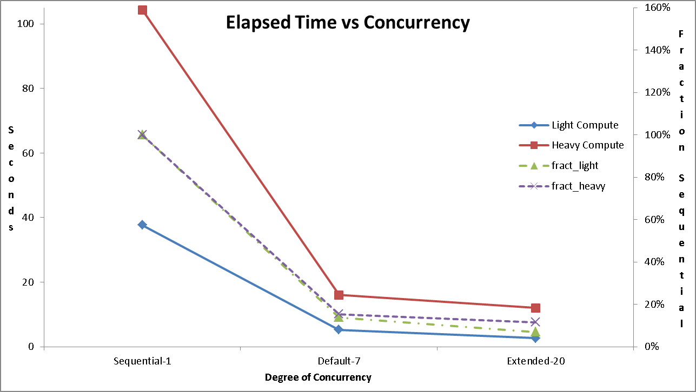

1. Csdfasdsad
2. Sdsdsdsdasd
3. asdasdsasadds