Root User output Queries

(1)

(2)

(3) a.

b.

4.

5 a. before

5 b. insert

5 c. results

7. a before

7 b. delete

7 c result

8 a. before

8 b. update

8 c. result

9 error  
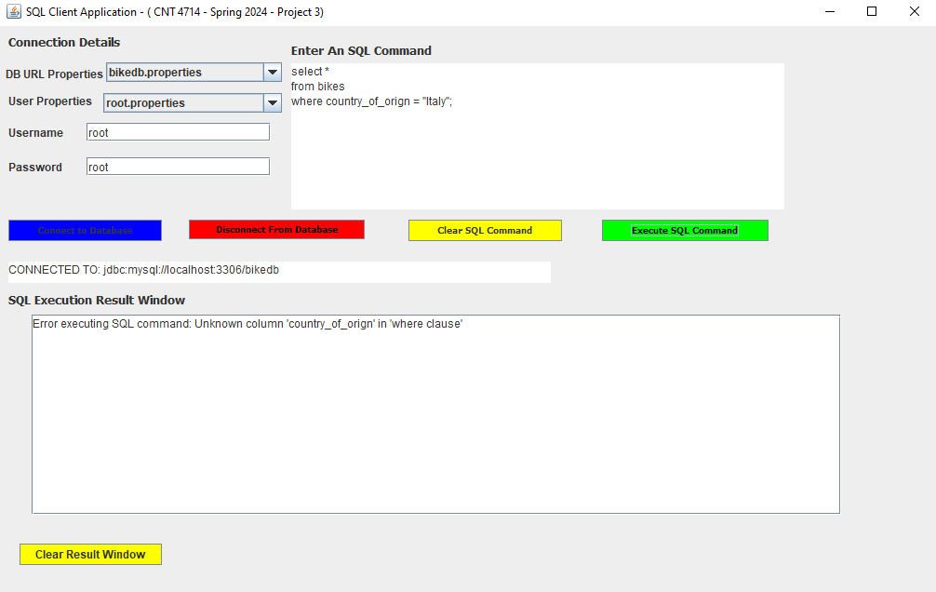

10 a.

10 b.

CLIENT1 Commands

1.

2.a before

2.b delete – Norway

2. c results

3 a before

3 b update

3 c results

4

5

6

7.

Client 2 commands

1.

2a before

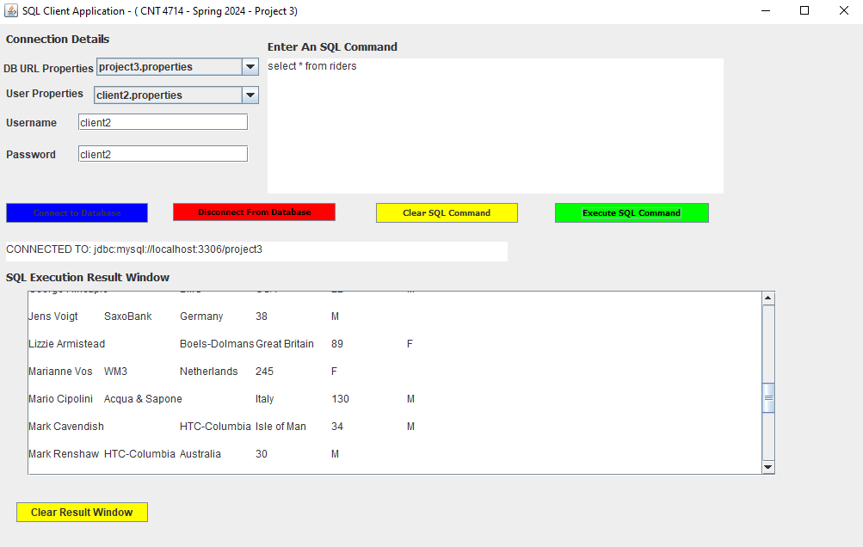

2b. delete

2.c results

3A before

3 b update

3 c results

4

5

6

7

The accountant

**MySQL Workbench**

**Bonus screenshots**

SC. 1

SC. 2

SC.3

SC.4

SC.5

SC. 6

SC. 7

SC 8 (Continue of SC 7 sql command)

SC 10

SC.11

SC. 12

SC. 13

SC 14

SC. 15

