Ten screen shots as shown on pages 15, 17, 18, 19,  
20, 24, 25, 26, 27, and 28.

SS1 – Task creation –  
general tab.”  
Task Name: StartNotePad

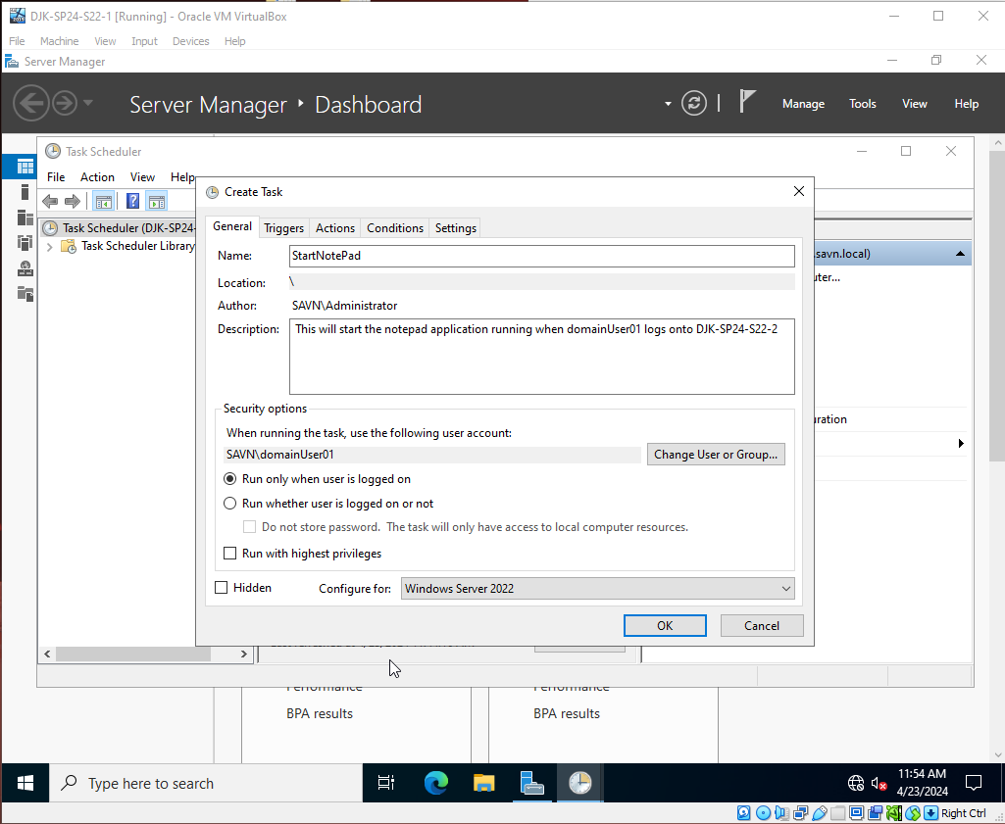

SS2  
– Task creation – trigger.”

SS3  
– Task creation – action.

SS4  
– Task executing for domainUser01 on MJL-  
SP24-S22-2.

SS5  
– Task listed on remote system MJL-SP24-S22-  
2 running under domainUser01

SS6 -  
displayDateMessage task creation - general tab

SS7 -  
displayDateMessage task creation - triggers tab

SS8 - displayDateMessage task  
creation - action tab

SS9 – displayDateMessage  
task listed as registered in the task  
library.

SS10 – displayDateMessage task  
executing

