Anasieze Ikenna
How the 2026 Iran Conflict
Affected Oil & Gas Prices

What Happened?
In late February 2026, a military conflict involving Iran disrupted one of the world's most important oil shipping routes — the Strait of Hormuz. This report explains how that conflict pushed up global oil prices and US gas prices at the pump, and how we analyzed the data using Amazon Web Services (AWS).

The Big Numbers
What | Before the war (Feb 27) | At the peak (Mar 20)
Global oil price (Brent) | $73 per barrel | $110 per barrel (+51%)
US gas at the pump | $2.92 per gallon | $3.92 per gallon (+34%)
Ships through Hormuz per day | 138 ships | 4 ships (97% drop)

In simple terms: the conflict made it much harder to move oil through the Middle East. Less supply available meant higher prices — first for crude oil, then for gasoline and diesel at US gas stations.

Price Changes Over Time
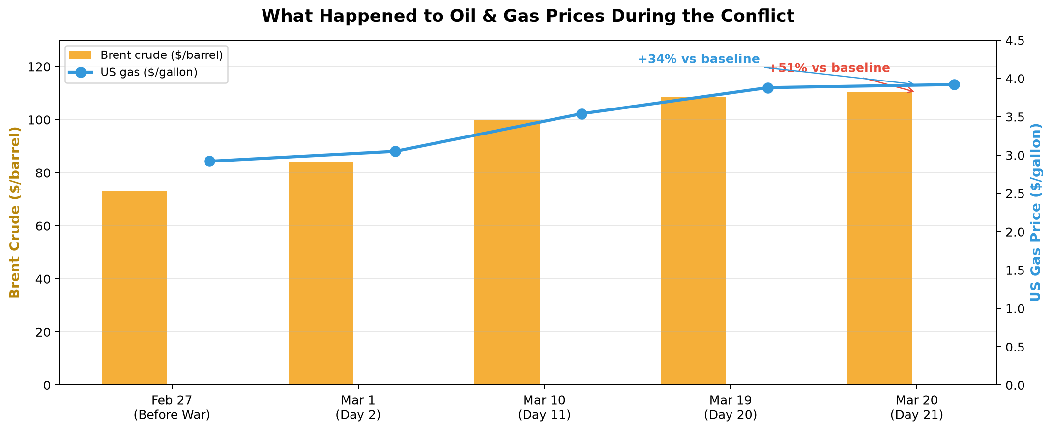
Figure 1 — Oil and gas prices rose steadily as the conflict escalated.

Why Some States Pay More for Gas
Gas prices did not rise equally everywhere. West Coast states like California ($5.53/gal) and Washington ($5.15/gal) pay the most, while states like Oklahoma ($3.24/gal) and Kansas ($3.25/gal) pay the least.
- Main reasons:
- Distance from refineries — coastal and western states often rely on more expensive supply routes
- State taxes and environmental rules — California requires special fuel blends
- Regional supply disruptions — attacks on LNG and gas facilities in the Middle East hit global energy markets

Average Gas Price by US Region (Mar 19, 2026)
Region | Before war | During war
West | $3.45/gal | $4.32/gal
South | $2.75/gal | $3.53/gal
Midwest | $2.79/gal | $3.55/gal
Northeast | $3.15/gal | $3.96/gal

Key Events That Moved the Market
These moments had the biggest impact on oil prices:
Date | What happened | Market effect
Feb 28 | War begins — Strait of Hormuz closed | Oil jumped 9% in one day
Mar 2 | Qatar LNG production shut down | Global gas supply at risk
Mar 4 | Emergency oil release (400 million barrels) | Governments tried to calm prices
Mar 10 | Oil crosses $100/barrel | First time since 2022
Mar 18 | Attacks on gas fields and refineries | Oil hits $108/barrel
Mar 20 | US considers releasing stored Iranian oil | Oil reaches $110/barrel peak

How We Built the Analysis (Cloud Pipeline)
This analysis was not done in a spreadsheet. It runs on Amazon Web Services — a set of cloud tools that store data, organize it, run queries, and display interactive charts. Everything was set up automatically using Terraform (infrastructure-as-code), so the whole system can be recreated with one command.
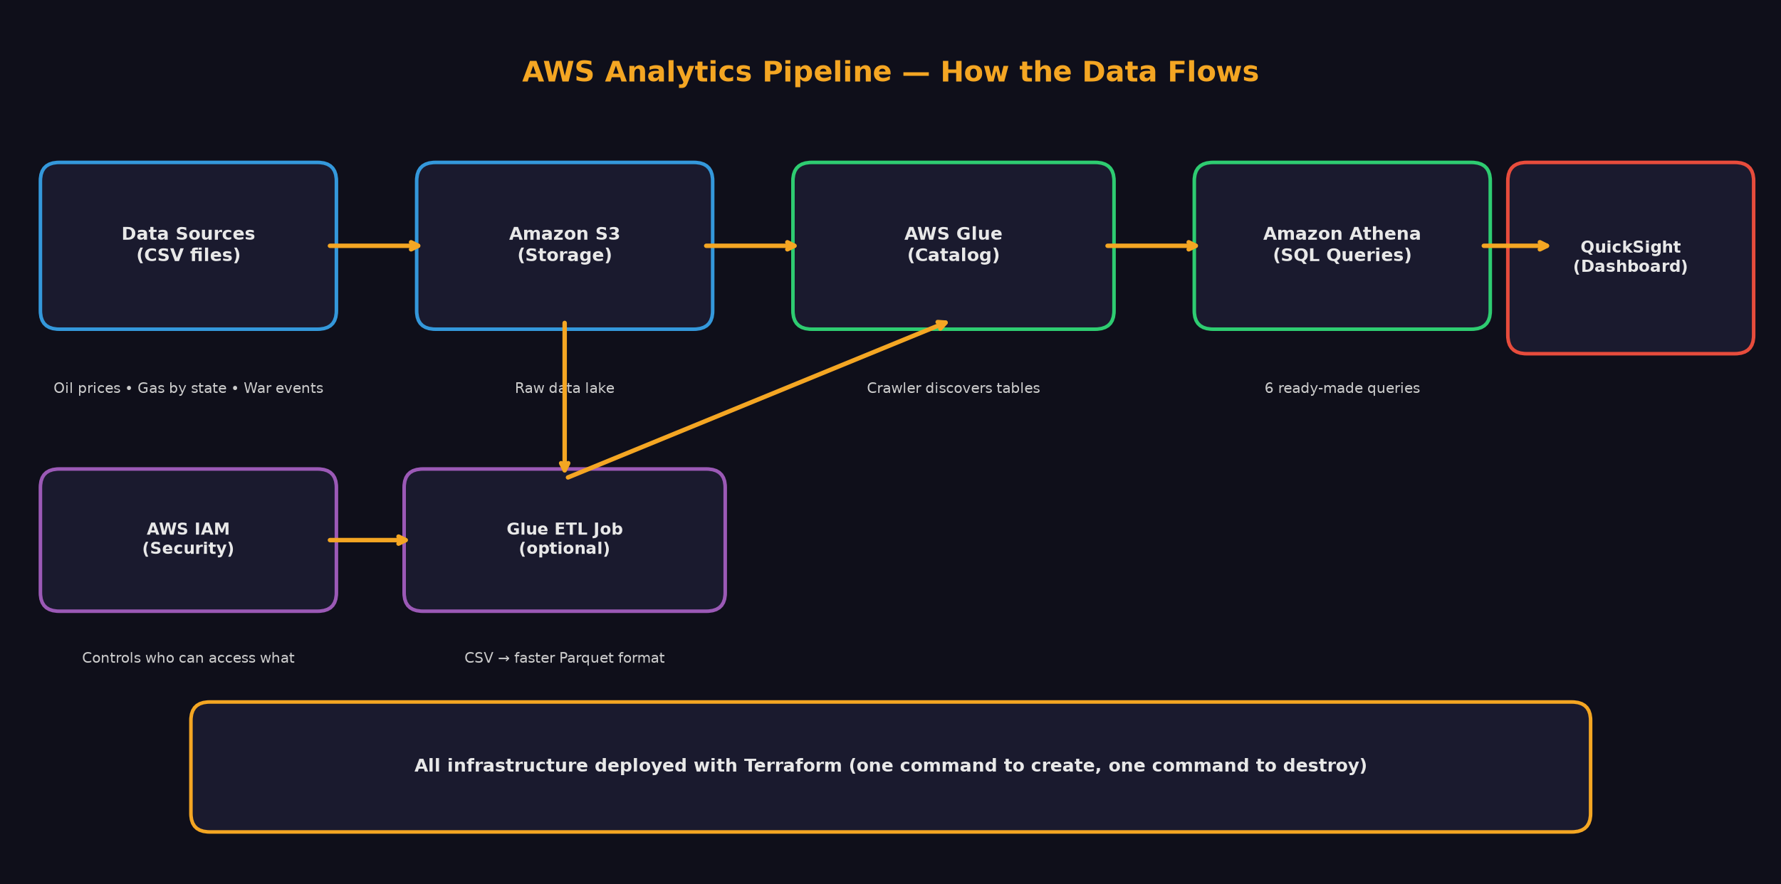
Figure 2 — AWS analytics pipeline: from raw data files to interactive dashboard.

Step by Step
1. Store data: Three CSV files (oil prices, gas by state, war events) are uploaded to Amazon S3 — cloud storage.
2. Organize data: AWS Glue automatically reads the files and creates a catalog so we know what data we have.
3. Ask questions: Amazon Athena lets us run SQL queries — like asking a database questions in plain SQL.
4. See results: Amazon QuickSight turns the answers into charts, maps, and KPI cards anyone can explore.

The Interactive Dashboard
The final output is a live dashboard with three pages anyone can open in a web browser — no special software needed.
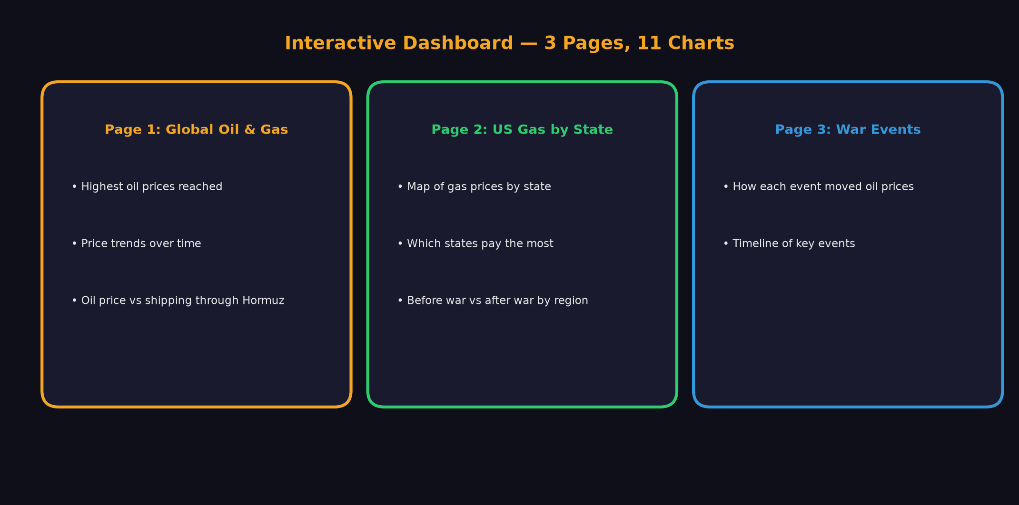
Figure 3 — Dashboard pages and what each one shows.

Live dashboard: https://us-east-1.quicksight.aws.amazon.com/sn/dashboards/s3-athena-qs-demo-dev-dashboard

Key Takeaways
- A single shipping route (Strait of Hormuz) can move global oil prices by 50% in weeks.
- Gas prices at the pump follow oil prices, but with a delay of 1–2 weeks.
- Where you live matters — West Coast drivers feel the pain more than Midwest drivers.
- Attacks on energy infrastructure (LNG plants, gas fields, export terminals) hurt prices more than political announcements alone.
- Cloud tools (AWS) make it possible to go from raw data to a live dashboard quickly and repeatably.

About the Data
Data comes from the Kaggle dataset 'Iran War Oil Shock 2026', compiled from public sources including AAA, Reuters, CNBC, and the IEA. It covers February 9 through March 20, 2026. This is a demonstration dataset used to showcase a cloud analytics pipeline.

Report generated from the s3-athena-quicksight-demo project

