Question: Terminal-Based Git Practice
Question 1: Setup & Initialization
- Configure your Git username and email.
- Create a new folder and navigate into it.
- Initialize a Git repository.
- Verify the repository using git status.
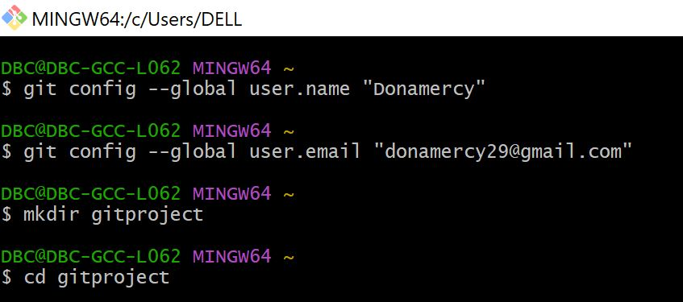
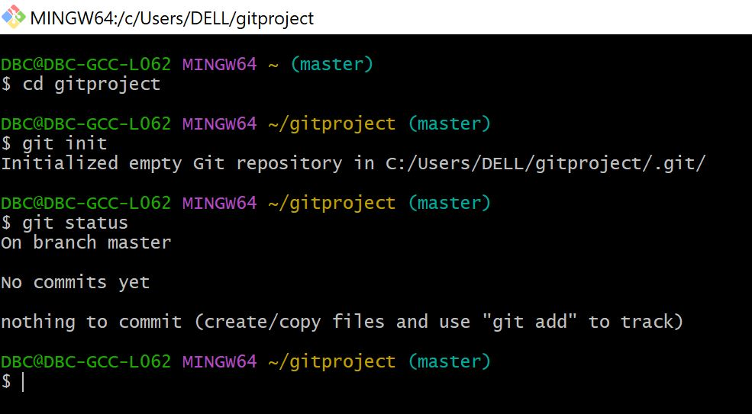
Question2: Connect to the Remote Repository
- Create a Repository in GitHub
- Paste the Desktop Git URL in Git Bash
- Push the local repository file to remote

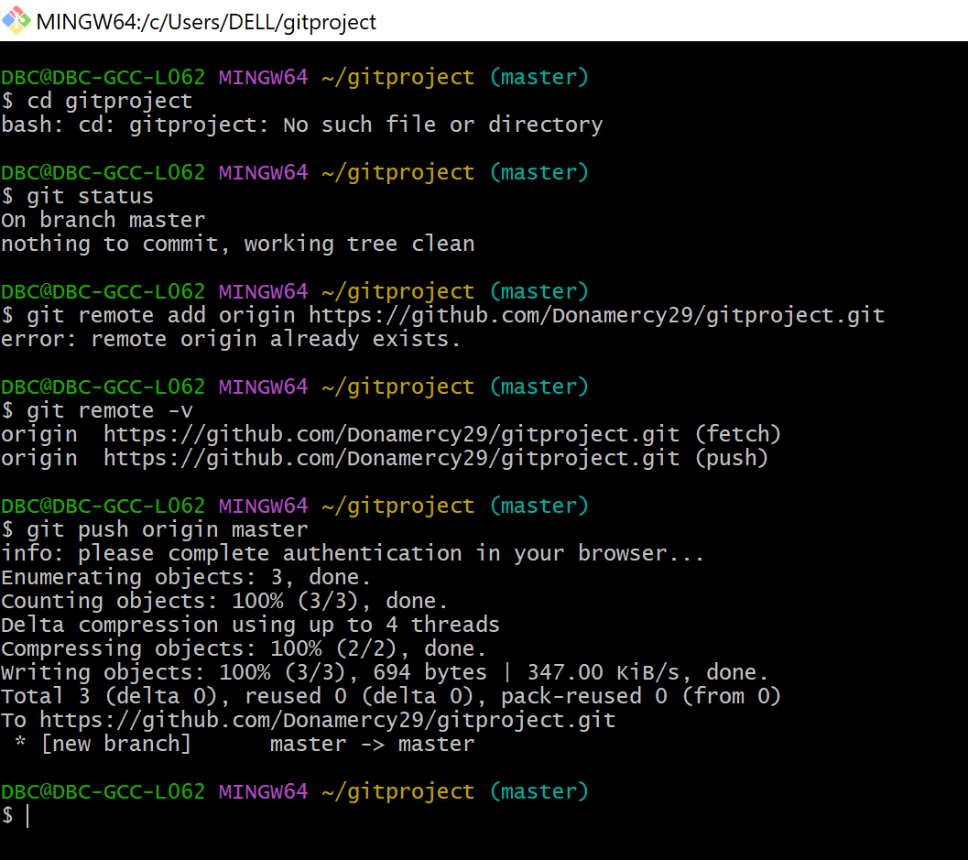
Question 2: File Tracking
- Create a file using touch file1.txt.
- Add some content using Notepad.
- Check status and identify untracked files.
- Stage the file and commit it.
- View commit history using git log.
