- Create your account on GitHub

- Configure your ssh key to connect your local to github
- On your computer, open your terminal (git bash or Vscode) at the root of your machine
- Generate an SSH Key by running:
ssh-keygen -t ed25519 -C "your_email@example.com"

- Click on: Enter
- You will see a message “Enter passphrase”, Click again on: Enter
- You will see another message “Enter same passphrase again: Click again on: Enter
- A magic message will appear that looks like this:
| .. |
| .+ |
|oo o . |
|o+oo o o = o |
|+o*.+ + S = B . |
|oB++o.oo + B E .|
|=oo. + +.. o o + |
|. . . . o . |
| . . |
+----[SHA256]-----+

→ This means you generated your key.
- On your terminal, run the following command: cat ~/.ssh/id_ed25519.pub
- You will see a magic code appear, this is your key, copy it for now in a text editor or wherever.
- Go back to your GitHub account and go to Settings > SSH and GPG keys.
  - Click on New SSH key.
  - Give a name to your key and Paste the SSH key there.



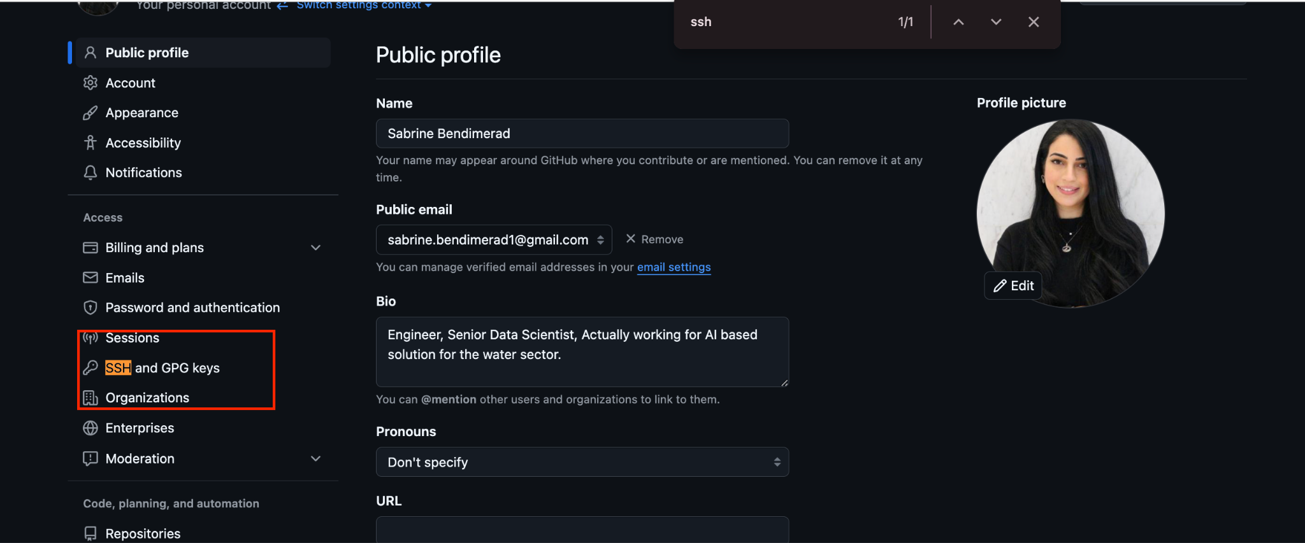

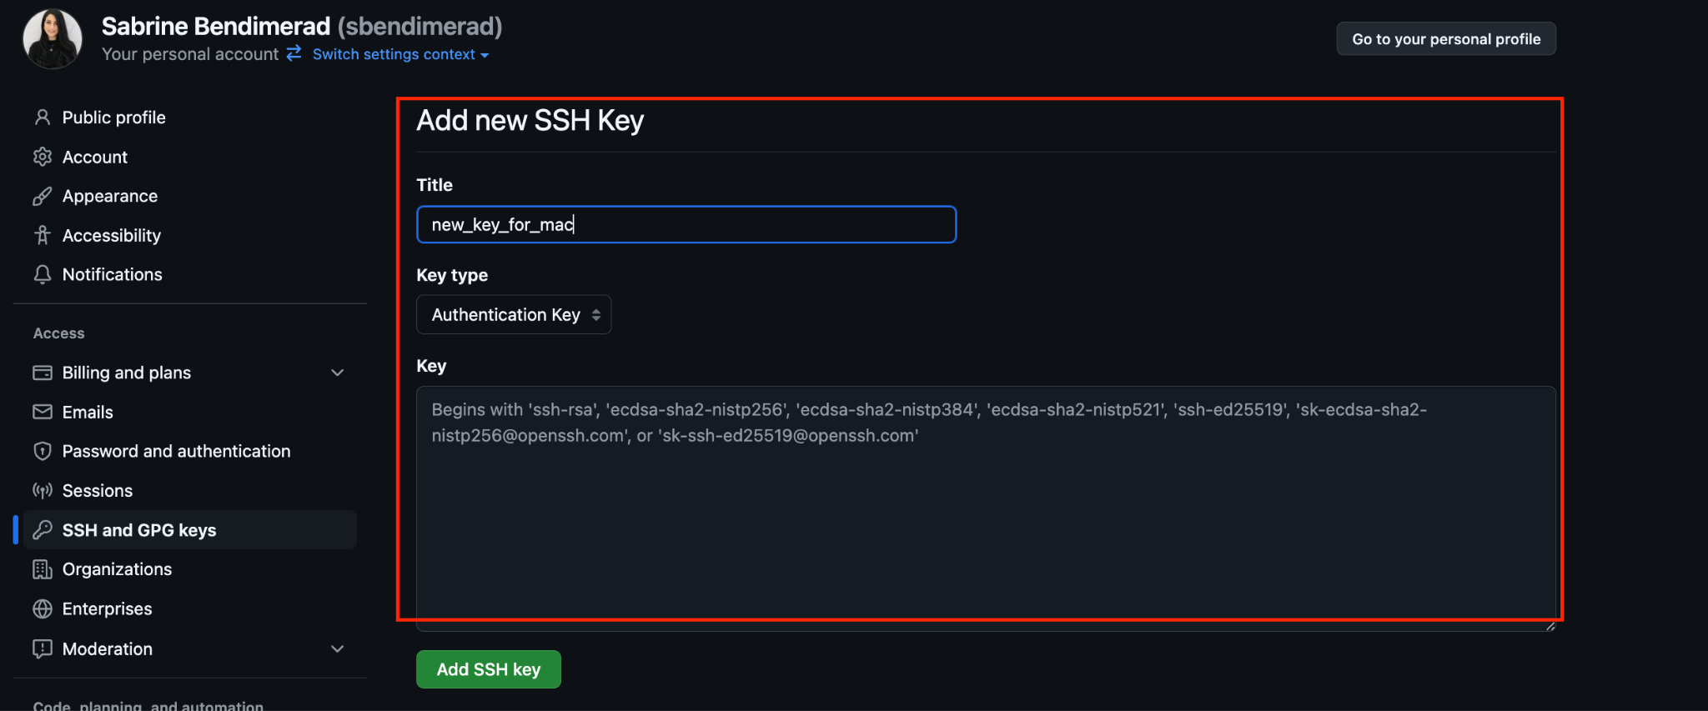

- Test your SSH connection:

- Enter on your teminal: ssh -T git@github.com
- Set up your remote:
git remote set-url origin git@github.com:username/repo.git
git config --global user.name "username"

