# Acknowledgements

Dr. Davies Segera – for his guidance, constructive feedback and support through the project

Mitch Macharia – for his collaboration on pcb design and fabrication as well as firmware development

Dominick & Alphonse – for designing and fabricating electrolysis chamber

Mr. Rotich, Madam Celestine & Mr. Nganga – for their assistance in a DC power supply and in pcb fabrication

# Introduction

Electrolysis is the use of an electrical current to drive a chemical reaction that otherwise would not occur spontaneously

This process typically requires careful manual control to maintain optimal conditions, including the regulation of voltage, current, and electrolyte concentration

An automated electrolysis system is a technology designed to streamline and optimise the electrolysis process

The control unit is the core of the automated electrolysis system. It employs a combination of hardware and software components to execute the electrolysis process with high precision

# Problem Statement

Increasing global demand for hydrogen and oxygen driven by their roles in energy, transportation and healthcare presents a significant challenge

Traditional methods of producing these gases often rely on fossil fuels, leading to environmental degradation. These methods are also costly.

An automated electrolysis system has the potential to produce gases in a cost effective and environmentally friendly manner

# Objectives

Main Objective - To develop an automated electrolysis system that enhances efficient, safe, and cost effective hydrogen and oxygen production

Specific Objectives

1. To detect gas flowrate, concentration and temperature realised by the system
2. To detect gas pressure in the gas reservoir of the system
3. To design and fabricate a pcb incorporating hardware used to automate the system
4. To develop firmware to achieve automation of electrolysis operation

# Other Hydrogen and Oxygen Production Processes

Hydrogen

1. Steam Methane Reforming – where methane reacts with steam under high pressure to produce hydrogen and carbon monoxide.
2. Partial Oxidation – where hydrocarbons are partially oxidised with oxygen to produce hydrogen and carbon monoxide
3. Biomass Gasification –where organic materials are converted into hydrogen, carbon monoxide, and carbon dioxide through high-temperature reactions

Oxygen

1. Cryogenic Air Separation -where atmospheric air is cooled to liquid then fed to a distillation column
2. Pressure Swing Adsorption – where compressed air is passed through a bed of adsorbent material which preferentially adsorbs nitrogen over oxygen at high pressure
3. Vacuum Pressure Swing Adsorption – which is similar to PSA but incorporates vacuum pressure to enhance desorption efficiency

The above methods pollute the environment and require high setup costs

# Hydrogen and Oxygen Production using Electrolysis

Involves the decomposition of water (H₂O) into its constituent gases as follows:

$$2H_{2}O\left(l\right)→2H_{2}\left(g\right)+ O_{2}(g)$$

This process occurs in an electrolyser, which consists of an anode and a cathode separated by an electrolyte. Hydrogen is produced at the cathode and oxygen at the anode

At the cathode (reduction):

$$2H_{2}O+2e^{-}→H_{2}+2OH^{-}$$

At the anode (oxidation):

$$4OH^{-}→ O_{2}+2H_{2}O+4e^{-}$$

# Advantages of gas production using electrolysis

1. It’s environmentally friendly when powered by renewable sources
2. It offers high purity gas production
3. It is scalable
4. It can be used as energy storage for renewable system
5. It can have decentralised production

# Types of Electrolysers

1. Alkaline Electrolysers – these use a basic solution as the electrolyte
2. Proton Exchange Membrane Electrolysers – thes use a solid polymer membrane as the electrolyte
3. Solid Oxide Electrolysers – these operate at high temperatures using a solid ceramic electrolyte

# Automation of Electrolysis

Important input parameters of consideration

* 1. Voltage and Current
  2. Temperature of electrolyte
  3. Electrolyte Concentration
  4. Electrode Material

Important gas parameters of consideration

* 1. Flowrate
  2. Concentration
  3. Temperature
  4. Pressure

Automation of the system involves controlling these parameters. Measurement of these parameters involves the use of sensors

# Measurement of Gas Parameters

Gas flowrate sensors

1. Thermal mass flow sensors
2. Differential pressure flow sensors
3. Ultrasonic flow sensors
4. Coriolis flow sensors

Gas concentration sensors

1. Electrochemical sensors – use electrolysis, gas absorbed by material to form electrolyte
2. Infrared sensors
3. Catalytic bead sensors
4. Metal oxide semiconductor sensors
5. Ultrasonic gas concentration sensors – use speed of sound in binary gas mixture, its temperature and molar mass

Gas temperature sensors

1. Resistance Temperature Detectors
2. Thermocouples – seebeck effect
3. Thermistors

Gas pressure sensors

1. Piezoelectric Pressure Sensors
2. Capacitive Pressure Sensors
3. Strain Gauge Pressure Sensors

# Hardware Design

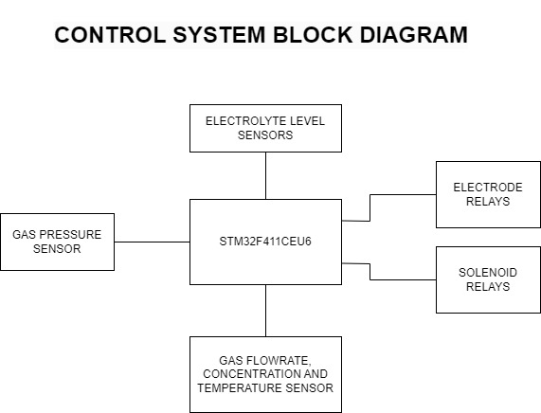

The Control system consists of

1. Microcontroller Unit – STM32F411CEU6
2. Electrode & Solenoid relays – to individually control 4 different electrolysis chambers
3. Electrolyte level sensors
4. Gas Pressure sensors
5. Gas Flowrate, concentration & temperature sensor

# Software Design

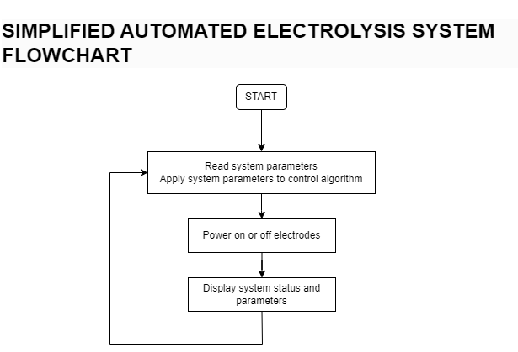

When the control system is activated, it is applied to the electrolyte level control algorithm.

Next, the system reads all gas parameters from the sensors. It then checks if gas parameters are all within threshold.

The system will power on or off the electrodes based on thresholds defined in the control algorithm

The system will display its status on the display and continue execution from the beginning of the loop.

# Implementation

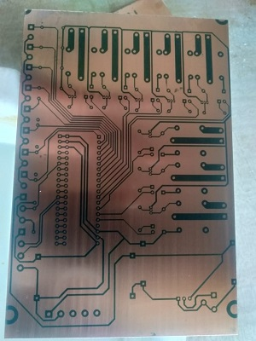

The following is our board during fabrication. After fabrication a portion of the components were soldered onto the board and preliminary tests were done. These tests included:

1. A power test
2. A microcontroller boot test and the running of a test program

Upon valid preliminary test results, full component assembly of the board was done and test with the electrolysis chamber was done. The following are images showing the control system and the electrolysis chambers

# Results

The system was able to

1. Measure and display system status and parameters such as gas flowrate, concentration, temperature and pressure
2. Power off and on of the electrode relays based on control thresholds

The following table shows amount of electrolyte concentration, input power and resulting flowrate in bubbles per minute

|  |  |  |  |
| --- | --- | --- | --- |
| Amount of electrolyte (g/litre) | Voltage(V) | Current(A) | Flowrate(Bubbles per minute) |
| 10 | 20 | 6 | 4 |
| 20 | 20 | 6.2 | 6 |
| 30 | 20 | 6.2 | 7 |
| 40 | 20 | 6.4 | 9 |
| 50 | 20 | 6.5 | 11 |
| 60 | 20 | 6.7 | 12 |
| 70 | 20 | 7.1 | 16 |

The following table shows the increase in oxygen concentration over time from starting of the electrolysis process. Electrolyte concentration was at 100g/litre

|  |  |  |  |
| --- | --- | --- | --- |
| Time(minutes) | Voltage(V) | Current(A) | Oxygen Concentration(%) |
| 1 | 24 | 8 | 25 |
| 3 | 24 | 8.4 | 34 |
| 6 | 24 | 9.0 | 48 |
| 9 | 24 | 9.7 | 62 |
| 12 | 24 | 10.2 | 83 |
| 15 | 24 | 11.1 | 95 |
| 18 | 24 | 11.6 | 95 |

# Conclusion

Design and implementation of an automated electrolysis control system was a success

Design and implementation of the electrolysis chamber needed more work. The major chamber design aspect to be corrected was to make the electrode spacing as small as possible

Current areas of improvement of the control system include:

1. Board design. Next board design should
   1. Delegate simple logic operations to an expander IC
   2. Add a GSM/GPRS module for connectivity
2. Connectivity of the system will allow over the air updates and systems deployed to various locations will able to update themselves with the latest firmware