Gas Pressure, Flowrate & Concentration monitoring for automated Electrolysis control

# Introduction

Automation of the electrolysis process is dependent on the gas pressure in the gas reservoir, gas flowrate through the pipe and concentration of the target gas flowing through the pipe.

Thus monitoring these variables is of essence

A state machine diagram of the process is a below

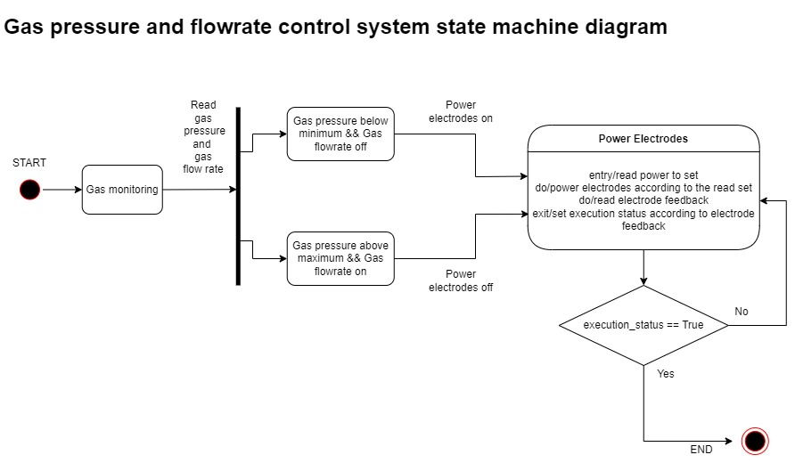

# Gas Pressure Measurement

Gas pressure measurement will be achieved using a pressure transducer at the gas reservoir.

The pressure transducer will convert pressure to a voltage reading which can be read by the microcontroller.

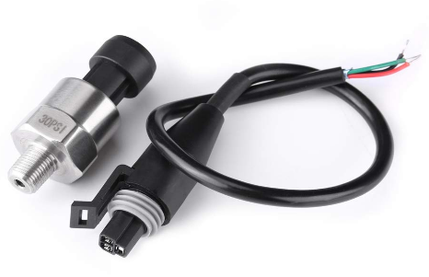

Using this we can determine whether to power on or power off the electrodes when the gas pressure reaches the maximum allowed value in the reservoir or goes below the allowed pressure in the reservoir.

Using this we can also determine if there are leaks in the reservoir if pressure reduces without use of gas

# Gas flowrate measurement

This is important in determining how efficient the electrolyzer is and is a good indicator of its state of health over time.

This is also important in situations whereby a variable amount of power is to be applied to power the electrodes depending on the net flowrate in the gas reservoir.

This can be achieved by measuring the change in gas pressure in the reservoir. However this method involves difficulty as a lot of factors are involved in calculating the flowrate.

A professional method is using a venturi tube and calculating gas flowrate using from known dimensions of pressure, fluid density and area measurements

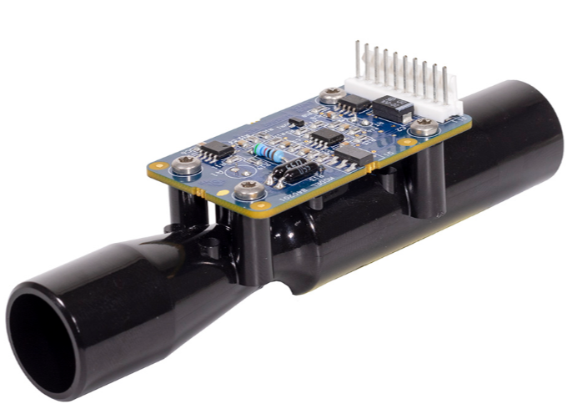

# Gas Concentration measurement

Since the reservoir is not a vacuum at the initial process of gas collection. The electrolysis process will need to operate for some time and drive out air in the reservoir since oxygen is denser than air.

Gas concentration will be measured at the outlet of the reservoir and collection will be commenced when concentration is at required levels

This will be achieved using an oxygen concentration and flow sensor as below

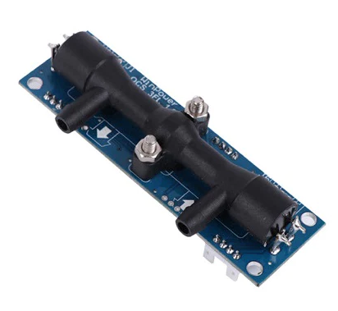

Using this both the flow and concentration of oxygen can be measured. However this is limited to a flow rate of up to 10L/min beyond which only concentration will be of importance

Using this the quality of oxygen being delivered can also be monitored

# Monitoring

Constant monitoring of whole process will be done. This will enable setting of the system appropiately and promptly in abrupt events such as power failure, gas leakage among others

# Pricing

The budget for this project can be broken into two, first the POC (proof of concept), second the alpha prototype which is a more refined prototype based on findings from the proof of concept

Budget for the POC

