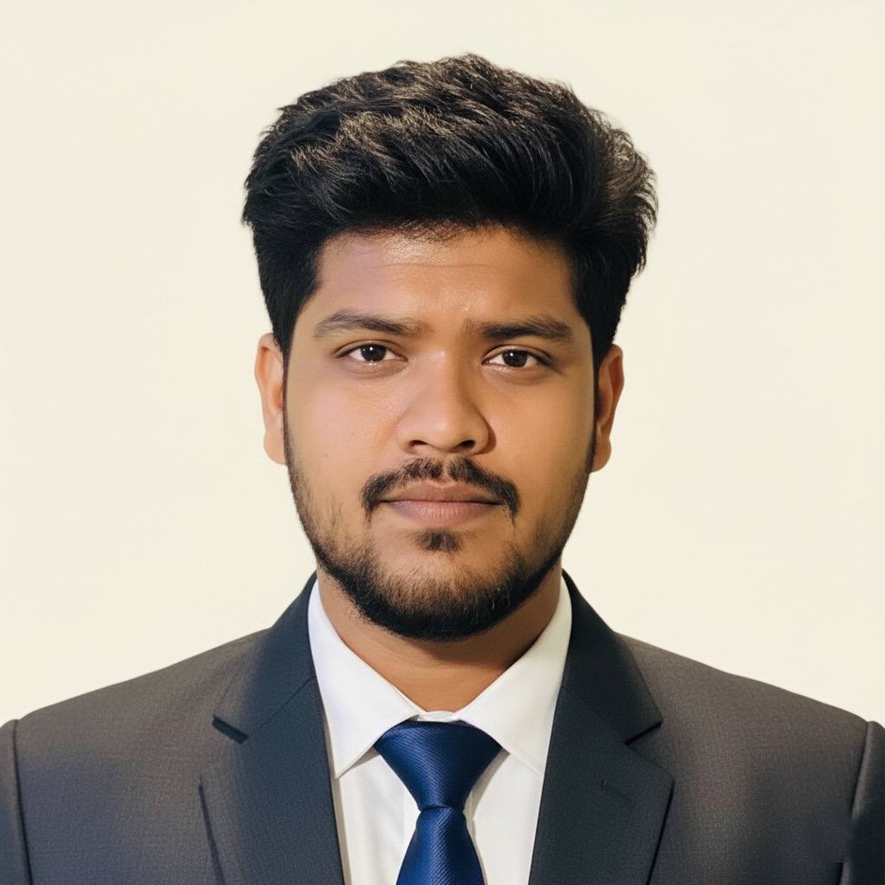
SHIHAB SARAR DEEPRO
Creative Professional (Digital Marketing | Graphics Design)
7400, Jashore, Bangladesh | Phone: +8801750042259 | Email: shihabsarar0929@gmail.com
About Me
I am Shihab Sarar Deepro, a confident and results-driven creative professional with proven experience in digital marketing, graphic design, and video editing. I specialize in leveraging AI tools and prompt engineering to optimize creative workflows, generate innovative design concepts, and craft compelling scripts for short-form videos and promotional advertisements. With a strong focus on quality, innovation, and strategic thinking, I aim to lead creative initiatives that deliver measurable impact, strengthen brand identity, and drive business growth through modern, technology-driven solutions.
Skills
- Digital Marketing & Social Media Management
- Graphic Design (Adobe Photoshop, Illustrator)
- Video Editing & Short-Form Content Creation
- AI Prompt Writing for Graphics & Video Editing
- AI-Assisted Script Writing for Short Videos & Promotional Ads
- Creative Branding & Visual Communication
Job Experience
Digital Marketing Manager & Graphics Designer — Savetech Builders (December 2025 – Present)
- Managing digital marketing strategies and online brand presence
- Designing marketing creatives, banners, and promotional materials
- Handling social media platforms and content planning
- Collaborating with management to support business growth
Graphic Designer — PUBG Mobile Underdog Community (January 2020 – November 2021)
- Designed graphics for social media posts and digital campaigns
- Edited short promotional videos and creative content
- Maintained visual consistency across platforms

Educational Qualification
Diploma in Engineering (Computer Engineering) — Jashore Polytechnic Institute, 2024 | CGPA: 3.28 / 4.00
Secondary School Certificate (Science) — Jashore Zilla School, 2020 | GPA: 4.78 / 5.00
Personal Information
Father’s Name : S.M.M. Shakirul Kabir
Mother’s Name : Shahnaj Akter
Date of Birth : October 9, 2003
Gender : Male
Marital Status : Unmarried
Nationality : Bangladeshi
Religion : Islam
Language Proficiency
- Bangla — Fluent
- English — Intermediate
- Hindi — Conversational

Future Plan
My future goal is to develop myself as a skilled creative and digital marketing professional by combining graphic design, video editing, and AI-based tools. I aim to continuously improve my knowledge of AI-assisted content creation, prompt writing, and short-form video marketing to produce effective and engaging promotional content.
In the long run, I want to work with innovative organizations, contribute to brand growth through creative strategies, and explore opportunities to lead or build creative projects that use modern technology to deliver impactful marketing solutions.

