Emp的相关查询
- 先书写sql，并在sqlyog上执行测试
SELECT e.`emp_id` eid,e.`dept_id` did, e.`emp_name` ename, e.`emp_gender` egender,e.`emp_salary` esalary,d.`dept_name` dname
FROM tb_emp e LEFT JOIN tb_dept d ON e.`dept_id` = d.`dept_id`
WHERE e.`emp_id` = 2;
- 书写dao
//查询一个员工
public Emp getOneEmp(int empId) {
Connection conn = null;
PreparedStatement pstmt = null;
ResultSet rs = null;
Emp emp = null;
try {
conn = JDBCUtils.getConnection();
String sql = "SELECT e.`emp_id` eid,e.`dept_id` did, e.`emp_name` ename, e.`emp_gender` egender,e.`emp_salary` esalary,d.`dept_name` dname\n" +
"FROM tb_emp e LEFT JOIN tb_dept d ON e.`dept_id` = d.`dept_id` \n" +
"WHERE e.`emp_id` = ?";
pstmt = conn.prepareStatement(sql);
pstmt.setInt(1,empId);
rs = pstmt.executeQuery();
emp = null;
if(rs.next()) {
int did = rs.getInt("did");
String ename = rs.getString("ename");
String egender = rs.getString("egender");
double esalary = rs.getDouble("esalary");
String dname = rs.getString("dname");
emp = new Emp(empId,ename, egender,esalary,new Dept(did,dname));
}
} catch (SQLException throwables) {
throwables.printStackTrace();
} finally {
JDBCUtils.close(rs, pstmt, conn);
}
return emp;
}

绘制界面
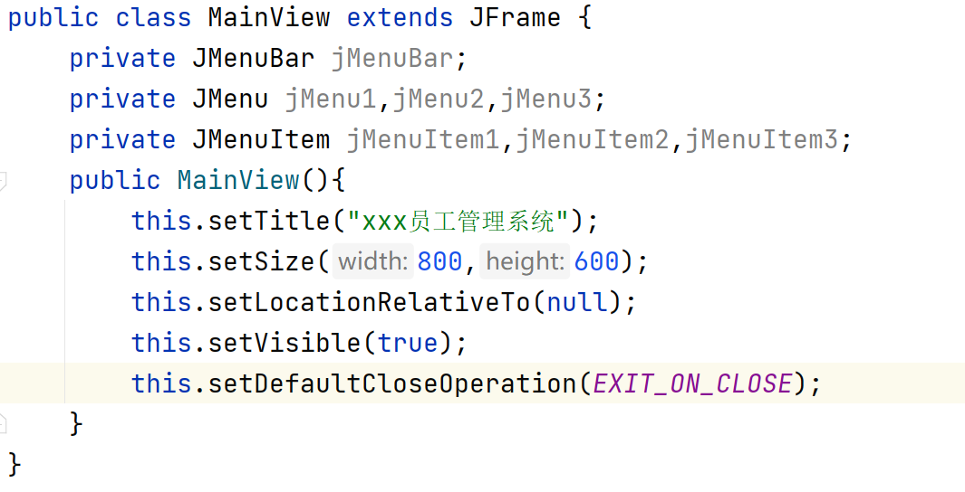
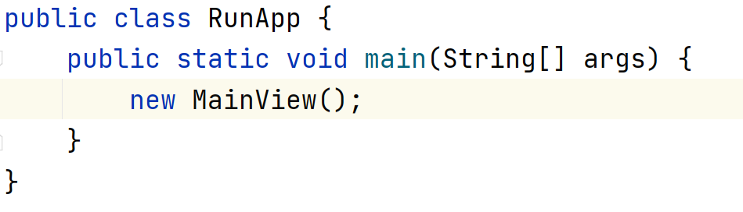

绘制菜单
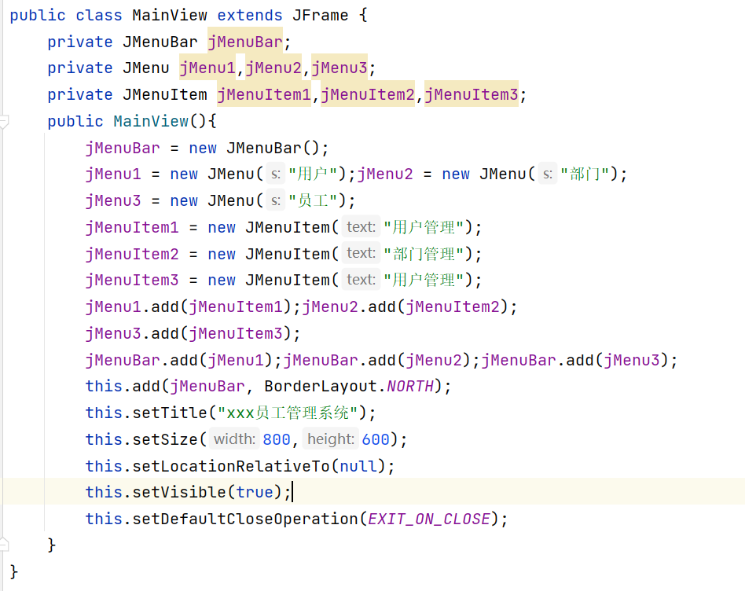

绘制用户面板
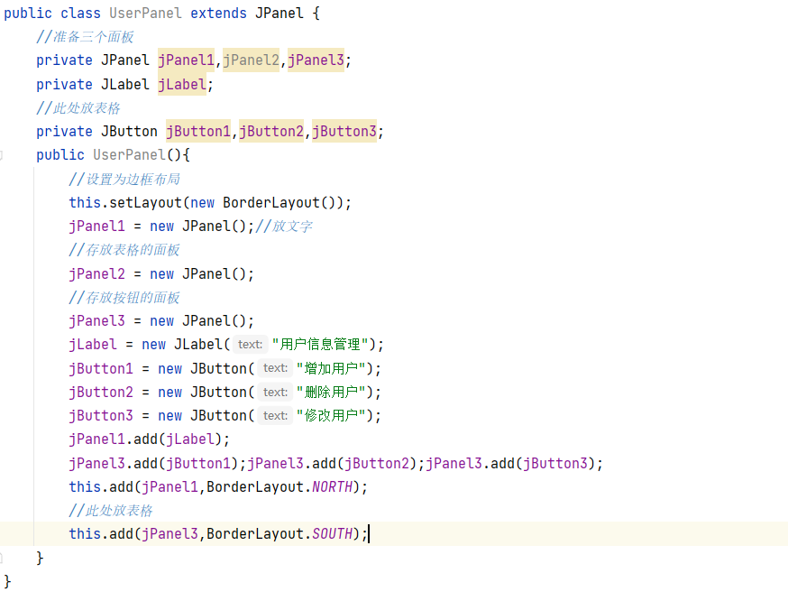

把面板添加到窗体中
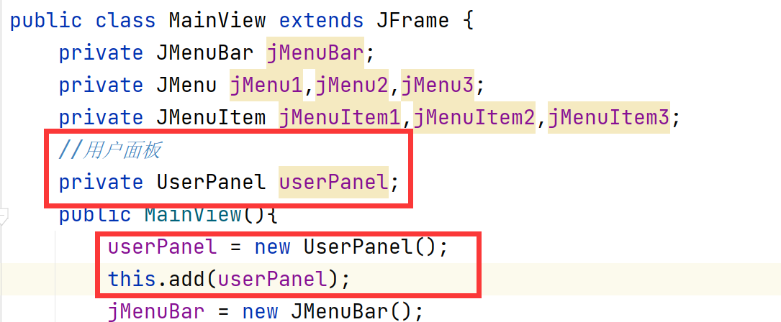

绘制部门面板和员工面板
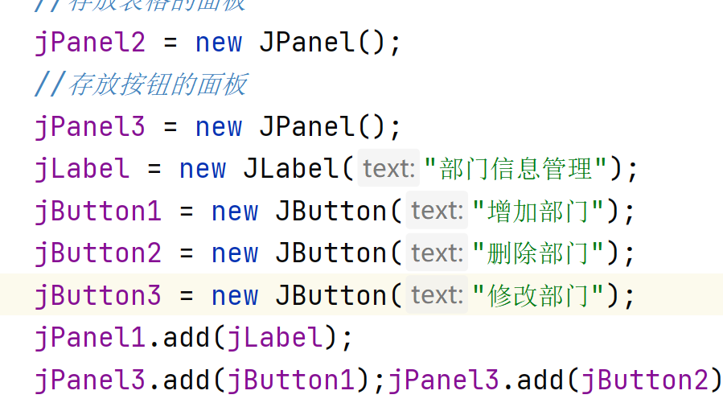
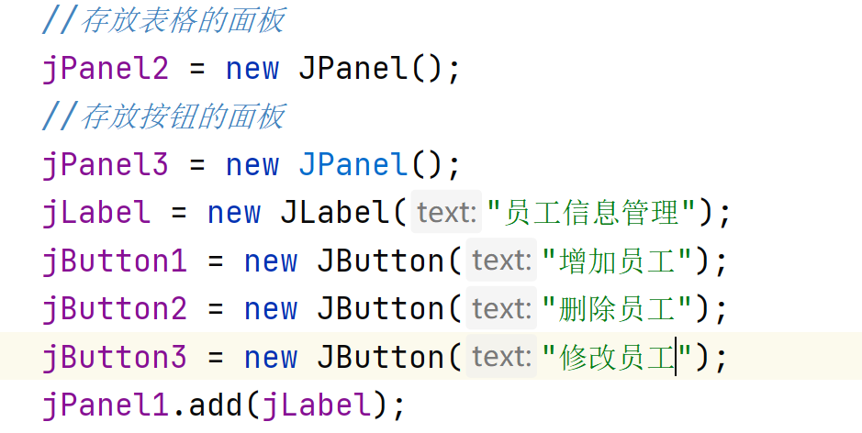

把部门面板和员工面板放到主界面
