对话框(JDialog)
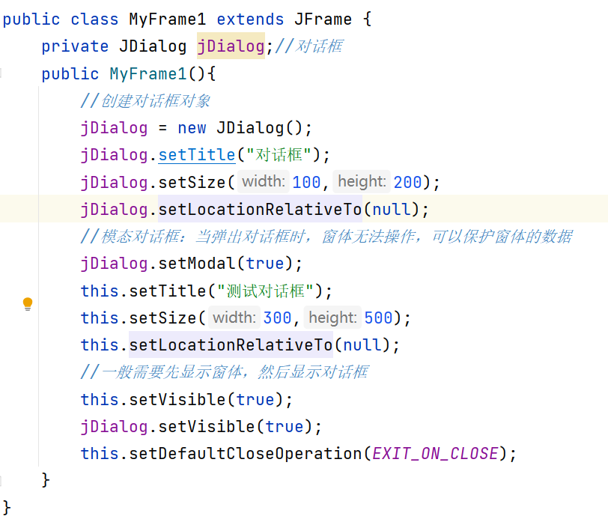

内置对话框
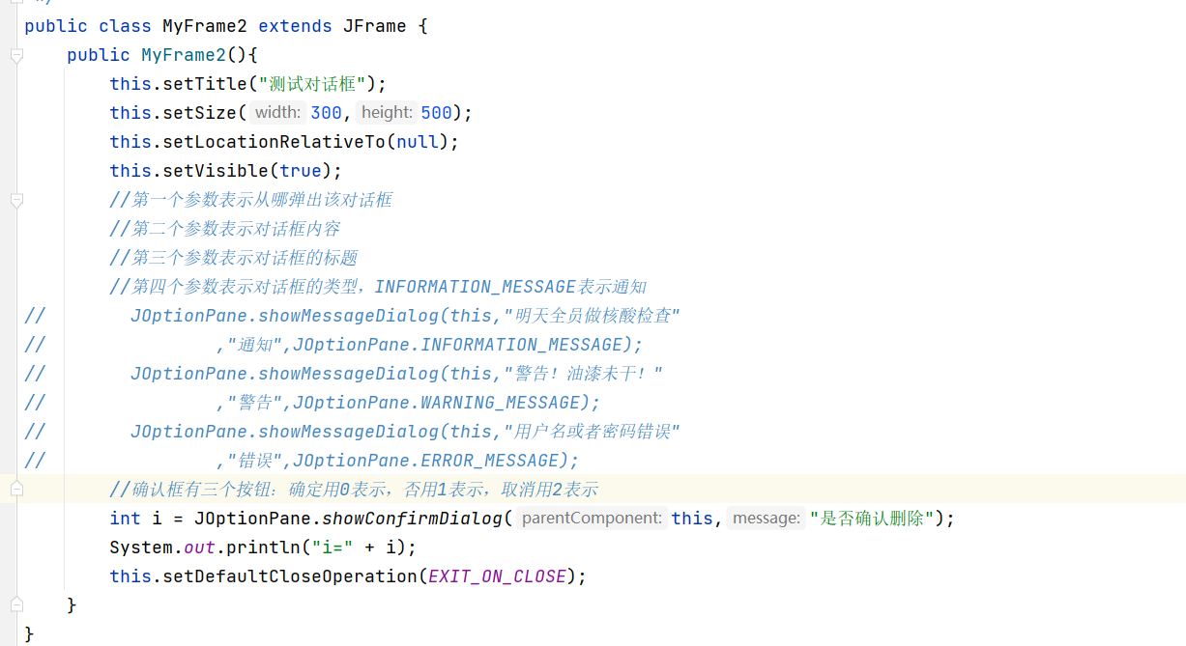

面板（JPanel）
GUI中除了菜单以外的组件，都需要放到面板中,再把面板添加到窗体中
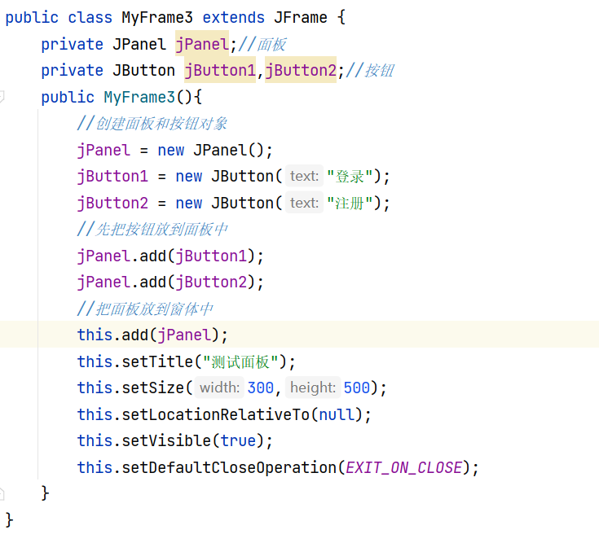

文本框和密码框

public class MyFrame4 extends JFrame {
private JPanel jPanel;//面板
private JLabel jLabel,jLabel2;//文字
private JTextField jTextField;//文本框
private JPasswordField jPasswordField;//密码框
public MyFrame4(){
//创建面板和按钮对象
jPanel = new JPanel();
jLabel = new JLabel("用户名");
//参数是文本框的长度
jTextField = new JTextField(20);
jLabel2 = new JLabel("密码");
jPasswordField = new JPasswordField(20);
jPanel.add(jLabel);
jPanel.add(jTextField);
jPanel.add(jLabel2);
jPanel.add(jPasswordField);
//把面板放到窗体中
this.add(jPanel);
this.setTitle("测试面板");
this.setSize(300,500);
this.setLocationRelativeTo(null);
this.setVisible(true);
this.setDefaultCloseOperation(EXIT_ON_CLOSE);
}
}

下拉列表
public class MyFrame5 extends JFrame {
private JPanel jPanel;//面板
private JComboBox<String> jComboBox;//下拉列表
public MyFrame5(){
//创建面板和按钮对象
jPanel = new JPanel();
//准备下拉列表的数据
Vector<String> vector = new Vector<>();//和ArrayList用法一样
vector.add("研发部");
vector.add("财务部");
vector.add("市场部");
jComboBox = new JComboBox<>(vector);
jPanel.add(jComboBox);

//把面板放到窗体中
this.add(jPanel);
this.setTitle("测试面板");
this.setSize(300,500);
this.setLocationRelativeTo(null);
this.setVisible(true);
this.setDefaultCloseOperation(EXIT_ON_CLOSE);
}
}

单选按钮和复选框
public class MyFrame6 extends JFrame {
private JPanel jPanel;//面板
private JCheckBox jCheckBox1,jCheckBox2,jCheckBox3;//复选框：一次可以选多个
private JRadioButton jRadioButton1,jRadioButton2;//单选按钮：一次只能选一个
//单选按钮默认都能被选中，需要把属于一组的按钮放到ButtonGroup对象中
private ButtonGroup buttonGroup;
public MyFrame6(){
//创建面板和按钮对象
jPanel = new JPanel();
jCheckBox1 = new JCheckBox("羽毛球");
jCheckBox2 = new JCheckBox("篮球");
jCheckBox3 = new JCheckBox("足球");
jRadioButton1 = new JRadioButton("男");
jRadioButton2 = new JRadioButton("女");
buttonGroup = new ButtonGroup();
//把单选按钮放到按钮组对象中
buttonGroup.add(jRadioButton1);buttonGroup.add(jRadioButton2);
jPanel.add(jCheckBox1);jPanel.add(jCheckBox2);jPanel.add(jCheckBox3);
jPanel.add(jRadioButton1);jPanel.add(jRadioButton2);
//把面板放到窗体中
this.add(jPanel);
this.setTitle("测试面板");
this.setSize(300,500);
this.setLocationRelativeTo(null);
this.setVisible(true);
this.setDefaultCloseOperation(EXIT_ON_CLOSE);
}
}

