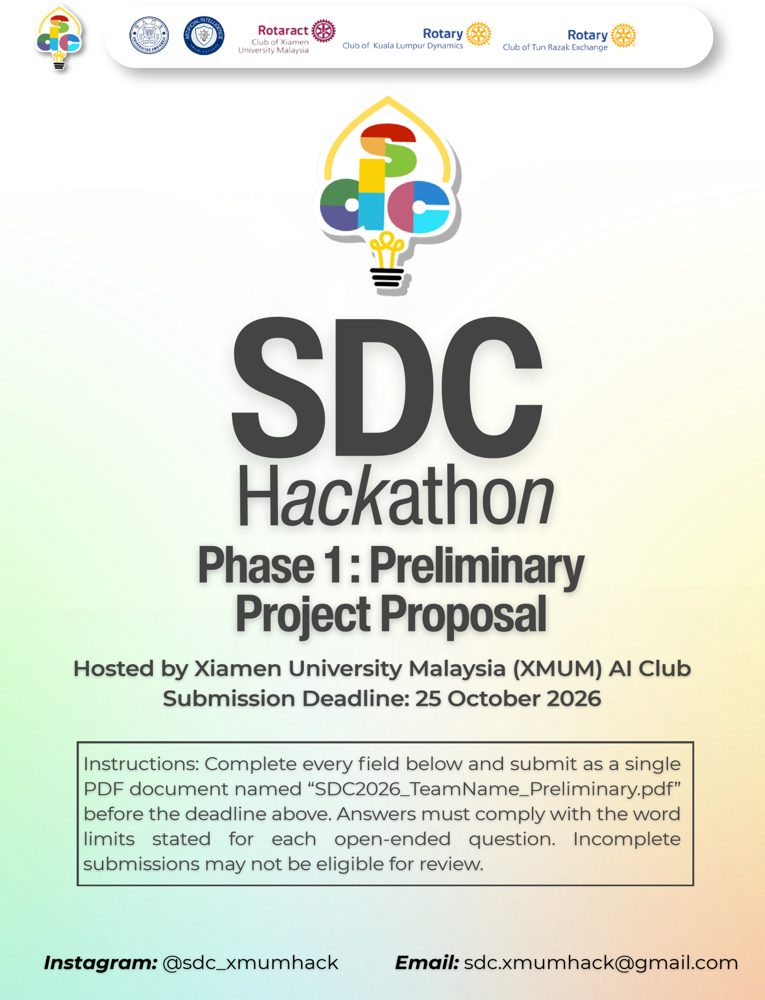
SDC HACKATHON 2026
Phase 1: Preliminary Project Proposal
Hosted by Xiamen University Malaysia (XMUM) AI Club
Submission Deadline: 25 October 2026
Instructions: Complete every field below and submit as a single PDF document named “SDC2026_TeamName_Preliminary.pdf” before the deadline above. Answers must comply with the word limits stated for each open-ended question. Incomplete submissions may not be eligible for review.

1. Team & Project Overview
Team Name | Lulu Master

Selected Domain | Domain 2

Selected SDG Track (1–17) | SDG8 / SDG9

Project / Solution Name | EzQuote

Name (Leader) | ZHANG LANXIN

Email & Phone (Leader) | Jrn2509030@xmu.edu.my

University Affiliation(s) | Xiamen University Malaysia

Number of Team Members | 5

2. Executive Summary & Problem Statement

2.1 The Problem Context
Describe the specific, real-world challenge your team is tackling. Who is affected by this problem, and why does it matter? Highlight the critical social, environmental, or economic issues involved.
[Maximum 250 words]
Many Malaysian small retailers and building-material/hardware SMEs still receive customer enquiries through WhatsApp or other chat channels in an informal form: “Need 50 bags of cement, delivery to this area, how much?” The customer may describe the product type, use case, quantity and delivery location without specifying a brand or exact SKU. The owner or a small sales team then has to identify suitable products from an Excel file or internal list, check current stock, calculate the base price, decide whether a discount is commercially safe, estimate delivery cost, and prepare a reply. This work is repetitive but risky: a wrong product match, outdated price, inconsistent discount, or forgotten delivery charge can reduce margin or delay the customer response. The problem is amplified when one owner is supervising several staff members who have different levels of product knowledge. EzQuote addresses this narrow operational bottleneck rather than trying to automate the entire business.

2.2 The Proposed AI Solution
Provide a high-level overview of your proposed application. How does it apply artificial intelligence to solve the problem stated above? Briefly mention the tools or technical skills gained from the SDC Phase 1 workshops (e.g., GenAI APIs, database architecture, cloud hosting) that you intend to leverage.
[Maximum 300 words]
EzQuote is an AI-assisted quotation workflow for small retailers. A customer enquiry is first converted by an LLM into structured fields such as product category, intended use, quantity, delivery area and explicit constraints. The application then searches the company’s own product/inventory database and filters candidates using deterministic fields such as category, unit and availability. Semantic matching is used only after this filtering step, reducing the risk of the model inventing a product. The system calculates the base quotation price with code, not with free-form AI reasoning. A transparent pricing rule engine then recommends a discount and delivery charge using historical sales/quotation outcomes, stock position, quantity and previous business rules. The owner sees the matched items, calculation, recommendation and reasons, and can Accept, Edit or Reject them. Once approved, EzQuote generates a quotation/PDF and a ready-to-send customer message, while recording the transaction as structured history for future recommendations. For Phase 1, the implementation will use a GenAI API for structured extraction and semantic matching, a relational database for products, inventory, quotation history and rules, and a cloud-hosted web application. The design deliberately keeps pricing and final approval under deterministic business logic and human control.

3. Technical Architecture & Implementation Plan

3.1 Conceptual Tech Stack
List the technologies, frameworks, APIs, and databases you plan to use to build a functional, deployed prototype. Describe (or attach as an appendix) a simple system block diagram showing how the workshop elements connect into one architecture.
Did your project utilize any official SDC sponsor-provided GenAI API or Cloud Platform? If yes, specify which one and how it is used.
Frontend and backend. Chrome extension (Manifest V3) and an HTML/CSS/JavaScript web workspace; Python FastAPI with Uvicorn for authenticated quotation and approval endpoints.
Data and outputs. SQLite stores accounts, quotation revisions, approvals and audit history. openpyxl imports the shop Excel workbook and exports quotation records. ReportLab generates approved PDF quotations.
Processing and deployment. The current local MVP uses Chinese, English and Malay requirement rules, catalog/stock matching and historical pricing statistics. Prices, discounts, delivery charges and approval checks are calculated by deterministic code. The proposed GenAI integration will assist structured extraction and semantic matching; cloud deployment is planned. GenAI provider/model and cloud host: QB.
Official sponsor services. No. The current prototype has not used any official SDC sponsor-provided GenAI API or cloud platform.
System workflow
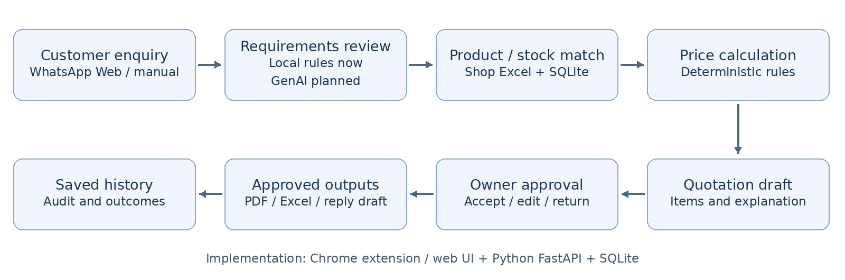

3.2 Design-Thinking & Deployment Strategy
Explain how your team applied design-thinking methodology to ensure this solution is technically viable, user-friendly, and ready for real deployment by Phase 2.
[Maximum 200 words]
We narrowed the problem from a broad “SME management system” to one recurring workflow: quotation preparation. The primary user is the SME owner or a small sales employee who needs a quotation in minutes, not a complex dashboard. The workflow was designed from realistic situations: incomplete WhatsApp enquiries, products described by use rather than SKU, limited staff, owner-dependent discount decisions and area-dependent delivery costs. Each screen answers one operational question: What did the customer ask? Which products match? Why? What is the verified base price? Why is the discount/freight recommended? What will be sent? To make deployment realistic, the prototype separates AI interpretation from deterministic calculations, uses synthetic business data for Phase 1, includes editable recommendations and requires human approval before the quotation is finalized. Phase 2 can test the same workflow with SME users and measure quotation preparation time, matching accuracy, price accuracy, owner edit rate and acceptance rate.

4. Preliminary Environmental & SDG Impact Framework
To align with SDC’s focus on meaningful global sustainability, establish your project’s impact baseline before building the prototype. Use estimated data, published research, or public benchmarks where exact figures are unavailable. Provide the citation of any sources used.
The target, baseline, and KPI you provide here will be used by judges during shortlisting to assess Innovation and Creativity as well as Feasibility of build. Vague or unsupported projections may weaken your case for advancing to Phase 2.

Metric Category | Your Response
Target SDG Sub-Target(s)  Identify the exact UN SDG sub-target your project addresses  e.g., Target 11.6 “Reduce the adverse per-capita environmental impact of cities, focusing on air quality and waste management.” | Target SDG Sub-Targets: SDG 8.2 — higher economic productivity through technological upgrading and innovation; SDG 8.3 — support productive activities, entrepreneurship and the growth of micro, small and medium-sized enterprises; SDG 9.3 — improve the access of small-scale enterprises to financial services and markets/value chains through stronger business capability and digital tools. EzQuote primarily contributes to productivity and SME digitalization rather than claiming a direct environmental impact.
Current Problem Baseline  What is the starting condition of the problem, expressed as a number?  e.g., “The target infrastructure currently experiences 35% energy inefficiency due to unoptimized scheduling.” | Phase 1 baseline: run a controlled test set of 30–50 realistic customer enquiries and record manual quotation preparation time (minutes per enquiry), product-match accuracy, price-calculation error rate, and discount/delivery-rule consistency. Until this test is conducted, we will not claim an unsupported industry-wide percentage.
Core Measurable KPI  The specific unit you will track  e.g., % reduction in power consumption, processing-latency improvement, or kg of resource waste avoided. | Primary KPI: median time from receiving a customer enquiry to producing a quotation-ready draft. Secondary KPIs: product-match accuracy, price-calculation accuracy, owner edit rate, and quotation acceptance rate.
Phase 2 Impact Target  Your realistic, percentage-based target by the final prototype presentation  e.g., “20% improvement in computational resource use.” | Phase 2 prototype target: reduce median quotation preparation time by at least 50% while maintaining at least 95% product/price accuracy on the agreed test set. At least 70% of generated quotation drafts should require only minor owner edits before approval. These are prototype targets, not claims about the wider SME sector.

5. Eligibility & Readiness Checklist
Tick all boxes that apply before submitting.
 | All team members have completed the mandatory GenAI, Database, and Cloud Deployment upskilling workshops.
  √

 | The project concept addresses a verified real-world problem mapped directly to one or more UN SDGs.
  √

 | The proposed solution targets a functional, deployed application rather than a theoretical business case study.
  √

 | All fields in this template have been completed within the word limits stated.
  √

6. IP & Originality Declaration
6.1 Pre-Existing / Prior-Owned Work
Does this submission include any code, design, research, or other work that any team member created or owned before the start of this hackathon?
☐ Yes ☑ No
If yes, briefly describe what was pre-existing and which team member(s) owned it:
Not applicable. No pre-existing or prior-owned work is included.

6.2 Third-Party Code, Datasets, or Models
Does your project use any third-party code libraries, open-source frameworks, public/private datasets, or pre-trained AI models that your team did not create?
☑ Yes ☐ No
If yes, list them below (open-source use is permitted provided it is declared and properly licensed/attributed):
Name | Type (code/dataset/model) | License
FastAPI; Pydantic; openpyxl | Code / runtime libraries | MIT
Uvicorn | Code / application server | BSD-3-Clause
ReportLab | Code / PDF generation | BSD
SQLite | Database engine | Public domain
Noto Sans SC | Font asset | SIL OFL 1.1
pytest; httpx | Code / development tests | MIT; BSD-3-Clause, respectively
Playwright | Code / browser tests | Apache-2.0
PyMuPDF | Code / PDF verification only | GNU AGPL v3 (open-source option)
The demonstration business workbook is team-created synthetic data. No third-party customer dataset or active pre-trained model is used in the current local MVP. GenAI integration is planned; existing library/font notices are retained, and the relevant licenses will accompany distribution.

6.3 Employment-Related IP Conflicts
Is any team member currently bound by an employment, internship, or consulting agreement under which their employer could claim ownership of work they create during this hackathon?
☐ Yes ☑ No
If yes, please describe the nature of the agreement and which member it concerns:

Not applicable. No employment-related ownership conflict has been identified by the team.

7. Declaration
By submitting this proposal, the team leader confirms that the information provided is accurate to the best of the team’s knowledge and that the project will be original work created during the SDC 2026 hackathon period.

[Signature]

[Date] 24/10/2026

