**CPT 205 Assessment1**

**A two-dimensional(2D) Birthday Card.**

|  |  |
| --- | --- |
| Module | CPT205 Computer Graphics |
| Degree Programme | Information and Computing Science |
| Name | Ruiyang Wu |
| Student ID | 2257475 |

1. **Brief Description**

The title of the birthday card is "**Birthday Card ~ Mario Adventure**", consisting of two parts: a **cover** and an **interactive page**.

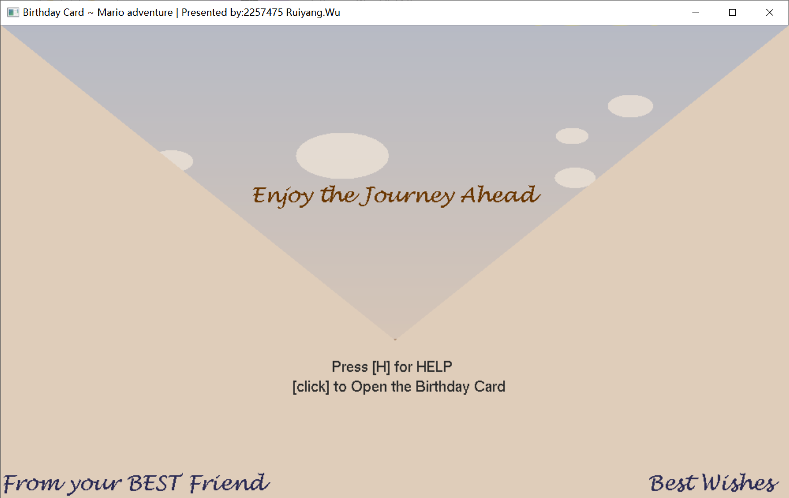The **initial page** is the **cover**, displaying the basic information of the greeting card (introduction and sender's information) and the method to open user operation help. By clicking on any position within the window, users can enter the interactive page.

Figure1. the Cover

In the **interactive page**, user can manipulate the character to obtain a birthday cake, while the time and objects in the scene will change. After receiving the birthday card, I designed a screen shaking effect, please be sure to experience it.

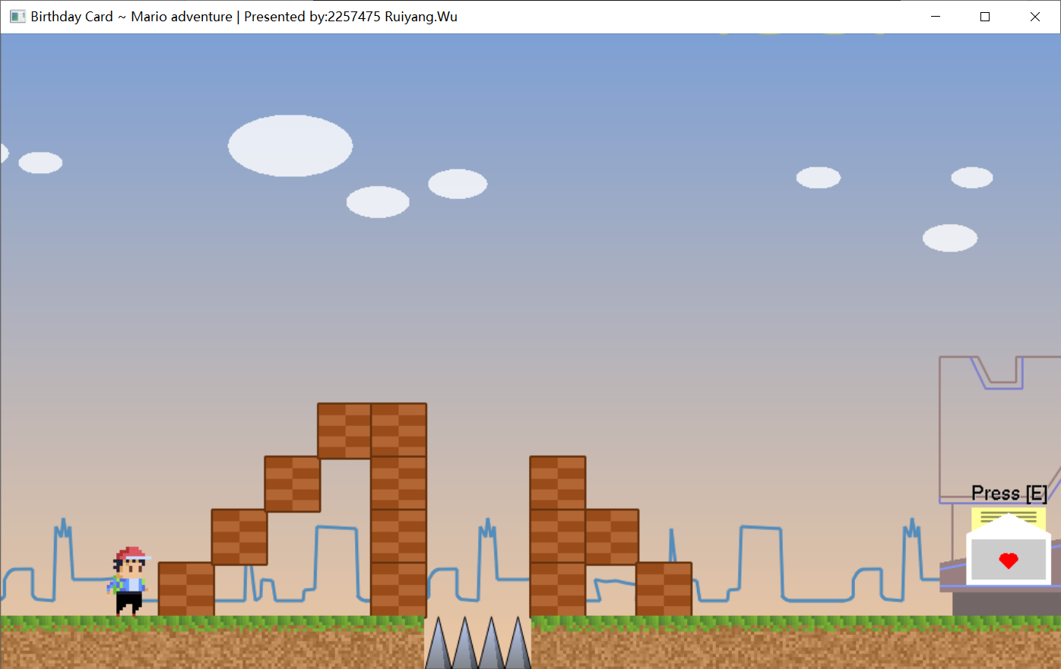 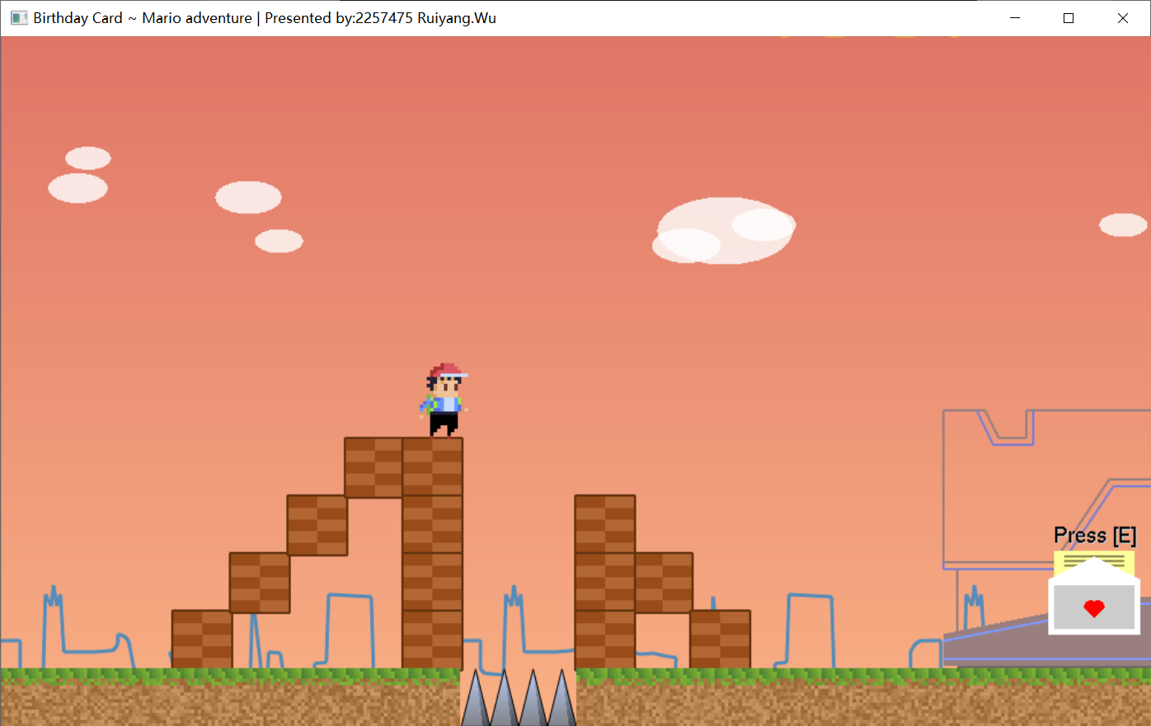 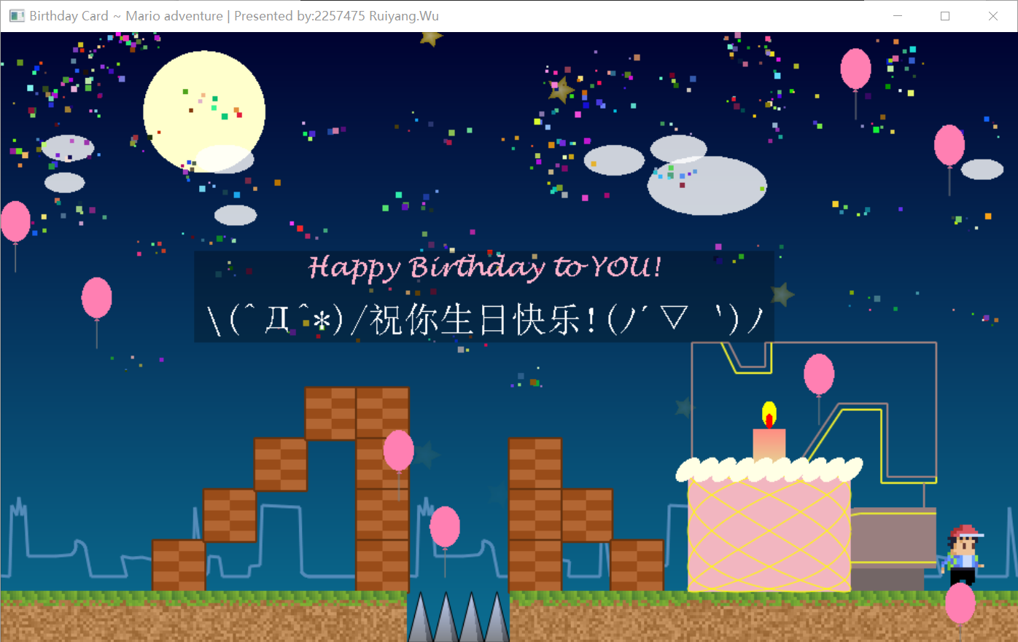

Figure2. the Interactive Page

1. **Features**

**2.1 The Window Setting**

Use the gluOrtho2D function to create the 2d projection, the window size is (1000, 600) . The position of the card depends on the user windows. The title of the window is “Birthday Card ~ Mario adventure”, which indicates the topic of the birthday card.

* 1. 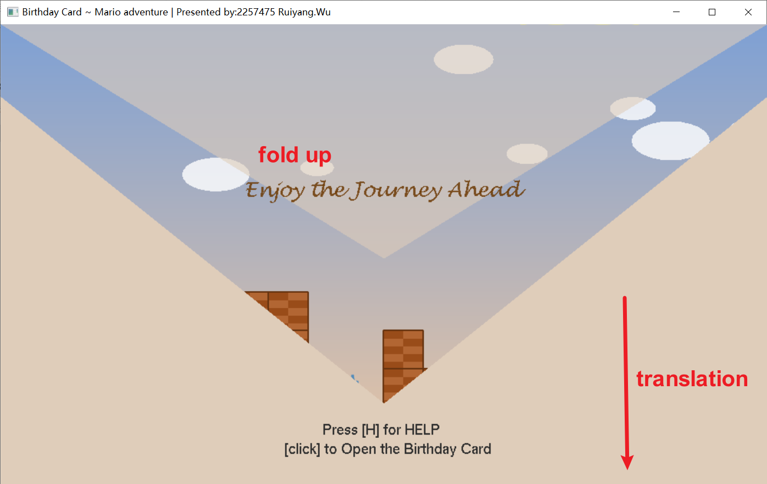**Background of the Cover**

The background of the envelope is drawn in two parts. The upper one is a **GL_TRIANGLES**, which can be fold up. The lower one consists of two **GL_QUADS**, they formed the irregular lower part of the envelope.

Figure3. the Cover Elements

* 1. **Sky of the Interactive Page**

Sky is drawn by **GL_QUADS**. As you can see in Figure2, by enabling **GL_SMOOTH**, the color of the sky gradually changes from top to bottom. There are 3 Color Matching conditions (morning, afternoon, night) and the color will gradually change through **linear interpolation** based on the horizontal axis of the character.

  

Figure2. the Interactive Page

* 1. 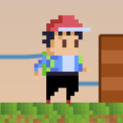**The Character**

The characters operated by the user are created through pixel art. Firstly, define the **color** of each pixel and the **size** to be rendered on the screen, and then use a **loop method** to draw the rectangle represented by each pixel.

Figure4. the Character

* 1. 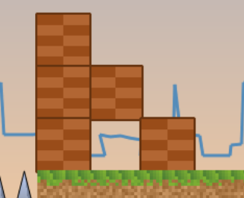**The Bricks**

By imitating the style of Super Mario, I constructed the structure of the staircase by drawing bricks. Each drawn unit is a cube of (50, 50) pixels, divided into 5 * 2 bricks for coloring, and each unit has its independent stroke.

Figure5. the Bricks

* 1. **The** **Spikes**

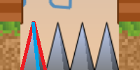As shown in the figure6, the ground spike is composed of two triangles and a stroke. The large red triangle uses a gradient color effect from top to bottom, while the small blue triangle uses darker colors to represent the light and shadow effect. Stroke is used to highlight spikes more clearly from the background.

Figure6. the Spikes

* 1. 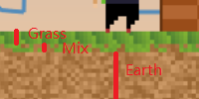**The Ground**

The effect of the Ground imitates "Minecraft", consisting of three layers: **Grass layer**, **Mixed layer,** and **Earth layer**. The **regular texture** of grassland **comes from pruning**. The randomness of mixed layers and soil layers comes from the use of random numbers of **seeds related to location**. They are rendered with the **Pixel Art technic** similar to rendering the Character.

Figure7. the Ground

* 1. 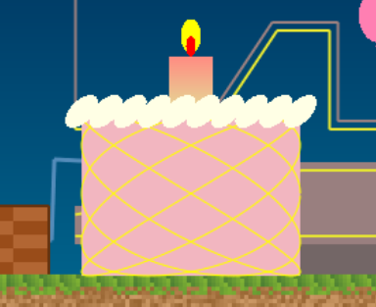**The** **Birthday Cake & *Shake Screen***

The birthday cake is composed of **Lissajous curve** (a kind of parametric curve), **ellipse** representing cream and flame, and **rectangle**. During the process of the cake falling, I used the special effect of **shaking the screen** (via **glTranslatef()**) to make the process full of fun.

Figure8. the Birthday Cake

* 1. 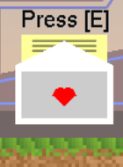**The Small Birthday Card & *Simple Harmonic Motion***

The scaled down version of the birthday card consists of rectangles, triangles, and straight lines. Love heart is composed of a triangle and two semicircles. Text interaction prompts are also encapsulated together for **simple harmonic motion along the Y-axis** to attract player’s interaction.

Figure9. the Small Birthday Card

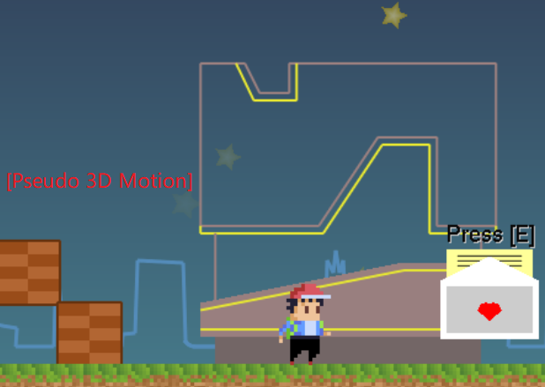**2.10 CB Building & City Skyline & *Pseudo 3D Motion***

CB is drawn using **GL_LINE_LOOP**, **GL_LINE-STRIP**, and **GL-POLYGON**. Depending on the brightness of the sky, CB's **lights gradually turn on**. The City Skyline is drawn using **GL_LINE-STRIP**, which is repeated 3 times to fill the entire screen. To present stereoscopic feel in a 2D plane, according to the principle of perspective, objects at different distances will produce varying degrees of displacement relative to the character's motion. Applying this technique can **produce a pseudo 3D effect**.

Figure10. CB Building & City Skyline

**2.11** **Star & Cloud & the Moon**

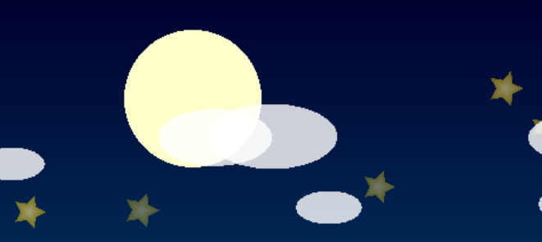Stars are generated using **GL_TRIANGLES** in loops of different directions, with different gradient colors inside and outside. As the altitude decreases, the **transparency** of stars increases. Clouds are generated by **stretching** circles and have transparency. They all loop down or float under the control of **update function**, with random size and position. The moon is generated by **GL_TRIANGLE-FAN**.

Figure11. Star & Cloud & the Moon

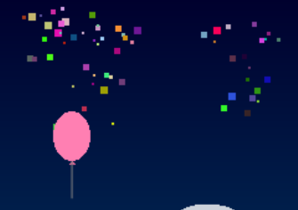**2.12** **Balloons & Confetti & *Random Walk***

After the player obtains the birthday card, the balloon will continuously rise from a **random location** underground while **drifting left and right**. After reaching a certain height, it will explode and **produce 25 colorful confetti**. The **color and movement of each piece of paper is random**, ultimately falling to the ground.

Figure12. Balloons & Confetti

**2.13** **Text & Artistic Characters & Help Window**

Conventional text is drawn using **renderBitmapString**, while a semi-transparent substrate is used for clarity. Due to the limited number of fonts provided by this method, I used **wglUseFontBitmapsW** to draw each character.

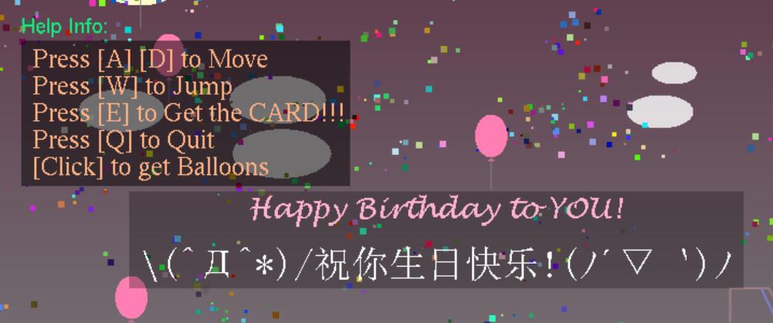

Figure13. Text & Artistic Characters & Help Window

1. **Instruction**

**Keyboard interaction**

* Move: ‘a’, ’A’ to move left; ’d’, ’D’ to move right.
* Jump: ‘w’, ‘W’ to jump.
* Get the Card: ‘e’, ‘E’.
* Quit the game: ‘q’, ‘Q’.

**Mouse interaction**

* At initial Page: Open the Card.
* After got the Birthday Cake: Generate two balloons at click position.

1. 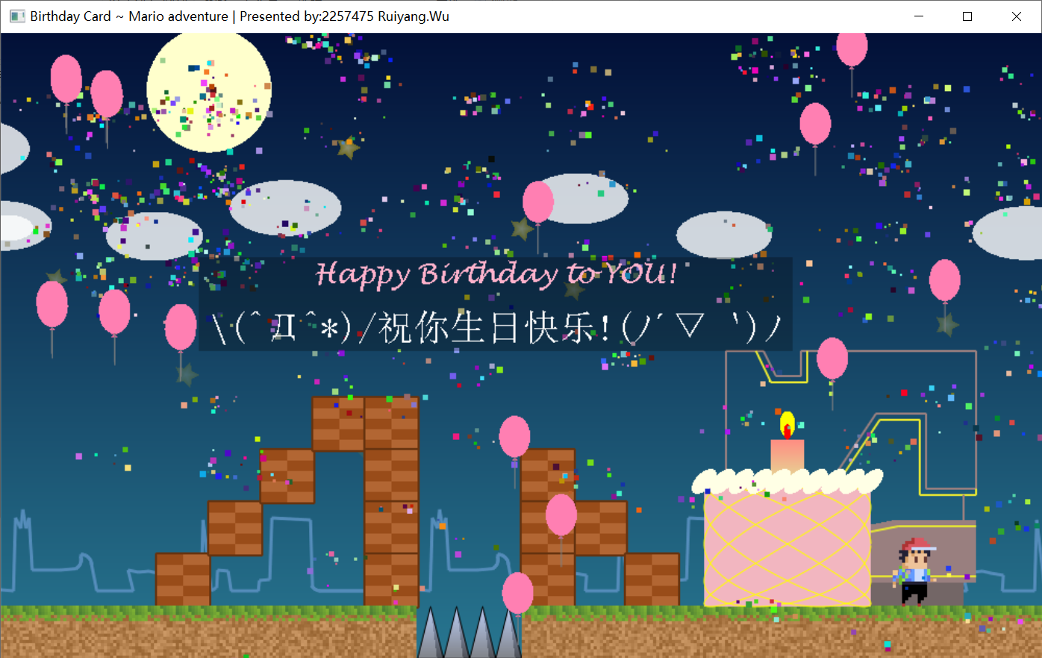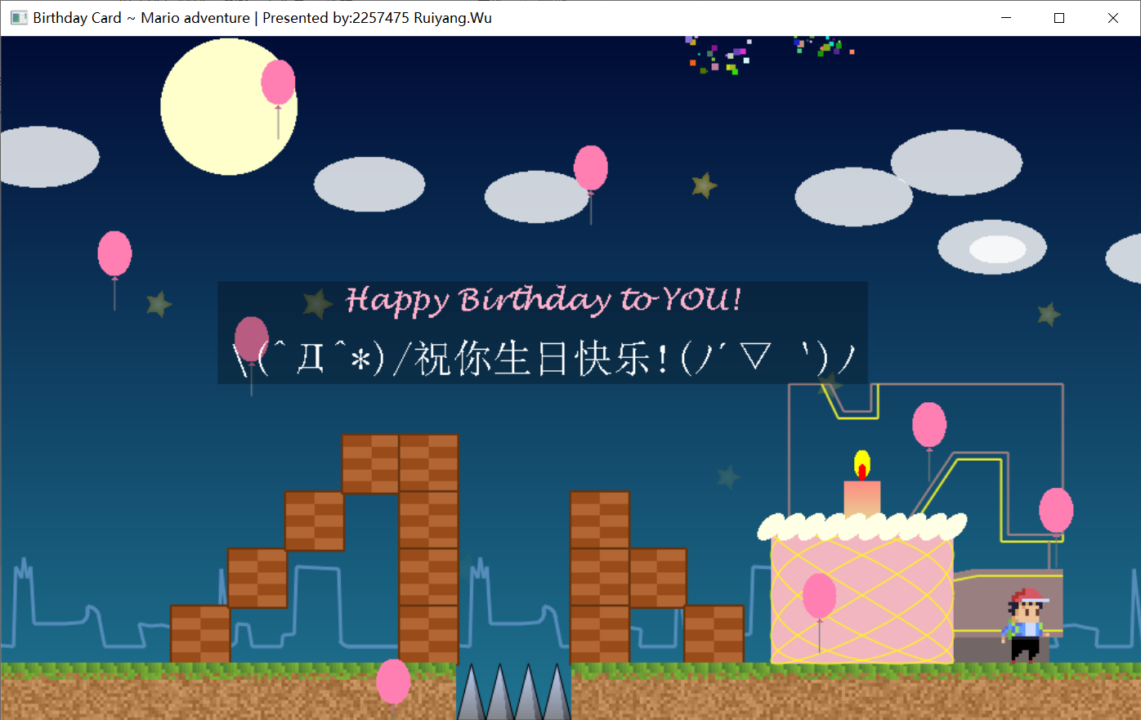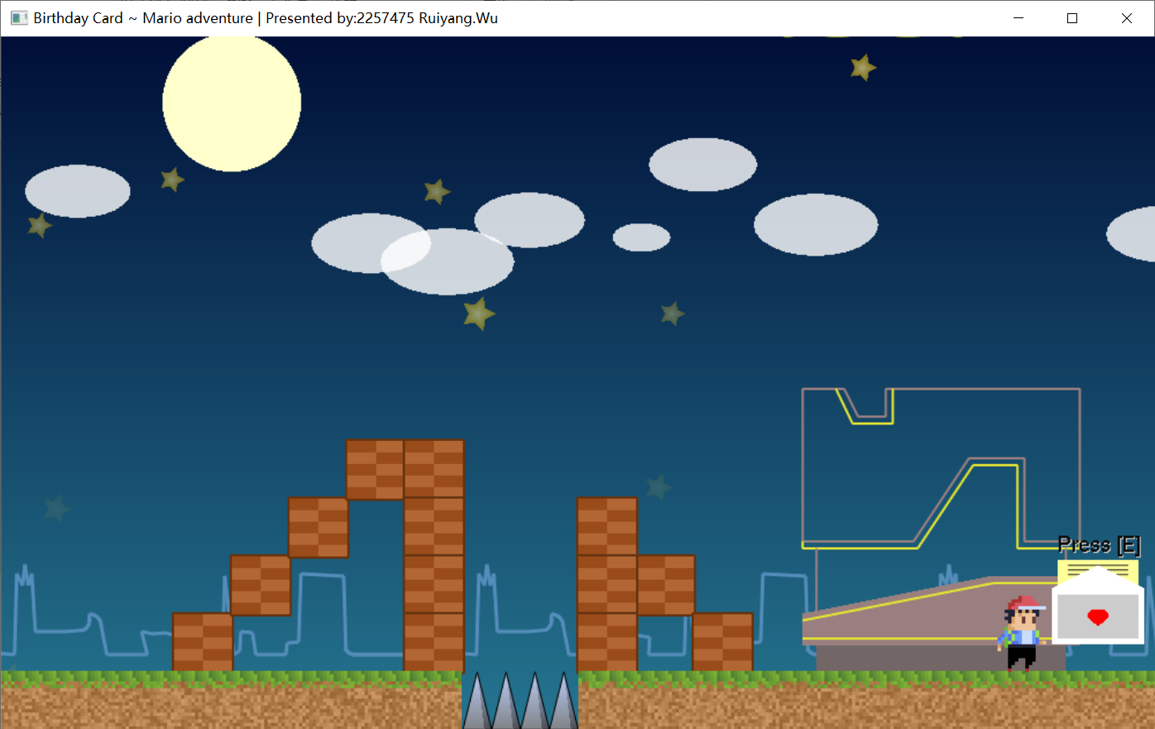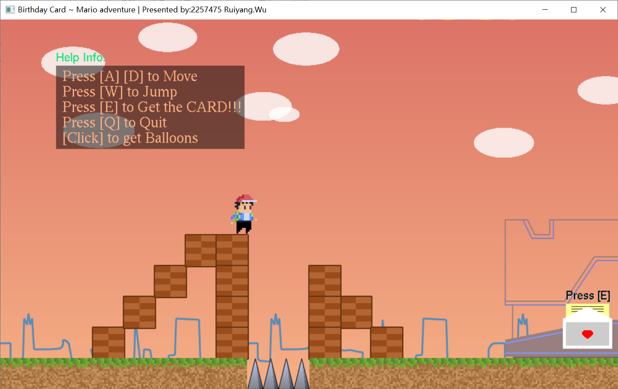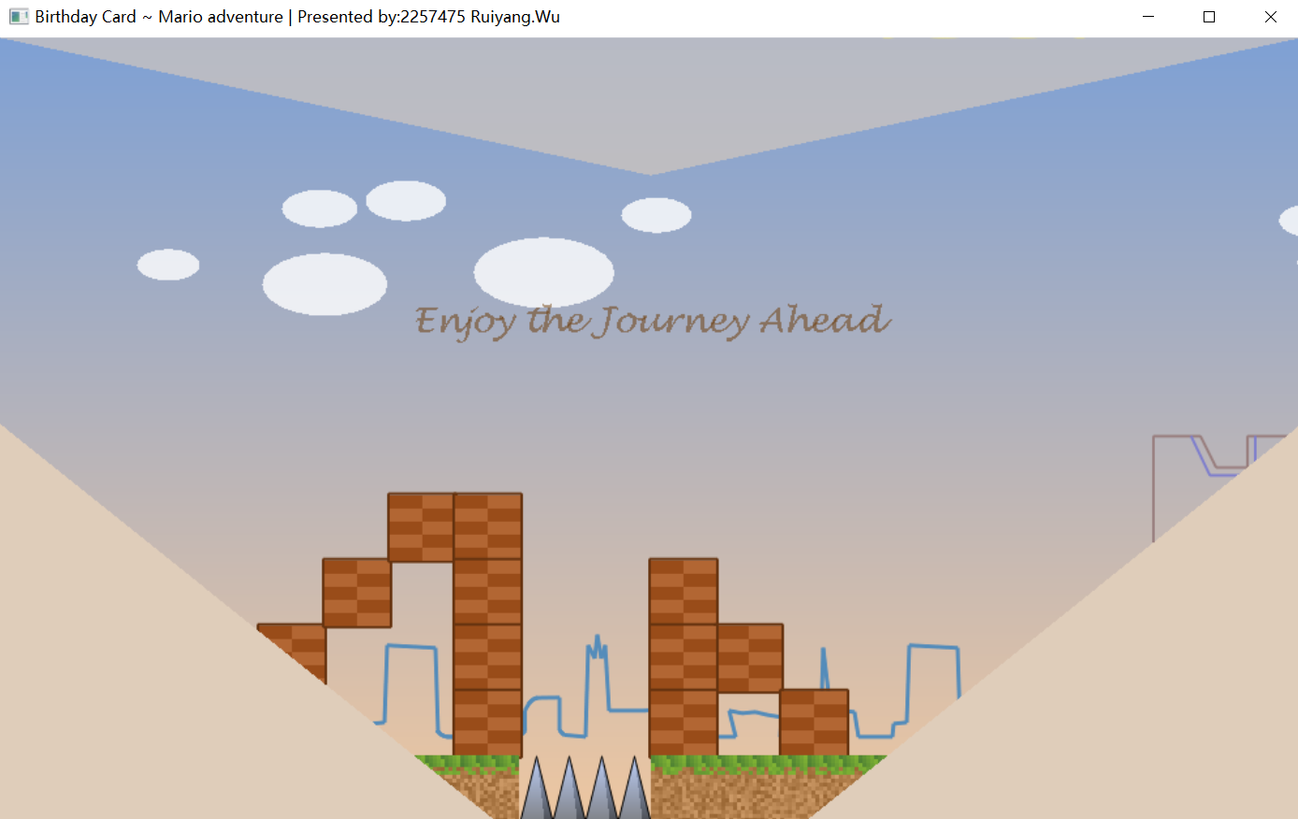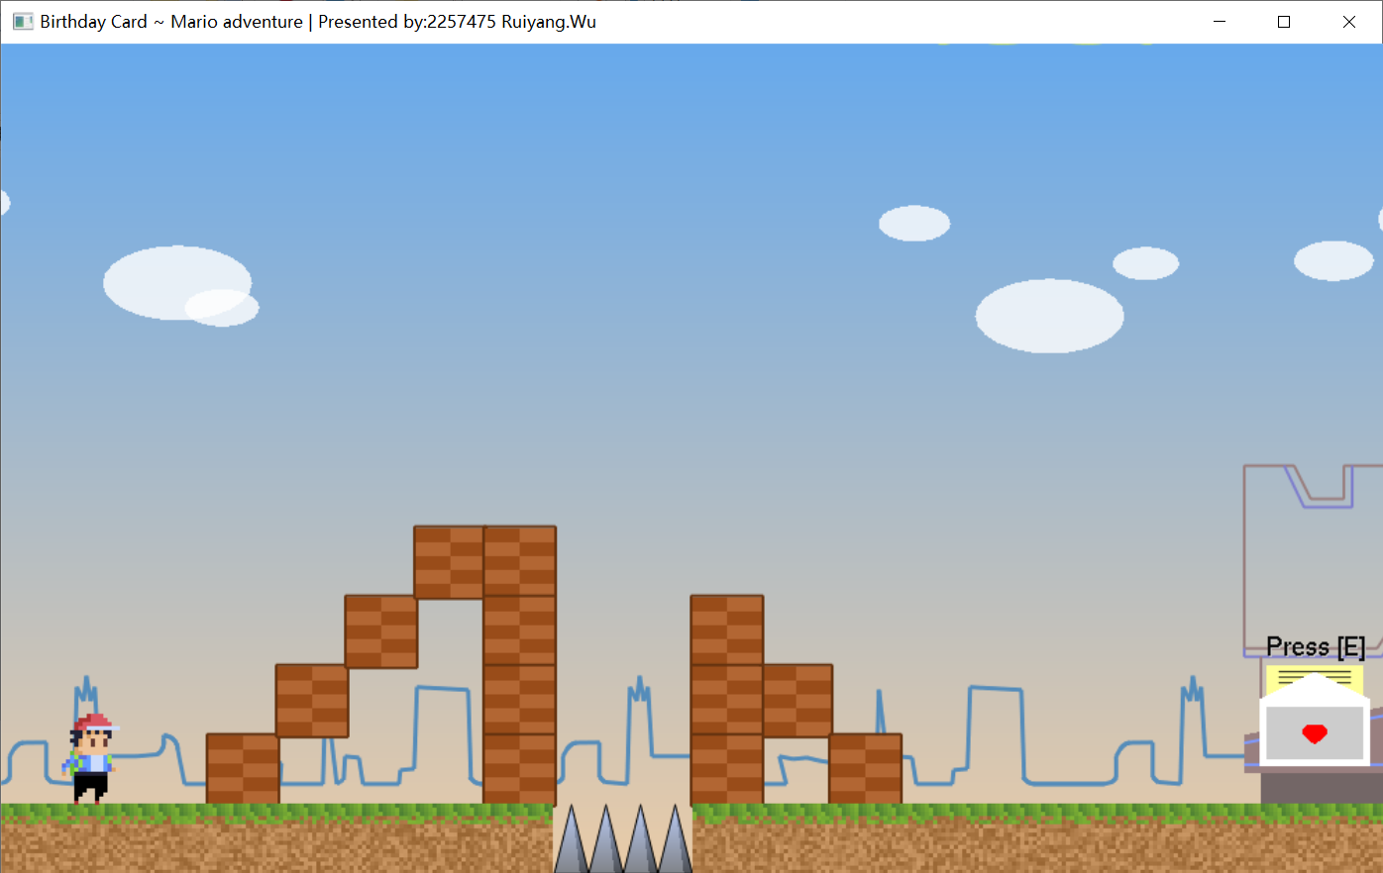**Typical Screenshots**

