Ceph Test Report

# Ceph data placement test

I have deployed ceph test beds both on local VM and Amazon EC2.

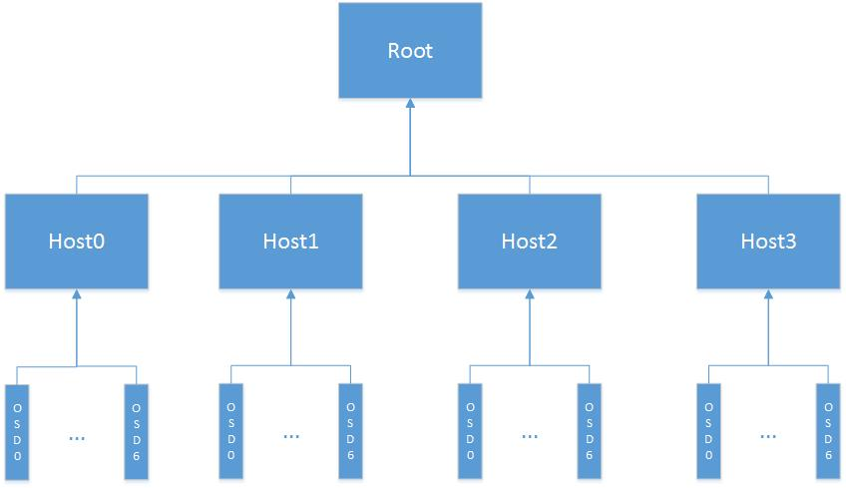

Figure Crush Map of Ceph on local VM

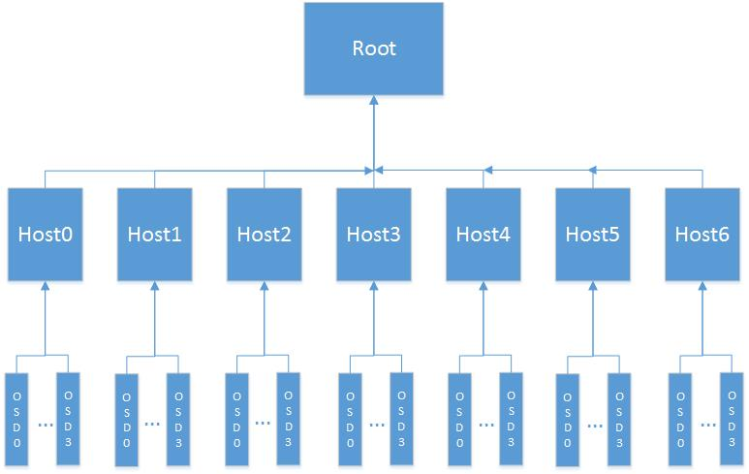

Figure Crush Map of Ceph on EC2

Both deployments have 28 osds.

And I have doing two tests on each of them. The test script analyzes data placement statics and time of placement (not very accurate).

* The first test adds 1000 objects to ceph:
  + VM:  
    Average number of objects on each osd: 71.43  
    Standard variance of data placement: 15.13  
    Max:108 Min:49   
    Data placement algorithm run time: 0.06s
  + EC2 (1024 objects):  
    Average number of objects on each osd: 73.14  
    Standard variance of data placement: 14.43  
    Max:98 Min:38  
    Data placement algorithm run time: 0.21s
* The second test adds 10000 objects to ceph:
  + VM:  
    Average number of objects on each osd: 714.29  
    Standard variance of data placement: 125.24  
    Max:951 Min:414   
    Data placement algorithm run time: 0.07s
  + EC2:  
    Average number of objects on each osd: 714.29  
    Standard variance of data placement:95.44  
    Max:904 Min:524  
    Data placement algorithm run time: 0.29s

# About ceph test script and auto configuration script

I have created a ceph test script (dptest.py) and an auto configuration script (autoConf.py) for automatic test.

The ceph test script will push specified number of objects to ceph and analyze the placement results. It will create a folder to store results. The test result is in stat.txt. If there are some errors during the test, you can find the details in log.txt.

The ceph auto configuration script is used for automatically set up a ceph test bed on Amazon EC2. Note that this script is not very adaptable, there are still some commands need to run manually, and a lot of errors may occur.