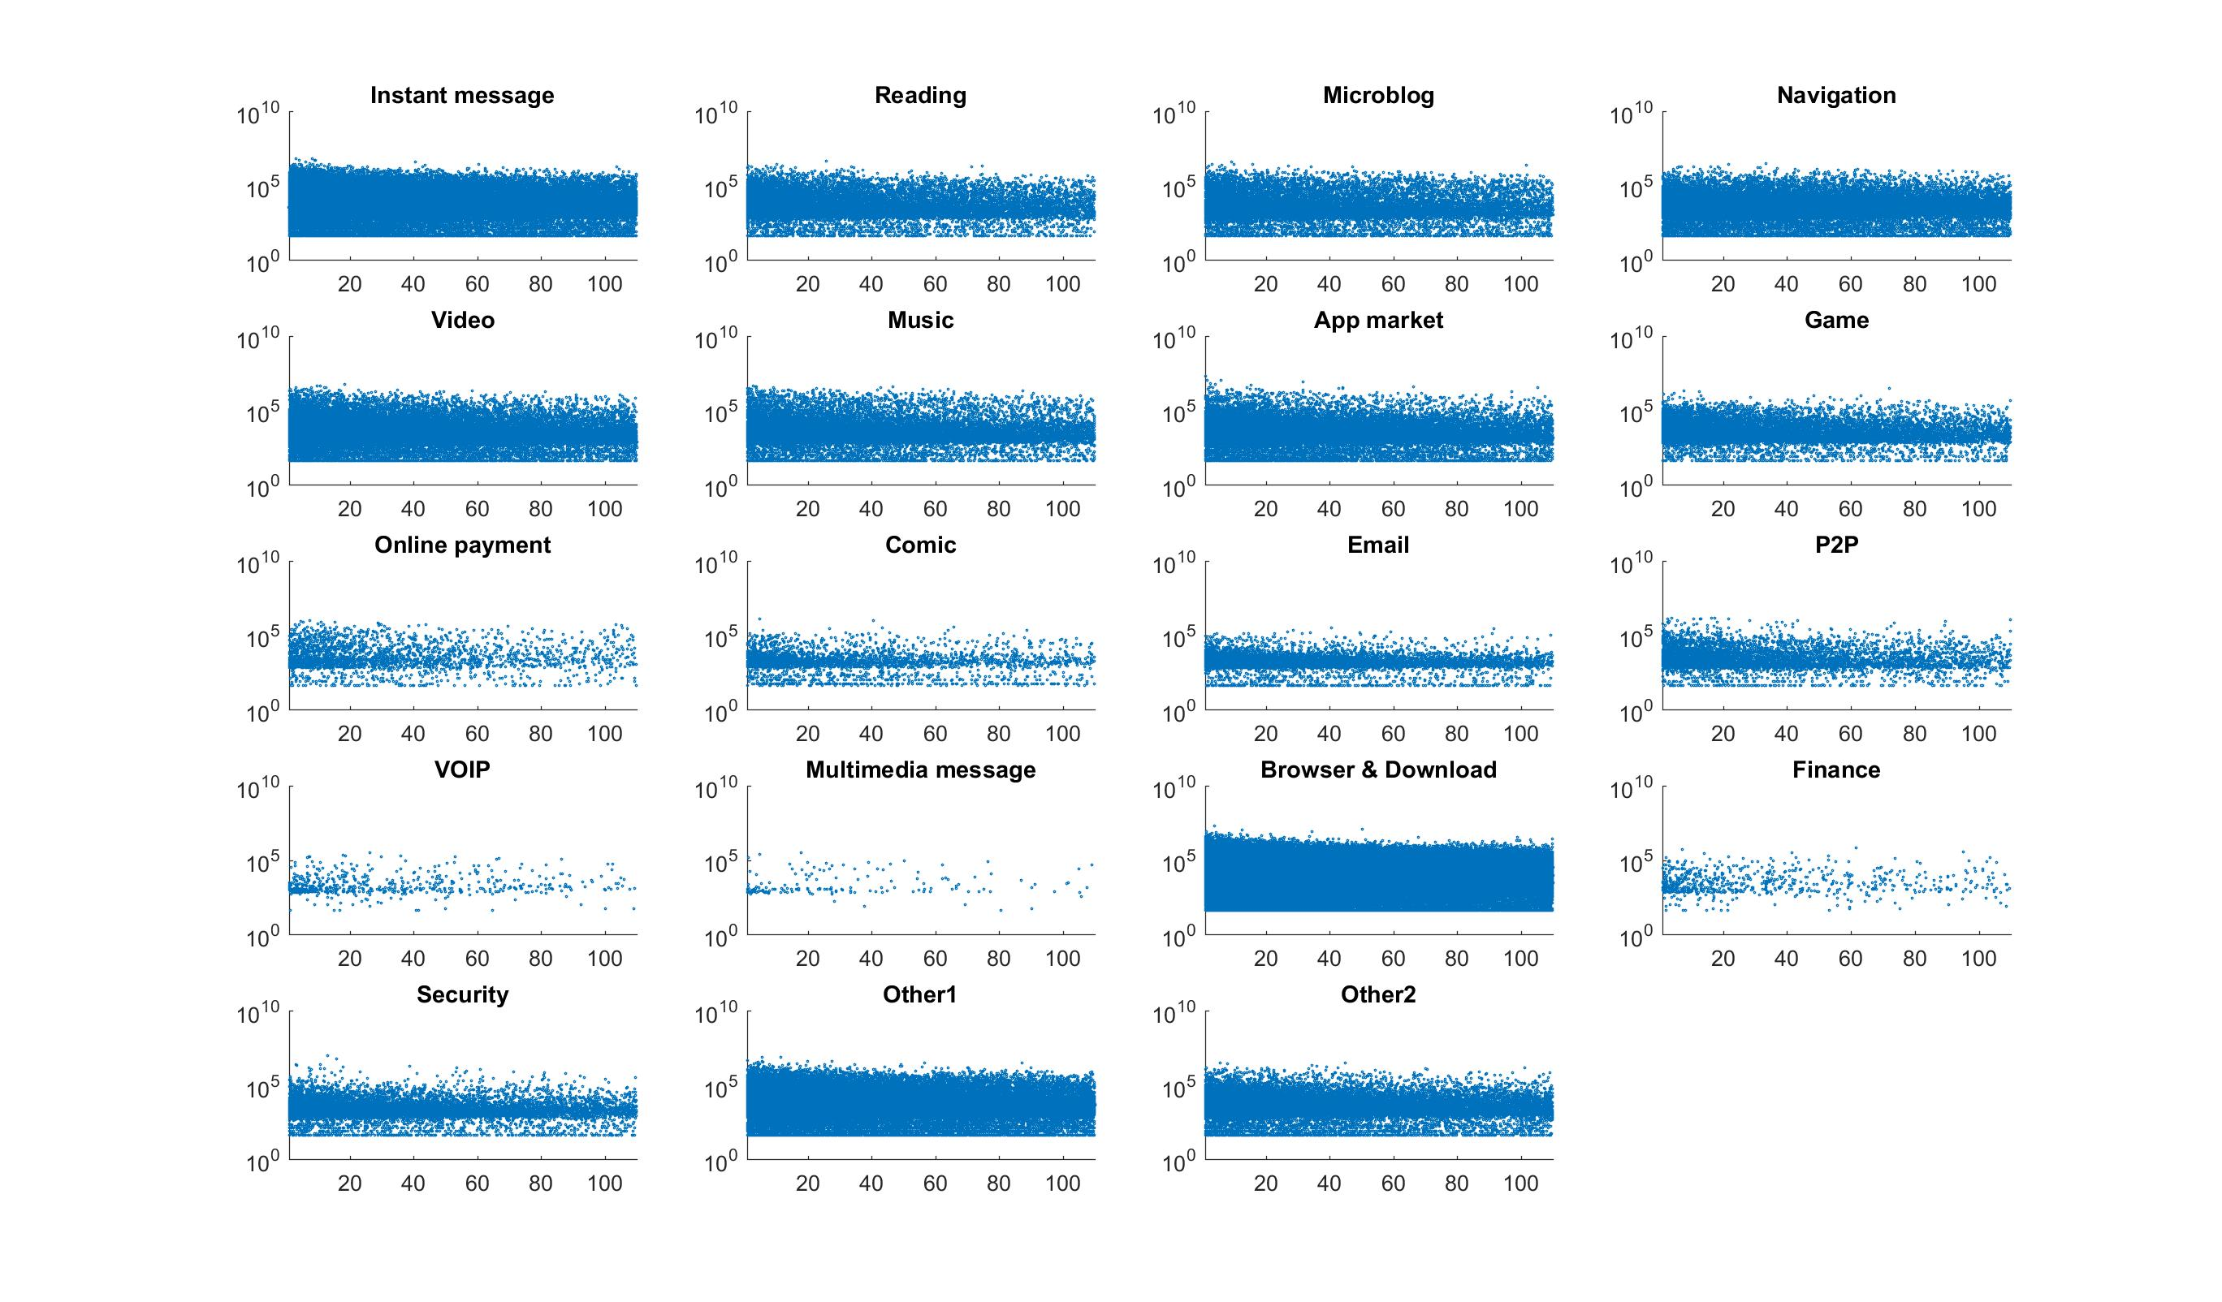

Figure 1 A scattered view of data access under various estimated speed

X axis is the speed (km/h), Y axis is the volume (Byte), and each dot represent an access session

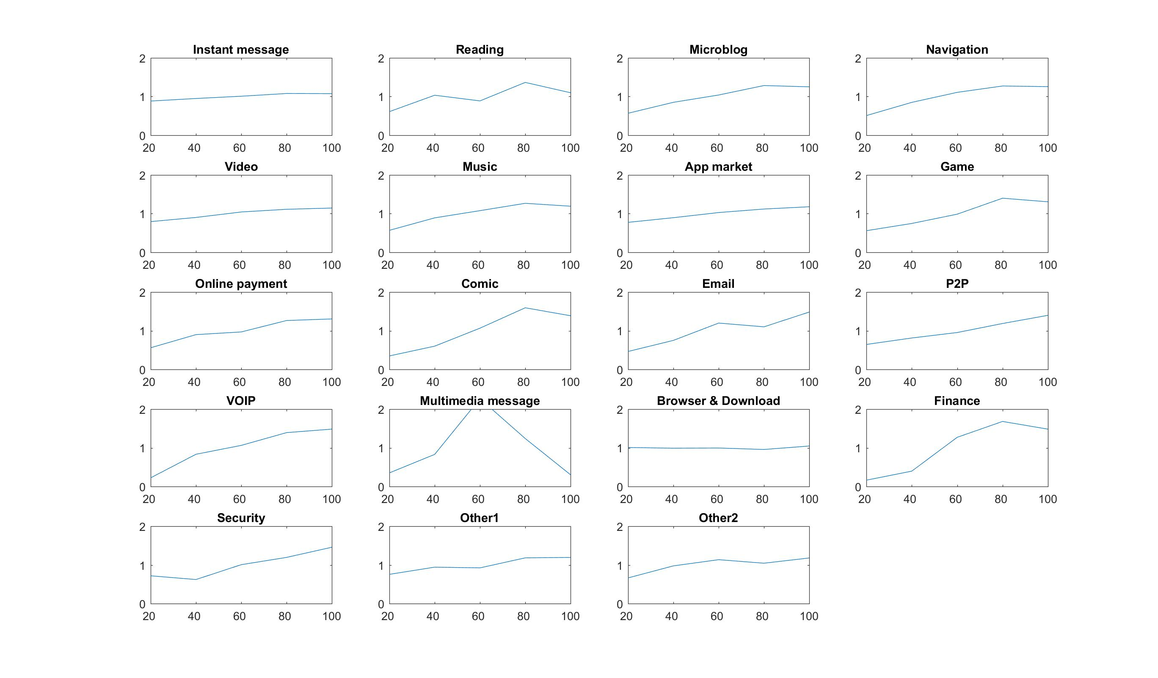

Figure 2 Average data access under various estimated speed

X axis is the speed (km/h), Y axis is the normalized volume (per user, per second, and divided by mean value)