USER MANUAL
HRM ODOO – HỌC BÁ EDUCATION
Recruitment Module (Tuyển dụng)
Project: HRM Odoo – Học Bá Education (ISP490_G2)
System: Odoo 19 ERP + ReactJS SPA (/hocba-hrm)
Module: hocba_recruitments
Version 1.0 – 14/08/2026
FPT University
Change history
Changed date | Items have been changed | Changed content / Reason | Updated by | Type (A/C/D) | Version
14/08/2026 | All | First Release | Hoàng Văn Việt | A | 1.0

A – Create C – Change D – Delete
FPT Signature
 | Full name & Role | Signature | Date | Note
Created by | Hoàng Văn Việt / vh902393@gmail.com / Developer – Recruitment module |  | 14/08/2026
Reviewed by | Phạm Đức Thắng / Reviewer – ISP490_G2
Approved by | Thesis Supervisor / FPT University

Table of Contents
1. OVERVIEW 5
1.1 Process used in guide document 5
1.2 The ten stages of a candidate 5
1.3 Roles and permissions 5
1.4 How to open the module 6
2. USER MANUAL 8
2.1 Create and approve a recruitment request (REC-BP-01) 8
Content 8
Navigation 8
Detail implementation 8
2.2 JD library and job posting (REC-BP-02) 11
Content 11
Navigation 11
Detail implementation 11
2.3 Candidate applies on the public site (REC-BP-03) 13
Content 13
Navigation 13
Detail implementation 13
2.4 CV screening (REC-BP-04) 16
Content 16
Navigation 16
Detail implementation 16
2.5 Interview scheduling and invitation (REC-BP-05) 19
Content 19
Navigation 19
Detail implementation 19
2.6 Interview attendance and result (REC-BP-06) 23
Content 23
Detail implementation 23
2.7 Offer and onboarding (REC-BP-07) 24
Content 24
Navigation 24
Detail implementation 24
2.8 E-mail templates and bulk sending (REC-BP-08) 27
Content 27
Detail implementation 27
2.9 Mail log (REC-BP-09) 30
Content 30
Detail implementation 30
2.10 Recruitment progress tracking (REC-BP-10) 31
Content 31
Detail implementation 31
2.11 Recruitment process configuration (REC-BP-11) 33
Content 33
Navigation 33
Detail implementation 33
Appendix A – Frequently asked questions 34
Appendix B – Reference documents 34

(Right-click the table of contents and choose “Update Field” to refresh page numbers.)

1. OVERVIEW

1.1 Process used in guide document
This user manual describes how to run the whole recruitment cycle of Học Bá Education on the HRM system: from the recruitment request raised by a department, through job posting, CV screening, interview and offer, up to the handover of the new employee. Each business process below is one section of chapter 2.
Process No | Definition | Note
REC-BP-01 | Recruitment request & approval (Phiếu yêu cầu tuyển dụng) | Section 2.1 · FS-REC-003
REC-BP-02 | JD library & job posting (Kho quản lý JD) | Section 2.2 · FS-REC-001
REC-BP-03 | Candidate application on the public site (/jobs) | Section 2.3 · FS-REC-002
REC-BP-04 | CV screening (Danh sách CV) | Section 2.4 · FS-REC-002
REC-BP-05 | Interview scheduling & invitation (Danh sách PV) | Section 2.5 · FS-REC-005
REC-BP-06 | Interview attendance & result | Section 2.6 · FS-REC-005
REC-BP-07 | Offer & onboarding (Offer & Nhận việc) | Section 2.7 · FS-REC-004 / 010
REC-BP-08 | Recruitment e-mail templates & bulk sending | Section 2.8 · FS-REC-006
REC-BP-09 | Mail log (Lịch sử gửi mail) | Section 2.9 · FS-REC-006
REC-BP-10 | Recruitment progress tracking (Theo dõi tuyển dụng) | Section 2.10 · FS-REC-007
REC-BP-11 | Recruitment process configuration (Cấu hình tuyển dụng) | Section 2.11 · FS-REC-008

1.2 The ten stages of a candidate
Every candidate record travels through ten stages (hr.recruitment.stage). The stage is shown as a column on the kanban board of tab Danh sách CV, and it decides which tab the candidate appears in.
# | Stage (Bước) | Who works on it | Where in the SPA
1 | Yêu cầu tuyển dụng | HR / Recruiter | Tab Phiếu yêu cầu
2 | Lọc CV | HR / Recruiter | Tab Danh sách CV
3 | Lên lịch phỏng vấn | HR / Recruiter | Tab Danh sách PV
4 | Hẹn & mời phỏng vấn | HR / Department manager | Tab Danh sách PV
5 | Phỏng vấn | Interviewer | Tab Danh sách PV
6 | Kết quả phỏng vấn | Interviewer / HR | Tab Danh sách PV
7 | Gửi Offer | HR / Recruiter | Tab Offer & Nhận việc
8 | Onboarding | HR / Recruiter | Tab Offer & Nhận việc
9 | Bàn giao nhân sự | HR / Recruiter | Tab Offer & Nhận việc
10 | Đã tuyển (hired) | HR / Recruiter | Module Nhân viên

1.3 Roles and permissions
Role | Can do | Cannot do
HR Manager / Recruiter  (group_hr_recruitment_user) | Everything in this manual: requests, JD, posting, screening, interview slots, results, offers, e-mails, configuration. | —
Department manager  (hr.department.manager_id) | Raise a request for the own department, declare interview slots, book candidates, send e-mails to candidates of the own department. | Approve a request, edit the shared e-mail templates, change the recruitment configuration.
Interviewer  (group_hr_recruitment_interviewer) | Read the week grid, create and edit own interview slots, record attendance and interview result. | Delete slots, edit offers.
Any logged-in employee | Read-only view of the recruitment screens (no action buttons; isRecruiter = false). | Every write API answers HTTP 403 Forbidden.
Candidate (public, no login) | Browse the published jobs on /jobs and submit an application. | Access any screen of the HRM back office.

1.4 How to open the module
(1) Open the HRM system: http://<server>/hocba-hrm and sign in with the company account.
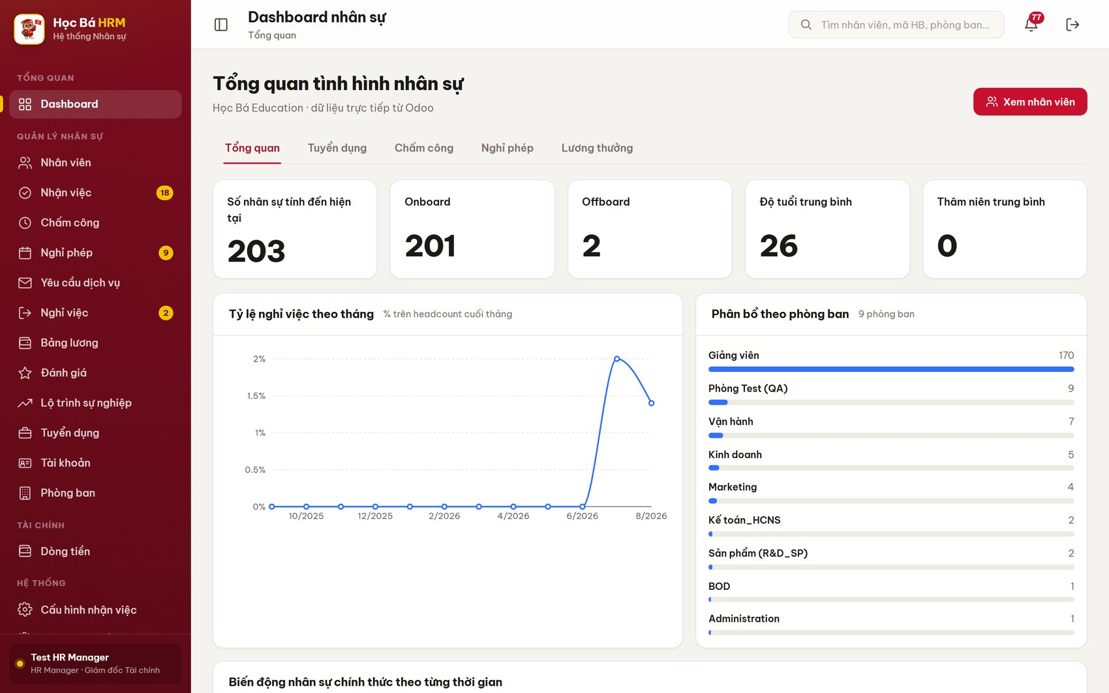
Figure 1 – The HRM workspace right after signing in
(2) In the left sidebar, group QUẢN LÝ NHÂN SỰ, click Tuyển dụng.
(3) The module opens on eight tabs. The tab you used last is remembered and reopened next time.
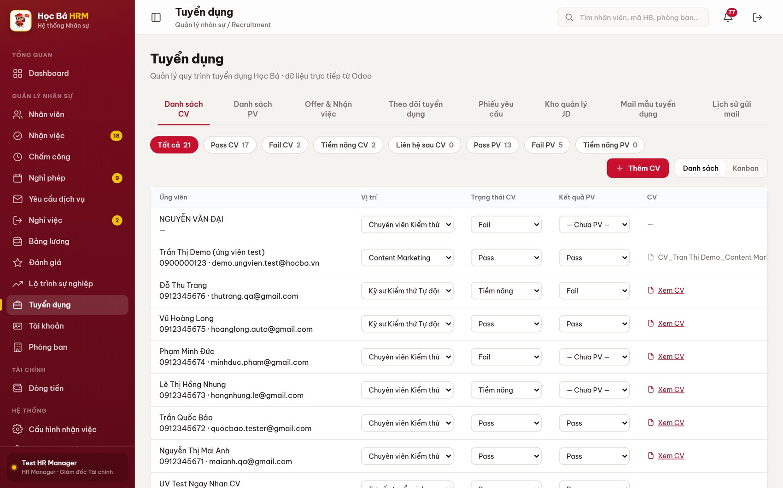
Figure 2 – Module Tuyển dụng and its eight tabs
The eight tabs, in working order:
Tab | Used for | Section
Danh sách CV | All candidates, screening result, kanban by stage | 2.4
Danh sách PV | Interview slots of the week, attendance and result | 2.5 – 2.6
Offer & Nhận việc | Candidates who passed the interview: offer, start date | 2.7
Theo dõi tuyển dụng | Progress of every open request: quota, hired, deadline | 2.10
Phiếu yêu cầu | Recruitment requests and their approval flow | 2.1
Kho quản lý JD | Job description library, create and publish a position | 2.2
Mail mẫu tuyển dụng | E-mail templates and bulk sending | 2.8
Lịch sử gửi mail | Every e-mail already sent to candidates | 2.9

2. USER MANUAL

2.1 Create and approve a recruitment request (REC-BP-01)

Content
Purpose: a department states in writing that it needs to hire. The request holds:
- the position and the department that will receive the new employee;
- how many people are needed and why (new hire, replacement, expansion);
- the profile asked for: level, education, experience, language, expected salary;
- the date the new employee must start (Ngày cần onboard) – this date becomes the deadline shown in tab Theo dõi tuyển dụng.
A request only starts receiving CVs after it has been approved. The states are: Nháp → Chờ BP duyệt → Đang tuyển → Đã đóng, plus Từ chối.

Navigation
Screen | Path | Description
Phiếu yêu cầu | Tuyển dụng ▸ tab Phiếu yêu cầu | List of every recruitment request

Detail implementation
(1) Open Tuyển dụng ▸ Phiếu yêu cầu. The chips on top filter by state and show the live count; click Chờ BP duyệt to see exactly what is waiting for you.
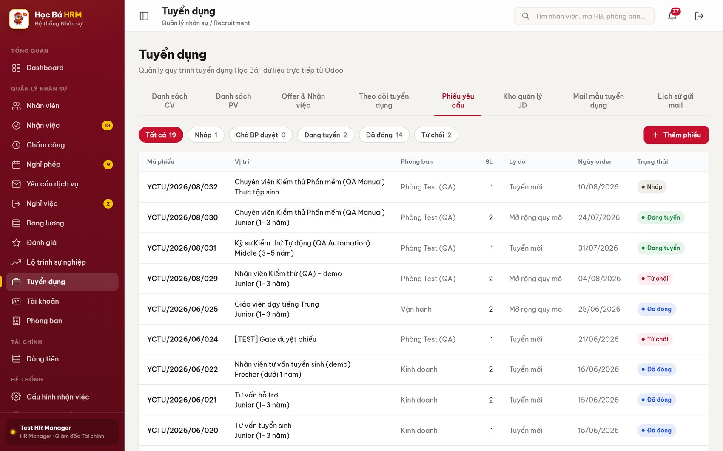
Figure 3 – Tab Phiếu yêu cầu – list of requests with the state filter chips
(2) Click Thêm phiếu to raise a new request.
(3) Choose the Phòng ban, then pick the JD từ kho – the position name and the JD link are filled in automatically. Fill in the quantity, the reason, the required profile and Ngày cần onboard, then click Lưu.
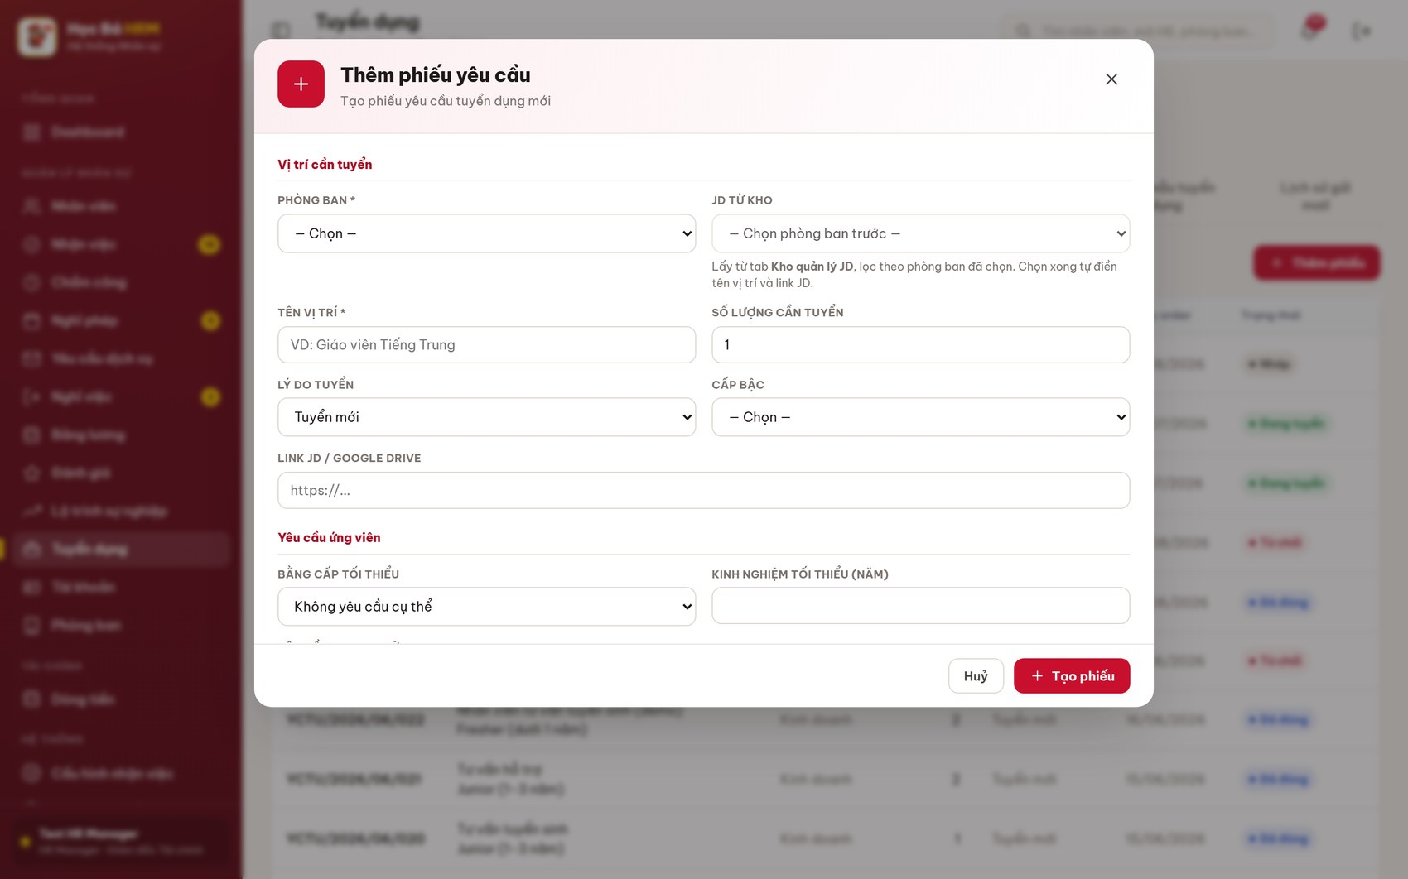
Figure 4 – Form Thêm phiếu yêu cầu tuyển dụng
(4) The request is created in state Nháp. The request code (Mã phiếu, e.g. YCTU/2026/08/032) is generated by the system.
(5) Click the row to open it, then click Gửi duyệt. The state becomes Chờ BP duyệt and the approver gets a notification on the bell icon.
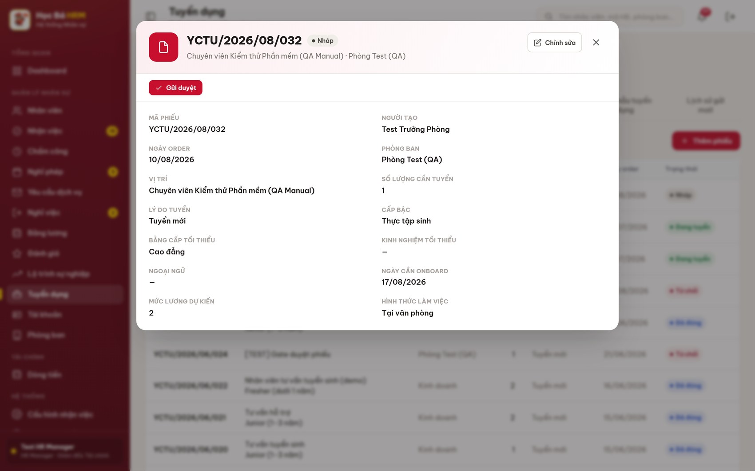
Figure 5 – Request detail – the action button changes with the state
(6) The approver opens the same screen and clicks Duyệt (state becomes Đang tuyển and the quota is added to the position) or Từ chối together with a reason.
(7) When the quota is filled the system closes the request automatically. To close it earlier, click Đóng phiếu. A closed or rejected request can be reopened with Mở lại (về nháp).
Note: only a request in state Đang tuyển appears in tab Theo dõi tuyển dụng and can receive CVs. A CV submitted for a position is attached automatically to the open request of that position.

2.2 JD library and job posting (REC-BP-02)

Content
Purpose: keep one job description per position and publish it on the public career site. The JD library is the single source of the position name, the department, the level, the salary range and the requirements that the public page and the request form both read.

Navigation
Screen | Path | Description
Kho quản lý JD | Tuyển dụng ▸ tab Kho quản lý JD | Look up a JD by position · department · state

Detail implementation
(1) Open Tuyển dụng ▸ Kho quản lý JD. Filter with the chips Đang tuyển / Dừng tuyển or use the search box in the top bar.
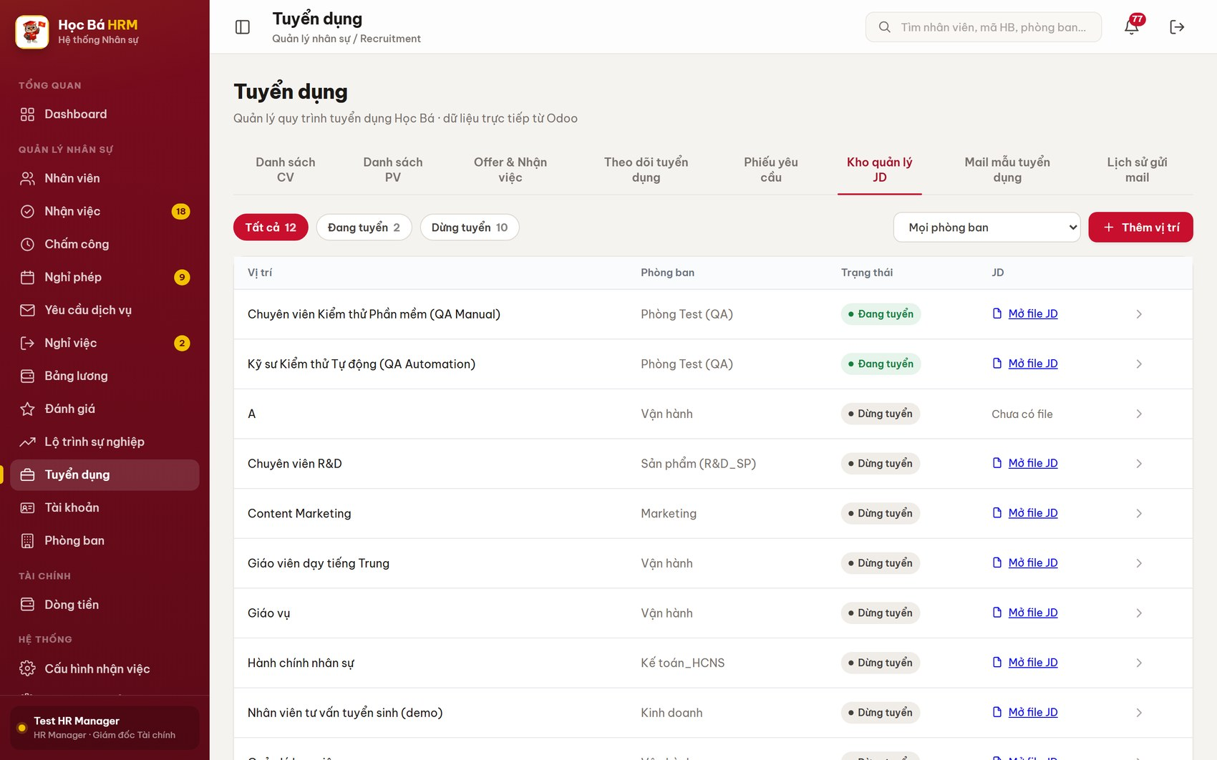
Figure 6 – Tab Kho quản lý JD – the job description library
(2) Click Thêm vị trí to create a new position, or click an existing card to edit its JD.
(3) Fill in the position name, the department, the level, the working type, the salary range and the requirements. Save.
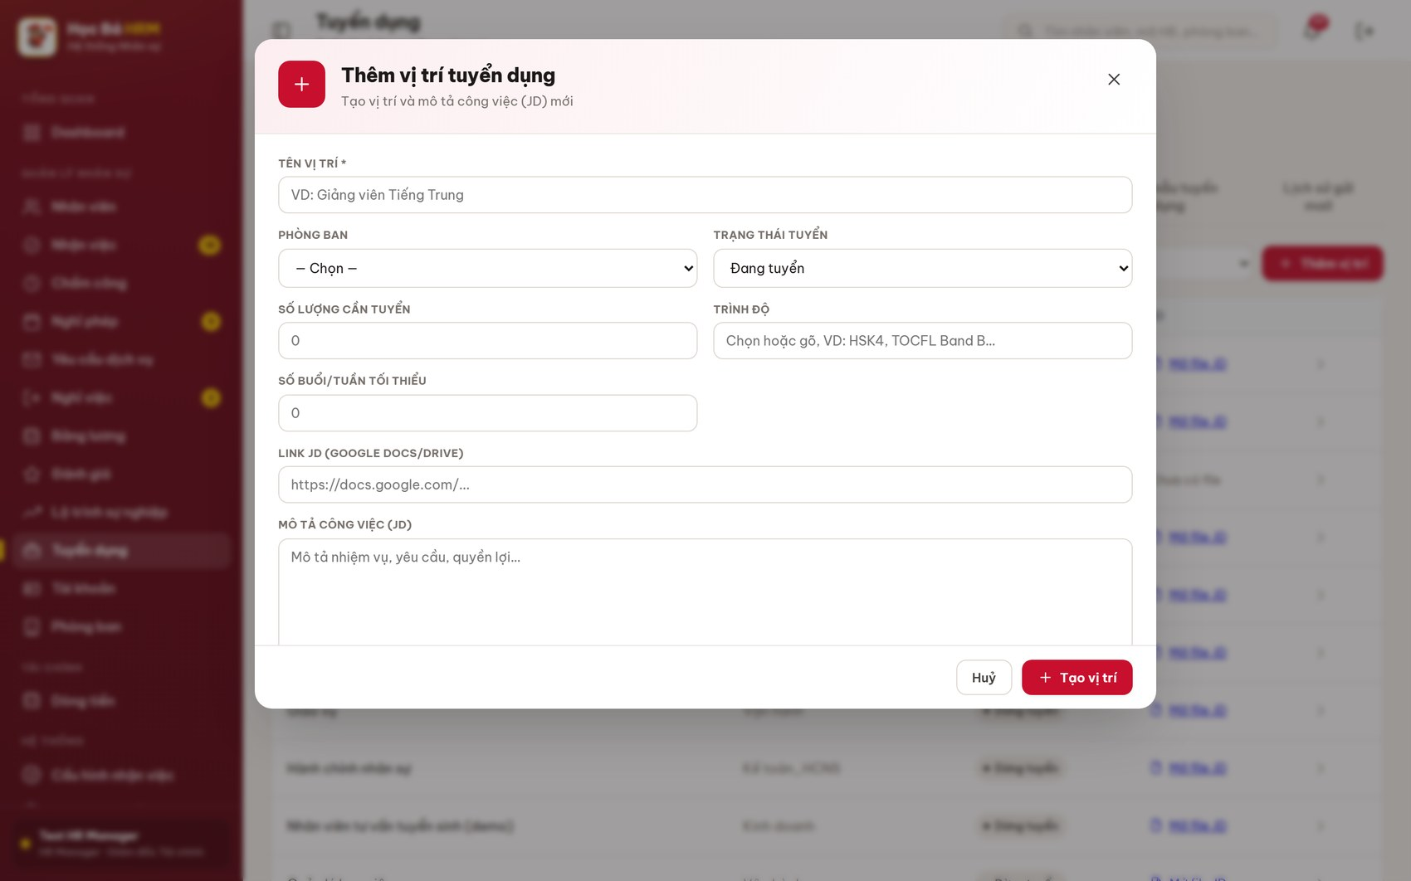
Figure 7 – Form Thêm vị trí – job description details
(4) To publish, go to tab Theo dõi tuyển dụng, expand the position and click Đăng tuyển. The badge turns to PUBLISHED and the position appears on the public site. Chép link copies the public URL, Ngừng đăng takes it down again.

2.3 Candidate applies on the public site (REC-BP-03)

Content
Purpose: let a candidate apply without any account. Every application creates a candidate record that lands directly in tab Danh sách CV at stage Yêu cầu tuyển dụng, attached to the open request of that position.

Navigation
Screen | Path | Description
Career site | http://<server>/jobs | Public, no login. Shows published positions only

Detail implementation
(1) The candidate opens /jobs and sees only the positions that are currently published.
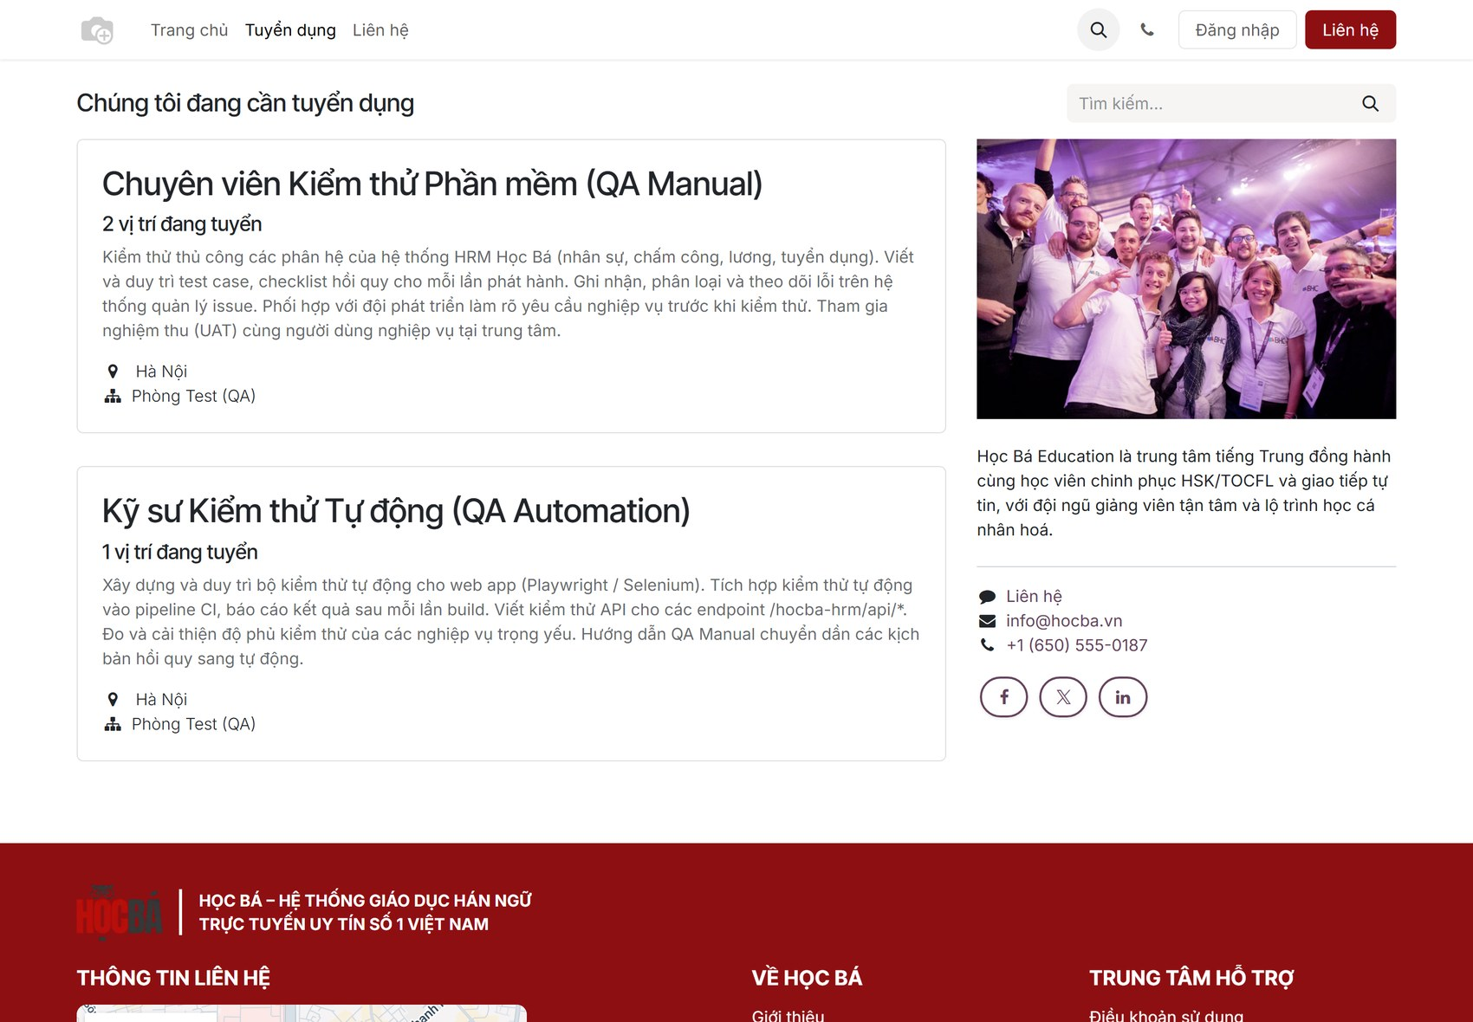
Figure 8 – Public career site of Học Bá Education
(2) Clicking a position opens the full job description: department, level, quantity, working type, salary range, expected start date and the requirements.
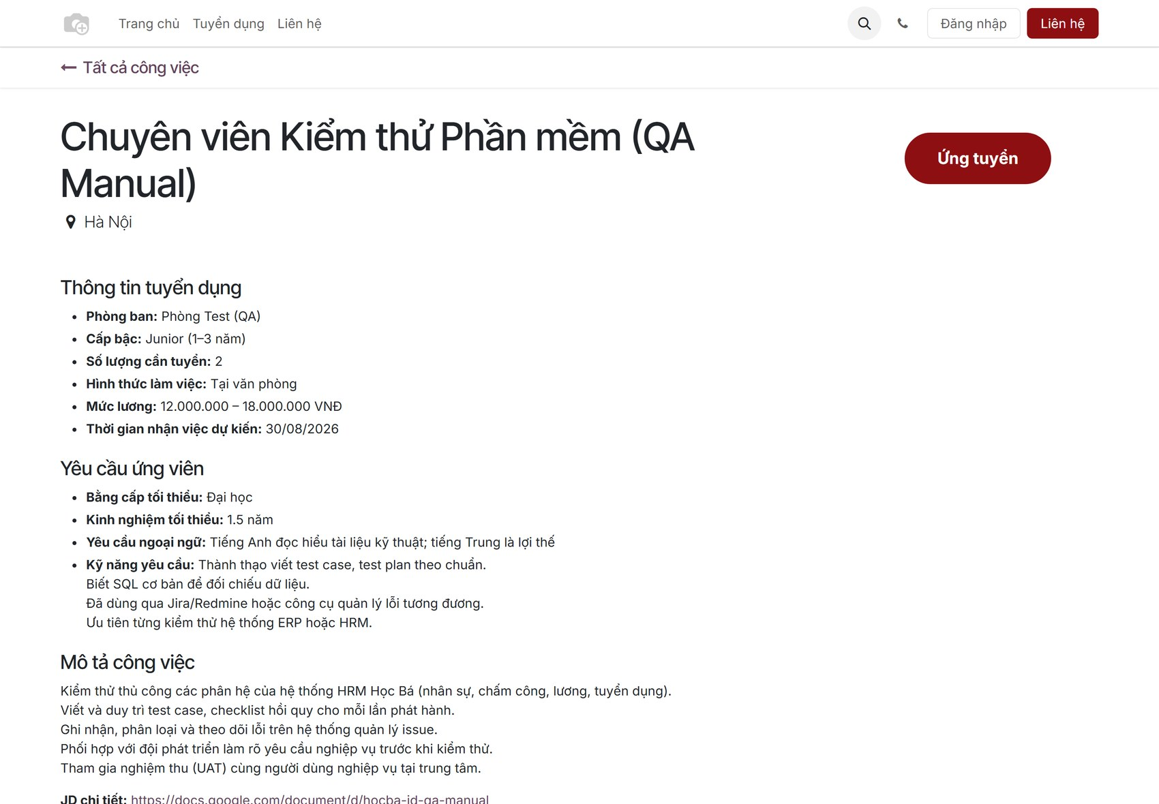
Figure 9 – Job description on the public site
(3) The candidate clicks Ứng tuyển and fills in the application form: name, e-mail, phone, LinkedIn profile, CV file and a short introduction. Name, e-mail and phone are required.
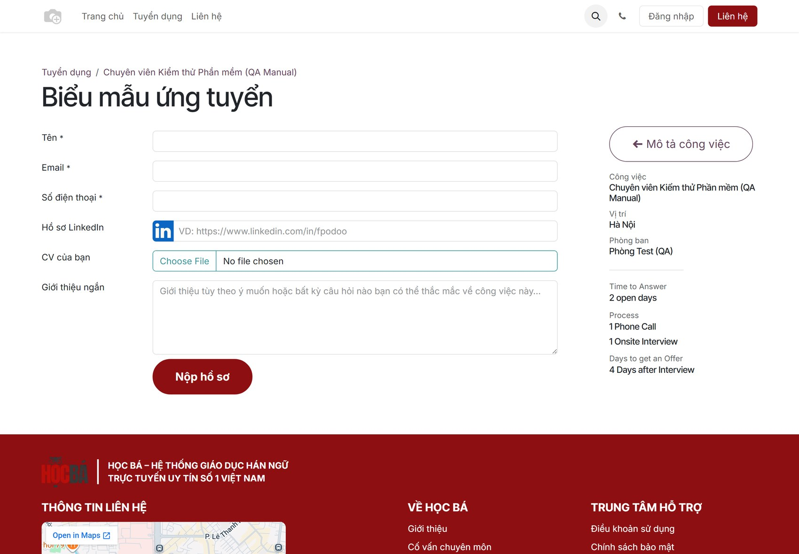
Figure 10 – Biểu mẫu ứng tuyển – the public application form
(4) After Nộp hồ sơ the candidate record is created immediately and is visible to HR in tab Danh sách CV.

2.4 CV screening (REC-BP-04)

Content
Purpose: read the CVs, decide who goes on to the interview, and keep the pipeline visible. The screen has two views: a table for fast editing and a kanban board that shows where every candidate stands.

Navigation
Screen | Path | Description
Danh sách CV | Tuyển dụng ▸ tab Danh sách CV | All candidates of every open request

Detail implementation
(1) Open Tuyển dụng ▸ Danh sách CV. The chips filter by screening result (Pass CV, Fail CV, Tiềm năng CV) and by interview result; each chip shows the live count.

Figure 11 – Tab Danh sách CV – table view
(2) To add a CV by hand (received by e-mail or from an agency), click Thêm CV. Always choose the Vị trí – a CV without a position is not attached to any request and will not appear on the tracking board.
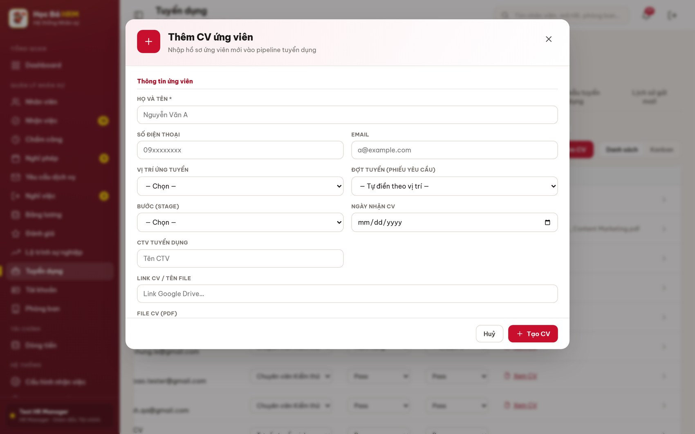
Figure 12 – Form Thêm CV – create a candidate manually
(3) Screen the CV directly in the table: the columns Vị trí, Trạng thái CV and Kết quả PV are drop-downs that save as soon as you choose a value. Column CV has a Xem PDF link that opens the original file.
(4) Click the arrow at the end of a row to open the full candidate record: contact details, position, request code, current stage, interview appointment and the screening result.
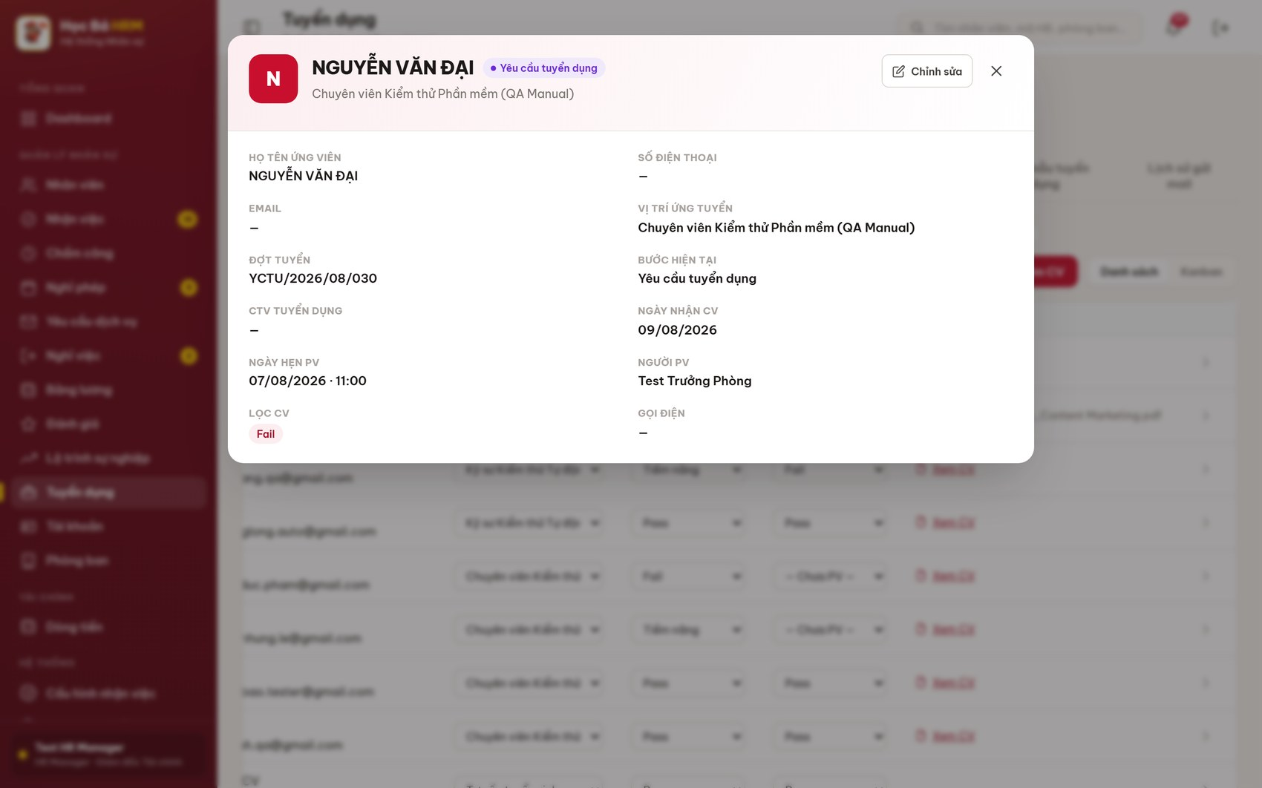
Figure 13 – Candidate record – full profile of one candidate
(5) Switch to Kanban to see the candidates by stage and to drag a card to the next stage. The system only allows moving forward; a backward move is refused with the reason.
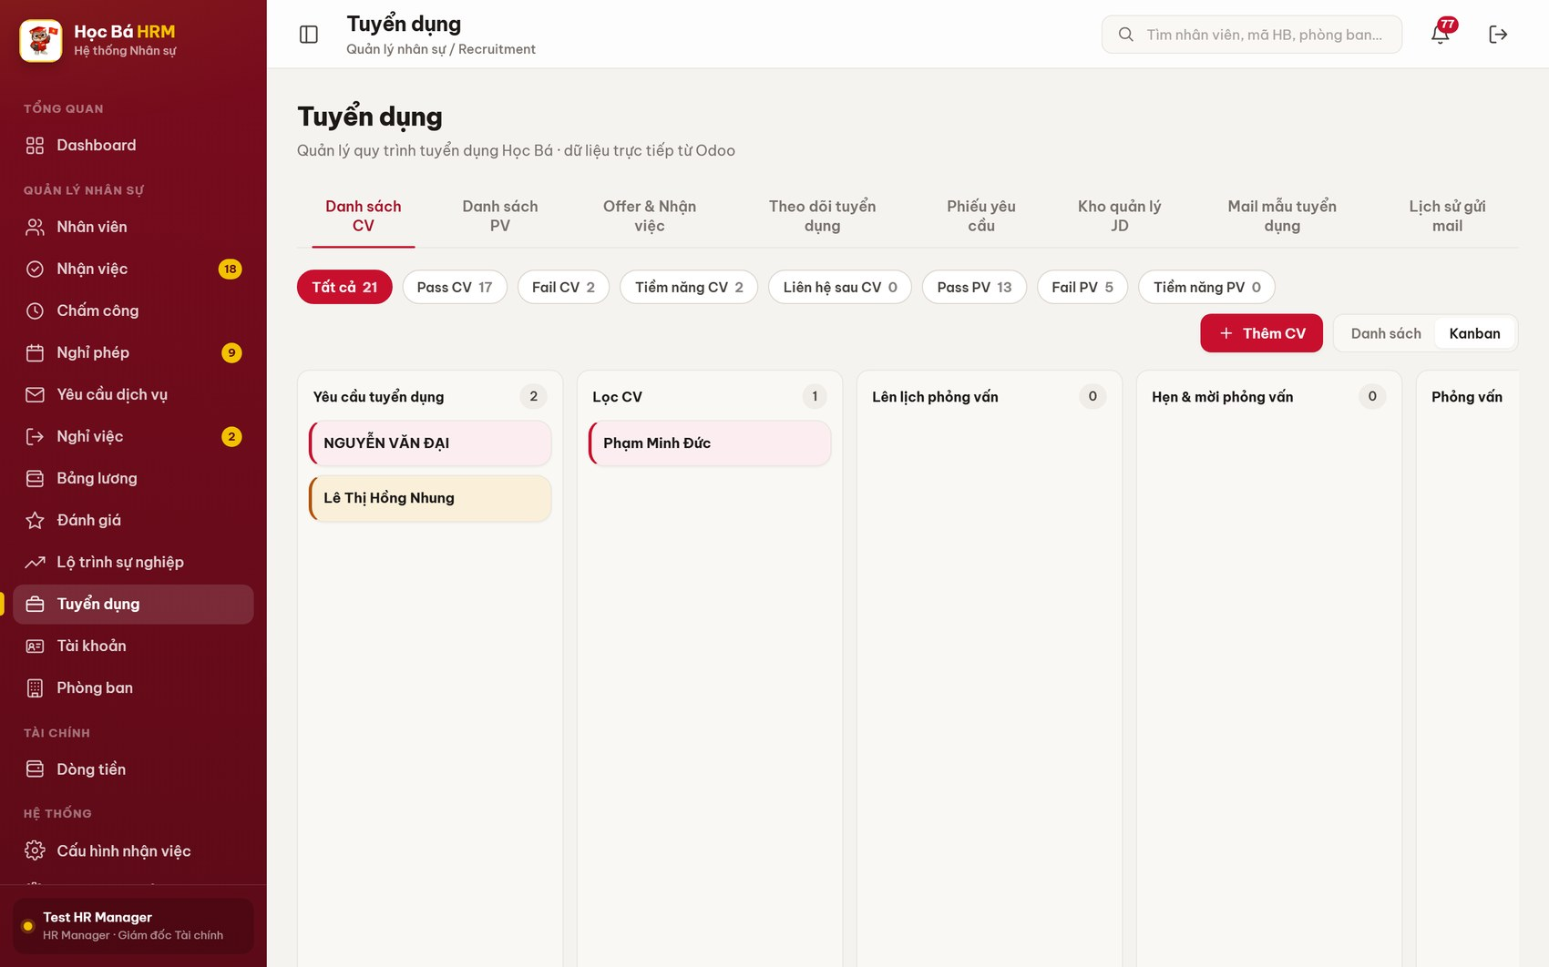
Figure 14 – Kanban view – candidates by stage, with the colour legend
Card colours: green = passed the interview (kept through Offer and Nhận việc); amber = still running, no result yet; red = Fail CV, or Fail / Tiềm năng at the interview. A red badge “Quá hạn N ngày” means the candidate has been sitting in that stage longer than the handling limit set in Cấu hình tuyển dụng.

2.5 Interview scheduling and invitation (REC-BP-05)

Content
Purpose: the interviewers say when they are free, and the recruiter puts candidates into those free time slots. Booking a candidate is a business event, not only a calendar entry: the date, the time and the interviewer name are written on the candidate record and the candidate moves forward to stage Phỏng vấn, so the invitation e-mail always carries the right date and time.

Navigation
Screen | Path | Description
Danh sách PV | Tuyển dụng ▸ tab Danh sách PV | Week grid of free slots + candidates in interview

Detail implementation
(1) Open Tuyển dụng ▸ Danh sách PV. The grid shows one column per day. Move between weeks with Tuần trước / Tuần này / Tuần sau; the counter next to the date range reads “N slot · M đã đặt”.
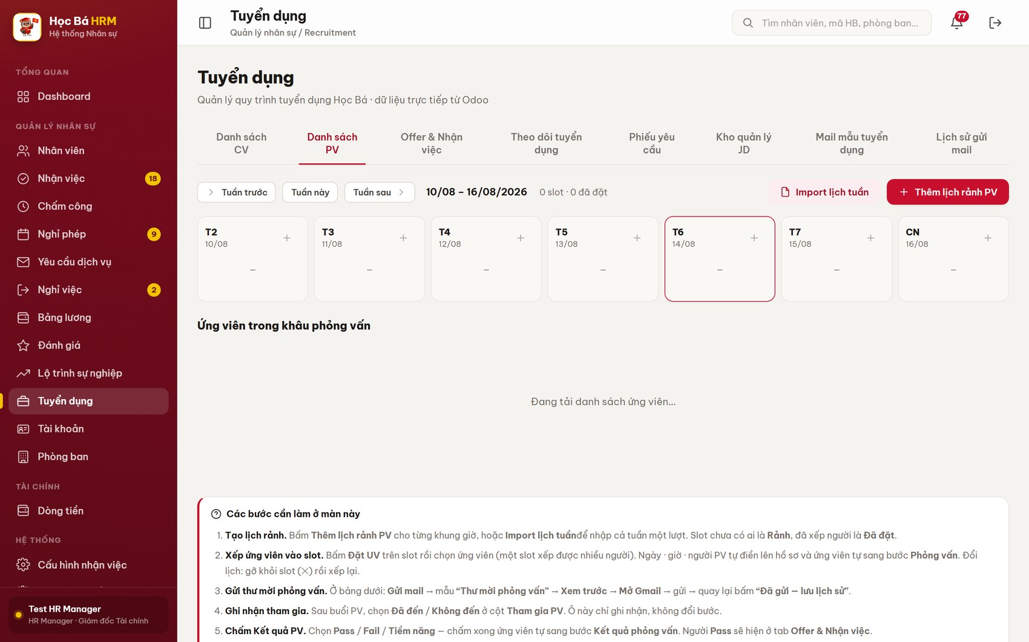
Figure 15 – Tab Danh sách PV – the week grid and the on-screen guide
(2) Click Thêm lịch rảnh PV to declare one or more free time ranges: choose the interviewer, then add lines of date + start hour + end hour. The hour lists come from the centre configuration, so an hour the server would refuse can never be chosen.
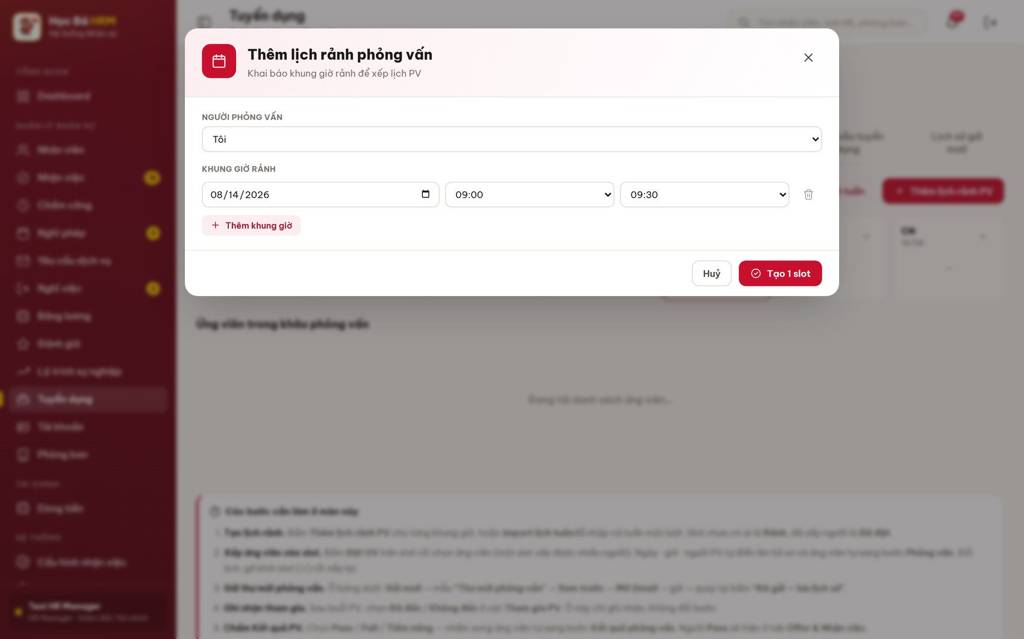
Figure 16 – Modal Thêm lịch rảnh phỏng vấn
(3) To declare a whole week at once, click Import lịch tuần and paste the rows copied from Excel or Google Sheets (or download the CSV template first). Every parsed row is shown in a preview before anything is saved.
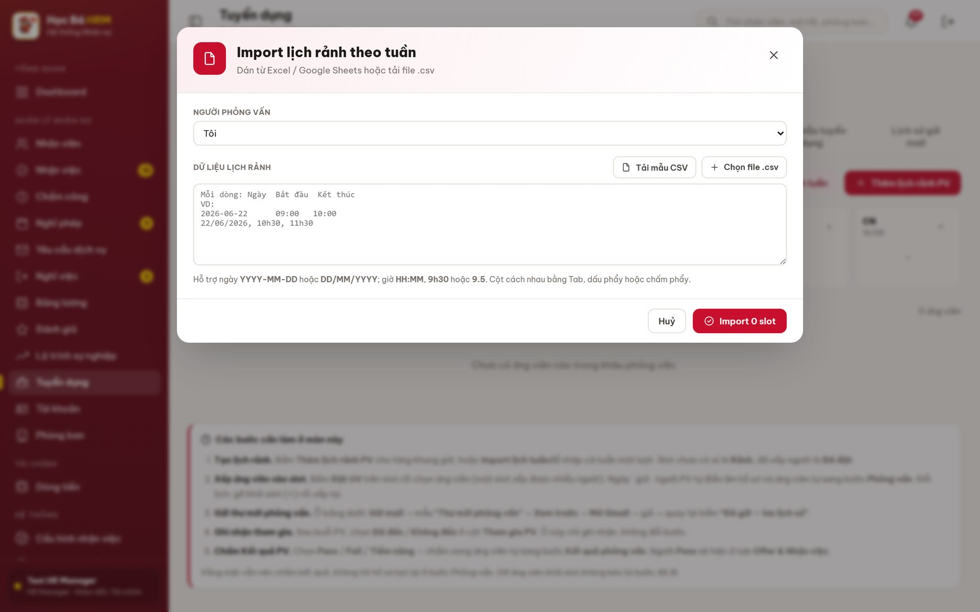
Figure 17 – Modal Import lịch rảnh theo tuần, with the preview table
(4) A slot with nobody in it shows the badge Rảnh; a slot with candidates shows Đã đặt · N.
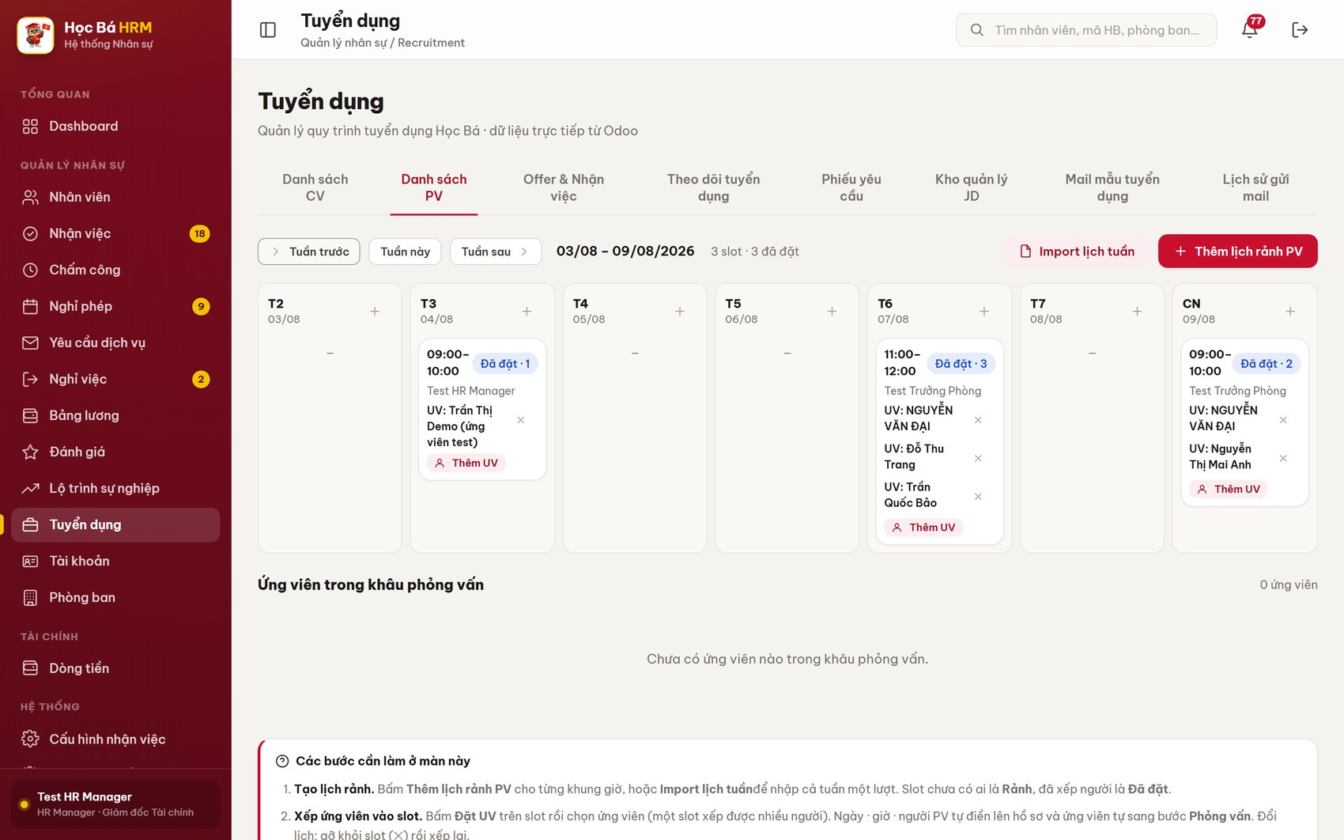
Figure 18 – A week that already has booked interview slots
(5) Click Đặt UV on a free slot (or Thêm UV on a slot that already holds candidates), search the candidate by name / phone / e-mail / position and click Chọn. One slot can hold several candidates; click Xong when you have finished.
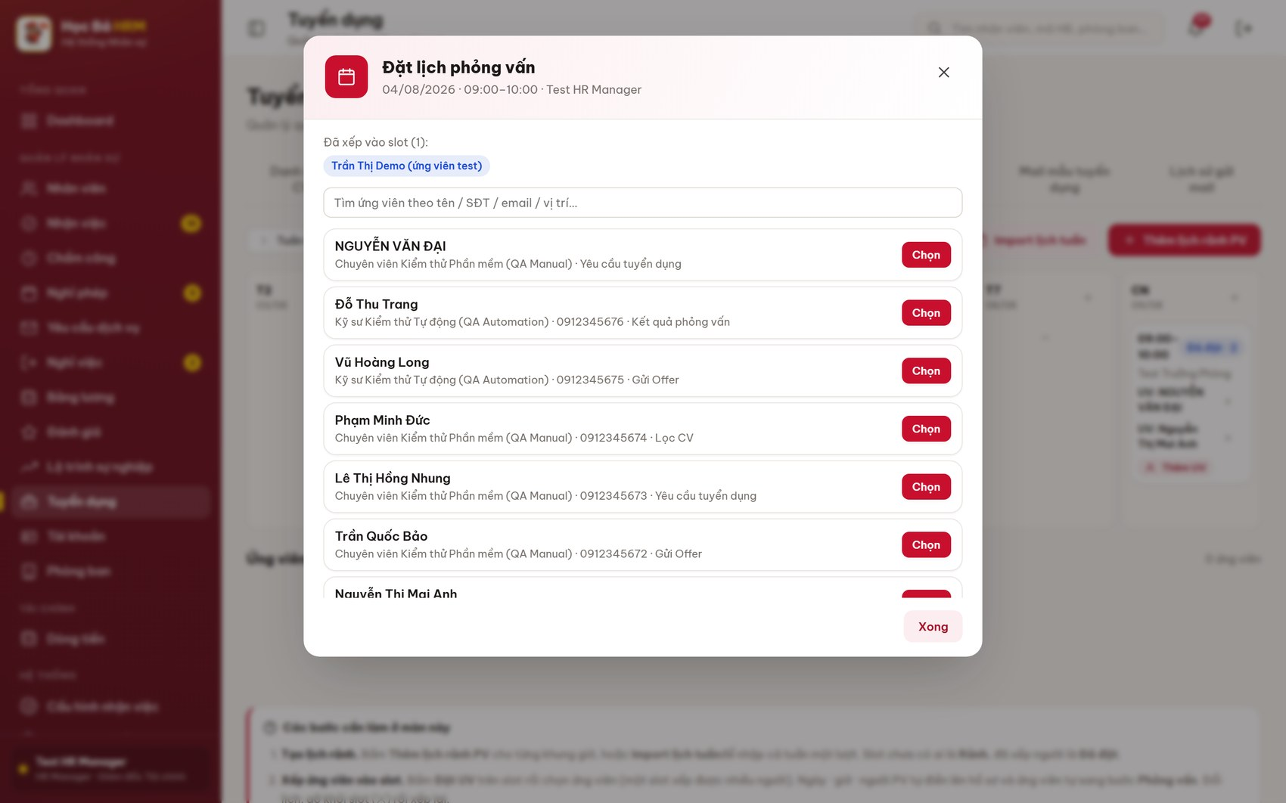
Figure 19 – Modal Đặt lịch phỏng vấn – choose the candidates for a slot
(6) To move an interview, remove the candidate from the slot with ✕ and book another slot. Removing a candidate does not undo the stage already reached.
(7) Send the invitation: in the table Ứng viên trong khâu phỏng vấn click Gửi mail, choose the template Thư mời phỏng vấn, click Xem trước, then Mở Gmail, send the message, and come back to click Đã gửi — lưu lịch sử.
Important: the stage only moves when you click “Đã gửi — lưu lịch sử”. Do not skip that step.

2.6 Interview attendance and result (REC-BP-06)

Content
Purpose: record what happened in the interview. Attendance and result are two separate fields: attendance is only a record and does not change the stage, while the result moves the candidate to stage Kết quả phỏng vấn and decides whether the candidate reaches the offer screen.

Detail implementation
(1) Scroll down in tab Danh sách PV to the table Ứng viên trong khâu phỏng vấn. It lists every candidate in the three interview stages, with the appointment fields editable in place.
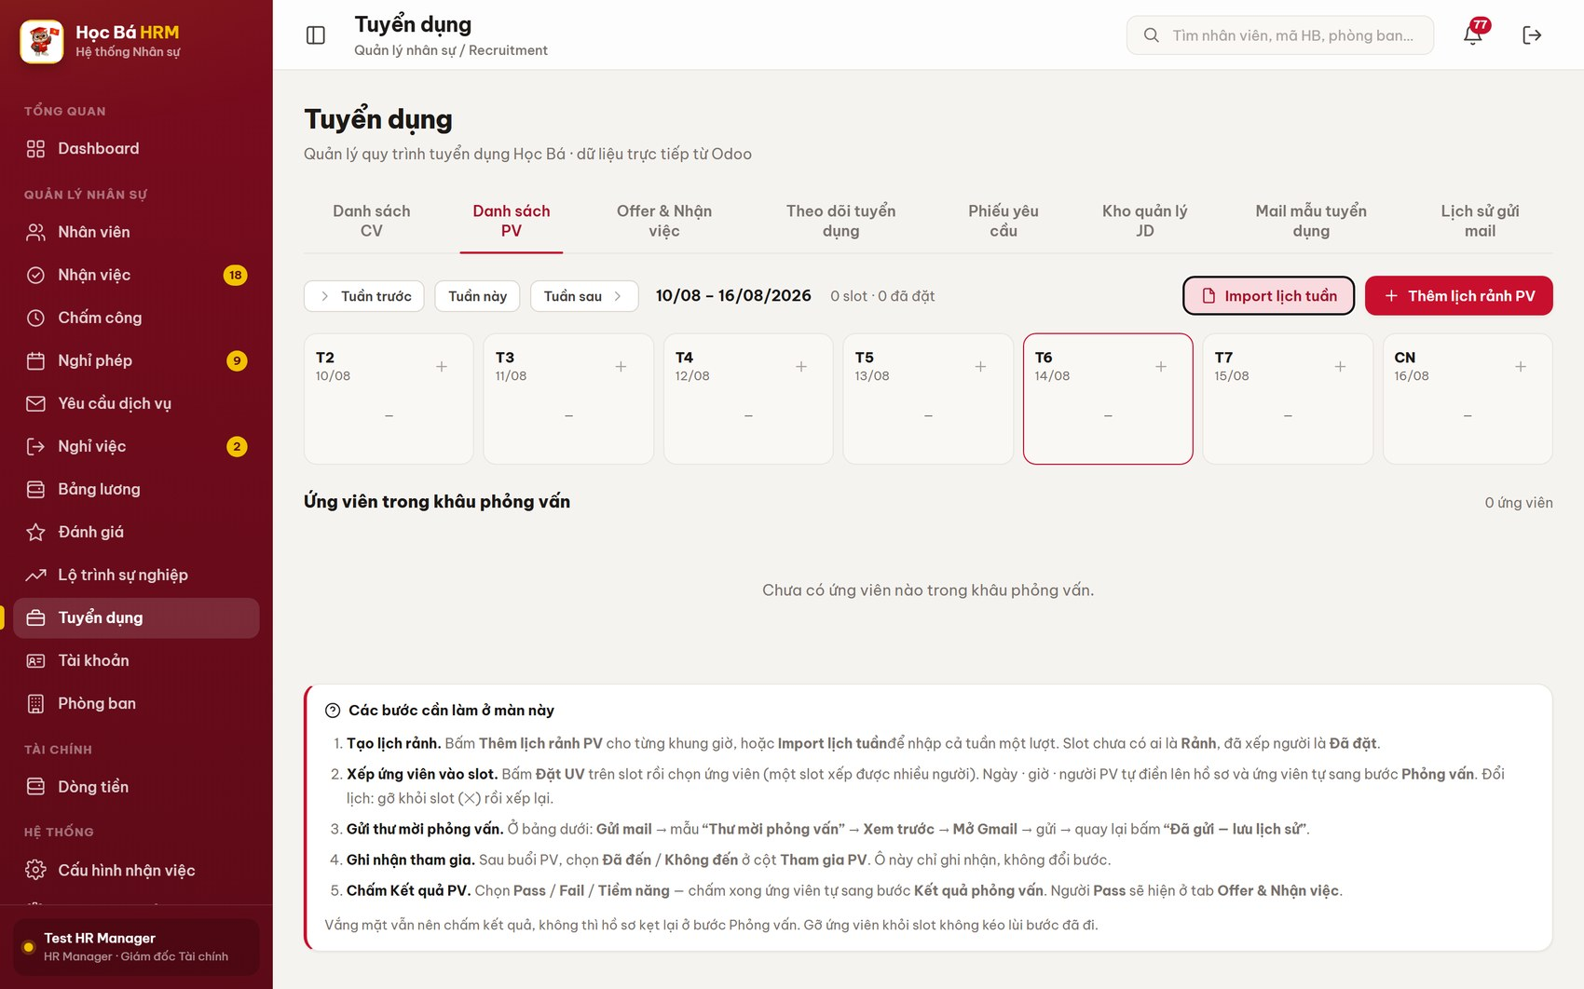
Figure 20 – Table Ứng viên trong khâu phỏng vấn
(2) After the interview, set the column Tham gia PV to Đã đến or Không đến.
(3) Set the column Kết quả PV to Pass / Fail / Tiềm năng. The candidate moves to stage Kết quả phỏng vấn straight away; a candidate marked Pass appears in tab Offer & Nhận việc.
(4) For a candidate who did not show up, still set a result – otherwise the record stays stuck in the interview stage.
(5) For a candidate who failed, send the template Thông báo kết quả phỏng vấn from the same Gửi mail button.
The field Kết quả PV is the same field shown in tab Danh sách CV; editing it on either screen has exactly the same effect.

2.7 Offer and onboarding (REC-BP-07)

Content
Purpose: agree the offer with the candidate who passed the interview, fix the start date, and hand the new employee over to the Employees module. The tab holds the last three stages of the pipeline: Gửi Offer, Onboarding and Bàn giao nhân sự.

Navigation
Screen | Path | Description
Offer & Nhận việc | Tuyển dụng ▸ tab Offer & Nhận việc | Every candidate who passed the interview

Detail implementation
(1) Open Tuyển dụng ▸ Offer & Nhận việc. The chips split the list into Gửi Offer, Bàn giao nhân sự, Chưa điền offer and Chưa hẹn ngày so nothing is forgotten. Two drop-downs filter by position and by onboarding result.
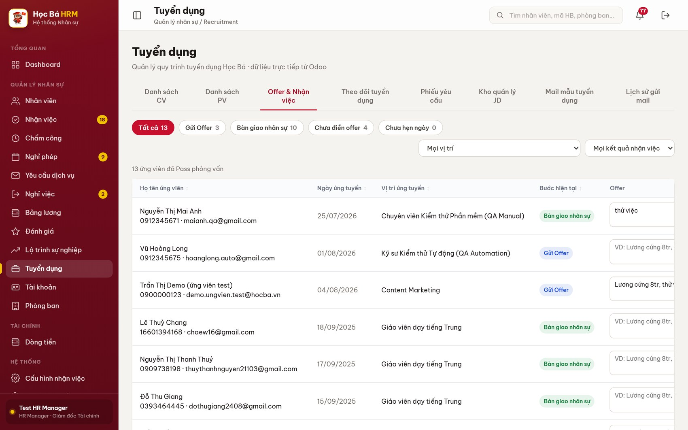
Figure 21 – Tab Offer & Nhận việc
(2) Type the offer content in the column Offer (for example “Lương cứng 8tr, thử việc 85%”) and set the start date in Ngày nhận việc. Both fields save as soon as you leave the box.
(3) Click Gửi mail on the candidate row, choose the template Thư mời nhận việc and click Xem trước.
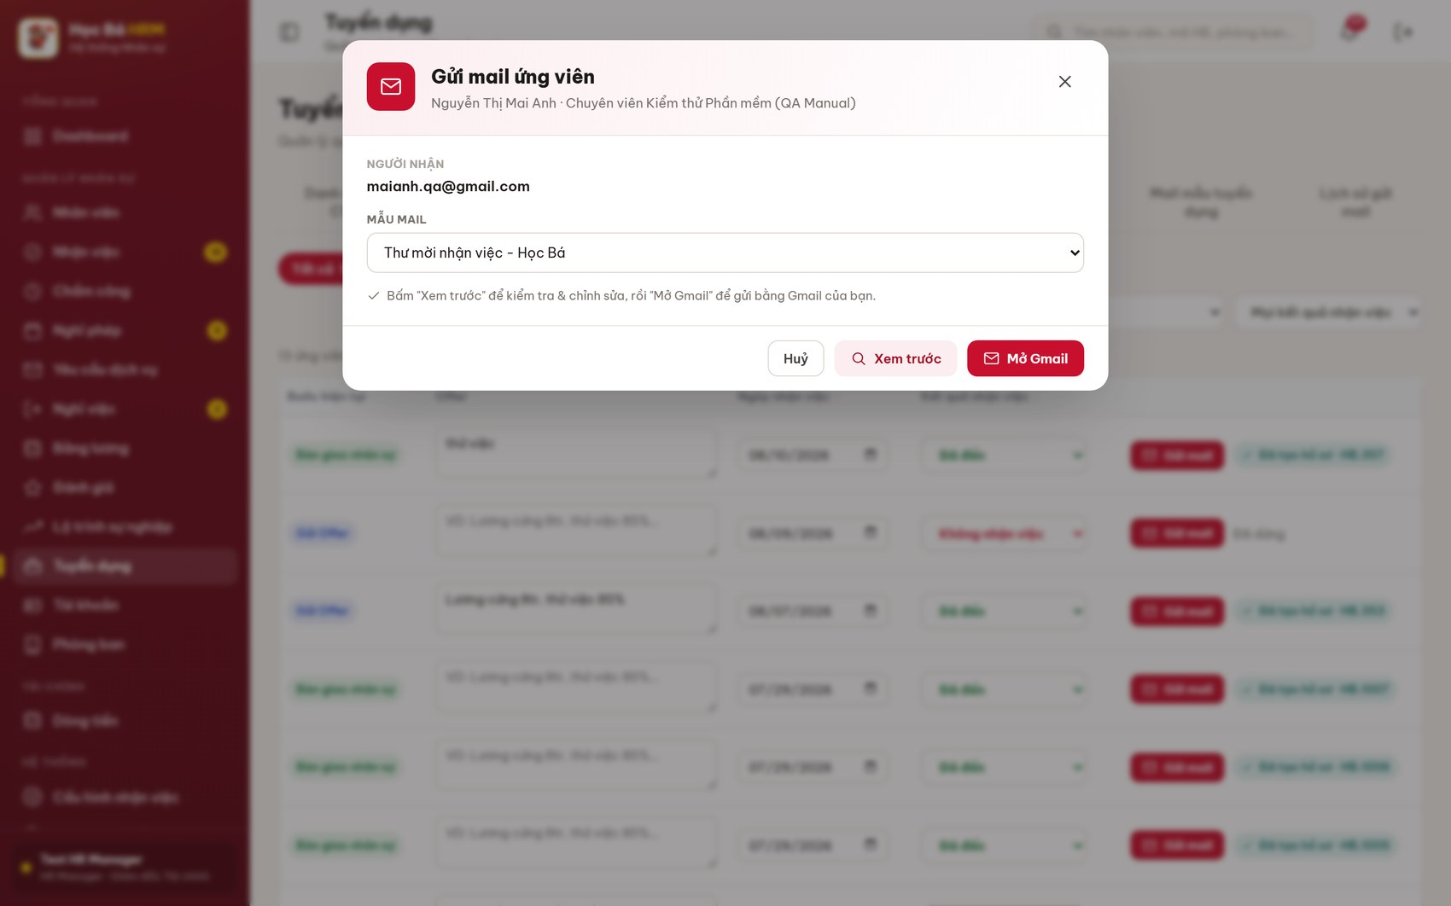
Figure 22 – Modal Gửi mail ứng viên – choose the template
(4) The preview fills the template with the real data of this candidate: recipient address, subject and body. You can still edit the subject and the body before sending.
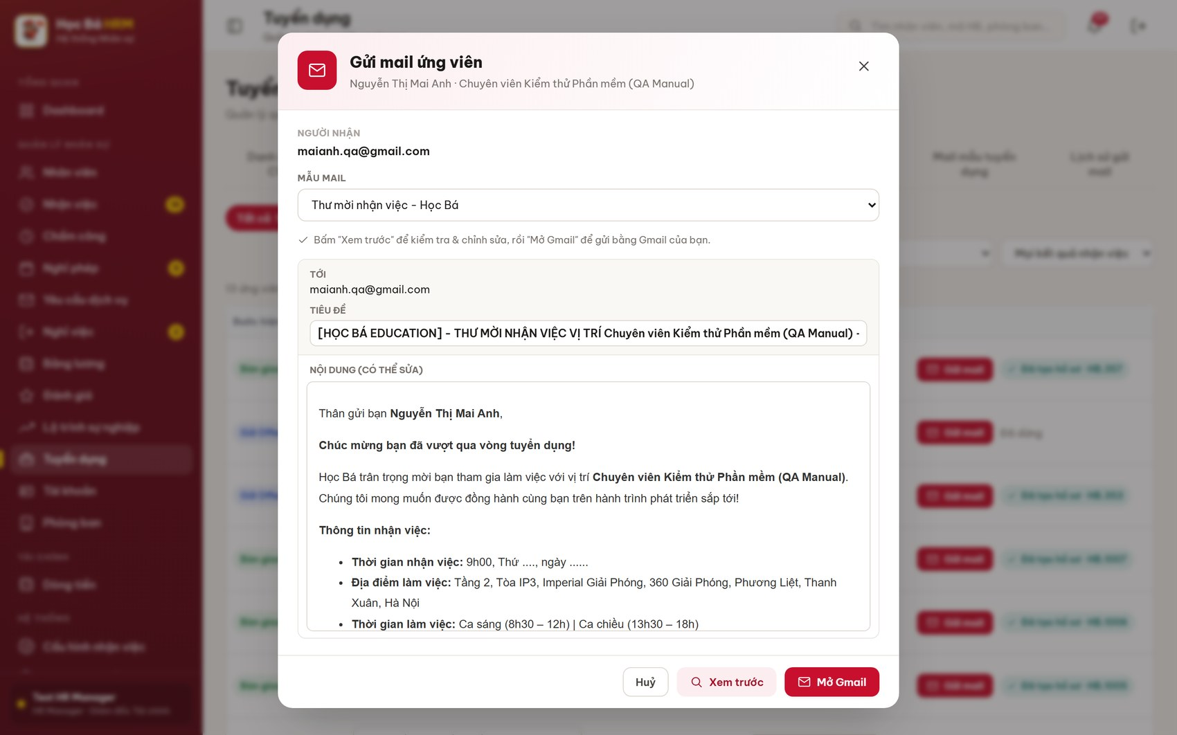
Figure 23 – Preview of Thư mời nhận việc, filled with the candidate data
(5) Click Mở Gmail, send the message, then come back and click Đã gửi — lưu lịch sử. Sending this template moves the candidate to stage Gửi Offer.
(6) When the candidate accepts, record the answer in the column Kết quả nhận việc and send the template Chào mừng đến với Học Bá on the first working day.
(7) Finally, use Tạo hồ sơ NV to create the employee record from the candidate. The candidate reaches stage Đã tuyển and the request quota is increased by one; when the quota is full the request closes itself.

2.8 E-mail templates and bulk sending (REC-BP-08)

Content
Purpose: keep the wording of the recruitment e-mails in one place and fill the candidate data automatically. Four templates cover the whole cycle:
Template | Used when | Filled in automatically
Thư mời phỏng vấn | After the candidate is booked into a slot | Name, position, interview date and time, recipient
Thông báo kết quả phỏng vấn | When the interview result is Fail | Name, position, recipient
Thư mời nhận việc | When the interview result is Pass | Name, position, recipient
Chào mừng đến với Học Bá | On the first working day | Name, recipient

Two of them also move the candidate forward: Thư mời phỏng vấn pushes the candidate to stage Phỏng vấn, Thư mời nhận việc pushes to stage Gửi Offer. The move happens when you click “Lưu lịch sử”, not when the mail window opens.

Detail implementation
(1) Open Tuyển dụng ▸ Mail mẫu tuyển dụng. Every template is one card showing its subject line.
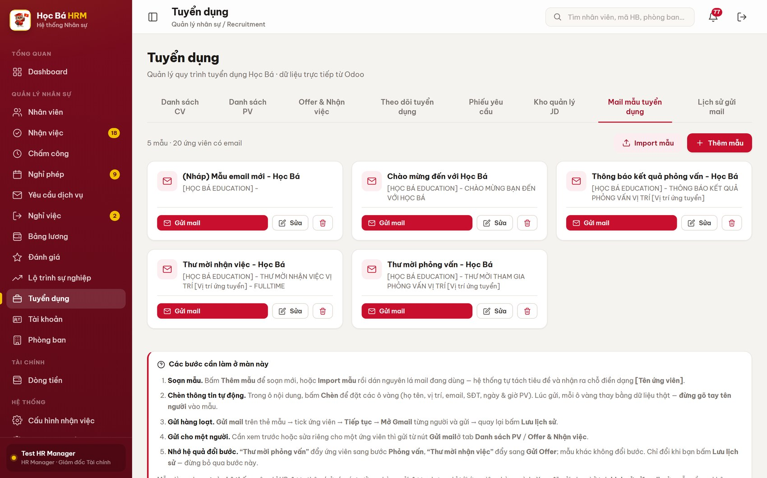
Figure 24 – Tab Mail mẫu tuyển dụng
(2) Click Thêm mẫu to write a new template, or Import mẫu to paste an e-mail you already use – the system separates the subject from the body and recognises the placeholders written as [Tên ứng viên].
(3) Click Sửa on a card to edit it. Use the Chèn buttons to place the yellow tokens (candidate name, position, e-mail, phone, interview date and time). Never type a candidate name by hand into a template.
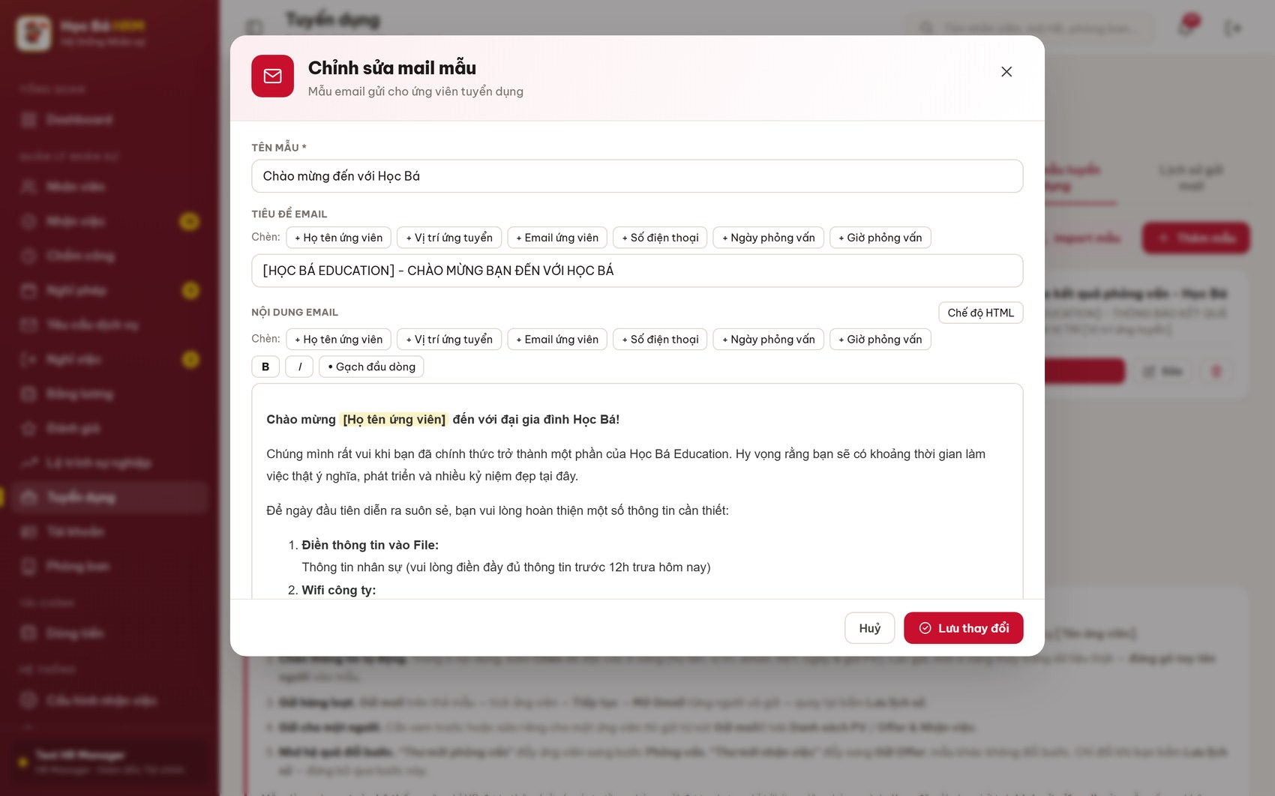
Figure 25 – Editing a template – the Chèn buttons place the auto-filled tokens
(4) To send one template to many candidates, click Gửi mail on the card, tick the candidates (or Chọn tất cả), click Tiếp tục, open Gmail for each of them, send, and finish with Lưu lịch sử.
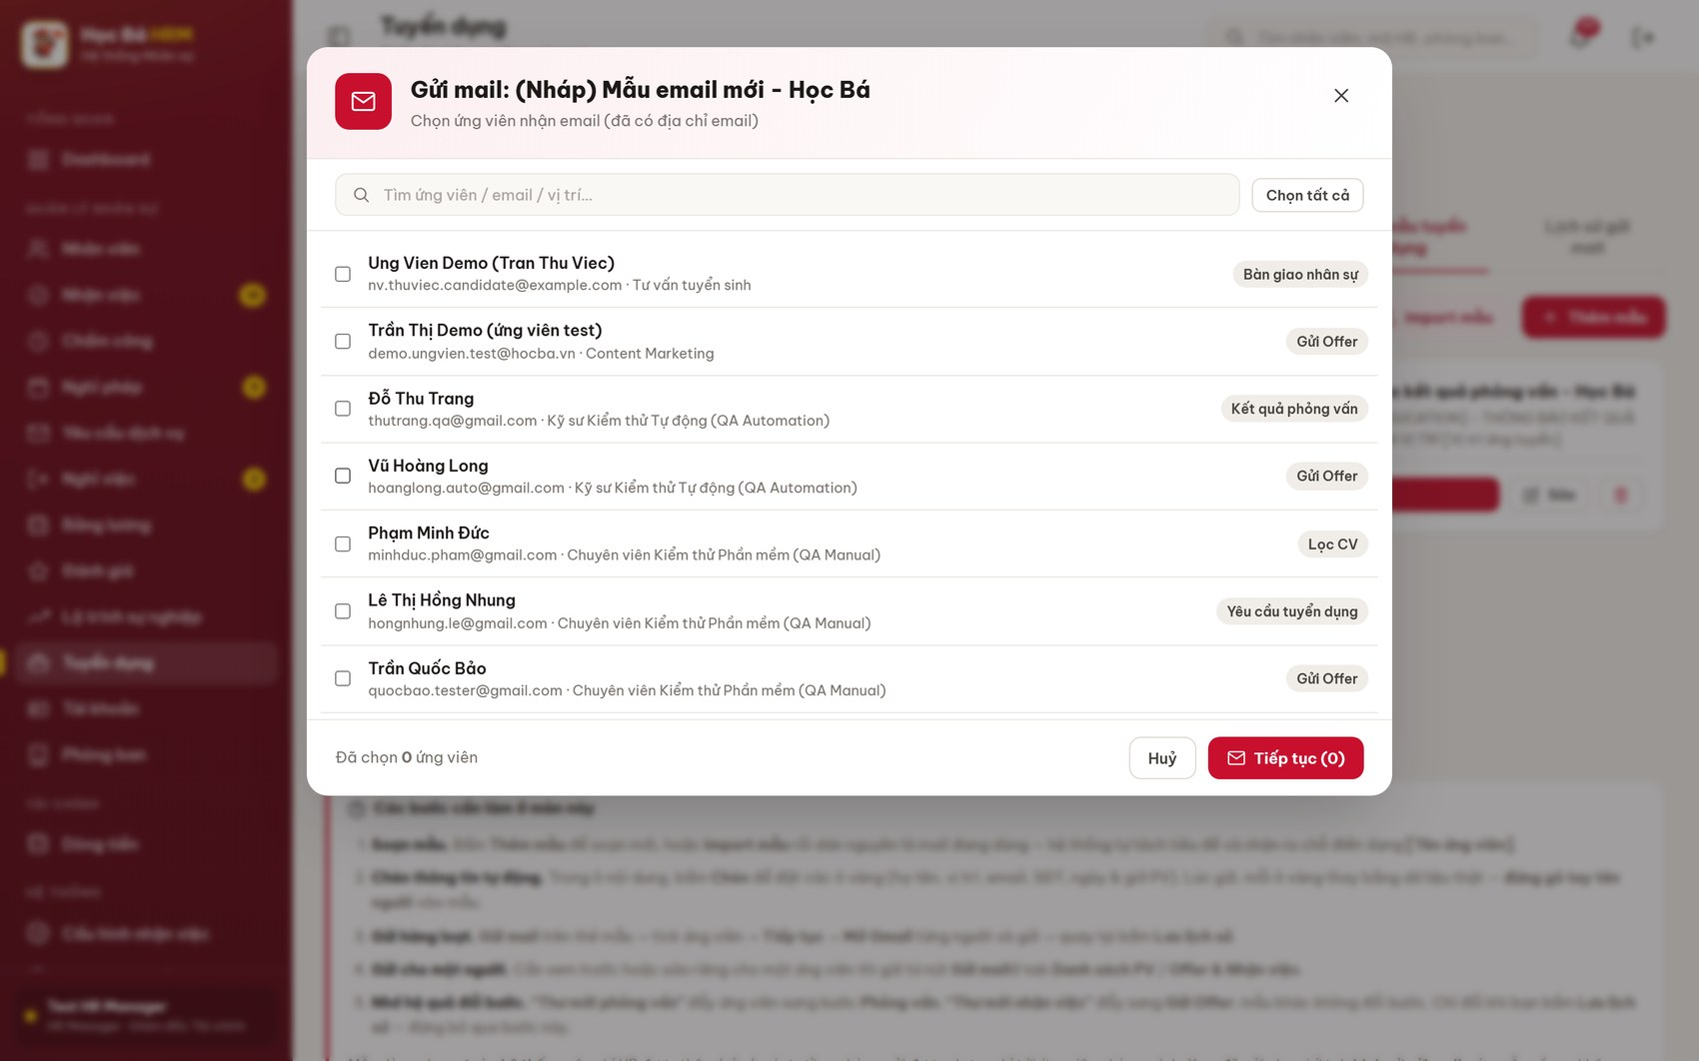
Figure 26 – Bulk sending – choose the candidates who will receive the template
Templates are shared by the whole system, so only HR may add, edit or delete them. A department manager may send them, but only to candidates of the own department. Editing a template later does not change the e-mails already sent.

2.9 Mail log (REC-BP-09)

Content
Purpose: prove what was sent, to whom and when. Every message sent through the module is written here with its delivery state.

Detail implementation
(1) Open Tuyển dụng ▸ Lịch sử gửi mail. Filter with the chips Đã gửi / Trong hàng đợi / Lỗi.
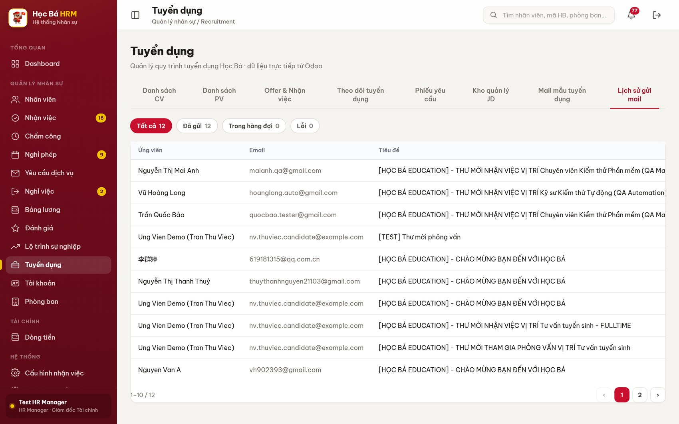
Figure 27 – Tab Lịch sử gửi mail
(2) Each line shows the candidate, the recipient address, the subject and the state. Use the search box in the top bar to find every message sent to one candidate.

2.10 Recruitment progress tracking (REC-BP-10)

Content
Purpose: answer, for every open request, how far the hiring has got: how many people are needed, how many are hired, how many CVs came in, how they split between pass and fail, and how many days are left before the onboarding deadline.

Detail implementation
(1) Open Tuyển dụng ▸ Theo dõi tuyển dụng. The summary line shows Cần tuyển, Đã tuyển, Còn thiếu and Trễ deadline over the whole filter; the chips and the department drop-down narrow the list.
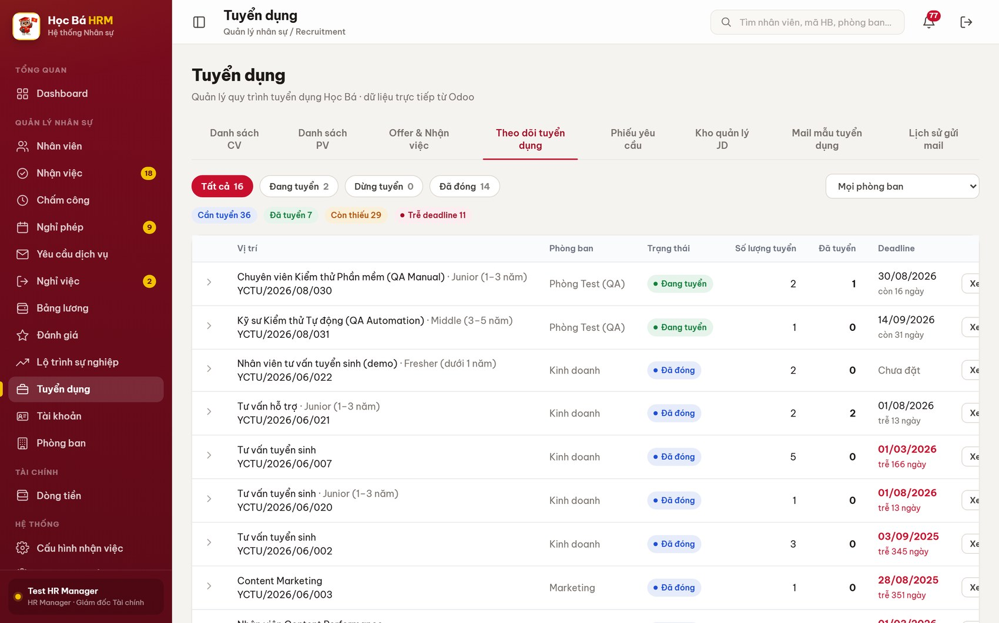
Figure 28 – Tab Theo dõi tuyển dụng
(2) Click Xem chi tiết on a row to expand the funnel of that request: CV, CV pass, CV fail, PV, PV pass, PV fail, Nhận việc, Đã tuyển. Every number is a link to the matching candidate list.
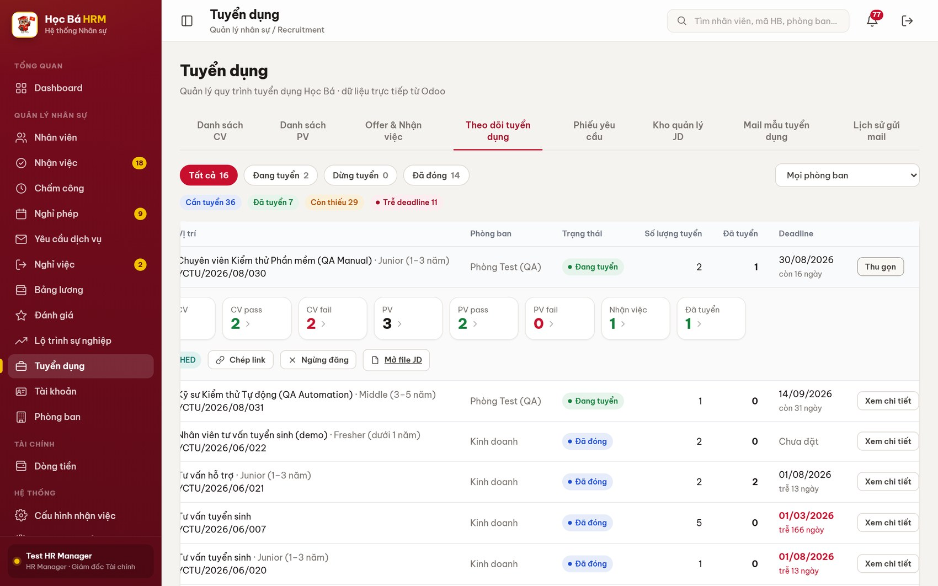
Figure 29 – A request expanded – the recruitment funnel and the posting buttons
(3) The same row carries the posting buttons: Đăng tuyển / Ngừng đăng, Chép link and Mở file JD.
(4) A deadline in red with “trễ N ngày” means the request has passed its onboarding date without being filled.

2.11 Recruitment process configuration (REC-BP-11)

Content
Purpose: adapt the recruitment process to the centre without changing any code. The configuration is shared by the whole system: a change here applies immediately to every open position.

Navigation
Screen | Path | Description
Cấu hình tuyển dụng | Sidebar ▸ HỆ THỐNG ▸ Cấu hình tuyển dụng | HR / Admin only

Detail implementation
(1) Open Cấu hình tuyển dụng. It has five tabs.
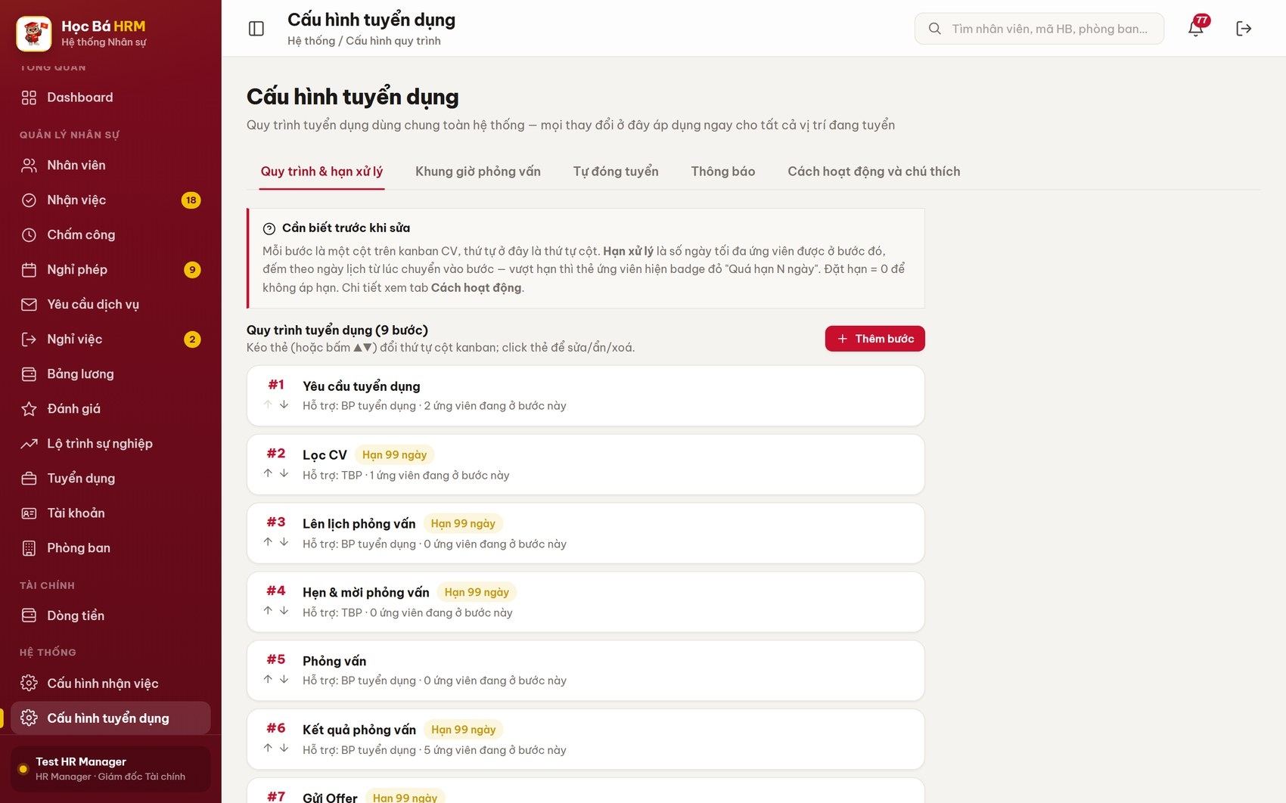
Figure 30 – Màn Cấu hình tuyển dụng – tab Quy trình & hạn xử lý
Tab | What it controls
Quy trình & hạn xử lý | The stages of the pipeline (each one is a kanban column), their order, and the handling limit (Hạn xử lý) in calendar days. Over the limit, the candidate card shows the red badge “Quá hạn N ngày”. Set 0 for no limit.
Khung giờ phỏng vấn | The interview window of the centre and the step between two hours (default 09:00–17:00, every 30 minutes). The slot forms read this list, so no invalid hour can be chosen.
Tự đóng tuyển | Whether a request closes itself once its quota is filled.
Thông báo | Which events raise a bell notification (request waiting for approval, overdue CV).
Cách hoạt động và chú thích | Read-only explanation of the rules and of the card colours.

(2) Drag a stage card (or use ▲▼) to change the order of the kanban columns; click a card to rename, hide or delete it; click Thêm bước to add a stage.
Warning: the stages are shared by every open position. Renaming or deleting a stage changes the board for the whole company, so agree the change with the HR team first.

Appendix A – Frequently asked questions
Question | Answer
A candidate does not appear on the tracking board. | The CV has no position, or the request of that position is not in state Đang tuyển. Open the candidate and set the field Vị trí.
The kanban card refuses to move. | The board only allows moving forward. The reason for the refusal is shown in the message; use the proper screen (interview result, offer) to advance the candidate.
The e-mail was sent from Gmail but the stage did not change. | The stage moves only after “Đã gửi — lưu lịch sử”. Reopen the mail window and confirm.
The candidate did not attend but the record is stuck in Phỏng vấn. | Set Kết quả PV as well; the attendance field alone does not move the stage.
A request cannot be approved. | Approval requires the recruitment group. The person who raised the request can only send it for approval or put it back to Nháp.
A red badge “Quá hạn N ngày” shows on a card. | The candidate has stayed in that stage longer than the limit set in Cấu hình tuyển dụng ▸ Quy trình & hạn xử lý. It never shows for a candidate marked Fail PV.

Appendix B – Reference documents
Document | Content
FS-REC-001 Job Position | JD library, position master data
FS-REC-002 Applicant Tracking | Candidate record, stages, screening
FS-REC-003 Recruitment Request Management | Request and approval flow
FS-REC-004 Offer Management | Offer content and acceptance
FS-REC-005 Interview Scheduling & Slot Booking | Interview slots and booking
FS-REC-006 Recruitment Email Templates & Mail Log | Templates, sending, mail log
FS-REC-007 Recruitment Progress Tracking By Request | Tracking board and funnel
FS-REC-008 Recruitment Process Configuration | Stages, handling limits, interview hours
FS-REC-009 Recruitment Automation & Notifications | Scheduled actions and notifications
FS-REC-010 Onboarding Result & Employee Handover | Onboarding result, employee creation

