USER MANUAL
HRM ODOO – HỌC BÁ EDUCATION
Employee Module (Nhân sự)

Project: HRM Odoo – Học Bá Education (ISP490_G2)
System: Odoo 19 ERP + ReactJS SPA (/hocba-hrm)
Module: hocba_employees
Version 1.0 – 14/08/2026
FPT University

Change history
Changed date | Items have been changed | Change content / Reason | Updated by | Type (A/C/D) | Version
14/08/2026 | All | First Release | Vũ Chí Tân | A | 1.0
A – Create C – Change D – Delete
FPT Signature
 | Full name & Role | Signature | Date | Note
Created by | Vũ Chí Tân / vct0866@gmail.com / Developer – Employee module |  | 14/08/2026
Reviewed by | Phạm Đức Thắng / Reviewer – ISP490_G2
Approved by | Thesis Supervisor / FPT University
Table of Contents
1. OVERVIEW 4
1.1 Process used in guide document 4
1.2 The working life of an employee 4
1.3 Roles and permissions 5
1.4 How to open the module 5
2. USER MANUAL 9
2.1 Employee profile (EMP-BP-01) 9
Content 9
Navigation 9
Detail implementation 9
2.2 Dependents for tax deduction (EMP-BP-02) 12
Content 12
Navigation 12
Detail implementation 12
2.3 Certificates and expiry alerts (EMP-BP-03) 13
Content 13
Navigation 13
Detail implementation 13
2.4 Asset register (EMP-BP-04) 15
Content 15
Navigation 15
Detail implementation 15
2.5 Onboarding by dynamic steps (EMP-BP-05) 16
Content 16
Navigation 16
Detail implementation 17
2.6 Onboarding process configuration (EMP-BP-06) 19
Content 19
Navigation 19
Detail implementation 19
2.7 Promotion and salary history (EMP-BP-07) 21
Content 21
Navigation 21
Detail implementation 21
2.8 Career dashboard and honour board (EMP-BP-08) 22
Content 22
Navigation 22
Detail implementation 22
2.9 Login account management (EMP-BP-09) 24
Content 24
Navigation 24
Detail implementation 24
2.10 Department management (EMP-BP-10) 25
Content 25
Navigation 25
Detail implementation 25
2.11 Resignation (EMP-BP-11) 27
Content 27
Navigation 27
Detail implementation 27
2.12 Self-service – my own profile (EMP-BP-12) 29
Content 29
Navigation 29
Detail implementation 29
Appendix A – Frequently asked questions 31
Appendix B – Reference documents 31

(Right-click the table of contents and choose “Update Field” to refresh page numbers.)

1. OVERVIEW

1.1 Process used in guide document
This user manual describes how to run the whole working life of an employee of Học Bá Education on the HRM system: from the profile opened on the first day, through the onboarding steps of the probation, the assets handed over, the certificates, the promotions and the career record, up to the resignation and the closing of the login account. Each business process below is one section of chapter 2.
Process No | Definition | Note
EMP-BP-01 | Employee profile – create, search, read, update (Hồ sơ nhân viên) | Section 2.1 · FS-EMP-001 / 002
EMP-BP-02 | Dependents for personal income tax deduction (Người phụ thuộc) | Section 2.2 · FS-EMP-003
EMP-BP-03 | Certificates, verification and expiry alerts (Chứng chỉ) | Section 2.3 · FS-EMP-008 / 009
EMP-BP-04 | Asset register (Tài sản đang giữ) | Section 2.4 · FS-EMP-006
EMP-BP-05 | Onboarding / probation by dynamic steps (Nhận việc) | Section 2.5 · FS-EMP-004 / 005
EMP-BP-06 | Onboarding process configuration (Cấu hình nhận việc) | Section 2.6 · FS-EMP-004
EMP-BP-07 | Promotion and salary history (Thăng tiến) | Section 2.7 · FS-EMP-007 / 011
EMP-BP-08 | Career dashboard and honour board (Lộ trình sự nghiệp) | Section 2.8 · FS-EMP-012
EMP-BP-09 | Login account management (Tài khoản) | Section 2.9 · FS-EMP-013
EMP-BP-10 | Department management (Phòng ban) | Section 2.10
EMP-BP-11 | Offboarding / resignation (Nghỉ việc) | Section 2.11 · FS-EMP-010
EMP-BP-12 | Self-service – my own profile (Hồ sơ của tôi) | Section 2.12 · FS-EMP-001 / 002

1.2 The working life of an employee
Every employee record carries a state (Tình trạng). The state drives the badge colour in every list, decides whether the person appears in tab Nhận việc, and is changed by the system itself at the two ends of the cycle: the onboarding step marked “Đạt → lên chính thức” turns the record official, and the completion of a resignation turns it resigned and archives it.
# | State (Tình trạng) | Meaning | Where the employee appears
1 | Thử việc | Probation – the onboarding steps are running | Nhân viên + Nhận việc
2 | Chính thức | Official – probation passed, official date set | Nhân viên
3 | TTS | Intern | Nhân viên
4 | Part-time | Part-time contract | Nhân viên
5 | CTV | Collaborator (cộng tác viên) | Nhân viên
6 | Cố vấn | Advisor | Nhân viên
7 | Đang offboarding | A resignation request is being approved | Nhân viên + Nghỉ việc
8 | Nghỉ việc | Resigned – record archived, login locked | Tài khoản (marked Đã nghỉ)
Beside the state, four classification axes are filled on the profile. They are not decoration: the first three decide which onboarding process the system assigns automatically (see section 2.6), and the department decides who may read the record.
- Hình thức làm việc – Offline or Online;
- Loại vị trí – Quản lý, Nhân viên, CTV, Freelancer, Cố vấn;
- Loại nhân viên – Nhân viên văn phòng, Giáo viên, Cộng tác viên;
- Phòng ban – the department the person belongs to.

1.3 Roles and permissions
A management account (HR, Admin, Giáo vụ) is separate from a personal account: it manages other people and therefore has no “Hồ sơ của tôi” entry in the sidebar. Read the table before reporting a missing button – most “the button is not there” cases are simply the permission working as designed.
Role | Can do | Cannot do
Administrator / (base.group_system) | Everything in this manual, on every employee of the centre. | —
HR Manager / (hr.group_hr_manager) | Everything: profiles, salary, onboarding steps and their deadlines, the onboarding configuration, accounts, departments, and the final approval of a resignation. | —
HR officer / (hr.group_hr_user) | Create and edit any profile, dependents, certificates, assets; create and lock login accounts; manage departments. | See or edit the salary block (Lương cơ bản, MST TNCN, số sổ BHXH, bank account); change an onboarding step deadline; complete a resignation.
Giáo vụ / (group_hocba_giaovu) | Everything an HR officer can do, plus the salary block – but only on the teachers (Loại nhân viên = Giáo viên). | Touch a record of any other employee type; manage accounts or departments.
Department manager / (hr.department.manager_id) | Read and edit the profiles of the own department and of its child departments, see their salary, approve at the first level a resignation of the own staff. | Reach an employee outside the own branch; manage accounts, departments or the onboarding configuration.
Employee / (any logged-in account) | Read the own profile in Hồ sơ của tôi, update contact and address, change the own photo, submit and cancel a resignation request, read the own career page. | Open the management screens – they are not in the sidebar, and every write API answers HTTP 403 Forbidden.

1.4 How to open the module
(1) Open the HRM system: http://<server>/hocba-hrm and sign in with the company account.
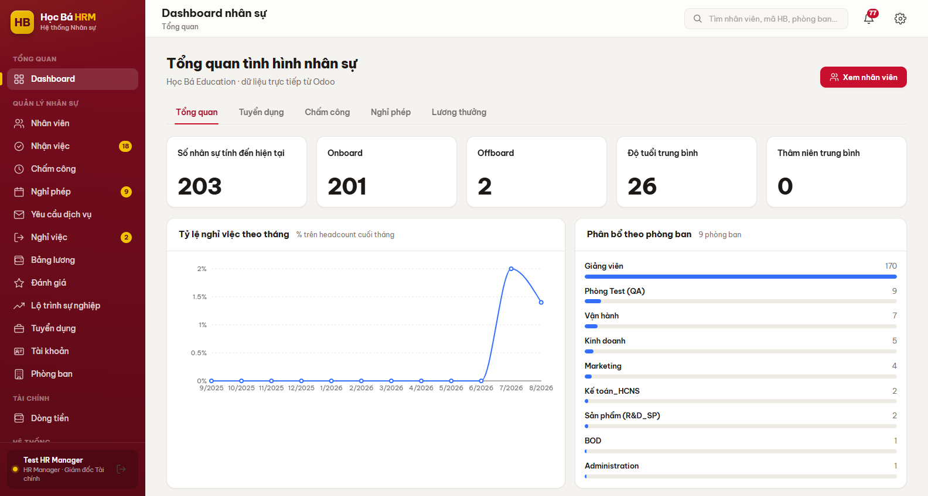
Figure 1 – The HRM workspace right after signing in
(2) In the left sidebar, group QUẢN LÝ NHÂN SỰ, click Nhân viên. The screens of this manual are spread over three sidebar groups.
Screen | Used for | Section
Nhân viên | Every profile: list, card view, and the detail drawer with five tabs | 2.1 – 2.4, 2.7
Nhận việc | Employees on probation and their onboarding steps | 2.5
Nghỉ việc | Resignation requests and their two-level approval | 2.11
Lộ trình sự nghiệp | Honour board and the full career record of one person | 2.8
Tài khoản | Login accounts: create, lock, reset the password | 2.9
Phòng ban | Departments, their manager and their headcount | 2.10
Cấu hình nhận việc | Onboarding process templates (HỆ THỐNG group) | 2.6
Hồ sơ của tôi | Self-service – personal accounts only | 2.12
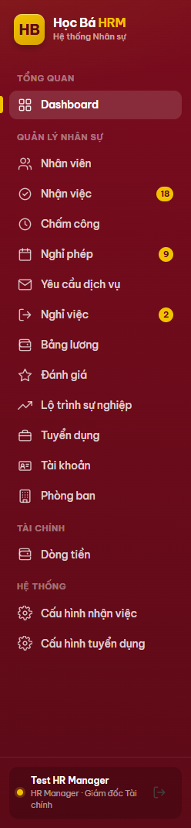
Figure 2 – The sidebar of a management account – no “Hồ sơ của tôi” entry

2. USER MANUAL

2.1 Employee profile (EMP-BP-01)

Content
Purpose: hold one record per person, from which every other module reads. The record carries:
- the identity block: employee code (Mã nhân sự, format HB.xx, generated by the system), full name, department, job title;
- the four classification axes of section 1.2;
- the legal block required by Vietnamese law: date of birth, CCCD, issue date and place, health insurance card, addresses;
- the salary block, visible only to the roles listed in section 1.3: base salary, PIT code, social insurance number, bank account;
- the child records: dependents, certificates, assets, onboarding steps, promotions – each in its own tab or block.
Rule BR-010: an employee cannot be turned Chính thức while the CCCD (exactly 12 digits), the PIT code (10 or 13 digits) and the social insurance number (exactly 10 digits) are not all filled. The system refuses the save and names the missing field.

Navigation
Screen | Path | Description
Nhân viên | Sidebar ▸ QUẢN LÝ NHÂN SỰ ▸ Nhân viên | Every employee inside your scope

Detail implementation
(1) Open Nhân viên. The chips on top filter by department and show the live headcount; the two drop-downs on the right filter by state and by working form. The list is paginated 20 rows at a time, and the search box in the top bar looks into the name, the code, the job title and the department.
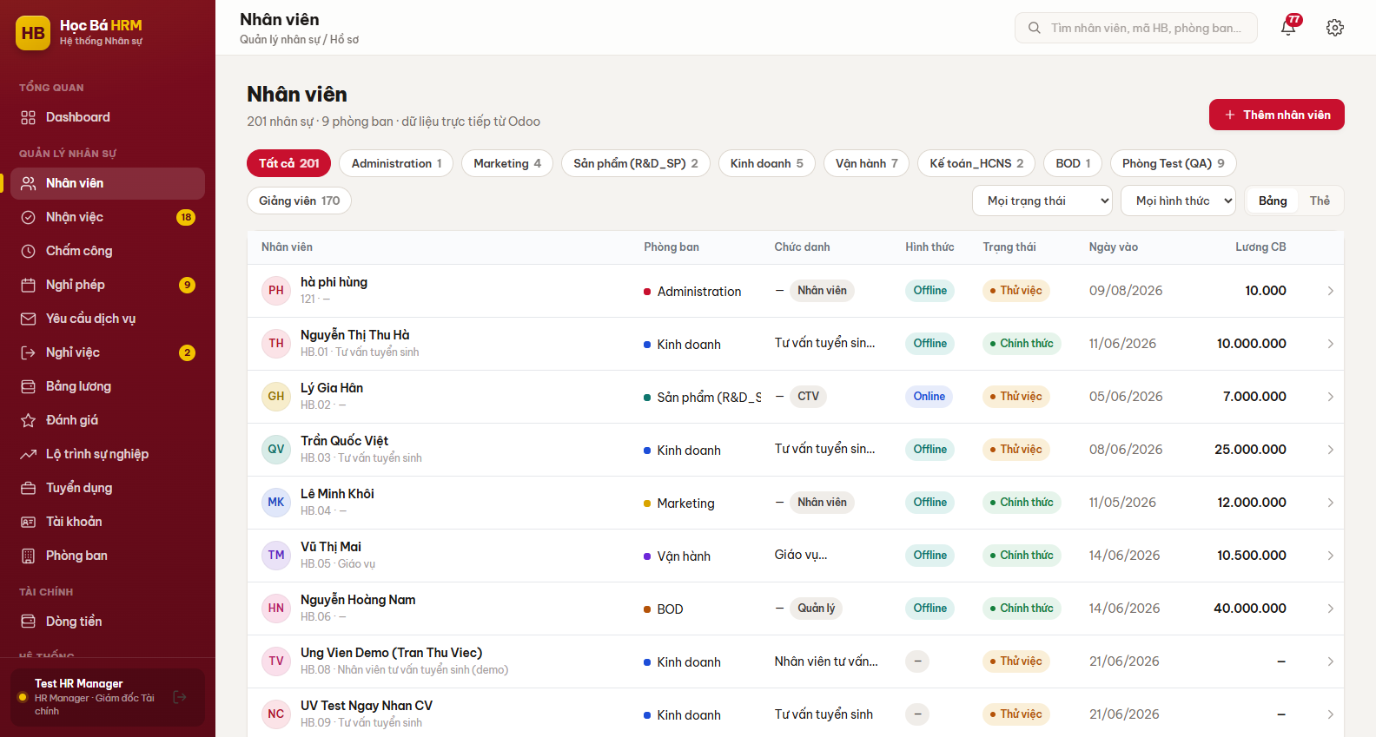
Figure 3 – Screen Nhân viên – table view with the department chips
(2) Use the switch Bảng / Thẻ on the right to change the presentation. The card view shows the same people with their state, working form and department as badges.
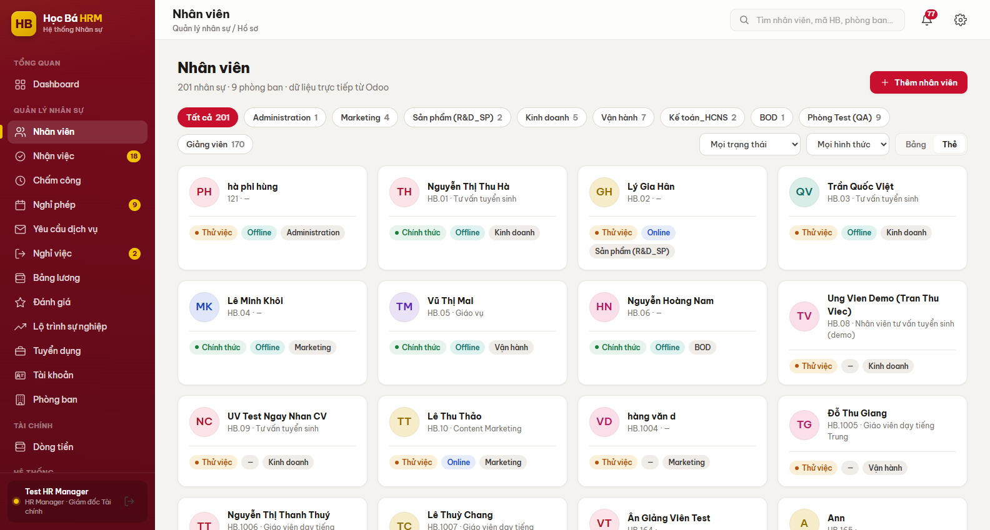
Figure 4 – Screen Nhân viên – card view (Thẻ)
(3) Click Thêm nhân viên to open a new profile. Họ và tên is the only required field; leave Mã nhân sự empty and the system generates it. Fill in Ngày bắt đầu thử việc – without it the employee gets no onboarding process at all (see section 2.5).
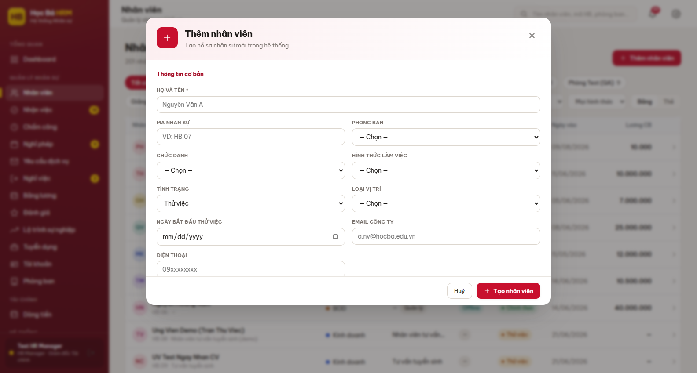
Figure 5 – Form Thêm nhân viên
(4) Click a row to open the profile drawer. It has four tabs for everybody – Thông tin, Thử việc, Tài sản, Thăng tiến – and a fifth one, Tài khoản, for HR and Admin only.
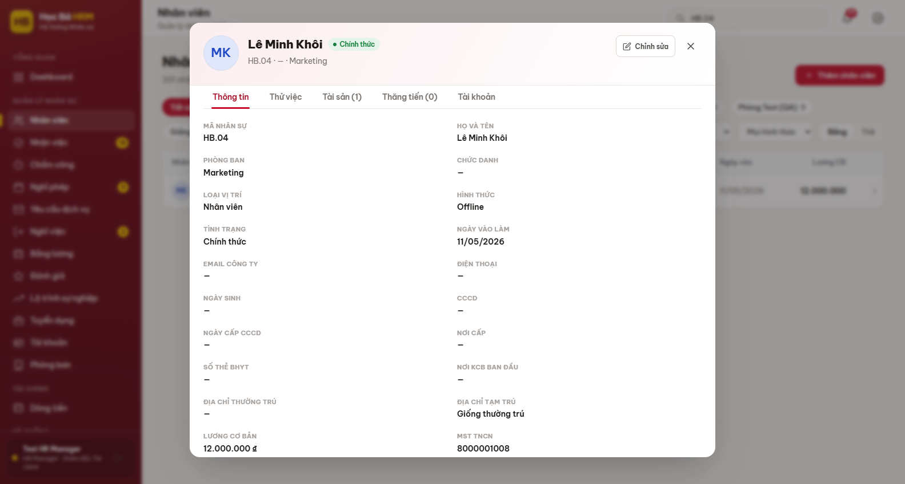
Figure 6 – Profile drawer – tab Thông tin
(5) Click Chỉnh sửa in the top right of the drawer to change the profile. The salary block appears in the form only for a role allowed to edit it; for everybody else the fields are not sent to the browser at all.
Note: the list only ever shows the employees of your scope – the whole centre for HR and Admin, the own branch for a department manager, the teachers for Giáo vụ. A profile you cannot see does not exist for your session, so a headcount read on this screen is a headcount of your scope, not of the company.

2.2 Dependents for tax deduction (EMP-BP-02)

Content
Purpose: register the people an employee supports so that the payroll can apply the personal income tax deduction. Each line holds the name, the relationship, the date of birth and the period the deduction runs over (Giảm trừ từ … đến). An open end date means the deduction is still running.

Navigation
Screen | Path | Description
Người phụ thuộc | Nhân viên ▸ open a profile ▸ tab Thông tin | Block under the identity fields

Detail implementation
(1) Open the profile and scroll down in tab Thông tin to the block Người phụ thuộc, which shows the number of lines in its title.
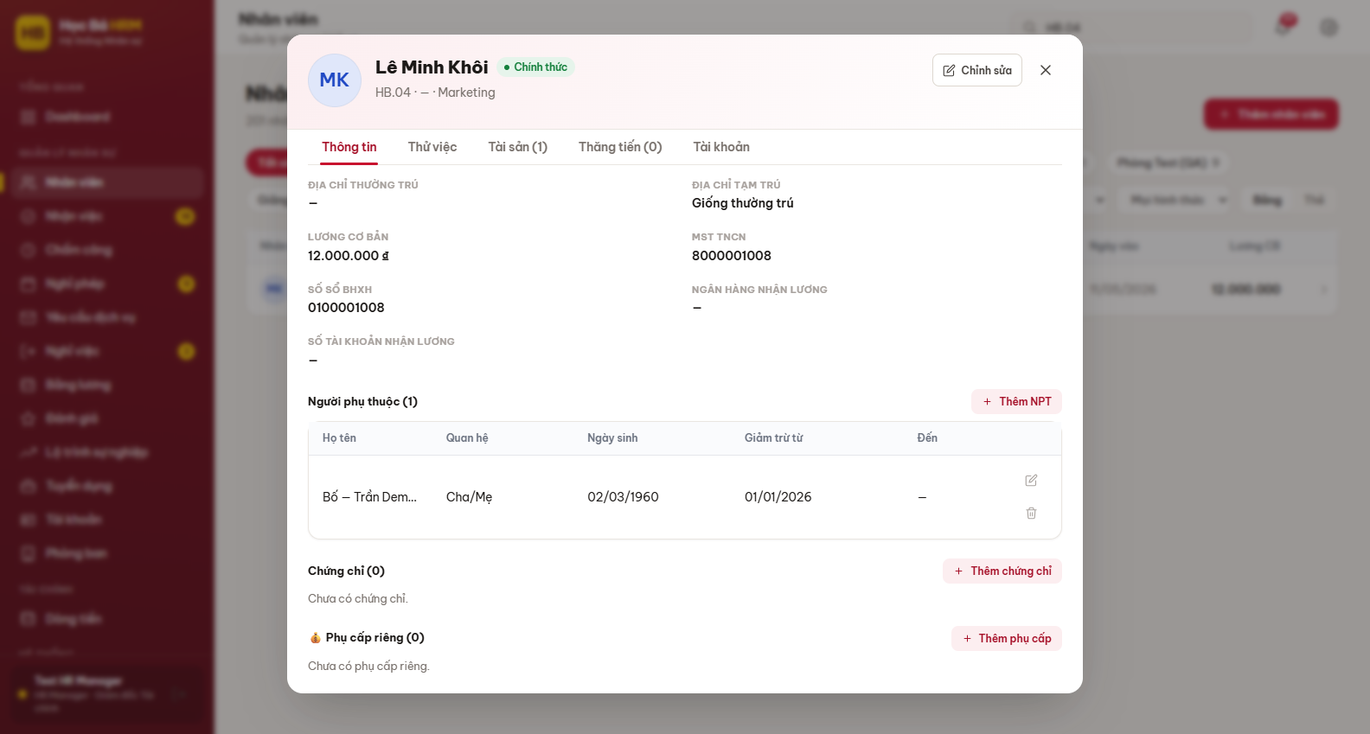
Figure 7 – Block Người phụ thuộc inside tab Thông tin
(2) Click Thêm NPT, fill in the form and save. Use the pencil icon to correct a line and the bin icon to delete it; the deletion asks for a confirmation because the payroll of the closed months keeps its own copy of the deduction.
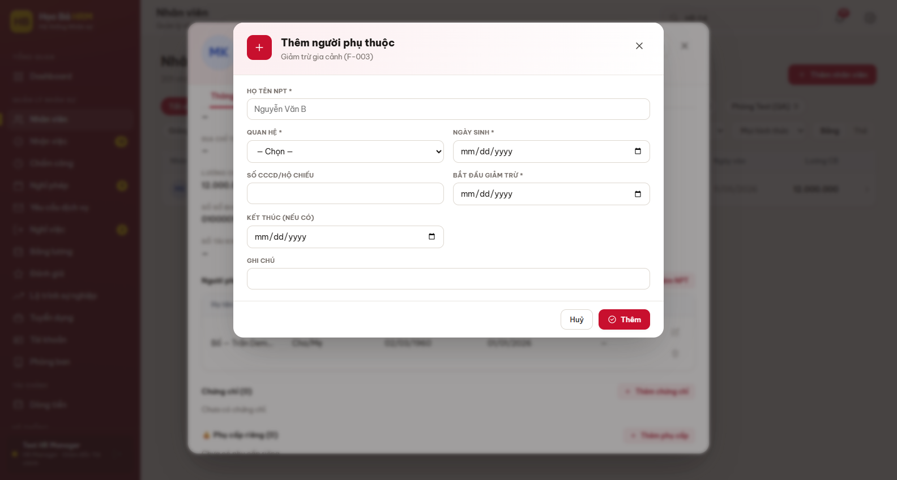
Figure 8 – Form Thêm người phụ thuộc
(3) The employee can also read and maintain this block on the own profile (section 2.12), which is the fastest way to keep the family data up to date at the end of the year.

2.3 Certificates and expiry alerts (EMP-BP-03)

Content
Purpose: keep the qualification of the teachers provable. A certificate line carries the type, the skill, the level, the issue date and, when the paper expires, the expiry date. The state column is computed from that date: Còn hạn, Sắp hết hạn and Hết hạn.
A daily scheduled action raises a notification on the bell icon for the certificates that fall due inside the alert window – 60 days by default, held in the system parameter hoc_ba.cert_alert_days. Only a certificate marked Đã xác minh is watched, so an unverified paper never triggers a false alert. A second daily action does the same for the contracts that come to their end.

Navigation
Screen | Path | Description
Chứng chỉ | Nhân viên ▸ open a profile ▸ tab Thông tin | Block under Người phụ thuộc

Detail implementation
(1) Open the profile, tab Thông tin, block Chứng chỉ.
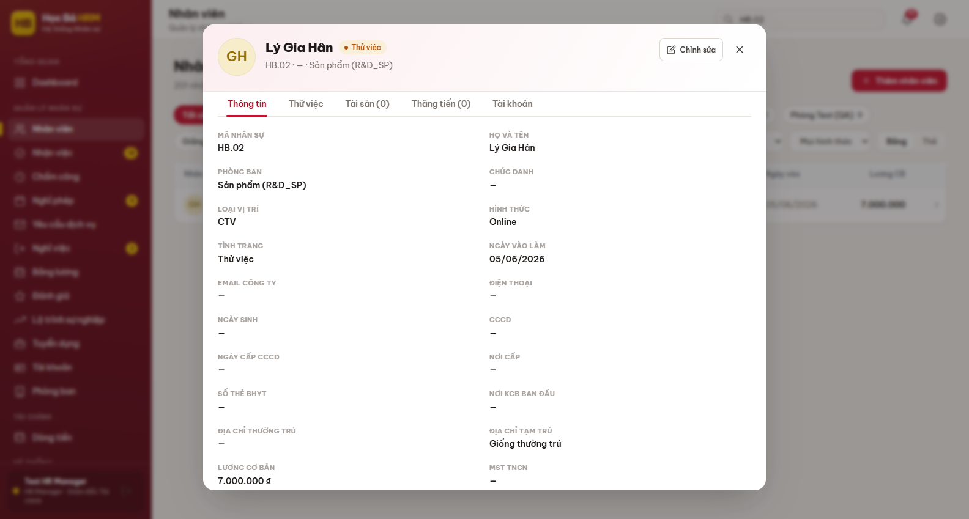
Figure 9 – Block Chứng chỉ with the expiry states
(2) Click Thêm chứng chỉ. Choose Loại first – the lists Cấp độ and Chứng chỉ are filled from it, so an impossible combination cannot be saved. Ngày hết hạn stays empty for a paper that never expires.
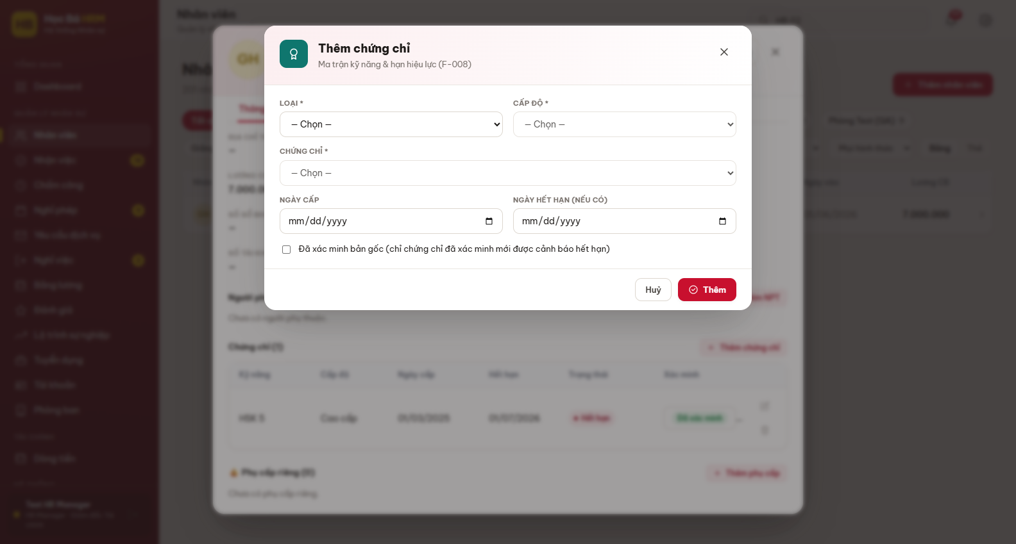
Figure 10 – Form Thêm chứng chỉ
(3) Tick “Đã xác minh bản gốc” once you have seen the original document. You can also switch the verification later straight from the table, by clicking the badge in the column Xác minh.

2.4 Asset register (EMP-BP-04)

Content
Purpose: know what company equipment a person is holding right now. The register is deliberately short – asset type, asset code, grant date and the condition recorded when it was handed over. There is no return or hand-over workflow: when the item comes back, the line is removed from the profile.
The count of the assets still held is shown on a resignation request (section 2.11), which is where it matters: it is the checklist of what has to be collected before the last day.

Navigation
Screen | Path | Description
Tài sản | Nhân viên ▸ open a profile ▸ tab Tài sản | Equipment currently held by this employee

Detail implementation
(1) Open the profile and go to tab Tài sản. The tab title carries the number of items.
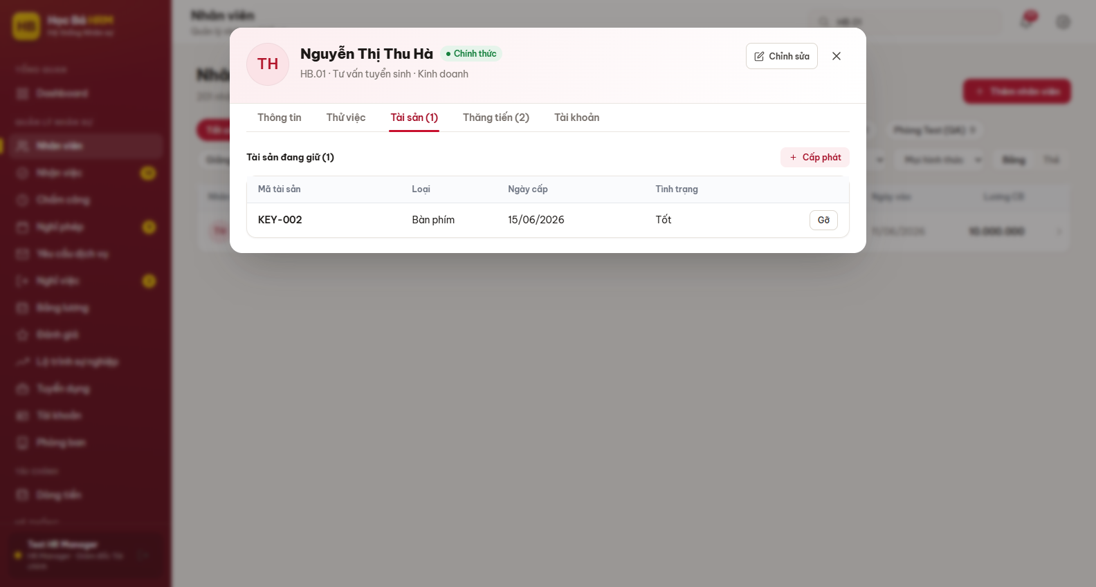
Figure 11 – Tab Tài sản – equipment currently held
(2) Click Cấp phát, choose the type, type the asset code and save.
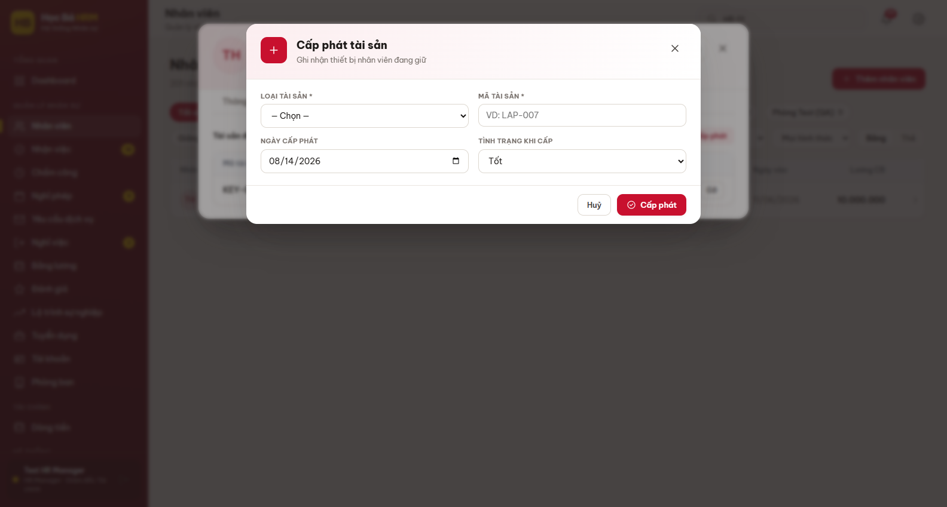
Figure 12 – Modal Cấp phát tài sản
(3) When the item is returned, click Gỡ on its row and confirm. The line disappears from the profile – the register answers “what is out there now”, not “what happened in the past”.
An onboarding step can hand out the standard equipment by itself: set its automation to “Tự cấp tài sản mặc định” in the onboarding configuration (section 2.6) and completing the step writes the default assets onto the profile.

2.5 Onboarding by dynamic steps (EMP-BP-05)

Content
Purpose: run the probation of a new employee as a list of steps that HR can configure, instead of three fixed evaluation gates. There are two kinds of step:
- Việc cần làm – something to do (hand over the laptop, sign the contract, open the mailbox). It is closed with Hoàn thành and an optional note;
- Đánh giá – an evaluation, closed with one of Đạt, Gia hạn or Không đạt. A comment is mandatory for Không đạt.
The steps run in order: only the current step can be acted on, the following ones stay “Chưa tới lượt”. A step marked “Không ràng buộc thứ tự” is the exception – it opens as soon as the process is assigned and can be done at any moment.
The three results of an evaluation have three different effects. Đạt on a step configured as “Đạt → lên chính thức” turns the employee Chính thức and writes the official date. Gia hạn extends the probation by opening the extension step of the process. Không đạt ends the probation and pushes the employee into the offboarding flow of section 2.11 – the system asks for a confirmation before doing it.

Navigation
Screen | Path | Description
Nhận việc | Sidebar ▸ QUẢN LÝ NHÂN SỰ ▸ Nhận việc | Every employee on probation inside your scope

Detail implementation
(1) Open Nhận việc. The four counters read the whole list: how many people are on probation, how many have a process still running, how many are waiting for an evaluation, and how many have passed the deadline of their current step. The column Tiến độ shows the progress bar, Bước hiện tại shows the current step with its deadline, in red when it is late.
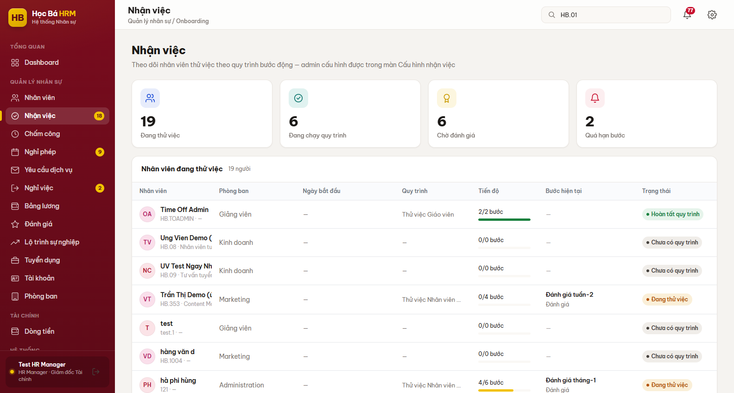
Figure 13 – Screen Nhận việc – employees on probation and their progress
(2) Click a row to open the profile drawer straight on tab Thử việc. The header shows the name of the process and the progress; below it every step is one card with its state, its deadline, who closed it and when.
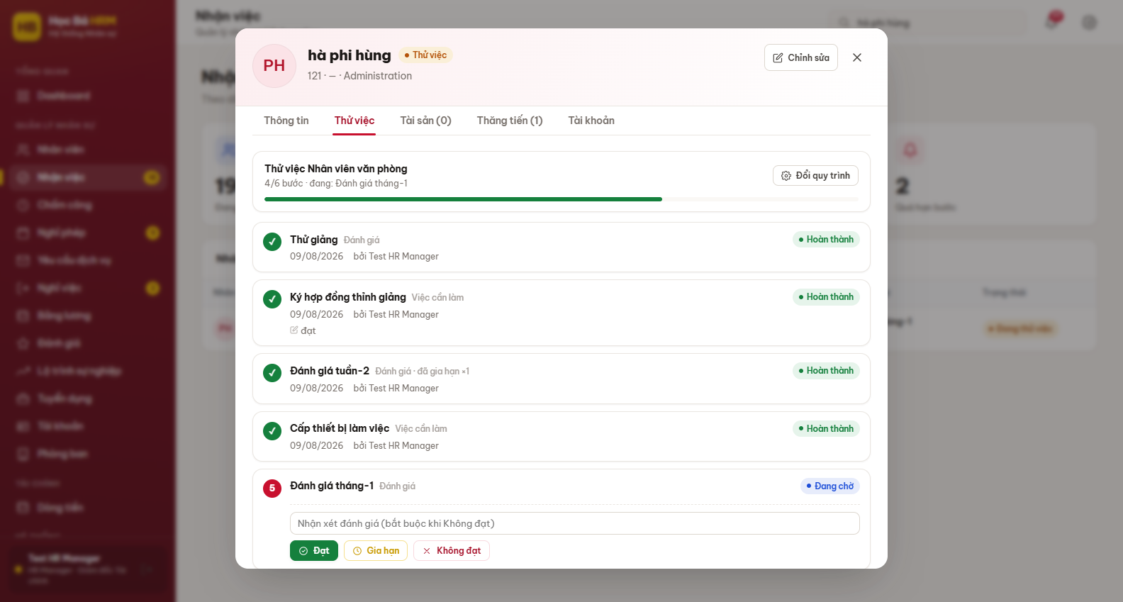
Figure 14 – Tab Thử việc – the steps of the assigned process
(3) The action block only appears on the step you are allowed to act on. For an evaluation step, type the comment and click Đạt, Gia hạn or Không đạt.
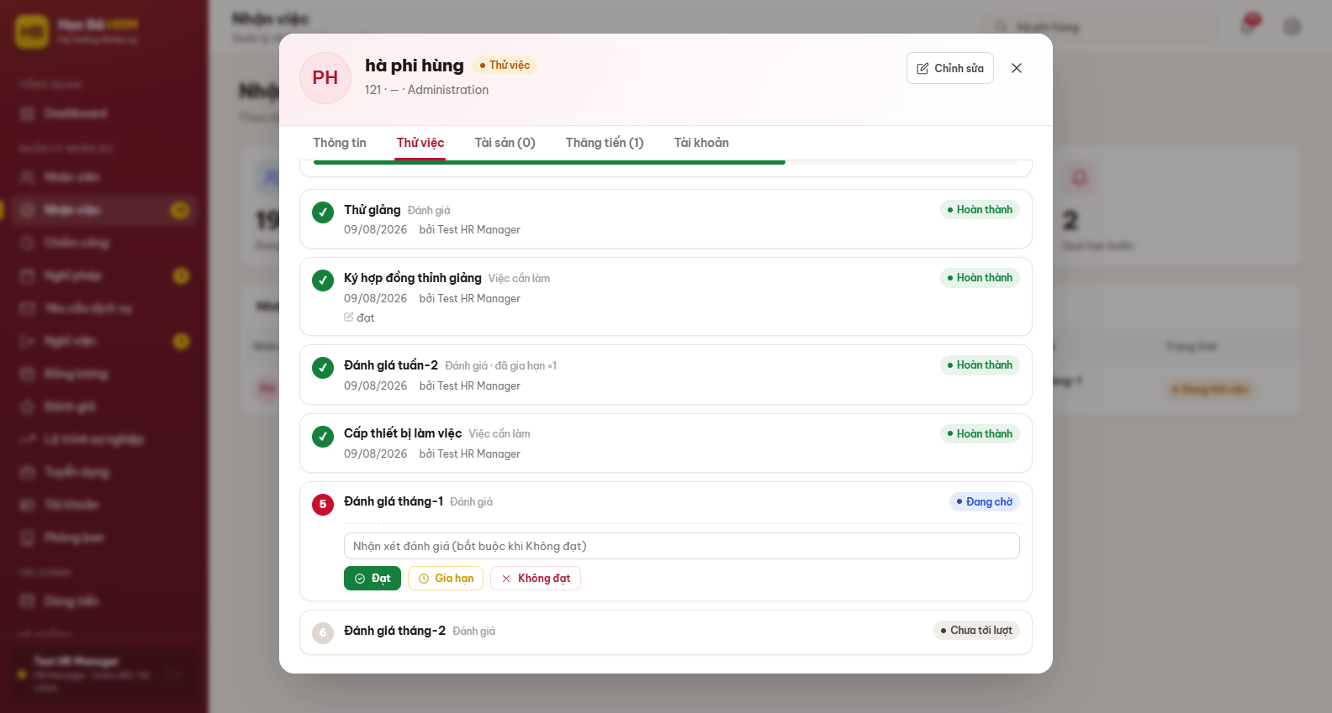
Figure 15 – Action block of an evaluation step
(4) An HR Manager can correct the deadline of the open step with the pencil next to the date, and can change the whole process with Đổi quy trình. Changing the process drops the steps not done yet and appends the steps of the new process after them; the steps already completed are kept as history.
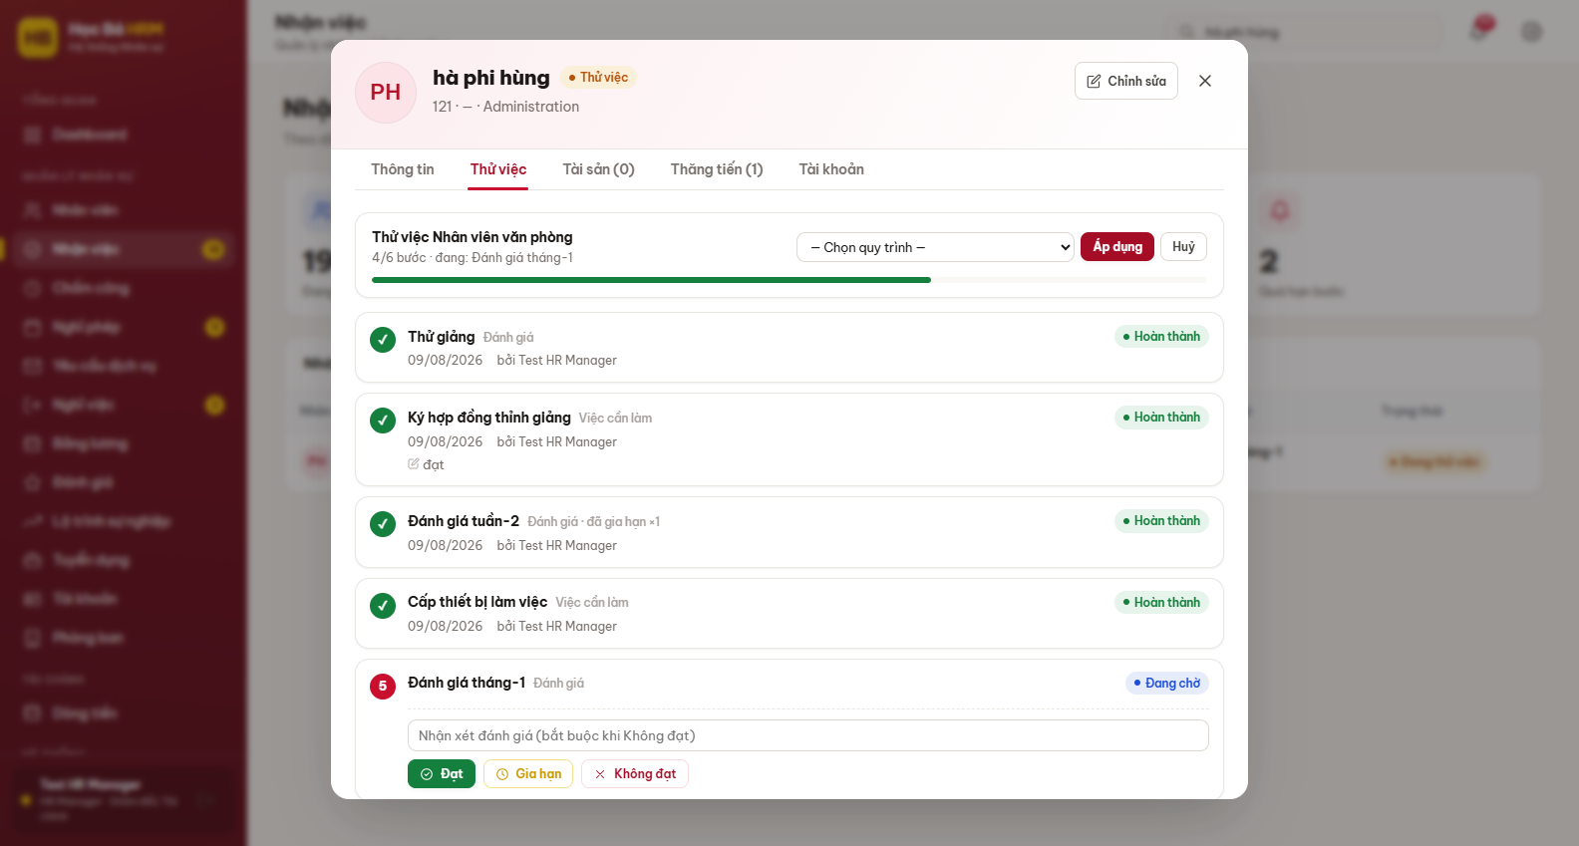
Figure 16 – Đổi quy trình – choosing another onboarding process
(5) When every step is done or skipped, the row reads “Hoàn tất quy trình”. If the process contains a step “Đạt → lên chính thức”, the line “Chính thức từ <date>” appears at the bottom of the tab.
Note: an employee with no start date of probation, or matching no process at all, shows the message “Chưa có quy trình nhận việc” instead of the step list. Fill in Ngày bắt đầu thử việc and the classification axes, or assign a process by hand with Đổi quy trình.

2.6 Onboarding process configuration (EMP-BP-06)

Content
Purpose: let HR write the probation processes of the centre without touching any code – a different list of steps for a teacher, for an office employee, for a collaborator.
Two rules decide everything on this screen. First, a new employee is matched against the processes from top to bottom and enters the first one that fits, so the order of the cards is the priority order. An empty criterion matches everything. Second, editing a process only changes the employees assigned from now on: the people already running keep the steps they were given (a snapshot), so a correction made today never rewrites a probation in progress.

Navigation
Screen | Path | Description
Cấu hình nhận việc | Sidebar ▸ HỆ THỐNG ▸ Cấu hình nhận việc | HR Manager / Admin only

Detail implementation
(1) Open Cấu hình nhận việc. Every process is one card showing its matching criteria and its steps in order. The number on the left is the matching position.
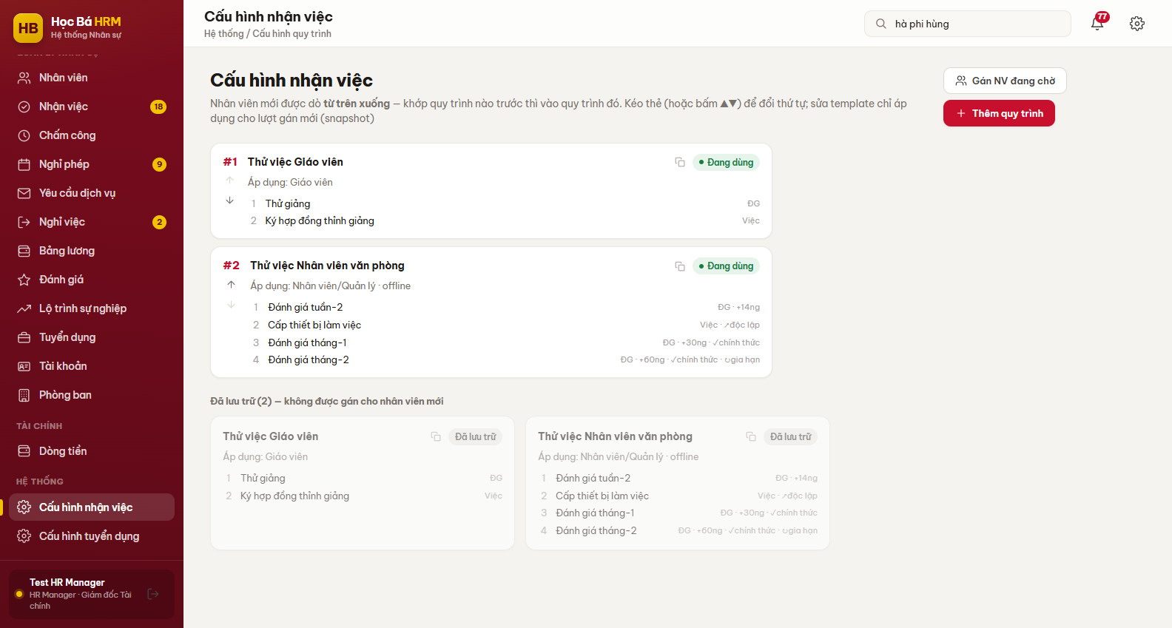
Figure 17 – Screen Cấu hình nhận việc – the processes in matching order
(2) Drag a card, or use the ▲▼ arrows, to change that order. The new order is saved immediately.
(3) Click Thêm quy trình, or click a card to edit it. Set the matching criteria on the three axes, then build the list of steps.
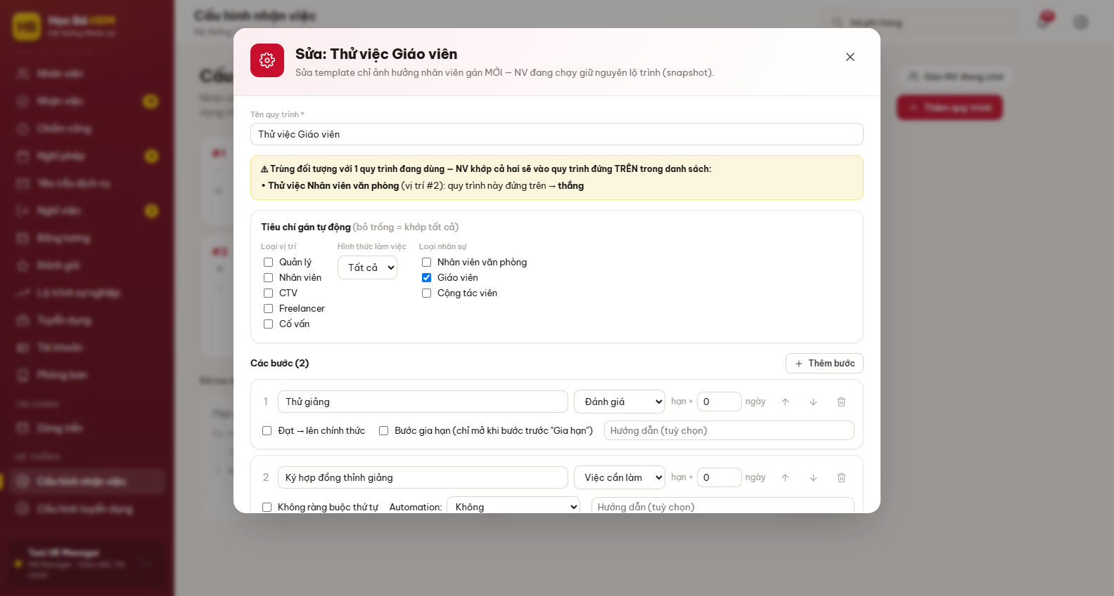
Figure 18 – Editing a process – criteria and steps
(4) Each step needs a name, a kind (Việc cần làm or Đánh giá) and a deadline written as a number of days after the start of the probation. The remaining switches are what make the process behave:
Switch | What it does
Đạt → lên chính thức | Evaluation steps only. Passing this step turns the employee Chính thức and writes the official date.
Bước gia hạn | Evaluation steps only. The step stays closed and only opens when the previous evaluation was answered Gia hạn.
Không ràng buộc thứ tự | Task steps only. The step opens as soon as the process is assigned and can be closed at any time, in any order.
Automation | Task steps only. “Tự cấp tài sản mặc định” writes the default assets onto the profile when the step is completed. Not available on a step with no order constraint.
(5) If the criteria of the process you are editing overlap another one, a yellow warning names the rival and tells you which of the two wins by position. Use it before saving – two processes that fully overlap mean the lower one will never match anybody.
(6) Use Gán NV đang chờ to assign a process to the employees on probation who have no steps yet – typically people created before the right process existed. The result line reports how many were assigned, how many matched nothing, and how many are missing their probation start date.
Warning: Lưu trữ hides a process from future matching but does not touch anybody running it. Deleting a step from a process, on the other hand, only affects the employees assigned after the change.

2.7 Promotion and salary history (EMP-BP-07)

Content
Purpose: keep every move of a person – job title and salary – as a dated milestone that can be read years later. A promotion record holds the date, the job title before and after, the department, the salary before and after, the decision reference and the reason.
Since 12/08/2026 this tab is read-only. A promotion is created from the evaluation form of module Đánh giá, together with the evaluation round that justifies it, so that a raise is never recorded without the paperwork behind it. What you see here is the result: the timeline, the salary chart and the radar of the criteria of the last round.

Navigation
Screen | Path | Description
Thăng tiến | Nhân viên ▸ open a profile ▸ tab Thăng tiến | Career milestones of this employee

Detail implementation
(1) Open the profile and go to tab Thăng tiến. The four metric cards read the seniority in months, the months since the last promotion, the number of evaluation rounds and the last score.
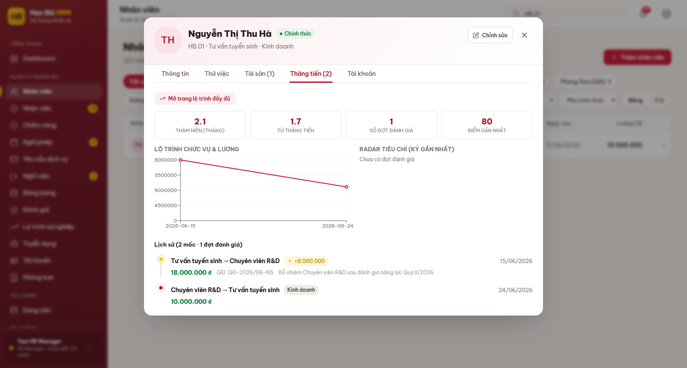
Figure 19 – Tab Thăng tiến – timeline and charts
(2) The timeline lists the milestones from the oldest to the newest. The salary figures and the green “+” badge of a raise are only drawn for a role allowed to see the salary.
(3) Click Mở trang lộ trình đầy đủ to jump to the career dashboard of the same person, described in the next section.

2.8 Career dashboard and honour board (EMP-BP-08)

Content
Purpose: put on one page everything that happened to one person – joining, onboarding steps, evaluations with their comments, promotions and honours – and, above it, the honour board of the whole centre. It is meant to be read, not clicked: the comments are open on the page, not hidden behind a popup.

Navigation
Screen | Path | Description
Lộ trình sự nghiệp | Sidebar ▸ QUẢN LÝ NHÂN SỰ ▸ Lộ trình sự nghiệp | Management accounts
Lộ trình của tôi | Sidebar ▸ CÁ NHÂN ▸ Lộ trình của tôi | The employee’s own record

Detail implementation
(1) Open Lộ trình sự nghiệp. The honour board is shown straight away because it belongs to the whole company. A management account has no employee record attached, so the career part below waits until you pick somebody: type a name or an employee code in the search box at the top right.
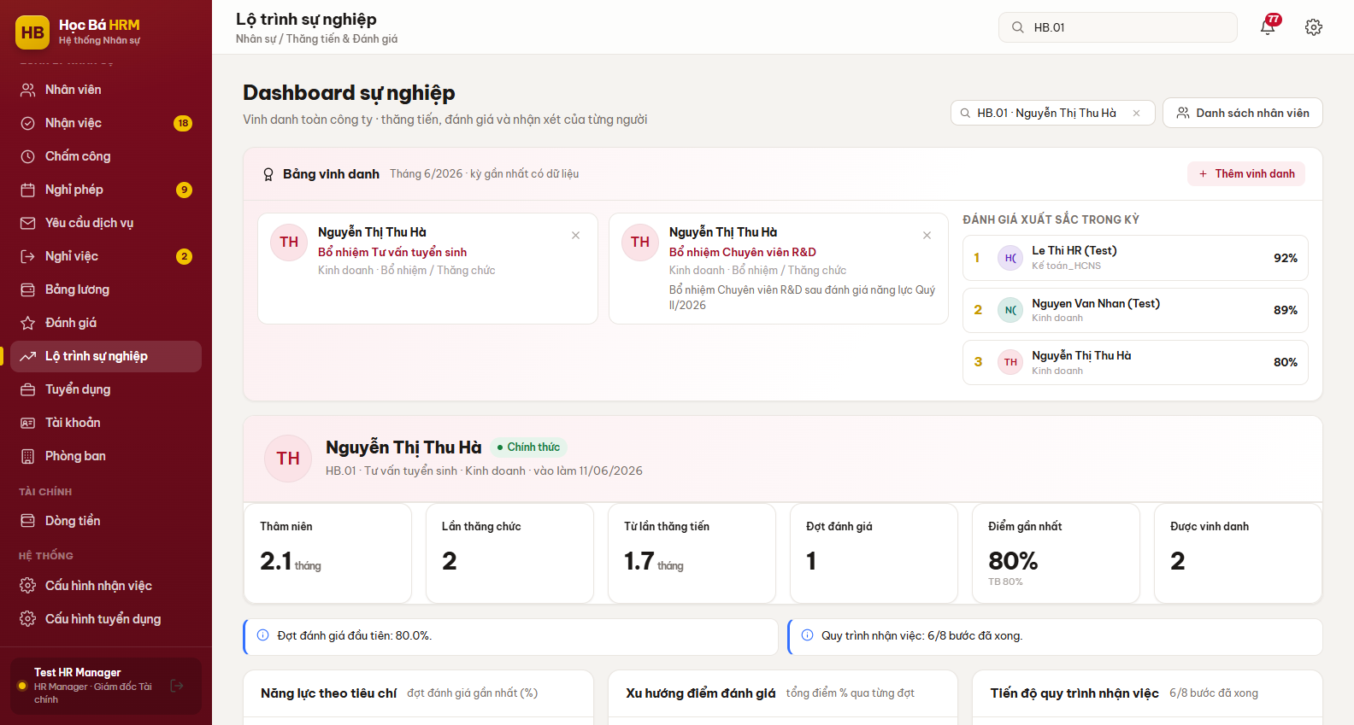
Figure 20 – Screen Lộ trình sự nghiệp – honour board and the header of one employee
(2) HR can add a name to the honour board with Thêm vinh danh, choosing the person, the title, the kind (Thành tích, Bổ nhiệm / Thăng chức, Kỷ niệm gắn bó, Khác) and the date. A department manager can read the board but not write on it.
(3) The six figures under the profile card read the seniority, the number of promotions, the months since the last one, the number of evaluation rounds, the last score with its average, and the number of honours. The insight cards under them say in one sentence what the charts show.
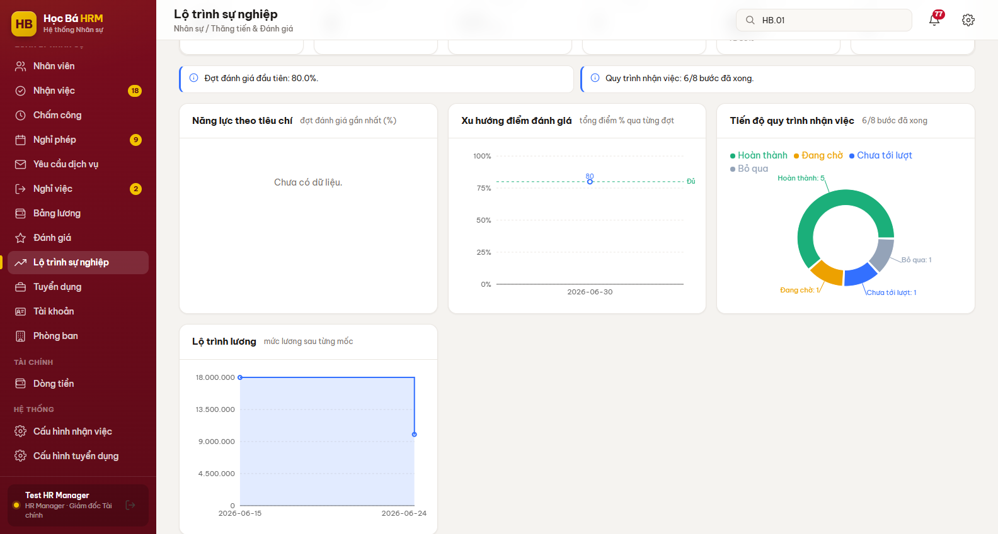
Figure 21 – Career charts – criteria radar, score trend and onboarding progress
(4) The charts compare the last evaluation round with the previous one: the radar needs at least three criteria to be drawn, the score trend marks the 80 % qualification threshold, and the salary chart is only drawn for a role allowed to see the salary.
(5) The table at the bottom is the full history. Use the buttons Tất cả / Thăng tiến / Đánh giá / Thử việc / Vinh danh to narrow it down; the score of each criterion is written as a chip under the corresponding round.
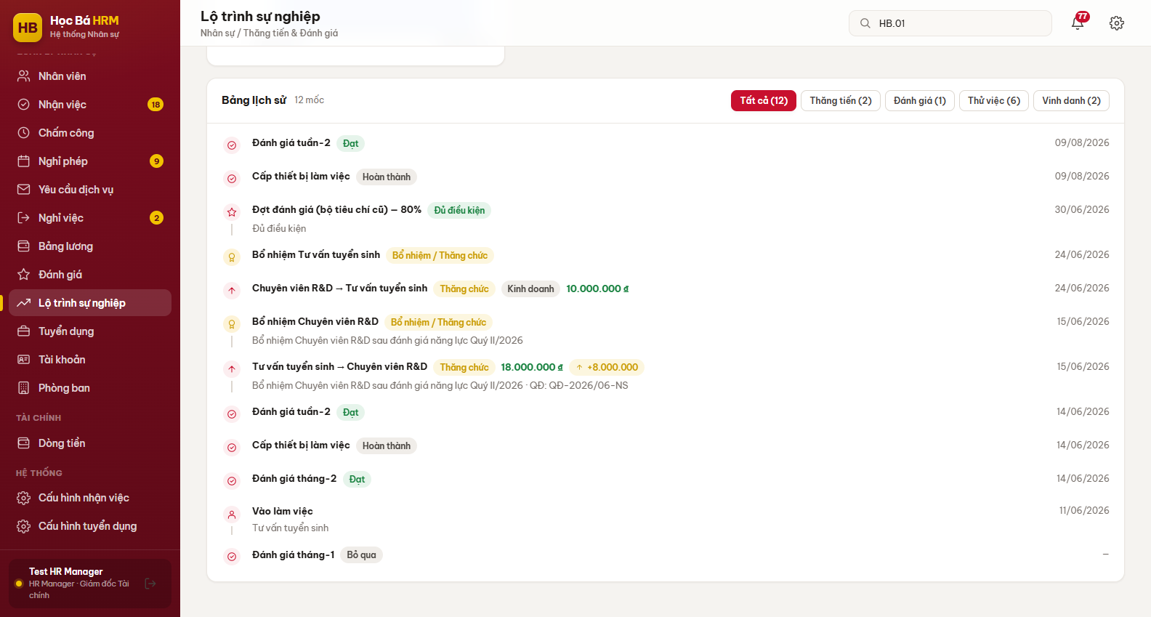
Figure 22 – Bảng lịch sử – the full record with the criteria scores

2.9 Login account management (EMP-BP-09)

Content
Purpose: decide who can sign in, with which role, and cut the access when it must stop. An account is always attached to an employee record; the account type sets the permission group of section 1.3.
Locking is reversible and immediate: a locked person cannot sign in until somebody unlocks the account, while the employee record itself stays untouched. Completing a resignation locks the account by itself, so a person who has left never keeps a working login.

Navigation
Screen | Path | Description
Tài khoản | Sidebar ▸ QUẢN LÝ NHÂN SỰ ▸ Tài khoản | HR / Admin only. Every employee who has a login

Detail implementation
(1) Open Tài khoản. The header counts the accounts and how many of them are locked; the two drop-downs filter by department and by state, and the search box looks into the name, the login and the employee code.
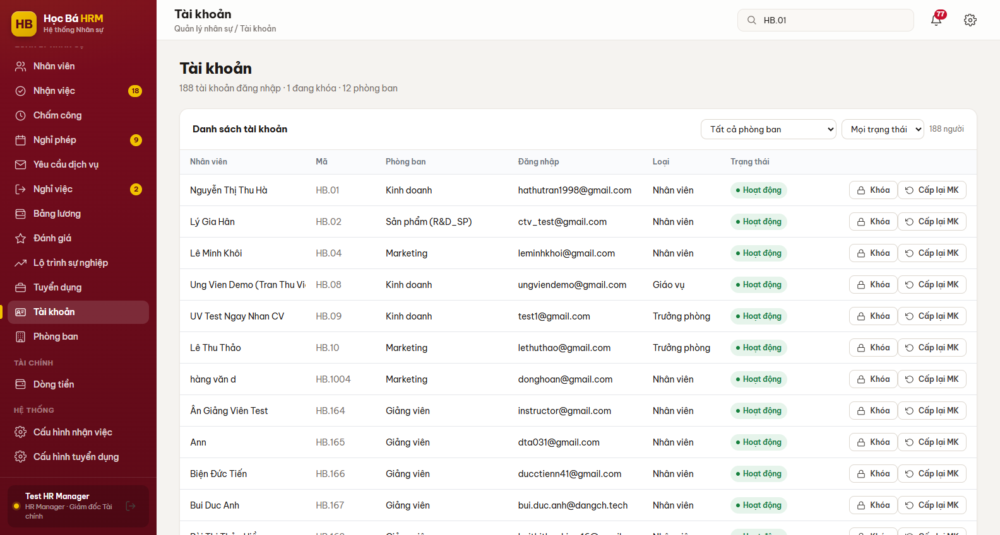
Figure 23 – Screen Tài khoản – the login accounts
(2) To create an account, open the employee profile and go to tab Tài khoản, then click Tạo tài khoản. Fill in the login, a password of at least 8 characters, its confirmation, and the account type – Nhân viên thường, Giáo vụ or Trưởng phòng. The field Phòng ban only appears for Trưởng phòng, because that is the account type whose rights depend on a department.
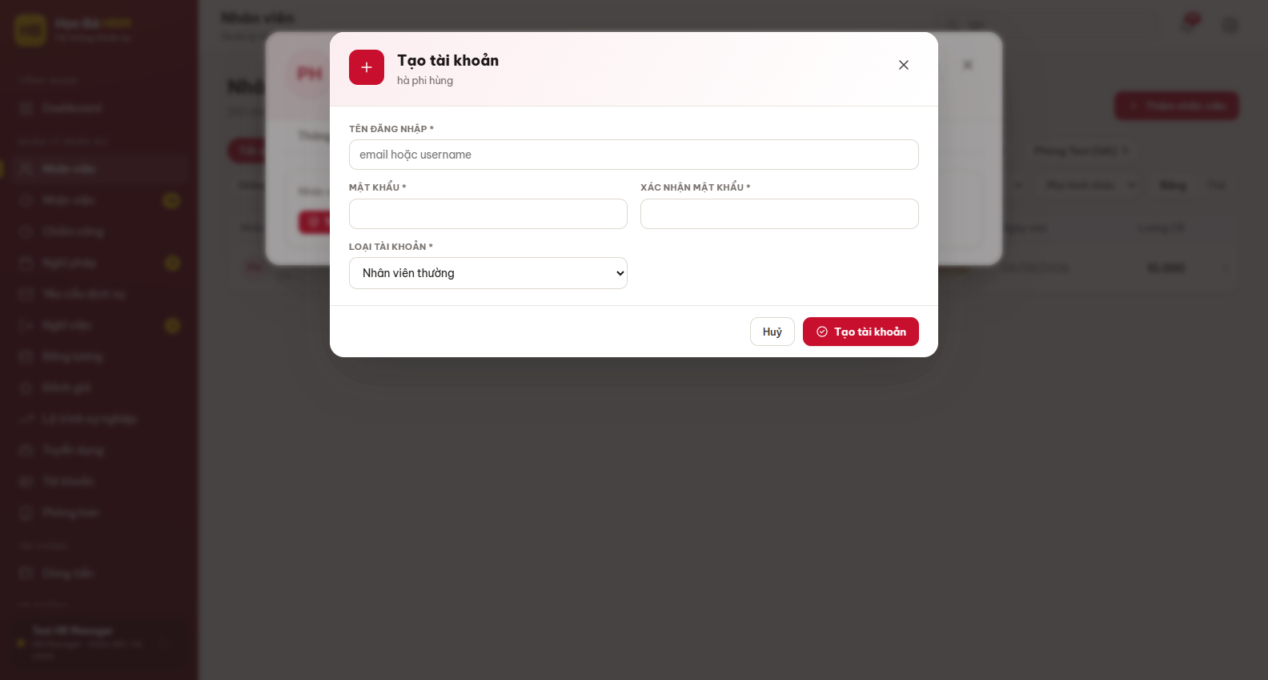
Figure 24 – Form Tạo tài khoản đăng nhập
(3) Back on the list, Khóa / Mở khóa switches the access and Cấp lại MK sets a new password. Both ask for a confirmation.
(4) Two rows carry no buttons on purpose. A system administrator account is marked “Quản trị hệ thống” and cannot be locked from here. An employee already gone is marked “Đã nghỉ”: the account was locked when the resignation was completed, and unlocking it would produce a login without an employee record behind it, which the server refuses anyway.

2.10 Department management (EMP-BP-10)

Content
Purpose: hold the departments of the centre, each with its function, its manager and its headcount. The department is not only a label: the manager set here is what gives that person the reading and approval rights over the branch, child departments included.

Navigation
Screen | Path | Description
Phòng ban | Sidebar ▸ QUẢN LÝ NHÂN SỰ ▸ Phòng ban | HR / Admin only

Detail implementation
(1) Open Phòng ban. The list shows the function, the manager, the headcount and the state of each department.
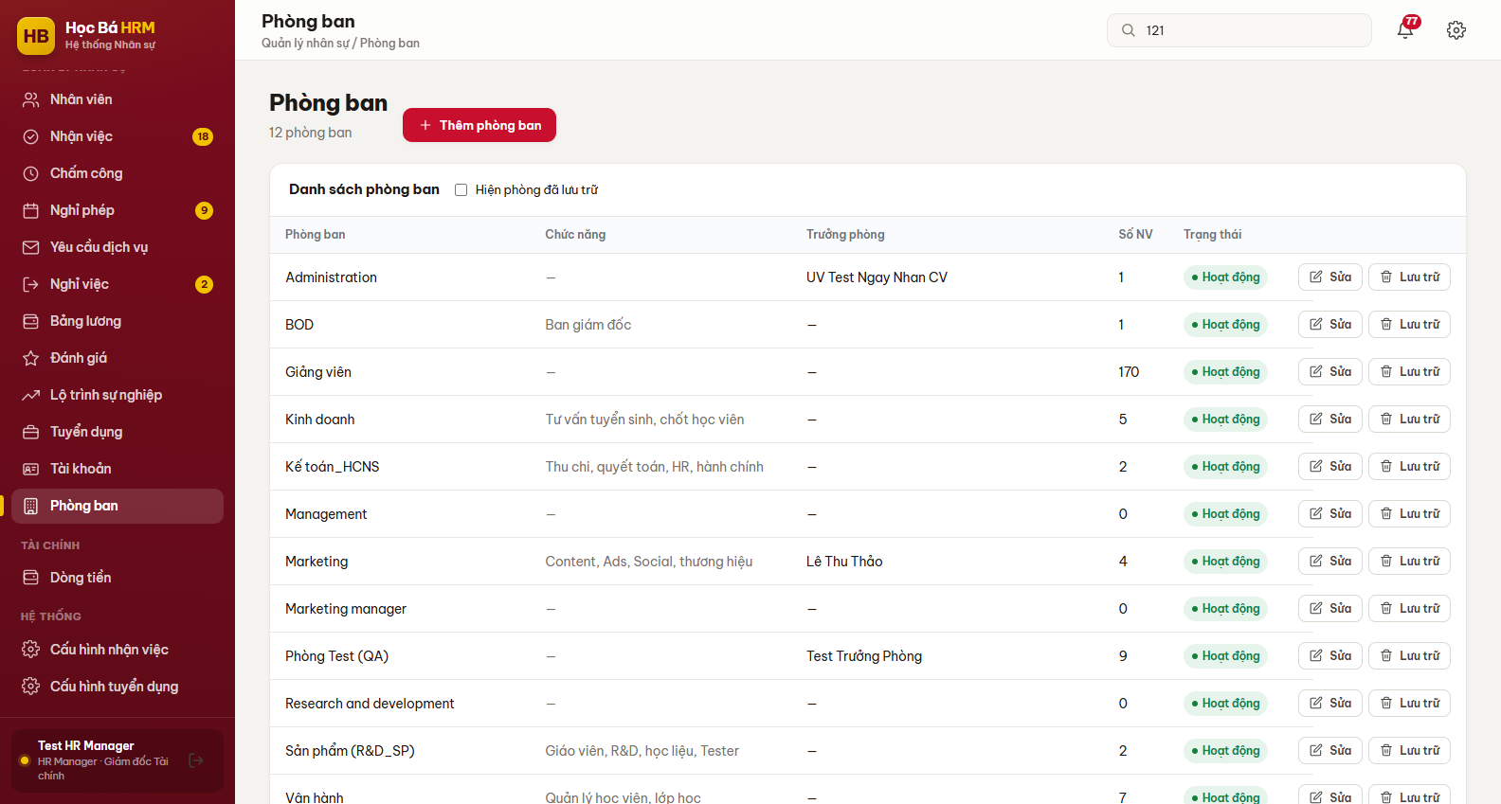
Figure 25 – Screen Phòng ban
(2) Click Thêm phòng ban to create one, or Sửa on a row to change it – typically to hand the department over to another manager.
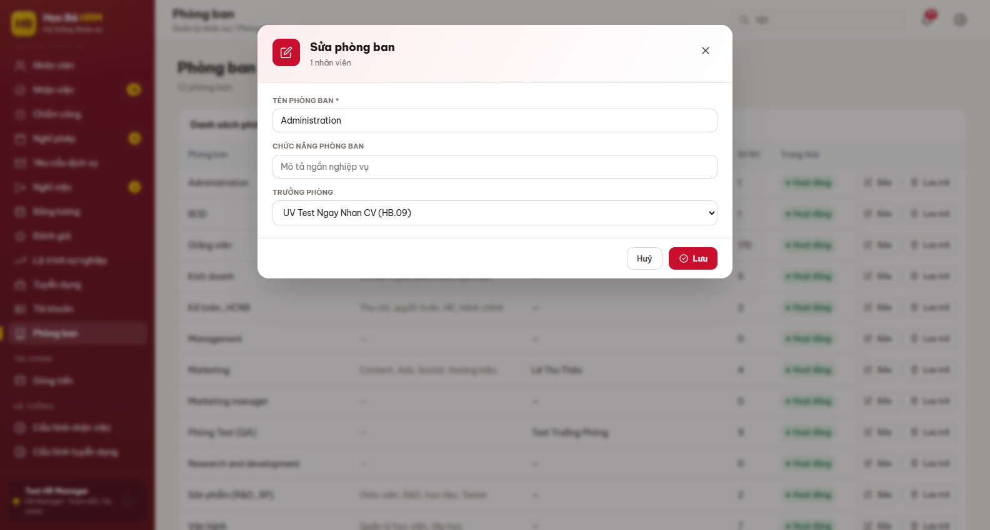
Figure 26 – Form phòng ban
(3) Lưu trữ takes a department out of use; if it still holds employees, the system says how many and asks for a confirmation. Tick “Hiện phòng đã lưu trữ” to see the archived ones and Khôi phục to bring one back.

2.11 Resignation (EMP-BP-11)

Content
Purpose: run a departure as a request that is approved twice and then completed, so that nobody disappears from the system without the assets being collected and the account being closed. The states are: Nháp → Chờ quản lý duyệt → Chờ HR duyệt → Chờ hoàn tất → Đã nghỉ, plus Từ chối and Đã huỷ.
A request is raised in three ways: the employee submits it, HR opens it on their behalf, or the system creates it when an onboarding evaluation is answered Không đạt (section 2.5).
Completing the request is the point of no return: the employee becomes Nghỉ việc, the record is archived and the login account is locked in the same movement. Only an HR Manager may do it.

Navigation
Screen | Path | Description
Nghỉ việc | Sidebar ▸ QUẢN LÝ NHÂN SỰ ▸ Nghỉ việc | Requests inside your scope, with the action buttons
Nghỉ việc | Sidebar ▸ CÁ NHÂN ▸ Nghỉ việc | The employee’s own requests

Detail implementation
(1) An approver opens Nghỉ việc and sees every request of the own scope. The column Tài sản shows how many items the person is still holding – hover it to read the asset codes. The buttons on a row are only the ones your role may press at the current state.
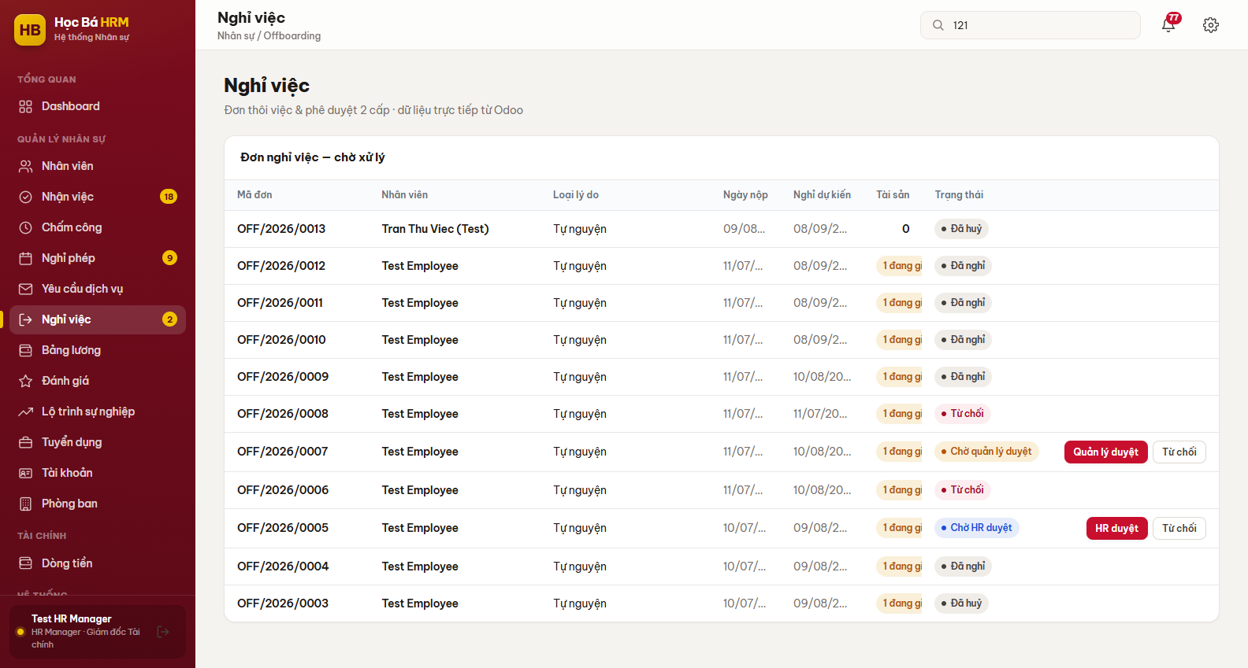
Figure 27 – Screen Nghỉ việc – requests waiting for approval
(2) An employee opens the same entry under CÁ NHÂN and clicks Nộp đơn nghỉ. The form asks for the kind of reason (Tự nguyện, Không đạt, Hết hạn HĐ, Khác), the detailed reason and the expected last day.
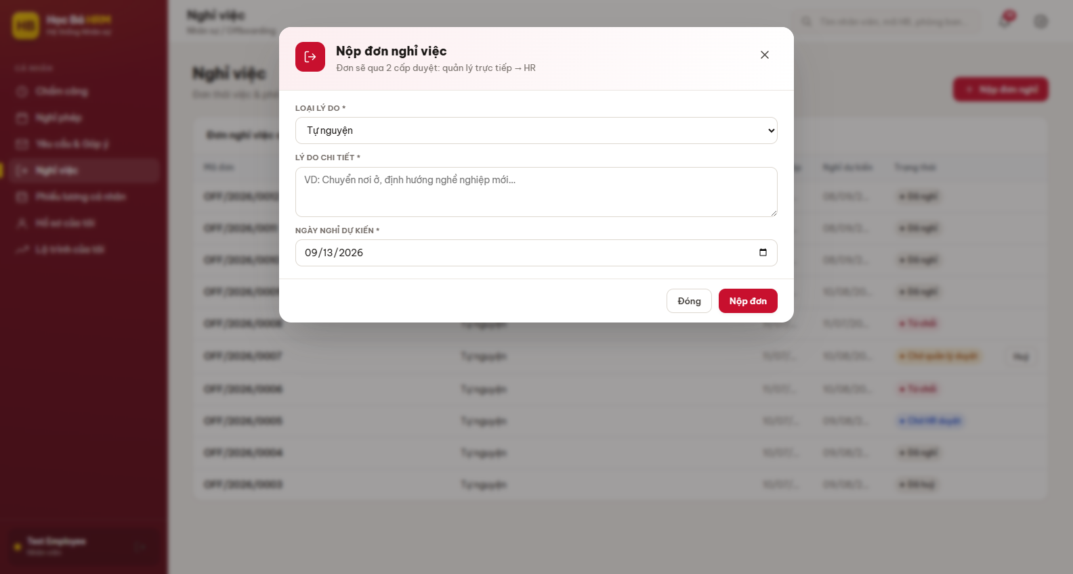
Figure 28 – Form Nộp đơn nghỉ việc
(3) The employee follows the request in the table Đơn nghỉ việc của tôi. Click the row to read the detail, including who approved at each level; Huỷ is offered while the request has not been approved yet.
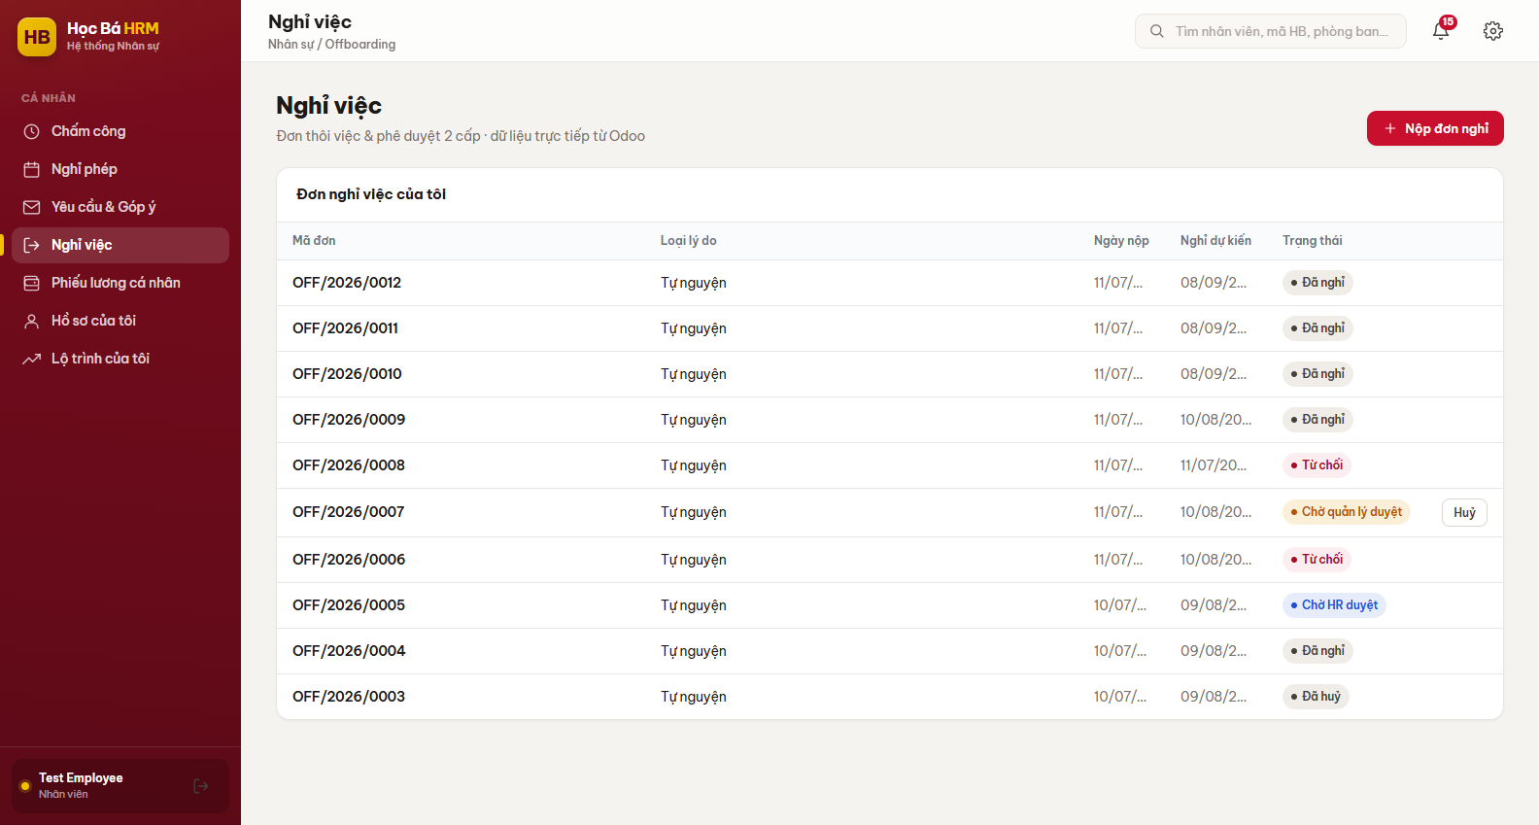
Figure 29 – Đơn nghỉ việc của tôi – the employee’s own requests
(4) The direct manager clicks Quản lý duyệt, then an HR Manager clicks HR duyệt. Either of them can click Từ chối, which puts the employee back into the state held before the request.
(5) Once the equipment has been collected and the last day has come, the HR Manager clicks Hoàn tất and confirms. Remove the assets from tab Tài sản before this step – after it the profile is archived and no longer reachable from the employee list.

2.12 Self-service – my own profile (EMP-BP-12)

Content
Purpose: let every employee read their own record without asking HR, and keep the data that only they know – phone number, addresses, dependents, photo – up to date. The screen reuses the tabs of the profile drawer, in read-only mode for everything the employee must not rewrite: the classification, the salary, the onboarding results and the promotions.

Navigation
Screen | Path | Description
Hồ sơ của tôi | Sidebar ▸ CÁ NHÂN ▸ Hồ sơ của tôi | Personal accounts only – not shown on a management account

Detail implementation
(1) Open Hồ sơ của tôi. The header carries the photo, the state badge and the contact details; the four tabs below are Thông tin, Thử việc, Tài sản and Thăng tiến.
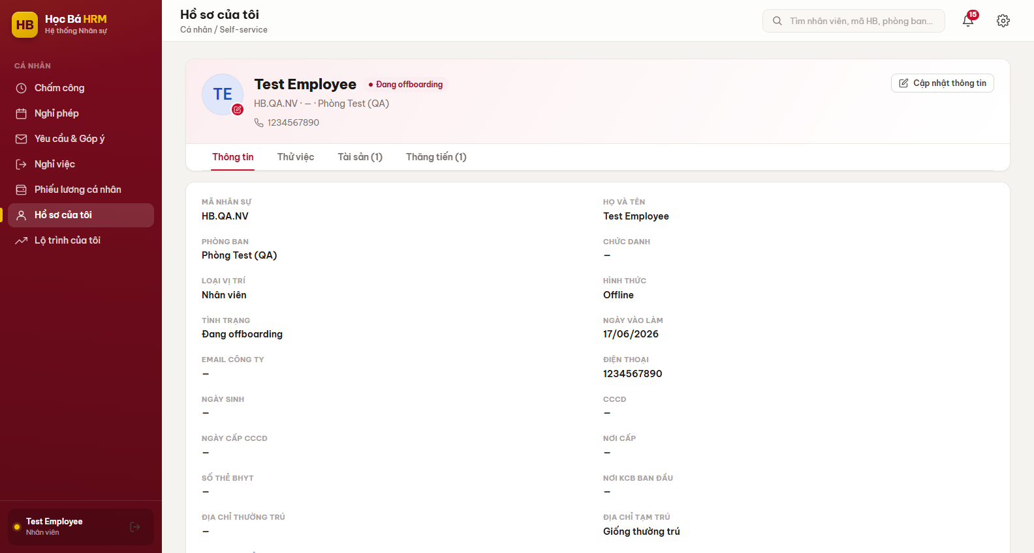
Figure 30 – Screen Hồ sơ của tôi
(2) Click the photo to replace it – any image up to 8 MB. The new picture is used everywhere in the system at once.
(3) Click Cập nhật thông tin to change the phone number and the two addresses. Everything else on the profile stays with HR.
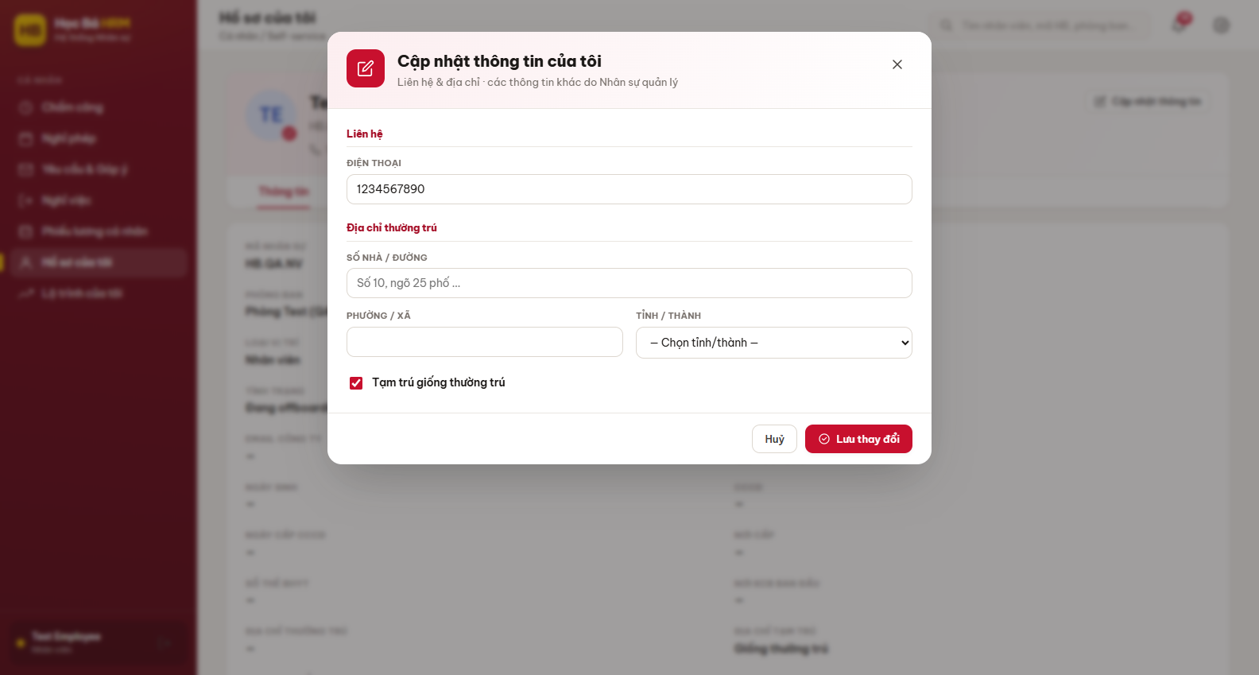
Figure 31 – Form Cập nhật thông tin cá nhân
(4) Tab Thử việc shows the onboarding steps as they stand, with no action buttons: the employee follows the probation but does not close its steps.

Appendix A – Frequently asked questions
Question | Answer
The employee cannot be turned Chính thức. | Rule BR-010: the CCCD (12 digits), the PIT code (10 or 13 digits) and the social insurance number (10 digits) must all be filled first. The error message names the missing field; the bell also raises “cần hoàn thiện hồ sơ” when the onboarding reaches that point.
A new employee has no onboarding steps. | Either Ngày bắt đầu thử việc is empty, or the classification axes match no process. Fill them in, or use Gán NV đang chờ in Cấu hình nhận việc, or assign a process by hand with Đổi quy trình.
The column Lương CB is not in the list. | The salary block is hidden from an HR officer by design. Administrator, HR Manager, Giáo vụ and the department manager of the person see it; nobody else does.
I edited a process but the employees on probation did not change. | That is the snapshot rule: an edit only applies to the employees assigned from that moment on. Use Đổi quy trình on the profile to move somebody onto the new version.
A resigned employee cannot be unlocked in Tài khoản. | Completing a resignation archives the employee record and locks the account together. An unlocked login without an employee record is refused by the server, so the button is hidden. Ask HR to restore the employee record first.
An evaluation answered Không đạt started a resignation. | That is the designed behaviour – a failed probation ends the contract. The confirmation dialog says so before the answer is saved. If it was a mistake, refuse the resignation request: the employee goes back to the state held before it.
A colleague does not appear in my employee list. | You only ever see your own scope: your branch as a department manager, the teachers as Giáo vụ. It is not a data problem.

Appendix B – Reference documents
Document | Content
FS-EMP-001 Employee Overview Profile | Profile fields, the drawer tabs, the permission matrix
FS-EMP-002 Vietnam Legal Data Fields | CCCD, PIT code, social insurance, bank account and their checks
FS-EMP-003 Dependent (Tax Deduction) Management | Dependents and the deduction period
FS-EMP-004 Onboarding Process & Dynamic Steps | Process templates, matching, steps and their switches
FS-EMP-005 Onboarding Step Automation & Reminders | Deadlines, scheduled actions and notifications
FS-EMP-006 Employee Asset Register | Asset types, grant and removal
FS-EMP-007 Promotion & Salary History (Snapshot) | Promotion milestones and the salary journey
FS-EMP-008 Trial Lesson Step & Teacher Skill Matrix | Teacher skills, levels and the trial lesson step
FS-EMP-009 Certificate & Contract Expiry Alerts | Expiry states, the alert window and the daily jobs
FS-EMP-010 Offboarding (Resignation) Management | Request, two-level approval, completion
FS-EMP-011 Promotion Evaluation Rounds & Criteria | Evaluation rounds, criteria and scores
FS-EMP-012 Career Path Dashboard & Honour Board | Career page, charts and the honour board
FS-EMP-013 Employee Login Account Management | Account creation, roles, locking and password reset

