**Homework on literature search & reference management**

(Hand in on Nov. 27, 2017 before class)

**Dong Jing 515370910182**

**1. Please list five or more of the frequently-used databases related to your majors.**

ASCE Online Research Library, Begell Digital Library, IEEE/IEE Electronic Library, Global Science Press, INSPEC

**2. Firstly, search literature on the area that you are interested in (e.g., “arithmetic for computers”, “fine blanking”, etc.) through the library database** [**Web of Science**](http://www.lib.sjtu.edu.cn/index.php?m=content&c=index&a=show&catid=223&id=224)**. Then do the following exercises:**

**(1****) Install the reference manager** **EndNote in your laptop (You can download the** **trial version via** <http://endnote.com/downloads/30-day-trial>**) or other reference manager. Then, save the complete bibliographic records of two or more articles that you are interested in, including the abstracts, to EndNote desktop or other reference manager.**

Please paste the screen capture of EndNote or other reference manager here.

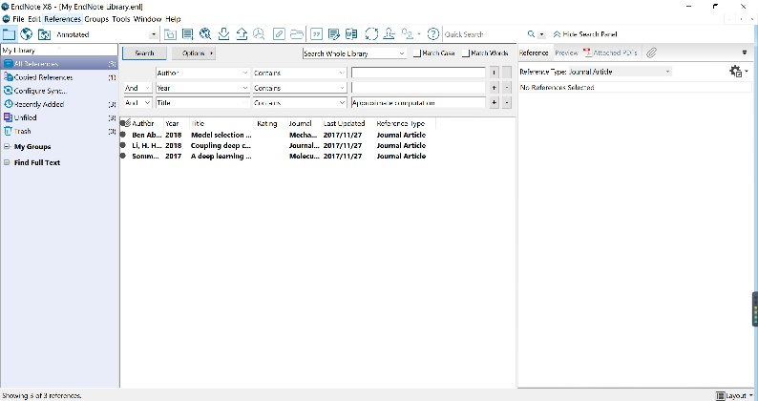

**(2) Analyze the records searched through** [Web of Science](http://www.lib.sjtu.edu.cn/index.php?m=content&c=index&a=show&catid=223&id=224)**, and answer the following questions:**

1) How about the publication year distribution of the searched records?

In the years earlier than 1990, there are a few publications. After 1990 and before 2010, there are about 2000 to 3000 publications every year. Most publications appeared after 2010. Every year after 2010 has more than 4000 publications.

2) Who writes the most articles?

KIM J

3) Whose articles are the most concerned? (highly cited papers, frequently-used articles. etc.)

DOOLITTLE, LR

**Notes:**

1. Use key words in the literature search, e.g., “cloud computing”, “absorption refrigerat*”. Besides, try to use different forms, representative synonyms and near-synonyms of the key words, e.g., forms and synonyms of “electric vehicle*” can be “electric car*”, EV, etc.

2. When you want to access the databases off campus, we suggest you try the Proxy Service: <http://net.sjtu.edu.cn/wlfw/xywdl.htm>.

3. If you run into difficulties, please do not hesitate to email the library mechanical engineering subject service team by [qlhuang@lib.sjtu.edu.cn](mailto:qlhuang@lib.sjtu.edu.cn), [xgao@lib.sjtu.edu.cn](mailto:xgao@lib.sjtu.edu.cn), [zlchen@lib.sjtu.edu.cn](mailto:zlchen@lib.sjtu.edu.cn) or [ywang@lib.sjtu.edu.cn](mailto:ywang@lib.sjtu.edu.cn).