1. **Constant Volatility** For  , it’s constant volatility case, the underlying asset price has an analytical solution:



We can directly sample the Brownian motion at time T as a normal random variable. The simulation result is:

|  |  |  |  |  |
| --- | --- | --- | --- | --- |
| N | price | Confi_L | Confi_H | SD |
| 1000 | 4.30 | 3.91 | 4.69 | 0.19882 |
| 10000 | 4.10 | 3.98 | 4.22 | 0.06122 |
| 100000 | 4.06 | 4.03 | 4.10 | 0.01935 |
| 1000000 | 4.07 | 4.06 | 4.08 | 0.00612 |

**Stochastic volatility** For  , it’s stochastic volatility case, we will use numerical integration to get the underlying price path:



The result from simulation is:

|  |  |  |  |  |
| --- | --- | --- | --- | --- |
| N | price | Confi_L | Confi_H | SD |
| 1000 | 3.66 | 3.18 | 4.14 | 0.24493 |
| 10000 | 3.74 | 3.56 | 3.91 | 0.08956 |
| 100000 | 3.81 | 3.74 | 3.88 | 0.03697 |
| 1000000 | 3.84 | 3.81 | 3.88 | 0.01630 |

(b). **Increasing Number of Simulation** First, We can improve the results in a by increase the number of simulations as the estimator converge to the true value with the inverse square root relation:



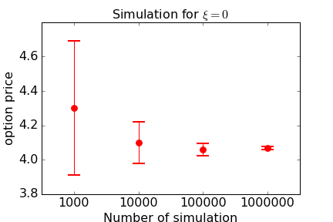

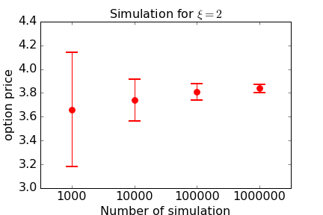

From the above figure, it’s clear to see that, when we increase the number of simulation, the results converge, and the 95% confidence interval become narrower, which means that we can increase the number of simulation to improve our result.

**Using antithetic variate** Second, another simple method we can try to improve the result is using antithetic variable.

|  |  |  |  |  |
| --- | --- | --- | --- | --- |
| N | price | Confi_L | Confi_H | SD |
| 1000 | 4.17 | 3.97 | 4.37 | 0.10218 |
| 10000 | 4.05 | 3.99 | 4.12 | 0.03185 |
| 100000 | 4.07 | 4.05 | 4.09 | 0.01024 |
| 1000000 | 4.08 | 4.07 | 4.08 | 0.00323 |

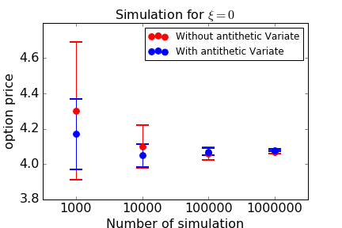

From the comparison, we can see that using the antithetic variate can help reduce the variance here.

(c). In this part, I will implement the method given by GSH paper.

**The Importance sampling:**

Importance sampling is in fact doing a change of probability measure, which aims to get a zero-variance estimate as a target:



However, it’s almost impossible to find a new probability measure to make the estimator become zero-variance, otherwise you can get the expectation exactly at the beginning. Therefore, here we go to find the optimal drift vector, where we place the most probability weight at the place where the integrand is most important with respect to value, that is , for example, suppose we can g(z) is a multivariate normal distribution with mean zero and variance matrix the identity matrix. We want to assign high probability to regions of D on which  is large. We choose the optimal drift vector according to :



As in the GSH paper, for the constant volatility case, the optimization problem is equivalent to solve the following equation:



**Constant volatility case**

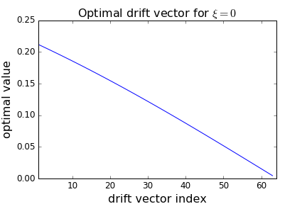

From the result, it’s easy to see the optimal drift vector compares well with GSH paper.

|  |  |  |  |  |
| --- | --- | --- | --- | --- |
| N | price | Confi_L | Confi_H | SD |
| 1000 | 4.18 | 4.05 | 4.30 | 0.06320 |
| 10000 | 4.07 | 4.03 | 4.11 | 0.02046 |
| 100000 | 4.06 | 4.05 | 4.08 | 0.00648 |
| 1000000 | 4.07 | 4.06 | 4.07 | 0.00205 |

**Stochastic volatility case** For the stochastic volatility case where , the analytical formula for underlying price is not possible, therefore, we directly solve the optimization problem:



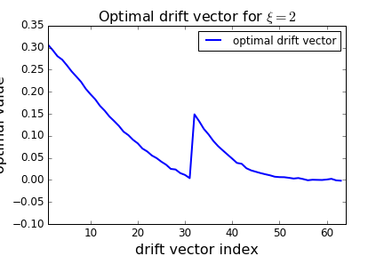

The numerical computation here compares very well with GSH paper.

|  |  |  |  |  |
| --- | --- | --- | --- | --- |
| N | price | Confi_L | Confi_H | SD |
| 1000 | 3.80 | 3.65 | 3.95 | 0.07702 |
| 10000 | 3.86 | 3.81 | 3.91 | 0.02608 |
| 100000 | 3.86 | 3.84 | 3.88 | 0.00825 |
| 1000000 | 3.87 | 3.87 | 3.88 | 0.00272 |

**Importance sampling and stratified sampling**

Now, We combine the importance sampling and the stratified sampling

The stratified estimators eliminate the variability across the strata without affecting the variability within the strata. We follow the procedure in the GSH paper to stratify along a projection direction. With numerical optimization, we can first find the optimal drift vector and then solve the eigenvalue problem to get the optimal eigenvector for stratification.

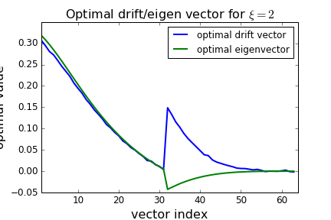

The numerical result for optimal drift vector and optimal eigenvector compares well with the results in GSH paper.

Importance sampling and stratify sampling for constant volatility.

|  |  |  |  |  |
| --- | --- | --- | --- | --- |
| N | price | Confi_L | Confi_H | SD |
| 1000 | 4.08 | 4.069 | 4.091 | 0.00555 |
| 10000 | 4.07 | 4.068 | 4.076 | 0.00191 |
| 100000 | 4.07 | 4.071 | 4.073 | 0.00060 |
| 1000000 | 4.07 | 4.072 | 4.073 | 0.00019 |

We compare the results from sampling without variance reduction, importance sampling, combined importance sampling and stratified sampling.

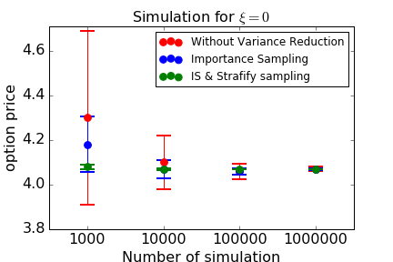

It’ s easy to see that with only importance sampling, we get variance reduction effect, but we get very significant variance reduction when we combine the importance sampling and the stratify sampling.

Importance sampling and stratify sampling for stochastic volatility.

|  |  |  |  |  |
| --- | --- | --- | --- | --- |
| N | price | Confi_L | Confi_H | SD |
| 1000 | 3.82 | 3.704 | 3.934 | 0.05874 |
| 10000 | 3.89 | 3.844 | 3.937 | 0.02369 |
| 100000 | 3.87 | 3.860 | 3.887 | 0.00678 |
| 1000000 | 3.87 | 3.865 | 3.873 | 0.00214 |

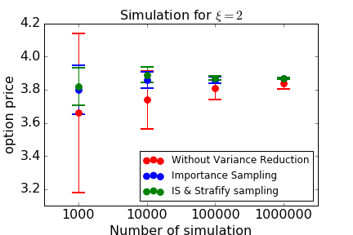

Variance reduction ratios

|  |  |  |  |
| --- | --- | --- | --- |
|  | price | Importance sampling | IS & stratify sampling |
| 0 | 4.07 | 9 | 1037 |
| 2 | 3.87 | 36 | 58 |

Here, We do not use the volatility cap as in GSH paper, but generally the variance reduction ratio compares well with GSH paper. For constant volatility case, the combined importance sampling and stratified sampling works much better than only importance sampling, but for the stochastic case, the combined sampling only works a little bit better than importance sampling.