**Object Oriented Programing Project Report**

<use appropriate image as per your project>

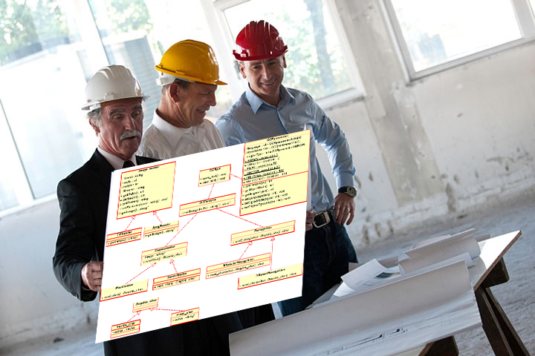

**<Project Title>**

**Prepared by**

**<Roise Roque>**

**<Mari Hiramoto>**

**at the**

**<institution/college>**

**August 2023**

**Table of Contents**

Contributions 3

I Presentation YouTube link 3

II Project Description 3

1 Project Overview 3

2 The Purpose of the Project 3

2a The User Business or Background of the Project Effort 3

3 The Scope of the Work 4

III Requirements 4

4 Product Use Cases 4

IV Design 4

5 UML Class Diagram 4

V Testing and Evaluation 4

6 Features to be tested. 4

7 Pass/Fail Criteria 4

VI Project Issues 4

8 Lessons Learnt 4

VII Conclusion 4

VIII References 4

### ****Contributions****

|  |  |  |  |  |
| --- | --- | --- | --- | --- |
| **Student ID** | **Name** | **Components** | **Details** | **Development hours** |
| 038771143 | Roise Roque |  |  |  |
| 132538232 | Mari Hiramoto |  |  |  |
|  |  |  |  |  |
|  |  |  |  |  |

# Presentation YouTube link

# Project Description

## Project Overview

A brief description of the product to be produced, before getting into details.

## The Purpose of the Project

### The User Business or Background of the Project Effort

Content

content, motivation, examples and Considerations

A short description of the business being done, its context, and the situation that triggered the development effort. It should also describe the work that the user intends to do with the delivered product.

Motivation

Without this statement, the project lacks justification and direction.

Considerations

You should consider whether the user problem is serious, and whether and why it needs to be solved.

## The Scope of the Work

# Requirements

## Product Use Cases

This section begins to describe in more specific and precise detail exactly what steps the system takes in the course of its performance. You can use Use case diagrams or just explain in plain English. Define the system ( and its boundaries ), but also to identify functional requirements, to identify initial objects / classes, and to organize the work.

# Design

## UML Class Diagram

# Testing and Evaluation

## Features to be tested.

## Pass/Fail Criteria

# Project Issues

## Lessons Learnt

# Conclusion

Write the conclusion of the project by discussing the issues, solutions and the outcome.

# References

This section describes the documents and other sources from which information was gathered. This sample bibliography was generated using the “Insert Citation” and “Bibliography” buttons in the “Citations & Bibliography” section under the “References” tab of MS Word. Creating new citations will not update this list unless you click on it and select “Update Field”. You may need to reset the style for this paragraph to “normal” after updating.

|  |  |
| --- | --- |
| [1] | Robertson and Robertson, Mastering the Requirements Process. |
| [2] | A. Silberschatz, P. B. Galvin and G. Gagne, Operating System Concepts, Ninth ed., Wiley, 2013. |
| [3] | J. Bell, "Underwater Archaeological Survey Report Template: A Sample Document for Generating Consistent Professional Reports," Underwater Archaeological Society of Chicago, Chicago, 2012. |
| [4] | M. Fowler, UML Distilled, Third Edition, Boston: Pearson Education, 2004. |