1. Location to download External Libs:

GLEW:

<https://sourceforge.net/projects/glew/files/glew/2.1.0/>

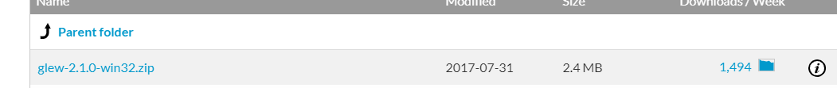

GLFW:

<https://www.glfw.org/download.html>

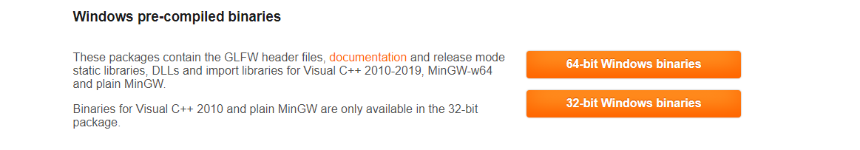

Choose 32-bit Windows binaries

1. Setup the External Libs:
2. 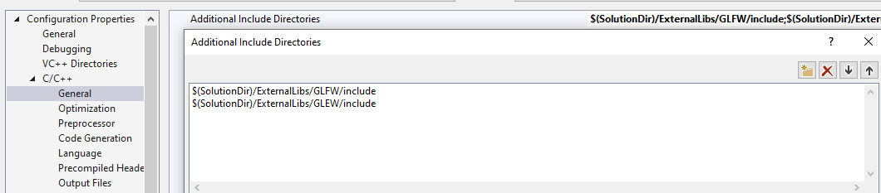
3. 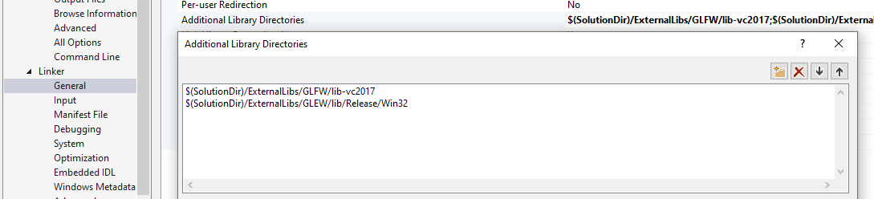
4. 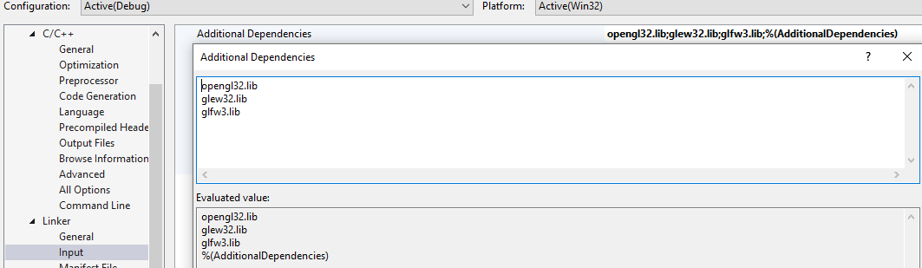
5. Put ExternalLibs\GLEW\bin\Release\Win32\glew32.dll to the directory of the project.