**OLS with sklearn & statsmodels**

1. **Summary**
   1. Dataset = iris
   2. Dependent variable: petal length
   3. Independent variables: petal width, sepal length and width.
2. **Result with sklearn**

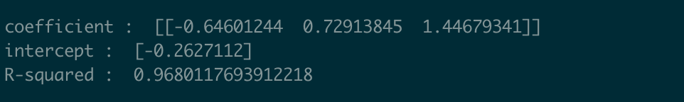

1. **Result with statsmodels**

