MailFlow AI Software Design
Current implementation and tentative direction
CSE 416 Fall 2026
Donghyun Lim / Donghyun.lim.2@stonybrook.edu
Seunghoon Jang

This document describes the system that exists in the repository today and separates it from the team’s tentative production and feature roadmap. The current system is a full-stack Next.js application that connects to Gmail, classifies messages, synchronizes message actions, and stores classification metadata in SQLite. Persistent sessions, AI-generated assistance, Calendar integration, and cloud deployment remain planned work.
Document status
- Implemented now: Google OAuth, Gmail retrieval, Daily Briefing, mailbox views, priority classification, message actions, and local priority metadata.
- Tentative next: Vercel deployment, managed PostgreSQL, persistent encrypted sessions, AI summaries and replies, and Google Calendar integration.

Contents
1 Introduction
2 Requirements and current status
3 System architecture
4 Data design
5 UML sequence diagrams
6 API design
7 Deployment
8 Code conventions
9 Schedule
10 Risks and constraints
11 Contributions
12 References

Design summary
MailFlow AI currently uses Next.js for both the React interface and server-side API routes. Google OAuth authorizes Gmail access, the Gmail API remains the source of truth for messages and labels, and a local SQLite database records MailFlow-specific priority decisions and their history. This architecture satisfies the implemented requirements without copying sensitive message content into the local database.
The earlier plan included a separate NestJS backend and a larger persisted domain model. The current repository does not contain that backend or those full entities. This document treats the repository as the current design authority and keeps the larger AI and Calendar capabilities as a future direction.

1 Introduction

1.1 Problem
People can miss urgent messages and deadlines when routine notifications dominate their inbox. They also spend time repeatedly opening, sorting, starring, and deleting messages before they can focus on the work that requires attention.

1.2 Solution
MailFlow AI connects to a user’s Gmail account and presents a focused Daily Briefing alongside familiar mailbox views. It assigns each non-draft message to Urgent, FYI, or Low Priority, allows the user to correct that assignment, and keeps read, star, trash, and restore actions synchronized with Gmail.

1.3 Design boundary
The design separates implemented behavior from tentative work. Current-state descriptions map directly to code in the repository. Future-state descriptions explain the direction under consideration and may change after the design review.

2 Requirements and current status
Area | Requirement | Status | Current interpretation
Authentication | Users connect a personal Google account | Current | OAuth state validation and HTTP-only session cookie
Inbox | Load Gmail messages and mailbox views | Current | Daily Briefing, All Email, Starred, Drafts, and Trash
Priority | Group messages by urgency | Current | Rule-based Urgent, FYI, and Low Priority labels
Message actions | Read, star, trash, restore, and reprioritize | Current | Changes are sent to Gmail
AI summary | Summarize selected messages | Tentative | No model integration or API route exists yet
Reply assistance | Generate an editable suggested reply | Tentative | No draft-generation route exists yet
Calendar | Extract an event and create it after approval | Tentative | Calendar interface exists, but Google Calendar integration does not
Deployment | Run the application online | Tentative | Vercel and Neon are the recommended direction

3 System architecture

3.1 Current architecture
The browser runs the React interface. Next.js route handlers perform OAuth operations, call Gmail, parse messages, apply MailFlow priority rules, and write classification metadata. The application currently keeps OAuth tokens in a process-local session map and stores priority metadata in SQLite.
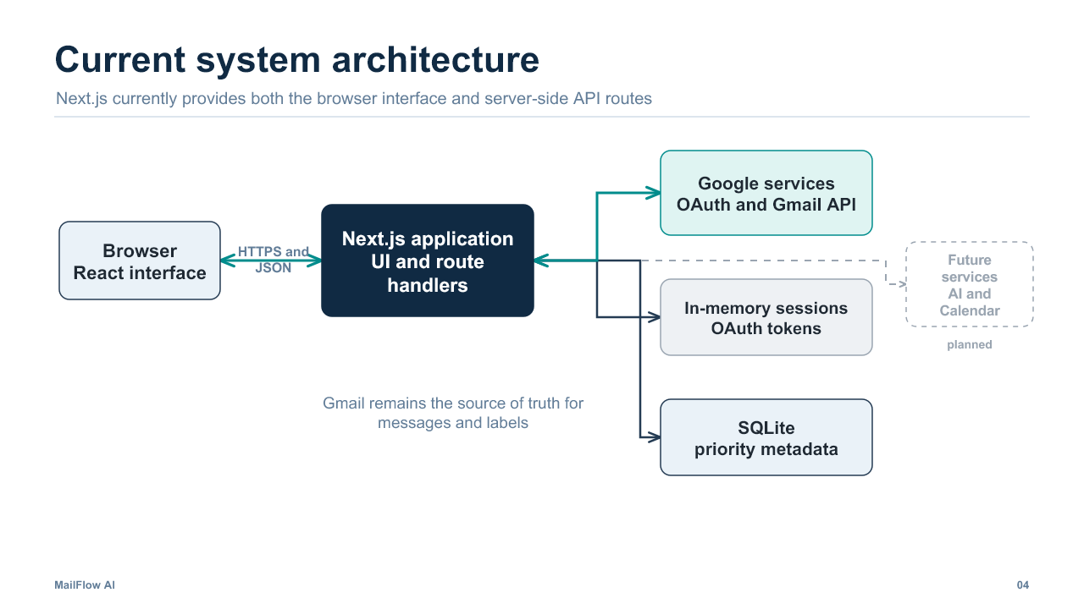
Figure 1 Current system architecture

3.2 Technology choices
Component | Choice | Rationale
User interface | React 19.2.8 | Component-based interaction model within the Next.js application
Application framework | Next.js 16.3.5 | One codebase for the interface and server-side route handlers
Language | TypeScript | Static checking across UI, routes, Gmail parsing, and persistence
Google integration | googleapis 181.0.0 | Official client for OAuth and Gmail API calls
Current database | Node SQLite | Small local store for classifications and change history
Tentative hosting | Vercel | Direct fit for Next.js and separate preview and production environments
Tentative database | Neon PostgreSQL | Managed persistence suitable for a serverless deployment

3.3 Design patterns
- Route boundary: Next.js route handlers isolate browser code from OAuth credentials and Google API calls.
- Repository boundary: mailflow-db.ts centralizes SQLite schema creation and classification writes.
- Service modules: OAuth, Gmail parsing, Gmail priority labels, session handling, and local classification rules live in focused modules.
- Human approval: Current message actions require user input, and future reply or Calendar operations will keep the same approval model.

4 Data design

4.1 Current persisted data
The current database deliberately stores less information than the earlier target model. Gmail message IDs connect local priority decisions to Gmail without copying subjects, bodies, attachments, passwords, or OAuth tokens into SQLite.
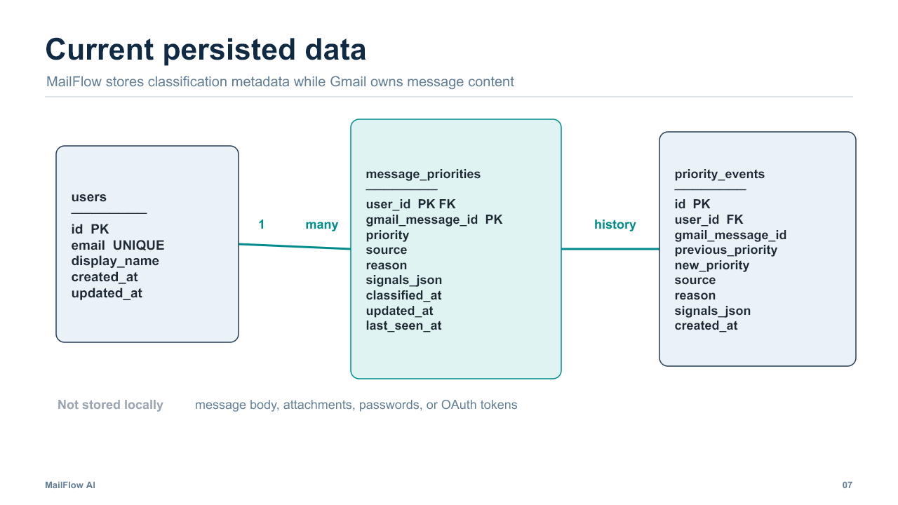
Figure 2 Current SQLite data model

4.2 Current tables
Table | Purpose | Important data
users | One row per Gmail account | Email address and optional display name
message_priorities | Current priority per Gmail message | Priority, source, reason, signals, and timestamps
priority_events | Append-only change history | Previous priority, new priority, source, reason, and timestamp

4.3 Tentative future data
A production version will require a persistent session or connected-account record with encrypted refresh tokens. AI summaries, draft replies, and Calendar events should be added only when those features exist. Their tables should not duplicate Gmail message bodies unless a documented product requirement requires local retention.

5 UML sequence diagrams

5.1 Daily Briefing and first priority classification
The Daily Briefing requests messages received since the start of the current day. The server validates the session, loads Gmail labels and profile information, retrieves messages, assigns a priority only when a MailFlow label is missing, records the decision, sorts the results, and returns JSON to the browser.
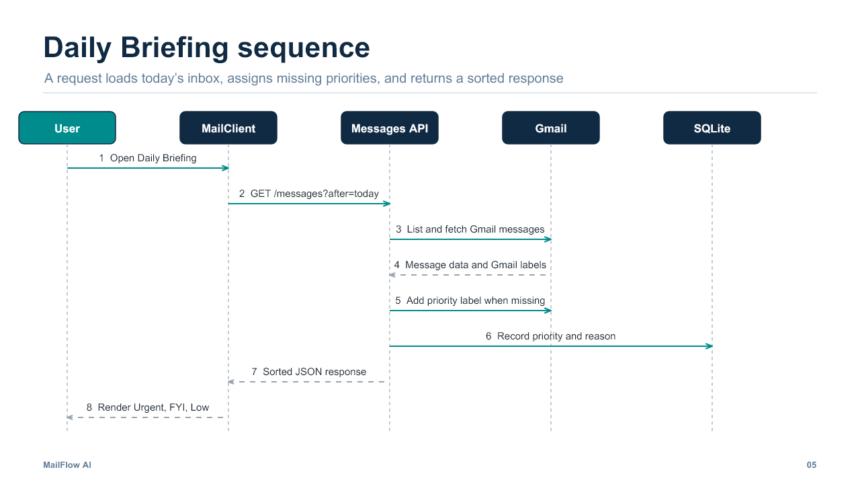
Figure 3 Daily Briefing sequence
Concurrency behavior
Before it writes a new priority label, the priority module fetches the latest label state. If another request has already assigned a MailFlow label, the module records that label as the current source instead of adding another classification.

5.2 Google OAuth login
The login route creates a random state value and redirects the browser to Google. The callback rejects missing or mismatched state, exchanges the authorization code for tokens, stores those tokens under a random session ID, and sets an HTTP-only cookie. The browser receives a session identifier rather than the OAuth tokens.
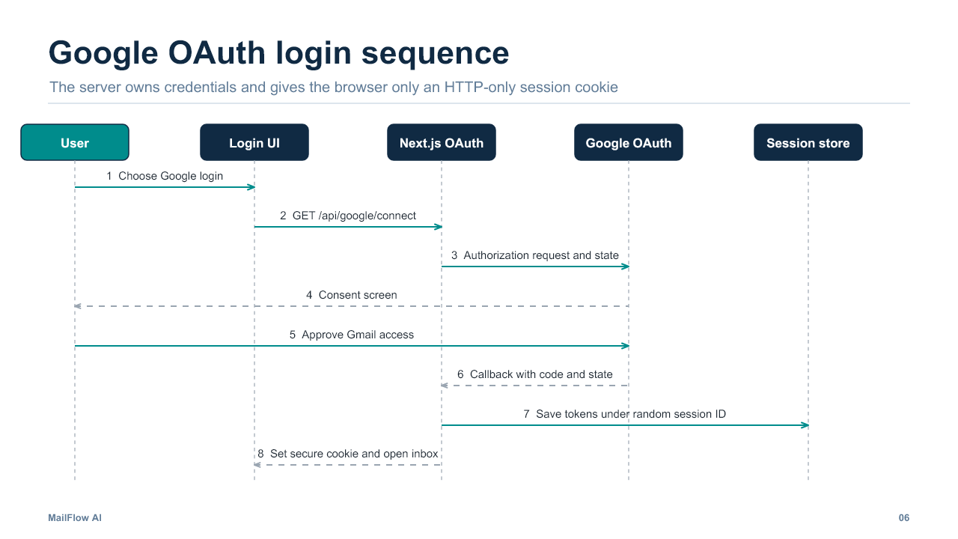
Figure 4 Google OAuth login sequence
Current limitation
The session map exists only in server memory. A process restart removes active sessions, and multiple server instances cannot share them. Production deployment therefore depends on persistent encrypted session storage.

6 API design
The browser uses a small JSON and redirect-based API surface. All Gmail routes require a valid gmail_session cookie. OAuth secrets stay on the server.
Route | Method | URL | Input | Success output | Errors
Google connect | GET | /api/google/connect | Optional popup=1 | Redirect to Google authorization | Redirect with oauth_not_configured
Google callback | GET | /api/google/callback | code, state, or error | Redirect and gmail_session cookie | invalid_oauth_state or token_exchange_failed
Google profile | GET | /api/google/profile | Session cookie | connected, name, email, authorization flags | 401 or profile_request_failed
List messages | GET | /api/gmail/messages | after, mode, pageToken | messages and optional pagination data | 401 or gmail_request_failed
Modify message | PATCH | /api/gmail/messages/:id | action plus starred or priority | Updated message state | 400, 401, or gmail_modify_failed
Trash message | DELETE | /api/gmail/messages/:id | Message ID and session cookie | trashed: true | 401 or gmail_trash_failed

6.1 Message query behavior
- Daily Briefing: after contains the start-of-day timestamp. The server follows Gmail pagination until it has collected the day’s inbox messages, then groups them by priority.
- Mailbox views: mode selects All Email, Starred, Drafts, or Trash. The server returns one page and an optional nextPageToken.
- Priority updates: PATCH validates Urgent, FYI, or Low, updates Gmail labels, and records a manual change in SQLite.
- Read, star, trash, and restore: the server translates each UI action into the corresponding Gmail API operation.

7 Deployment

7.1 Tentative production direction
The tentative production direction is Vercel for the Next.js application and Neon PostgreSQL for persistent sessions and MailFlow metadata. Vercel directly supports Next.js deployments and separates local, preview, and production environments. Neon provides managed PostgreSQL access suitable for serverless applications.
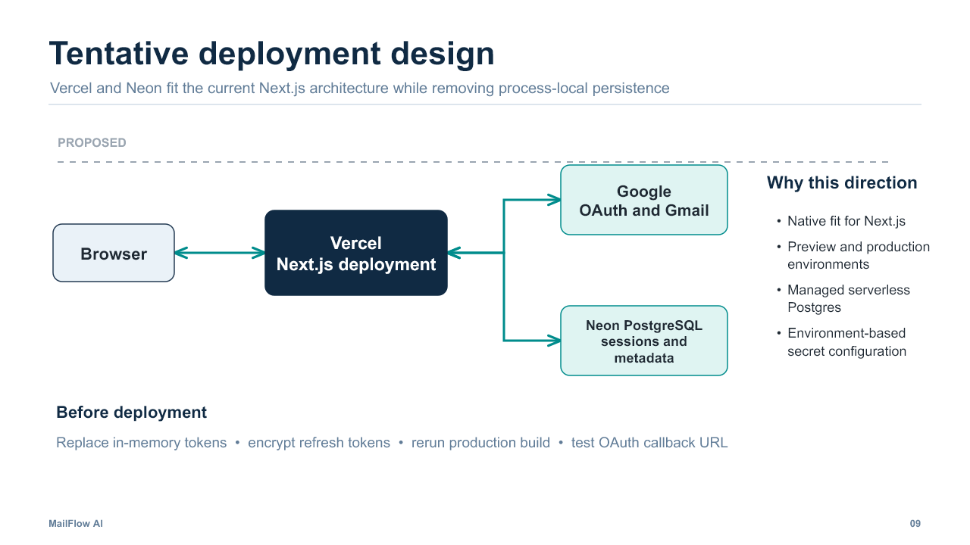
Figure 5 Tentative Vercel and Neon deployment

7.2 Work required before deployment
- Replace the process-local session map with a shared persistent session store.
- Encrypt refresh tokens before database storage and restrict decryption keys to the server environment.
- Set Google client credentials, database credentials, redirect URI, and encryption keys as deployment environment variables.
- Register the production callback URL in Google Cloud and verify test users on the consent screen.
- Run the production build outside the sandbox and investigate any repeatable Turbopack failure.
- Test login, briefing, message actions, logout behavior, and restart recovery in a preview deployment.

7.3 Privacy and security
MailFlow requests gmail.modify because it reads messages and changes labels and message state. The application should request Calendar scope only when Calendar integration exists. Tokens must never appear in browser-accessible variables or logs. Message HTML should continue to render through a constrained and reviewed path.

8 Code conventions
Area | Convention
TypeScript | Use strict mode, explicit domain types, and typed Next.js route contexts
Naming | camelCase for values and functions; PascalCase for React components and types
Files | Use focused modules named for the responsibility they own
Formatting | Follow ESLint with Next.js Core Web Vitals and TypeScript rules
Secrets | Keep OAuth and database secrets in server-only environment variables
Errors | Return stable JSON error codes and log server-side diagnostic context
Tests | Add route and pure-function tests for security checks and state transitions

9 Schedule

9.1 Presentation readiness
Stage | Date | Work | Assgined
Day 1 | October 23 | Freeze architecture, diagrams, API inventory, and current-versus-future labels | tentative
Day 2 | October 24 | Run tests and build locally, verify OAuth, prepare demo evidence, and rehearse sequence flows | tentative
Day 3 | October 25 | Finalize PDFs, prepare a recording or screenshots, and complete a timed rehearsal | tentative
Review | October 26 | Present the design and capture feedback for the next implementation phase | tentative

9.2 Tentative implementation roadmap

Order | Milestone | Deliverables | Dependencies
first | Deployment foundation | Persistent encrypted sessions, managed database, and stable production build | Current Gmail workflow and hosting accounts
second | AI summary and reply | Model service, prompt boundary, editable draft, and evaluation cases | Persistent identity and message access
third | Calendar integration | Date extraction, event preview, approval, and Calendar API | Additional OAuth scope and event model
fourth | Hardening | End-to-end tests, monitoring, rate handling, and privacy review | Completed production flows

10 Risks and constraints
Risk | Impact | Mitigation
Session persistence | Restart or scaling ends in-memory sessions | Move sessions and encrypted tokens to PostgreSQL before deployment
OAuth scope | Gmail modify access may require verification and careful handling | Use the minimum scopes and document test-user limitations
Build readiness | The sandbox build ended with a Turbopack worker error | Reproduce locally and separate environment failure from code failure
AI quality | Summaries and replies may be incorrect or inappropriate | Keep drafts editable and require explicit user approval
Date extraction | Ambiguous dates can create incorrect events | Show a preview with date, time, time zone, and location
Team capacity | Two people own the whole system | Complete the production foundation before expanding feature scope

11 Contributions
Donghyun Lim and Seunghoon Jang share ownership of the Software Design Document, architecture, implementation review, diagrams, presentation, testing, deployment planning, and rehearsal. Repository history shows contributions from both team members across the Gmail interface, Calendar view, OAuth, priority behavior, SQLite storage, data design, and project documentation.

