HOW TO’s and FAQ’s: Compose Bot

**Compose Bot formats your messages by taking the first line and bolding it. Then, it finds the second line and italicizes it. Every line after that is considered a line in the body of your text. To create new lines in a discord message, use SHIFT+ENTER 🡨 Note that this is a non-issue if you are copy-pasting finished blog posts from another text editor.**

**EX:**

**Test Title One**

**04 September 2020**

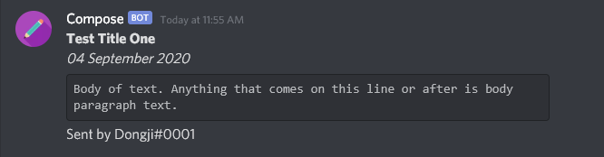 **Body of text. Anything that comes on this line or later is body paragraph text.**

**What inputs work? Any of them! Type how you normally would, with tabs or new lines between paragraphs. However, do not add extra lines between your title line and date line. Please check before uploading that there are no extra empty lines at the end of your text. Also, double check to make sure the formatting characters are removed because the bot will add those in for you.**

**EX:**

**\*\*Test Title Two\*\***

**\*04 September 2020\***

**```Body of text. Anything that comes on this line or later is body paragraph text. ```**

**This example will break the bot because it’s not programmed to read inputs in this form.**

**EX:**

**Test Title Three**

**04 September 2020**

**Body of text. Anything that comes on this line or later is body paragraph text.**

**This example will work because the line break is not between the title line and date line.**

**However,**

**EX:**

**Test Title Four**

**04 September 2020**

**Body of text. Anything that comes on this line or later is body paragraph text.**

**This example will break.**

**Compose only works with text. Images, Spotify embeds, and webpages all must be manually entered by you. Wait until the bot finishes sending your blog post and then send your photo/link.**

**Although Compose is written to accommodate user error, following these simple rules will keep Compose a very happy and healthy bot! If you want to opt-out of having Compose format your messages lmk because I’ll have to adjust the code. If there is an issue (i.e. missing text, out of order paragraphs) contact me because that means I am bad at coding.**

👋

Frequently Asked Questions:

**Q:** How do I send images and links with my blog post?

**A:** No. Since the bot must download each media file to reupload, it wouldn’t make sense to implement. Also, it would be difficult to code. Because of this, users must send their media/link messages after the body of the text and the bot will ignore the input based on the data type, keeping it in chat.

**Q:** There are missing periods or extra periods in my blog.

**A:** First check to see that the typo isn’t in the input text. There actually is a case where a period at the end of a paragraph could potentially be missing, but other than that, extra periods and other typos are from unchecked inputs. As always, make sure to lmk just to be safe and call me out on it.

**Q:** Help! I pasted my text, but nothing is being sent into the chat!

**A:** One of two things happened. If you can see your message (either plain text or a .txt file) in the chat, that means the bot is either offline or broken. If you can see that Compose Bot is online; congrats! You broke him. However, if Compose is online and your message was deleted but no message was sent, then Compose has detected an error in your input. Double check to make sure that there are no empty lines before your posts starts or in-between the title and the date lines. Then, send your message again.

**Q:** When will the pain stop?

**A:** When we die.