**Lab 2 --- Understanding Oracle’s architecture and key parameter files**

**Purpose:** This lab reinforces your classroom discussions concerning Oracle architecture

**Requirements:** Complete the required tasks and submit the required responses in the **same** word document renamed as ***lab2_****fname_lname* (e.g., ***Lab2_Doug_King***) via Brightspace by the end of the lab and demonstrate your work to the lab professor.

A complete and on-time submission will earn **2 marks**.

**Resources**: <https://docs.oracle.com/cd/B28359_01/server.111/b28318/startup.htm#CNCPT1293>

<https://docs.oracle.com/database/121/CNCPT/startup.htm#CNCPT601>

<https://docs.oracle.com/cd/B28359_01/server.111/b31189/ch12042.htm>

<https://docs.oracle.com/cd/B28359_01/server.111/b28286/statements_6008.htm#SQLRF01308>

**Lab Submission tasks:**

1. **Demo / Problem Solving: During Week 2's lab, you will be required to confirm your Oracle 12c installation is working properly.**
2. **Concepts: Refer to the above noted resources. Copy your answers to your submission document.** 
   1. Without using virtual tables or similar mechanisms, a database instance can be associated with __single(one)_ database(s).
   2. To start a database instance, configuration parameters must be read. This information is contained in binary format in __SPFile__ and in text format in ___PFile__.
   3. During STARTUP, the instance knows where the data files are located by reading the __control__ file.
   4. The main difference between a TRANSACTIONAL SHUTDOWN and an IMMEDIATE SHUTDOWN is, in a TRANSACTIONAL SHUTDOWN ___waits for the open transaction to complete__________________________________________.
3. **Review the Startup/Shutdown Process (Write the queries and their results):** 
   1. Logon as **SYS as SYSDBA**.
   2. Enter **SHOW PARAMETERS**
      1. From the SHOW PARAMETERS results, determine where the SPFILE file is located. Record this location in your lab file below.



* 1. **Create a PFILE:** Enter: ***CREATE PFILE from SPFILE;***
  2. Locate and resulting **PFILE** and in your lab document, specify:
     1. the name of the pfile



* + 1. Open the file and determine the **oracle_base** name



* + 1. the location of the **control_files**



* 1. Enter: **SHUTDOWN**
  2. Enter: **STARTUP**
  3. Indicate, in your lab document, the sequence of objects being started.

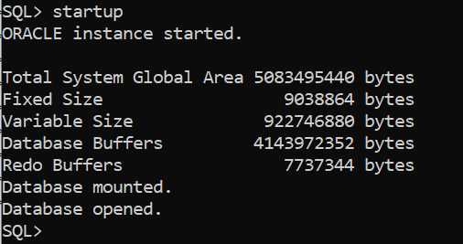

1. **DATA DICTIONARY:** From the SQL prompt, enter **DESC DICT-** this command describes the structure (the columns) of the internal data dictionary.

*Hint:**Throughout the course, when you forget the names of special tables you can return to the dictionary and determine the name.*

In your lab document answer the following questions **(Write the queries and their results)**:

* 1. List the number of rows that are in this table (you may not want to select the rows as there are a lot). __Query : select count(*) from dict;  
      __Result : 4666___________

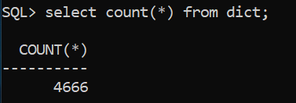

* 1. List the name of the view or table that describes Tablespaces:   
     __Query : select table_name from dict where table_name like‘%TABLESPACE%’;_

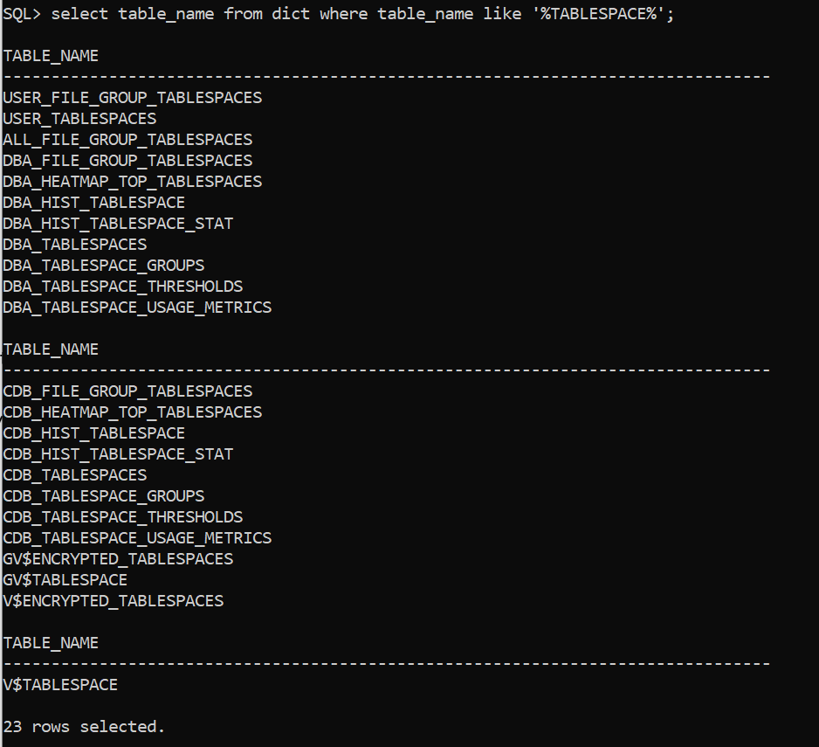

* 1. List the name of the view or table that describes Datafiles:   
      _Query : select table_name from dict where table_name like ‘%DATAFILE%’;_

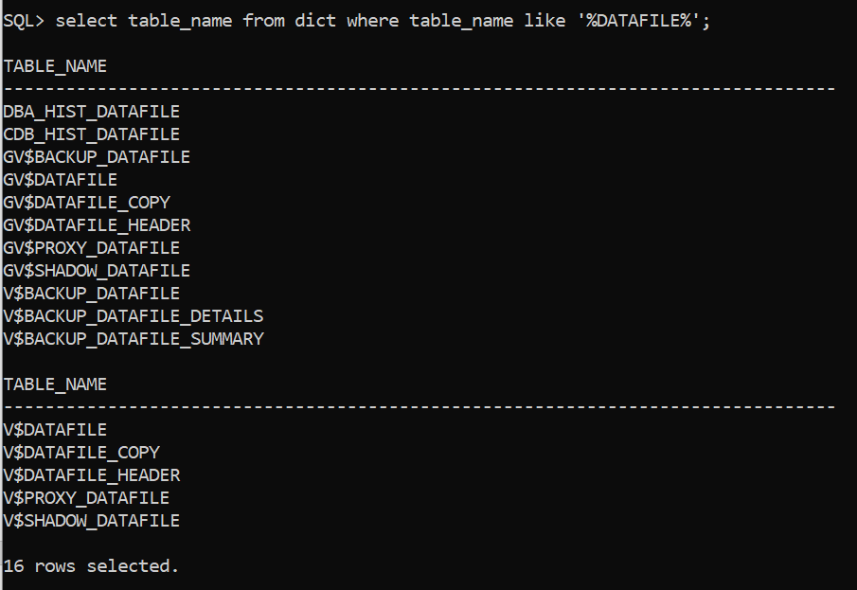

* 1. Write a query that joins the **V_$DATAFILE** and **V_$TABLESPACE** tables, then use the query results to answer the following questions:
     1. What is the location and name of the datafile associated with the SYSTEM tablespace.   
        Query : select V_$DATAFILE.NAME from V_$DATAFILE, V_$TABLESPACE where V_$DATAFILE.TS# = V_$TABLESPACE.TS# and V_$TABLESPACE.NAME = ‘SYSTEM’;



* + 1. What is the location and name of the datafile associated with the USERS tablespace.   
       Query : select V_$DATAFILE.NAME from V_$DATAFILE, V_$TABLESPACE where V_$DATAFILE.TS# = V_$TABLESPACE.TS# and V_$TABLESPACE.NAME=’USERS’;



**You're done. Submit your lab.**