CST8276 – Advanced Database Topics: Lab Assignment 3

Student Name: __________________

Student ID: __________________

Student email: __________________

# Hand-in:

1. The lab assignment will be graded out of a maximum 2 points.
2. This template should be used to submit your lab assignment.
3. Make sure you have enough screenshots to completely document that you have completed all the steps.

# Activities (Steps):

1. In this lab you will be using the Oracle (Version 19c) database management system, and rman facility to manage backups. The documentation for backups and restoring data using rman can be found at:

<https://docs.oracle.com/en/database/oracle/oracle-database/19/bradv/index.html>

Although the content of the backups is the same, BACKUP DATABASE and BACKUP INCREMENTAL LEVEL 0 DATABASE are different. A full backup is not usable as part of an incremental strategy, whereas a level 0 incremental backup is the basis of an incremental strategy. No RMAN command can change a full backup into a level 0 incremental backup.

As with full backups, RMAN can make incremental backups of an ARCHIVELOG mode database that is open. If the database is in NOARCHIVELOG mode, then RMAN can make incremental backups only after a consistent shutdown.

What is the difference between a level 0 and a level 1 incremental backup? Paste your answer below:

1. **Please note: you need to carefully follow the steps A through V! Take screen shots of your work and paste them into the boxes below.**

### First: Connect to Oracle (using cmd running as administrator & then invoking sqlplus) as the SYSTEM user and unlock the SYSBACKUP user.

### Then, alter the password of the SYSBACKUP user and change it to 1.

Then, connect to Oracle as the unlocked SYSBACKUP user.

1. In a separate cmd window, log in to RMAN as SYSBAKUP (using: ‘rman target sysbackup/1’). Remember, you have to exit the SQL command prompt and return back to the perating system cmd window in order to start RMAN.
2. Open a new command window and SQLPLUS session and log in as SYSTEM. Use the ***show parameter recovery*** command to show the settings of all recovery parameters. Take a screen shot of your work and paste it below.
3. Now we want to configure the fast recovery file destination and size. (Show all your work in the box below)
   1. Set the fast recovery file destination size to be 10G (use: sqlplus> **alter system set db_recovery_file_dest_size=10G;** )
   2. and then set the file destination to be ‘C:\app*yourname*\fast_recovery_area\orcl’. Change the path depending on your computer setting.
   3. Run the ***show parameter recovery*** command again and take a screen shot of all your work and paste it below.
4. Open a new SQL session and log in as sysdba user ( > SQLPLUS / AS SYSDBA). Check if the database is in the archive mode by executing the ***archive log list*** command. Take a screen shot of your work and paste it below.
5. Open a second cmd terminal and invoke RMAN and connect as SYSBACKUP user. Then execute the ***shutdown immediate*** command to shutdown the database instance. After that startup the instance and mount the database (startup mount). Take a screen shot of your work and paste it below.
6. Execute the ***backup database*** command to create a backup before you change the archivelog mode. Take a screen shot of your work and paste it below.
7. Use the command ***List backup;*** to list the backups. After that, use the ***delete backup;*** command to delete the backups. List again the backups that you have. Take a screen shot of all the commands that you have executed in this part.
8. Execute the ***alter database archivelog*** command to put the database in ARCHIVELOG mode. Then open the database (***alter database open***). Take a screen shot of your work and paste it below.
9. Now return to the SQL session, you may need to connect as sysdba again, and execute one more time the ***archive log list*** command. Take a screen shot of your work and paste it below and then exit the SQL session.
10. Return to your RMAN session. Back up the database by executing the ***BACKUP DATABASE PLUS ARCHIVELOG*** command. Take a note of the name of the control file. Take a screen shot of your work and paste it below
11. Use the ***SHOW ALL*** command to view the RMAN configuration settings, including backup settings.
12. If the default device for backups is not set to disk (the default), use the ***CONFIGURE DEFAULT DEVICE TYPE TO DISK*** command to set it.
13. Verify the setting by using the SHOW DEFAULT DEVICE TYPE command. Take a screen shot of your work and paste it below.
14. Enter the ***LIST BACKUP SUMMARY*** command to display backup information stored in the RMAN repository. Take a screen shot of your work and paste it below.
15. Execute the ***LIST BACKUP OF DATAFILE specific_datafile_ID;*** command to view detailed information stored in the RMAN repository about the backup of a **specific** datafile. Take a screen shot of your work and paste it below.
16. Take note of one of the datafile_IDs, and then execute the ***VALIDATE DATAFILE specific_datafile_ID;*** command to validate the backup for the **specific** datafile. The VALIDATE command determines whether the backup exists. Take a screen shot of your work and paste it below.
17. Execute the ***RESTORE TABLESPACE tableSpaceName VALIDATE*** command to validate that the datafiles for the specified tablespace named ‘tableSpaceName’ can be restored. Take a screen shot of your work and paste it below. The VALIDATE parameter means that the restoration is not done, but it shows the restoration *could* be done.
18. Shutdown the database and then exit RMAN. Then, copy all of the physical files of the database to a safe location outside of the Oracle file hierarchy. Make sure to do so before the following steps. Delete the original files after you have taken the copy. (worst case file loss!!) Here are my files: copy yours to a safe location before you delete the originals….

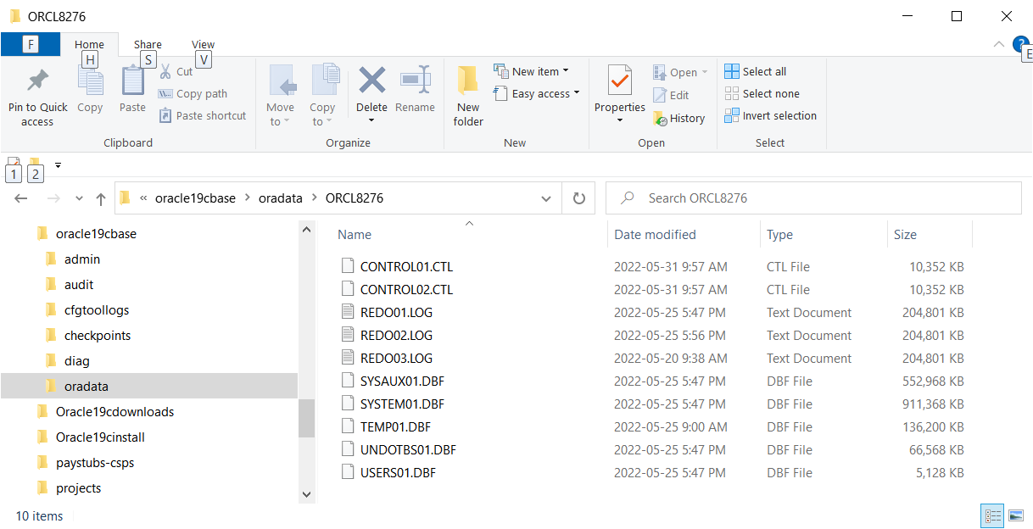

1. Try to connect to the database as sysdba and then try to startup your database. Take a screen shot of what happens (error messages, etc) and paste it below. (It should not be able to start…)
2. Start a new cmd session. Invoke RMAN (***RMAN target sysbackup*** ). Then start up with no mount ( RMAN > ***STARTUP NOMOUNT;***)
3. It is time now to restore the control file from backup. When I did my backup, I received the following output near the end of the backup command output…:

Starting Control File and SPFILE Autobackup at 2-MAY-22

piece handle=D:\ORACLE19CINSTALL\DATABASE\C-3002098481-20220502-00 comment=NONE

Finished Control File and SPFILE Autobackup at 2-MAY-22

The location of my backup control file is at:  
‘D:\ORACLE19CINSTALL\DATABASE\C-3002098481-20220502-00’

Execute the following command, taking into consideration the location of your backup control file:

RMAN> restore controlfile from ‘D:\ORACLE19CINSTALL\DATABASE\C-3002098481-20220502-00’;

1. Now that the control file has been restored, you can restore and recover the database. Execute the following commands: Show your work and the resulting output:

RMAN> ***Alter database Mount;***

RMAN> ***Restore Database;***

RMAN> ***Recover Database;***

RMAN> ***Alter Database open resetlogs;***

1. **The database should be restored. Make sure all using sqlplus - log on as sysdba and execute the following commands. Take a screen shot of your work**.

SQL> ***select name from V$database;***

SQL> ***select open_mode from V$database;***

SQL> ***Select tablespace_name from dba_tablespaces;***

1. Once you have embedded all of your screenshots, submit the file in Brightspace and you’re done!