**Purpose:** To provide you with the opportunity to gain additional insight into aspects of query performance.

**Deliverables:** Provide the specified answers and results in the spaces marked below and submit the updated file using BrightSpace. You do not have to demonstrate your work to your lab professor if you have good documentation provided. Your lab professor may request a lab demonstration. The lab exercise is worth 2 marks towards your lab grade if correct and submitted on-time or early.

**Activities:**

1. Logon to your general user account and use the supplied script (contained in lab6.sql) to create a sequence, create two tables, and to populate both tables with several rows of data. (Note: neither table has a primary key or an index). Think of the *lab6_parent* table as a strong entity (e.g., *Employees*) and the *lab6_child* table as a weak entity (e.g., *Dependents* of the employee). You may recall a weak entity inherits its parent's primary key and adds this inherited key to a local partial key to create a composite primary key. In our situation the *lab6_child* table will eventually (i.e., several steps later) have a composite primary key of (ee#, fname).   
     
   Note: To ensure that you are able to create a sequence, connect as SYS and *grant create sequence to* your general user. Then connect as your general user and run the lab6.sql script.   
   1. From your general user account:
      1. Enter: *EXPLAIN PLAN FOR*

*Select ee#*

*From lab6_parent*

*Where ee# = 123456;*

Enter: *SELECT PLAN_TABLE_OUTPUT*

*FROM TABLE(DBMS_XPLAN.DISPLAY());*

Note: The “EXPLAIN PLAN….” command above creates some rows of text as output, and then you access it using the “SELECT PLAN_TABLE_OUTPUT … “ command. The number of rows shown is just the number of rows in the plan output – NOT the number of rows in the result set of the original query that was part of the EXPLAIN PLAN command.

* + 1. Paste a screen snapshot of the Explain Plan query and the Plan_Table_Output into the area below .

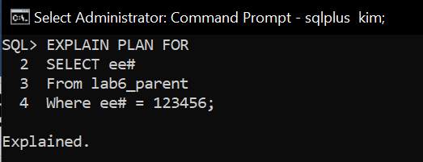

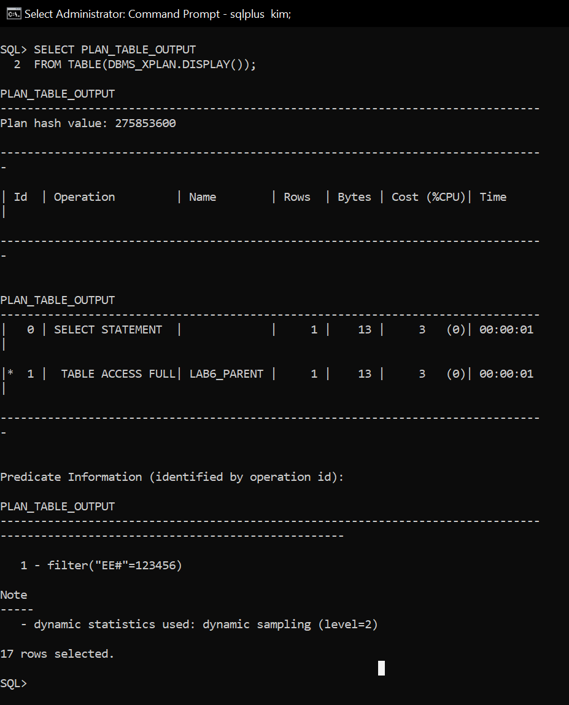

* 1. Change the WHERE clause in *1ai* so that the query returns a range of approximately 25 ee#s. Copy your Explain Plan and Plan_Table_Output below.

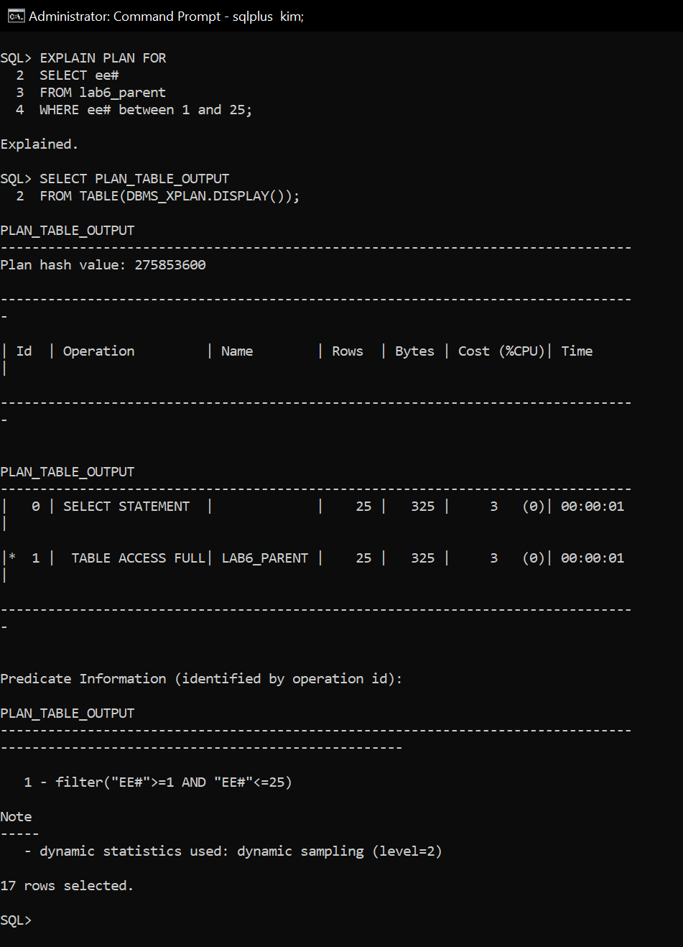

* 1. Write an Explain Plan for a query that displays Parent.EE#, Parent.Lname, Child.EE# and Child.Lname. Take a screenshot of the Explain_plan and the Plan_Table_Output

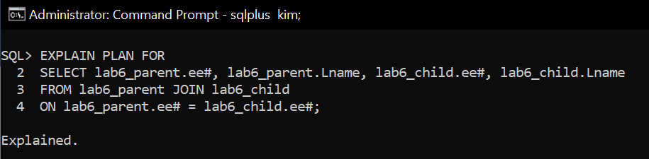

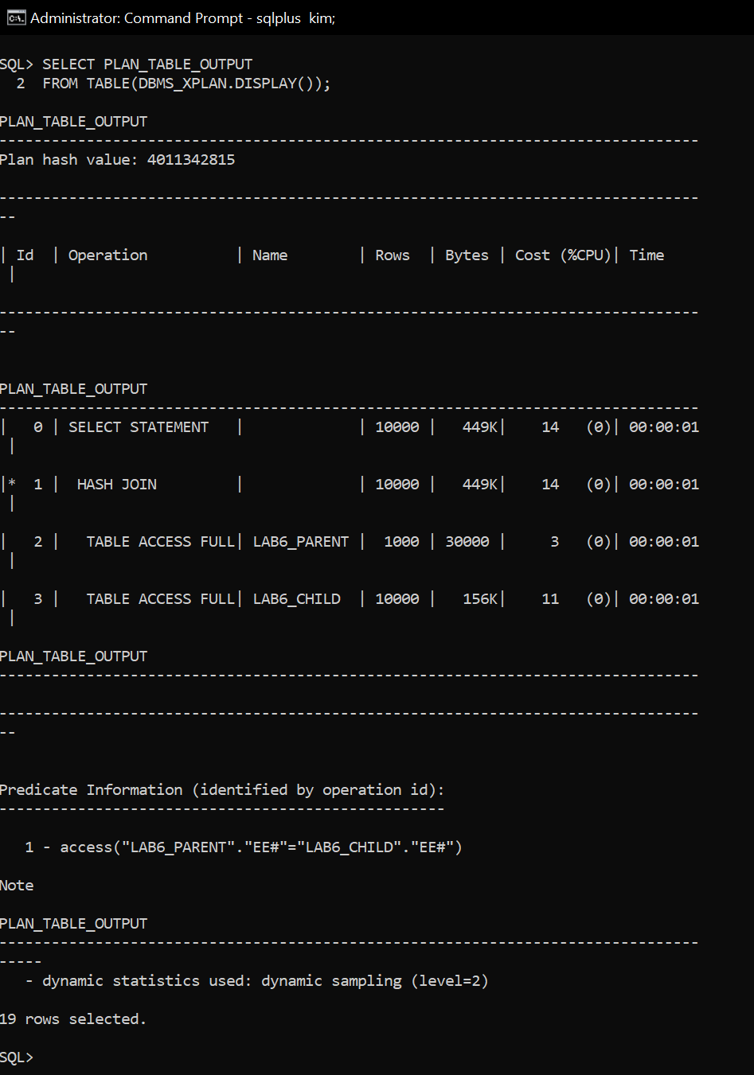

* 1. The main purpose of the preceding activities was to reinforce the idea that a certain type of retrieval – generally considered relatively slow - will be the default approach to retrieving data. Look at the explain plan – it likely shows that each row is retrieved and accessed to check the “where” clause.

1. Add a primary key to both the parent table (ee#) and the child table (ee#, fname). Then rerun *1ai*. The idea is that with the key, there will be an index, which could allow the table to be accessed more efficiently for queries that use ee#. If you obtain the same result as *1ai*, then connect to sys as sysdba and enter: *ALTER SYSTEM FLUSH SHARED_POOL;* and bounce the database (shutdown, startup), reconnect to your general user and rerun the EXPLAIN PLAN query. That will ensure the cached data is flushed.
   1. Your Plan_Table_Output should now be significantly different from the non-indexed version. Take a screenshot of the Explain Plan query and the Plan_Table _Output and add it to your submission document.

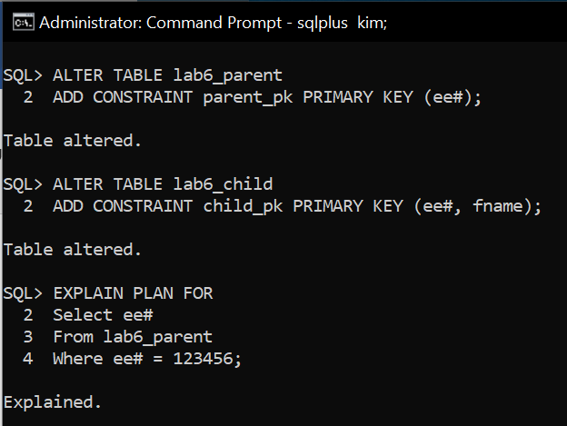

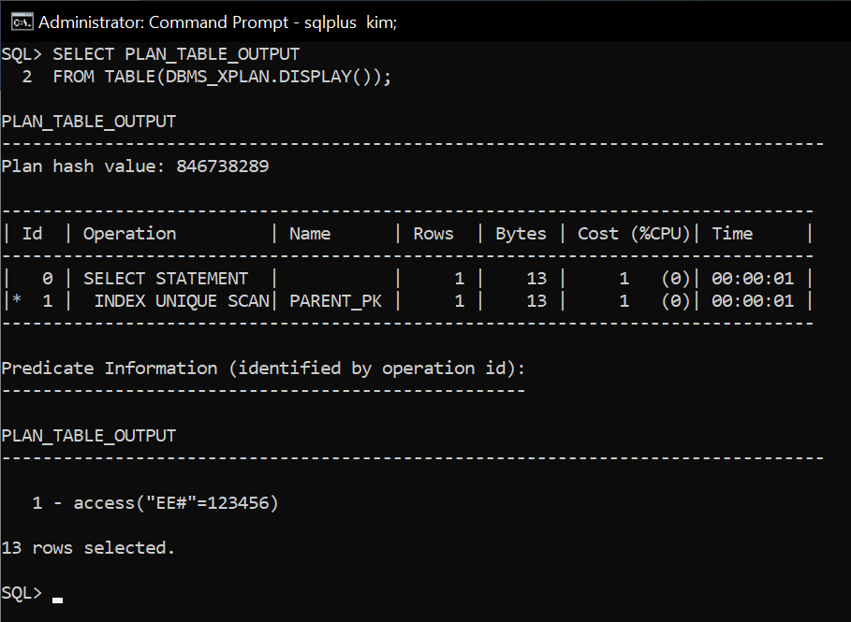

Explain how your actions in 2 changed the query plan (if your plan doesn't change, explain what you expected to occur. You can also try different where clauses to get the index to be used….). _

By using ee# as the Primary Key, and index is created on the table, and by using the index, the table can be accessed more efficiently for queries using ee#(primay key).

* 1. Now that you have added primary keys to both tables, try each of the following scenarios and include screenshots of the explain plan and plan table output for each scenario
     1. a single ee#

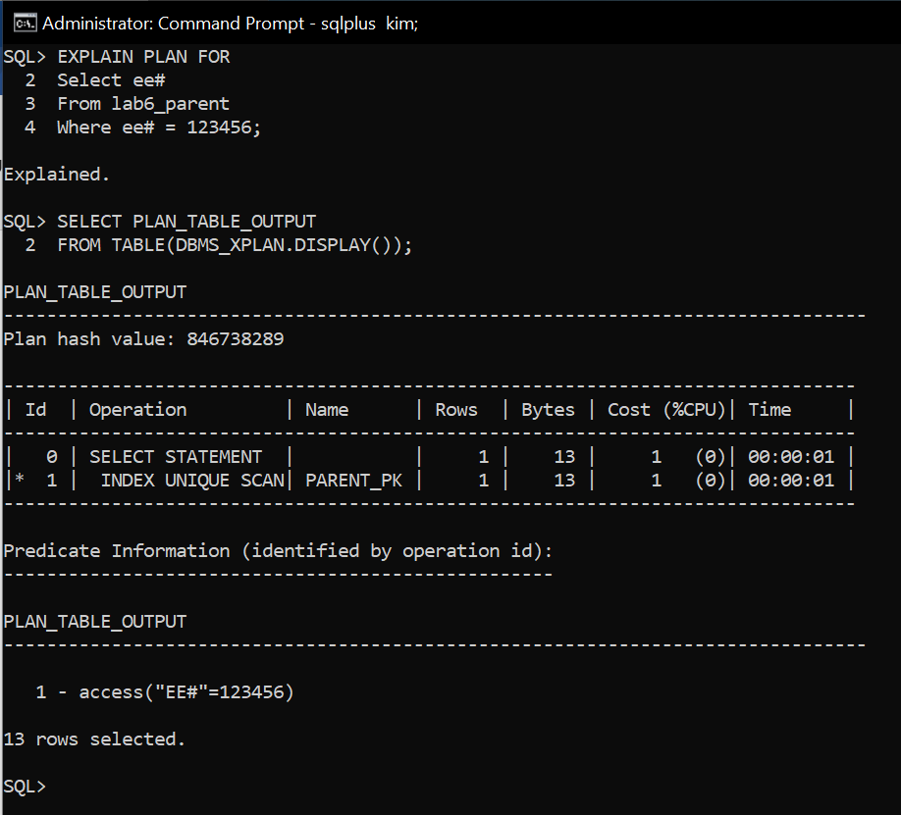

* + 1. a range of ee#s

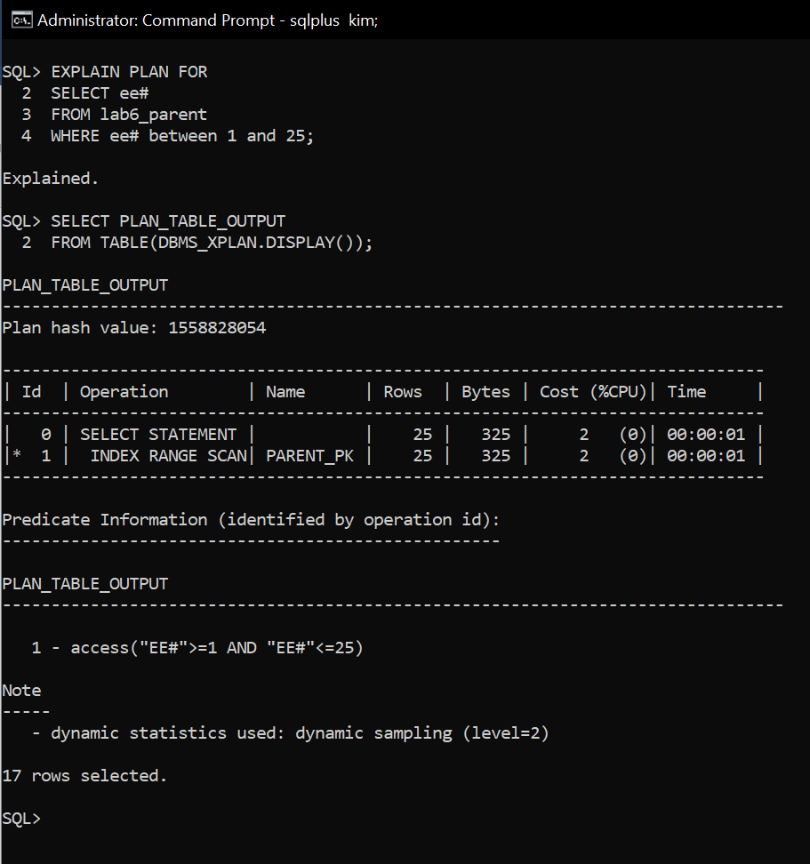

* + 1. a table join on ee# similar to Question 1. Include a screenshot of the explain plan and plan table output.

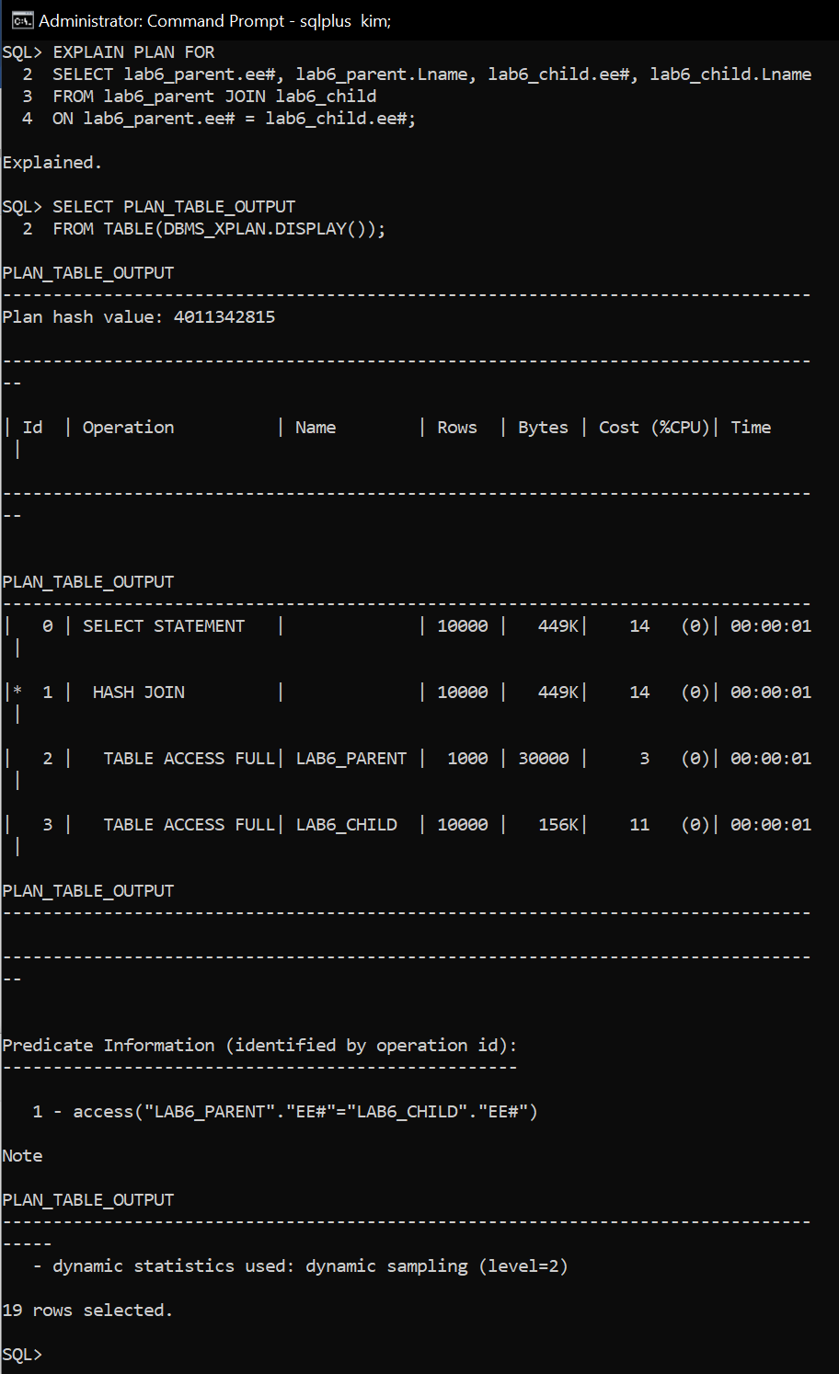

1. Add a foreign key to the child table referencing the parent table. Rerun the table join case from 2 b iii. If your results did not change from the pre-foreign key table join results then, from SYS, bounce the database and retry. Include a screenshot of the explain plan and the resulting plan table output. IF there is still no difference, try changing the where clause to include multiple criteria.   
     
   Describe what you expected to happen (and why) and show your actual results below.



This is small amount information for Oracle, so I can’t see any difference in this case.

1. Write an Explain Plan query that contains a child ee# range and a child lname range selection criteria.
   1. Copy the explain plan and plan­ table output.

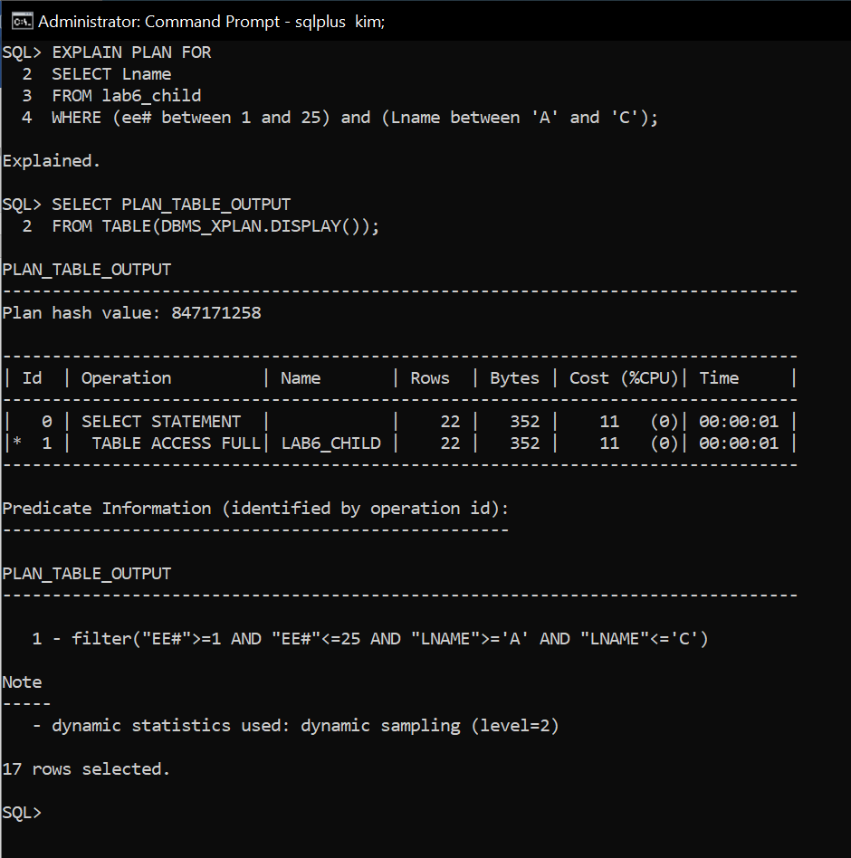

* 1. Add an index to child.lname. Rerun the previous child ee# and child lname range query. Copy the explain plan and plan­ table output. Again, if you don't see any change in results, bounce the instance and rerun.

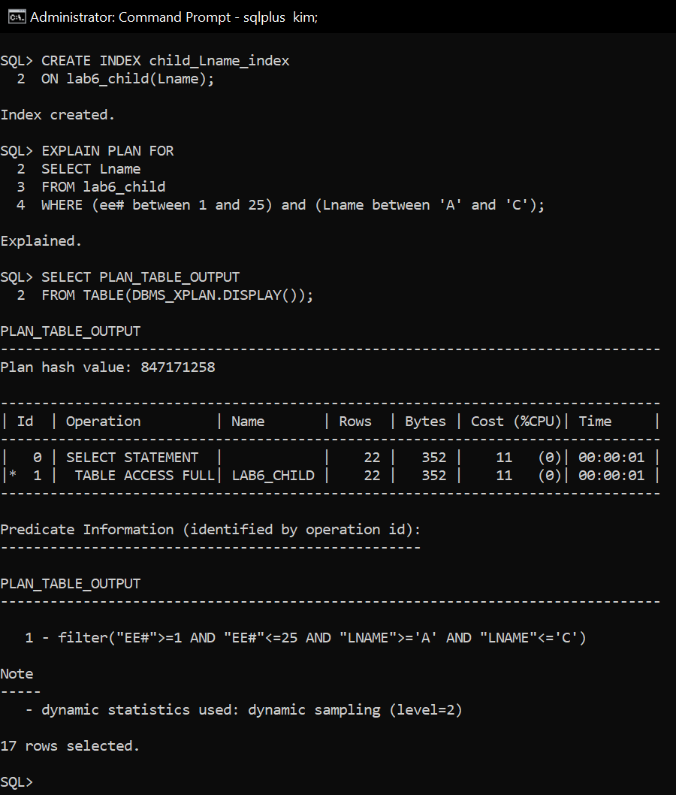

1. Write an Explain Plan query that contains parent ee#, count(lname) an ee# range selection criteria and an ordering of the results by ee# in ascending order. Copy the explain plan and plan­ table output.

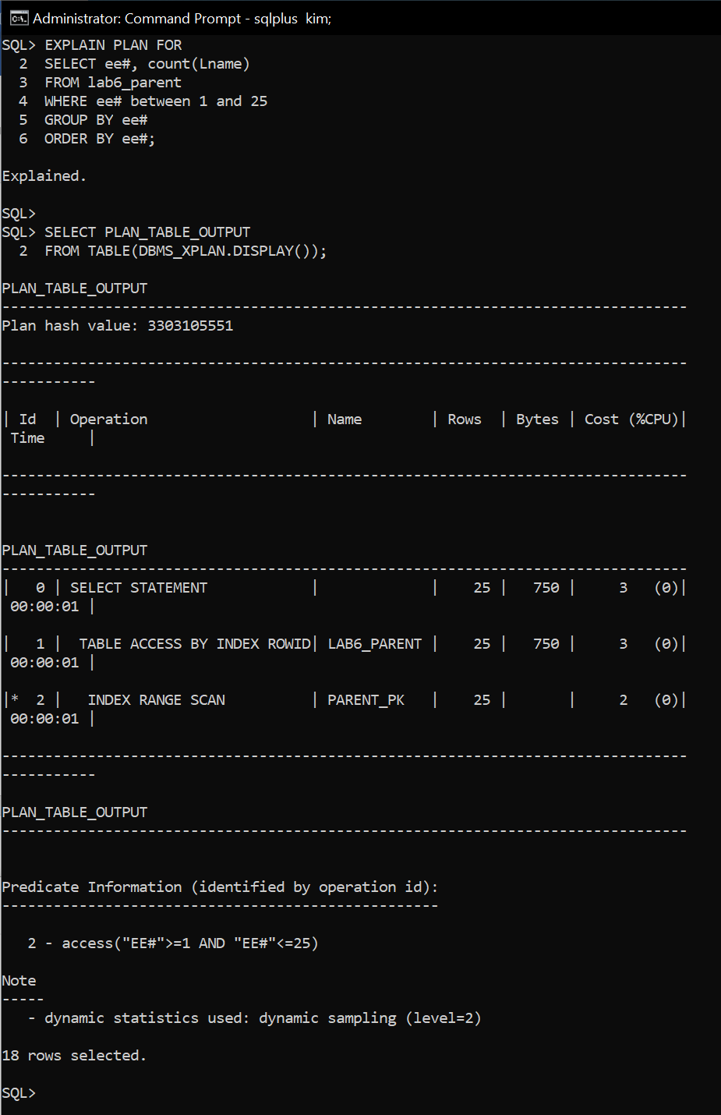

1. Materialized views are very important performance enhancing objects in large databases and/or data warehouses that either need to join multiple tables or perform significant aggregation from remote instances. The materialized view avoids reexecuting the query for each access, even across restarts of the database. The Oracle Data Warehousing Guide, located here, <http://docs.oracle.com/database/121/DWHSG/basicmv.htm#DWHSG008> , provides a good description of this feature.

What does a materialized view contain that a regular view does not?

In Views query result is not stored in the disk or database but Materialized View allows to store the query result in disk or table.

1. Connect to SYS as SYSDBA and grant your generalized user the privilege of being able to *create materialized view*.
   1. Connect as your general user and create a materialized view using a query that returns parent ee#, count(fname) and count(lname). Show your work below.
   2. Edit the query from Q5 to use the newly created materialized view instead of the underlying tables. Execute the new query, and copy the explain plan and plan­ table output.

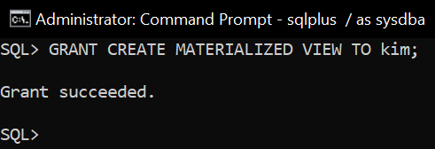

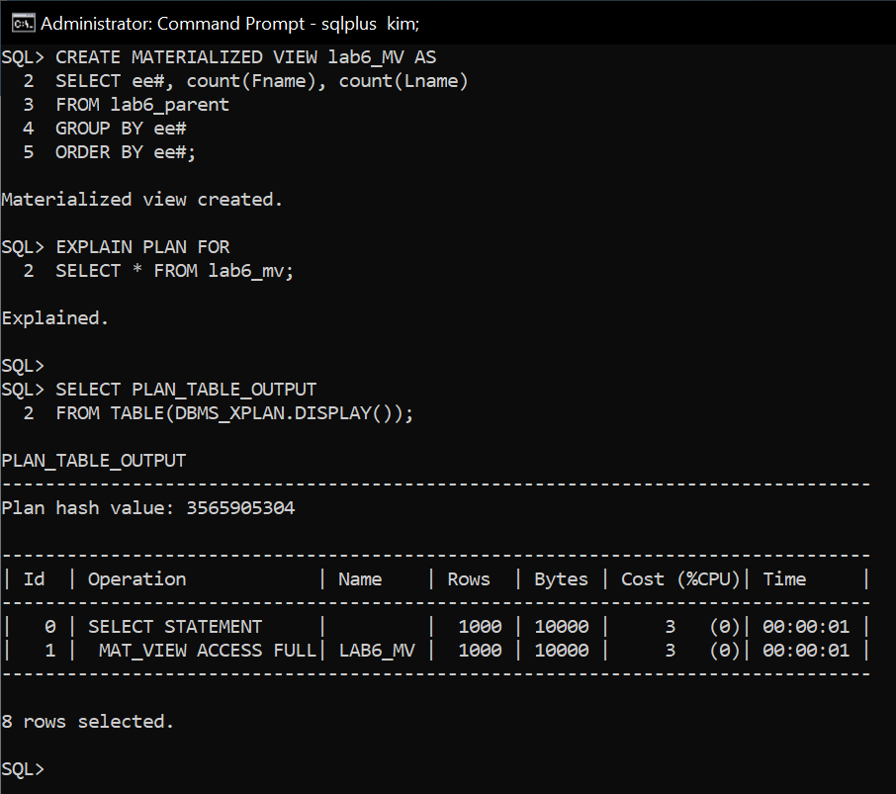

You're finished. Please submit.