CS 206 Data Structure

Hw 1

StudentID: 20160443

Name: 이동민

**Problem1.**

(a)

structure Stack

objects: an ordered list with zero or more elements

functions:

Push(self, value) :

append the value in the stack (created the “list” and in the list class, I made the method append)

Pop(self) :

remove the top value of the stack and return it

(b)

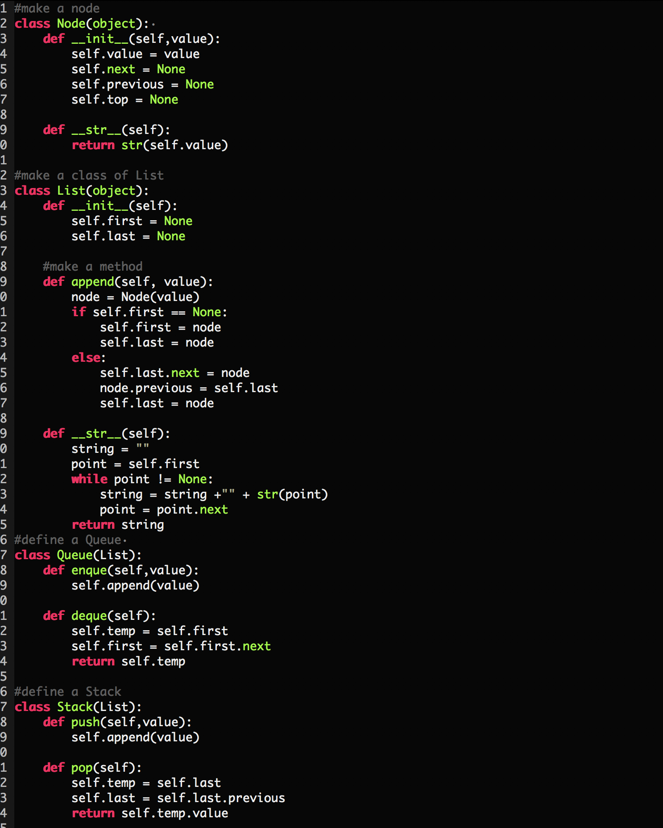



(c)



**Problem2.**

(a)

structure Queue

object: an ordered list with zero or more elements

functions:

Queue(List):

create a queue

enque(self, value):

append the value in the queue (created the “list” and in the list class, I made the method append)

deque(self):

remove the first value of the queue and return it

(b).



(c).

