Project 2

Name: 이동민, 이민지

1.

Code attached. Below is the result of the code.

# file = post-order, Answer = right

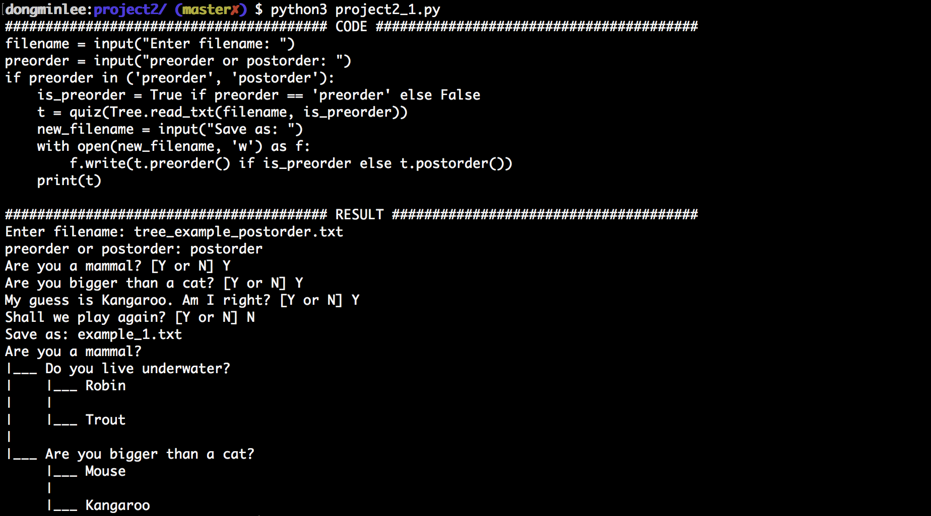

# file = post-order, Answer = wrong

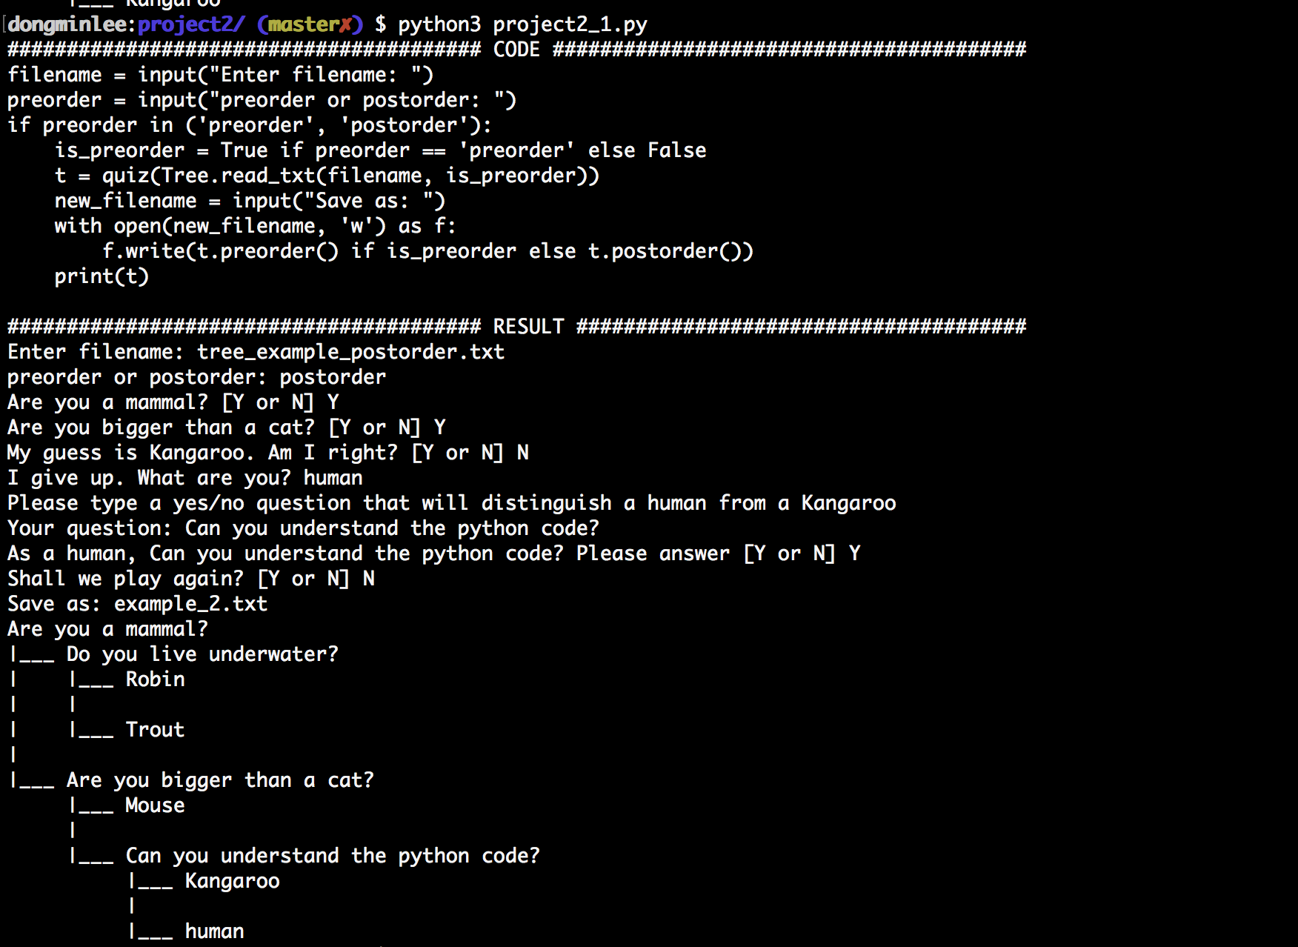

# file = pre-order, Answer = right

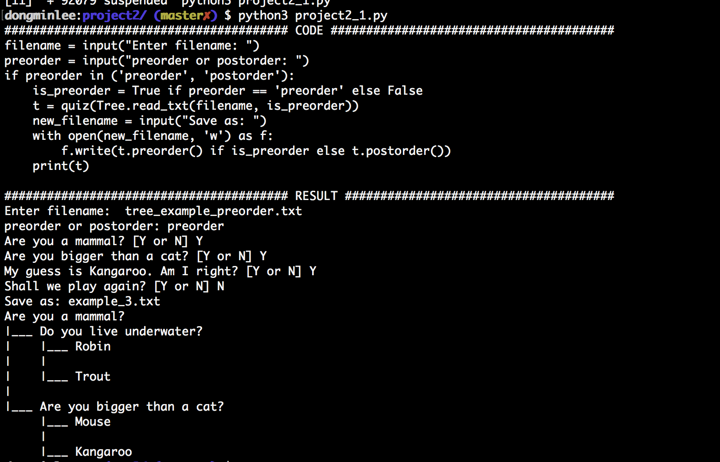

# file = pre-order, Answer = wrong

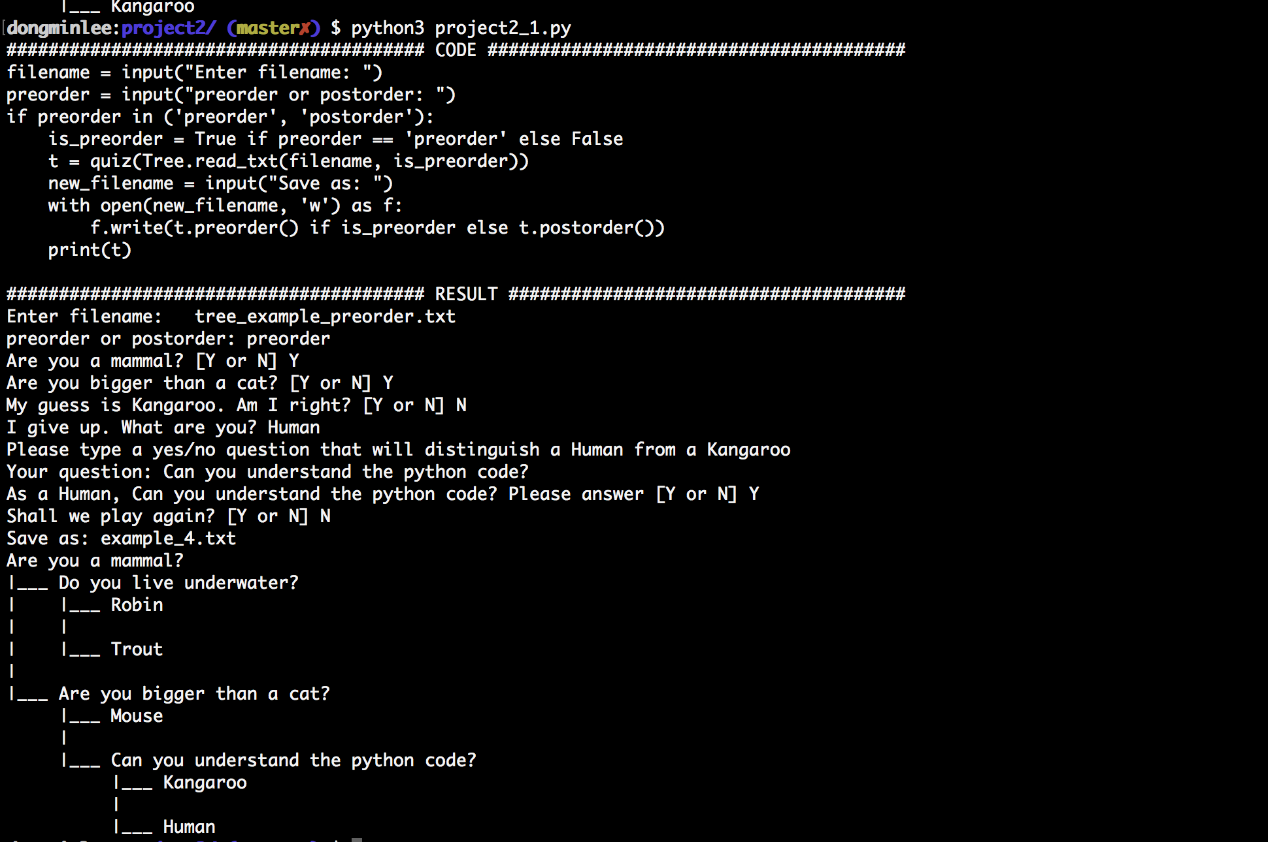

2.

Let n be the number of the nodes. Then both data structures, reading in pre-order and post-order takes O(n).

3.

Code attached. Below is the result of the code.

# file = post-order, Answer = right

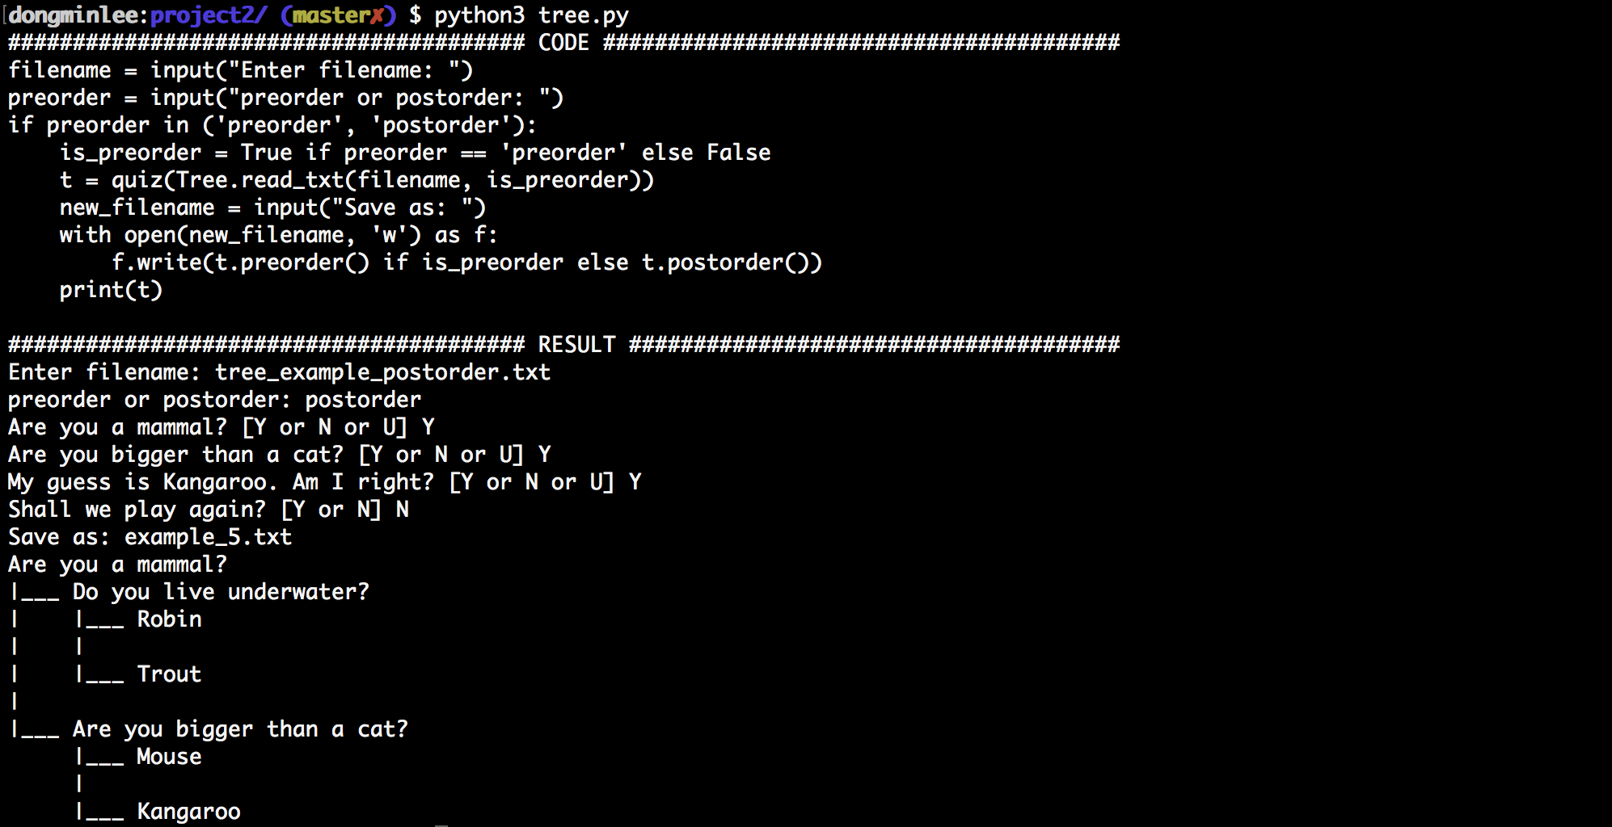

# file = post-order, Answer = wrong  
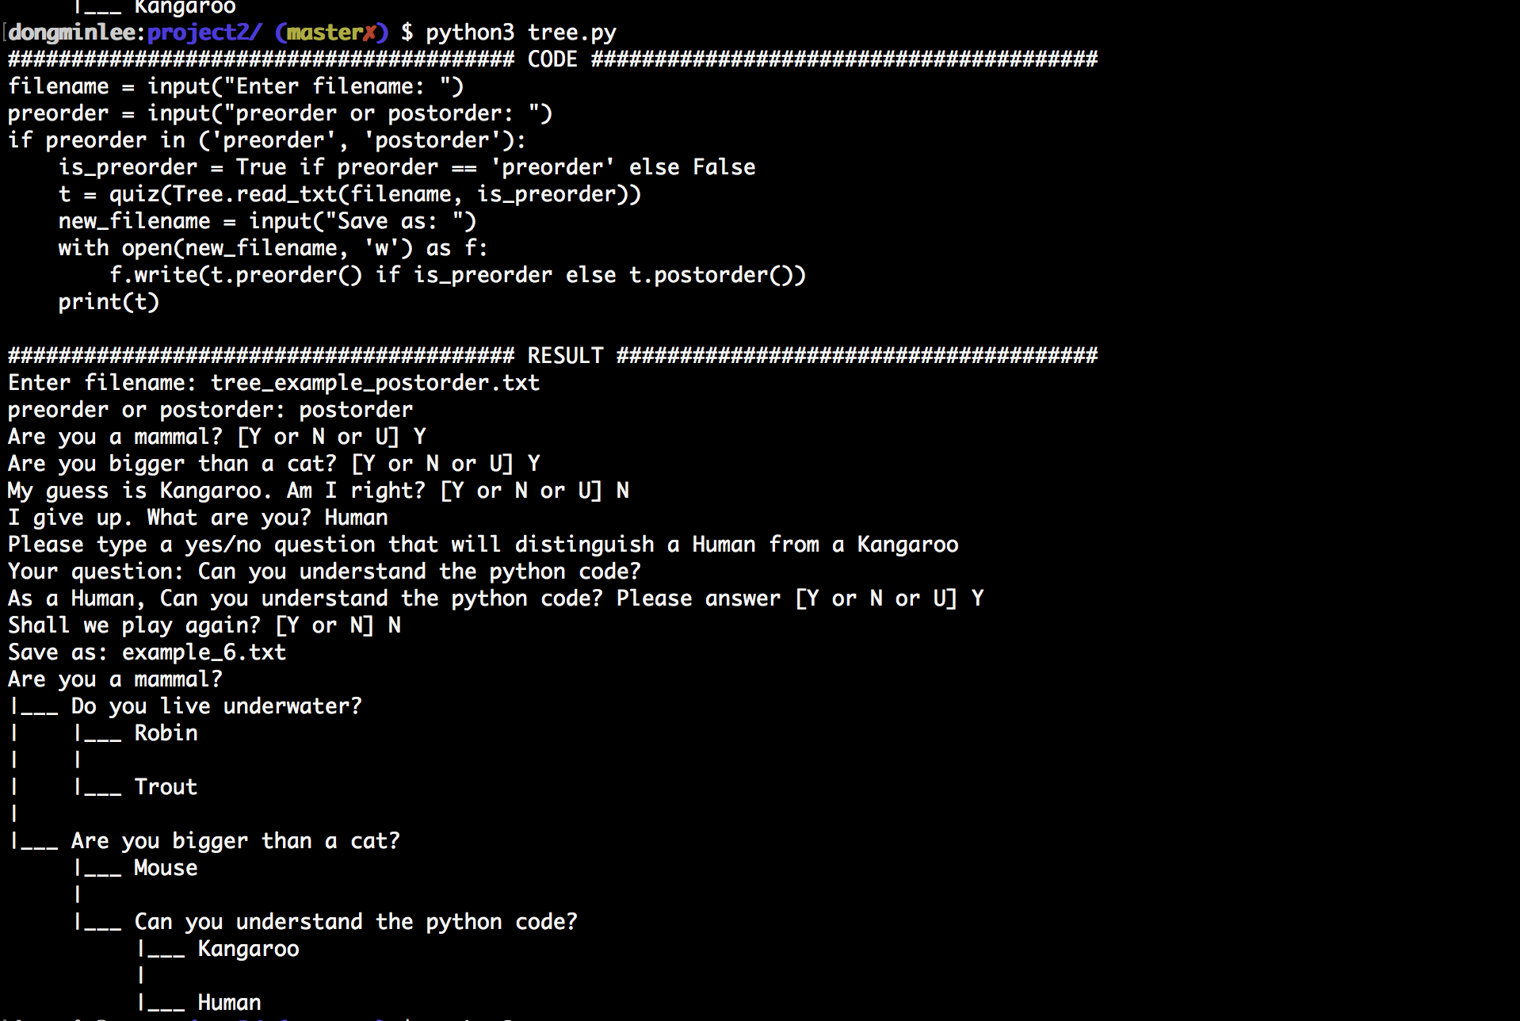

# file = pre-order, Answer = right

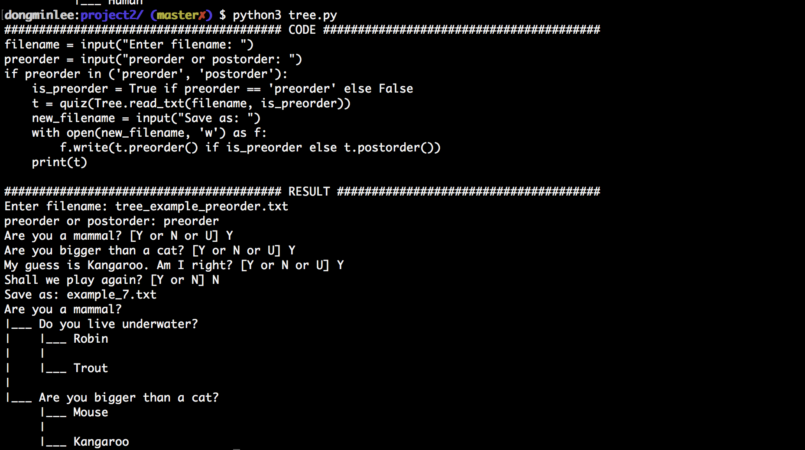

# file = pre-order, Answer = wrong

