

Course code 206
Course Name Software Engineering Theory
Phase 2: Software Design Document Team Name: Hulk

Dec 2020

12 /2020

Contents
Instructions [To be removed] ............................................................................................................................. 3
Team ................................................................................................................................................................... 3
Document Purpose and Audience ...................................................................................................................... 3
System Models ................................................................................................................................................... 4 I. System Decomposition ................................................................................ Error! Bookmark not defined.
- Class diagrams ............................................................................................................................................ 4
- Sequence diagrams .................................................................................................................................... 6
Class - Sequence Usage Table ..................................................................................................................... 7 IV. Physical Entity-Relationship Diagram ........................................................................................................ 15
- User Interface Design ................................................................................................................................. 16
- Algorithms and Data Structures .............................................................................................................. 25
Ownership Report ............................................................................................................................................ 33
Policy Regarding Plagiarism: ............................................................................................................................. 33
References ........................................................................................................... Error! Bookmark not defined. Authors ................................................................................................................ Error! Bookmark not defined.

Team
ID | Name | Email | Mobile
203123 | Mohamed Mostafa Fouad | Mohamedmostafagarieb19@gmail.com
203132 | Mahmoud Fathy Mahmoud
203140 | Mostafa Ahmed Ibrahim
203147 | Momen AboElmagd Ibrahim

Document Purpose and Audience
- This document shows how the software designing model is processed
- Targeted audience: fitness club owner, online stores owners, project managers,

System Models

Class diagrams

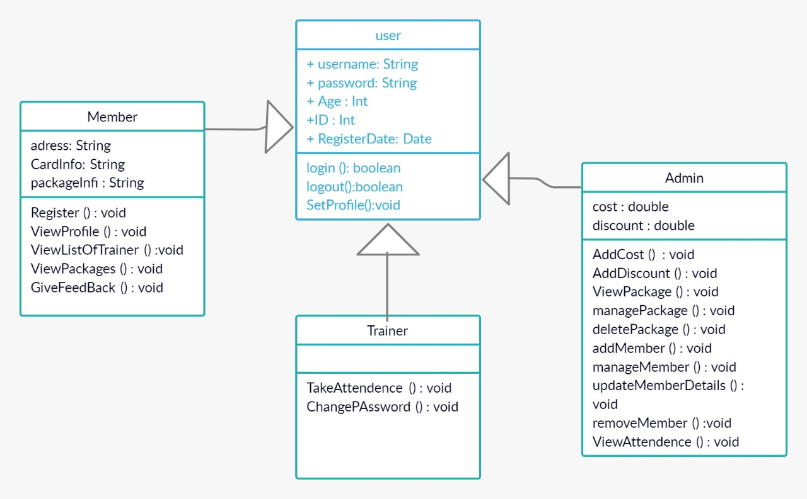

Class ID | Class Name | Subsystem ID | Description & Responsibility
0001 | user | none | Setup profile and take data of users, can login & logout
0002 | Admin | none | Manage the system “packages & member’s details “
0003 | Member | none | View list of trainer and enroll packages, give feedback
0004 | Trainer | none | Take attendance of the member

Sequence diagrams

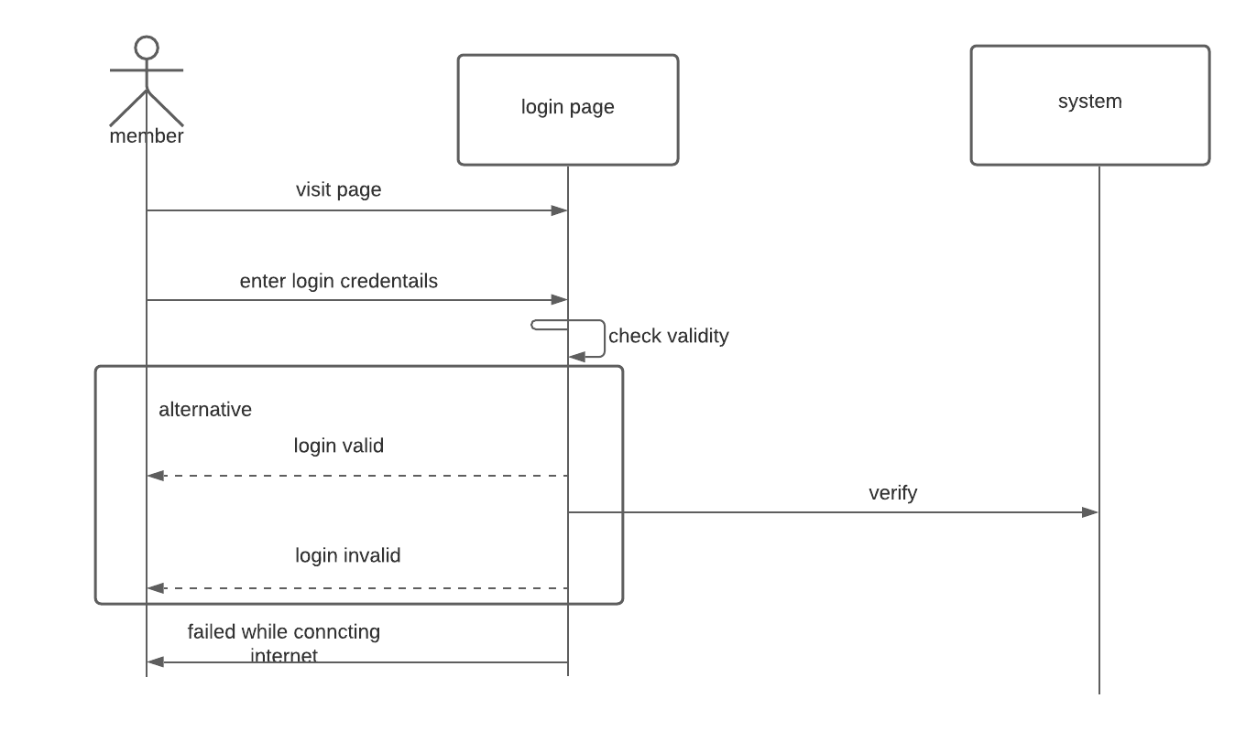

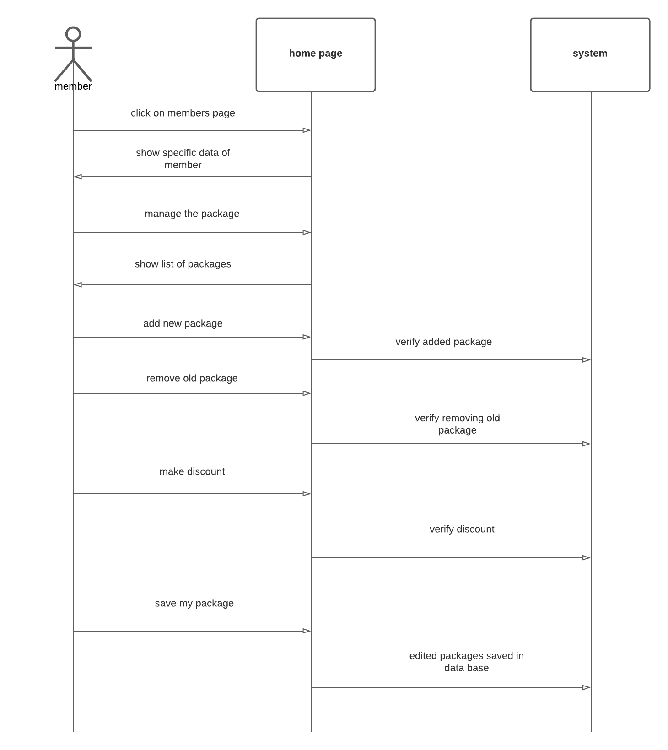
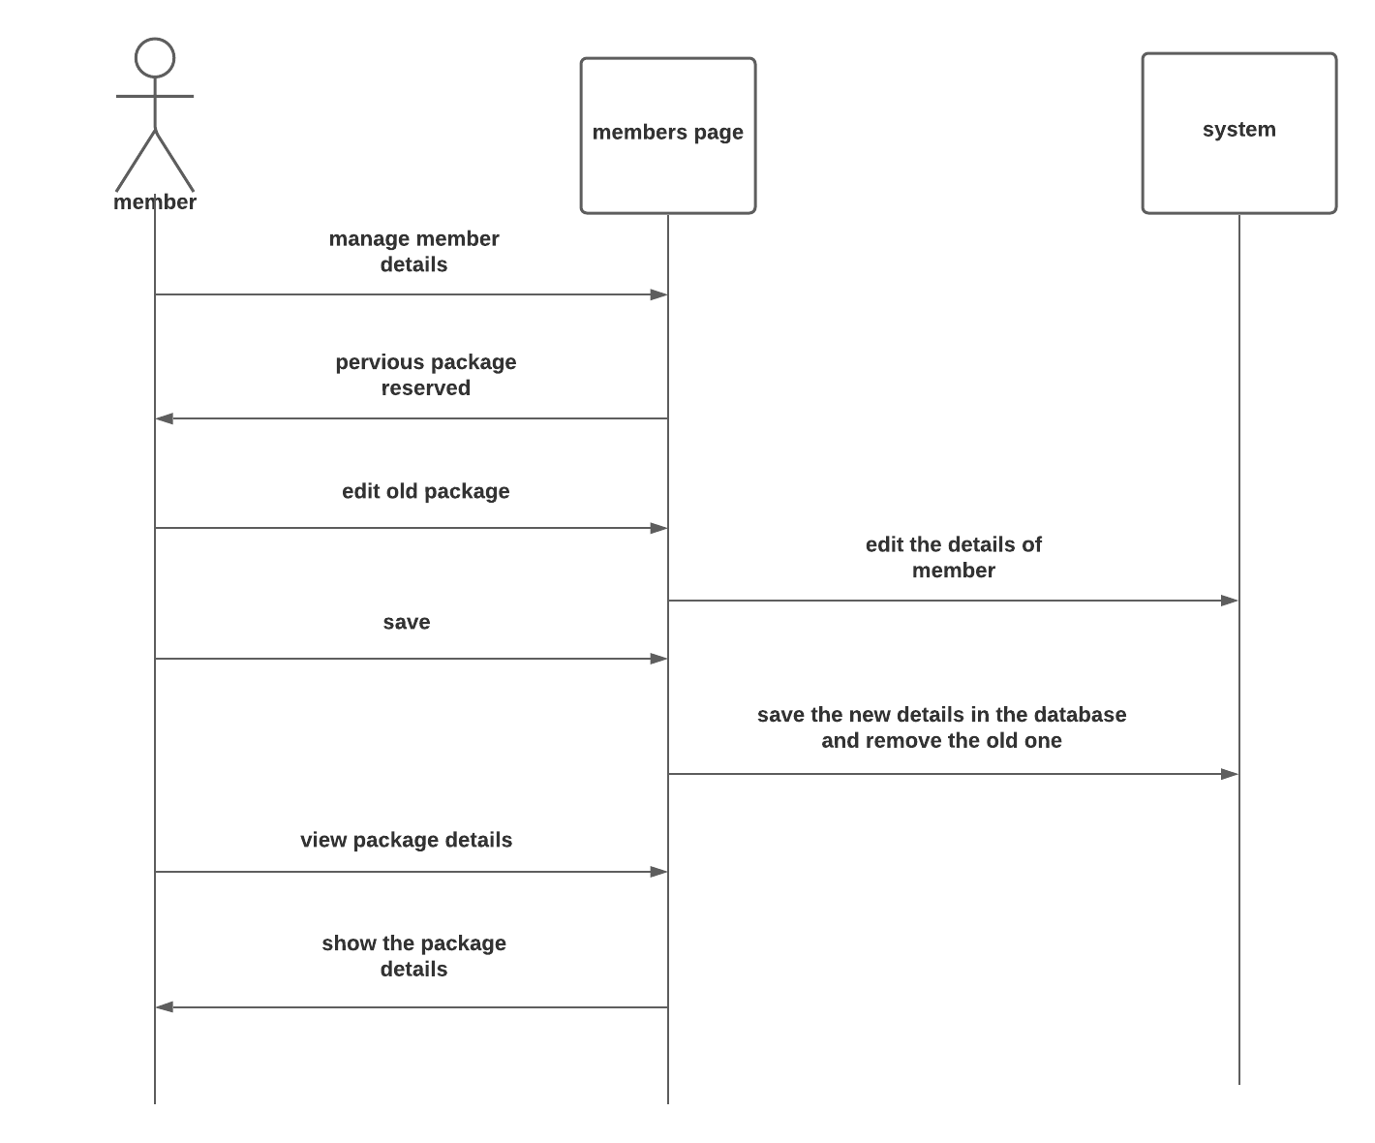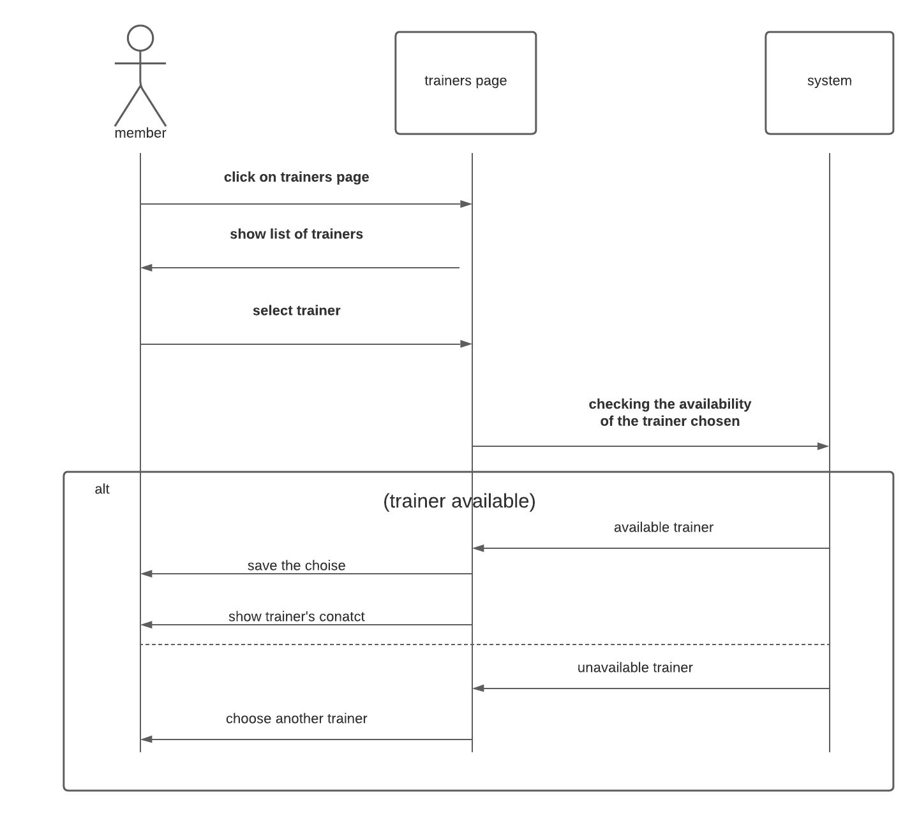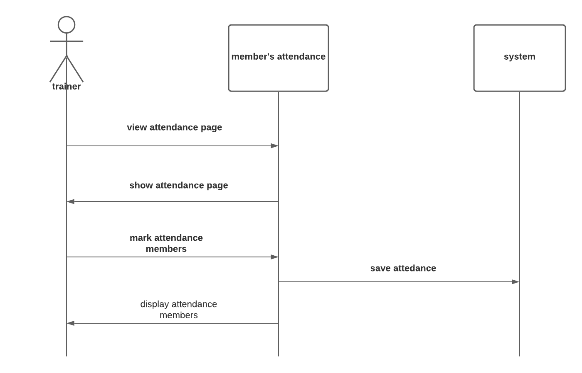
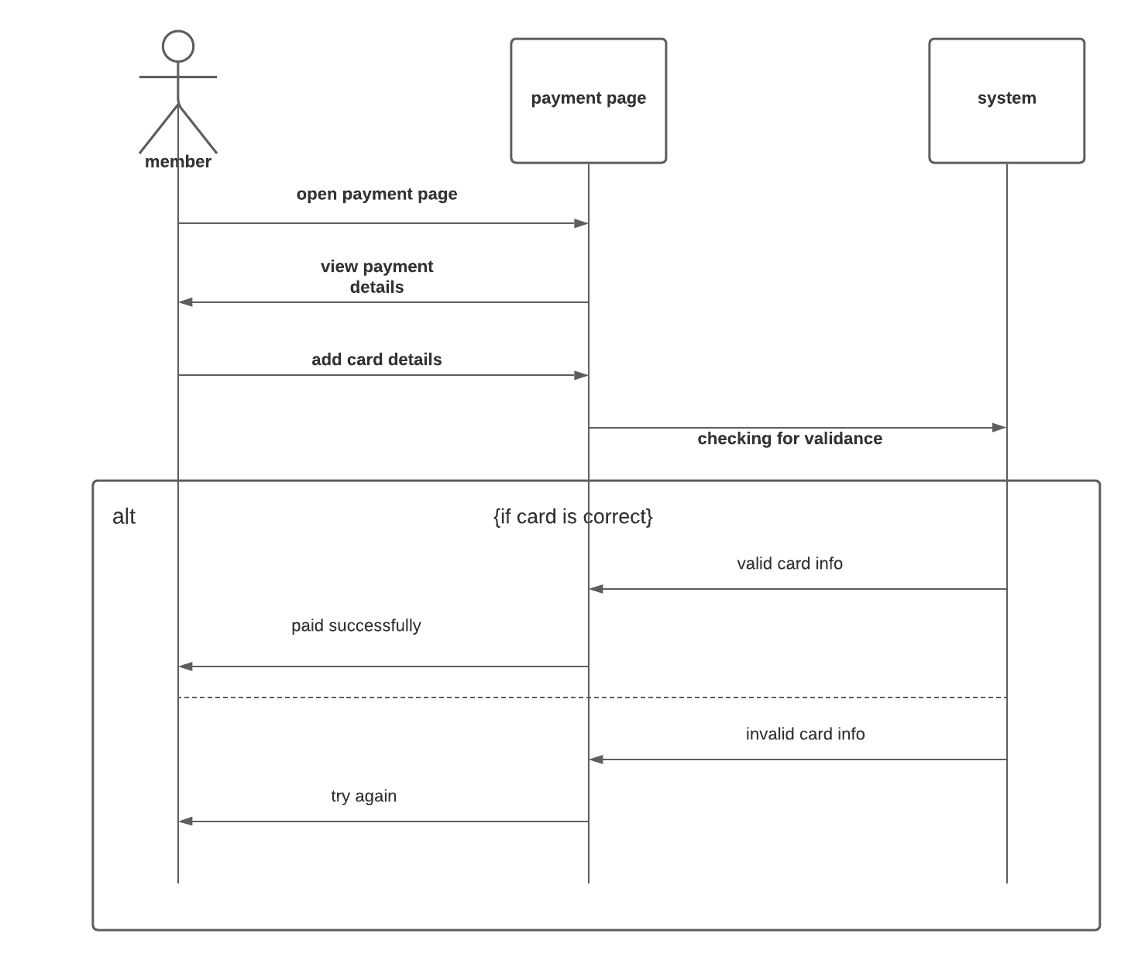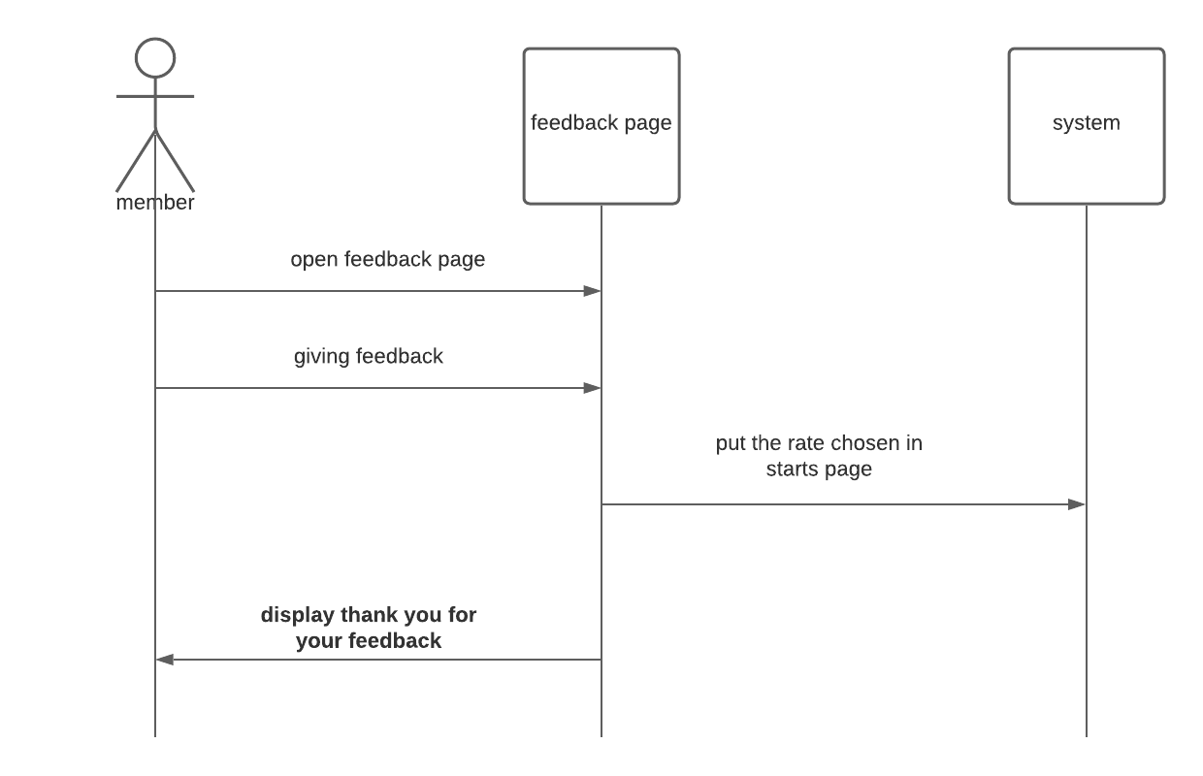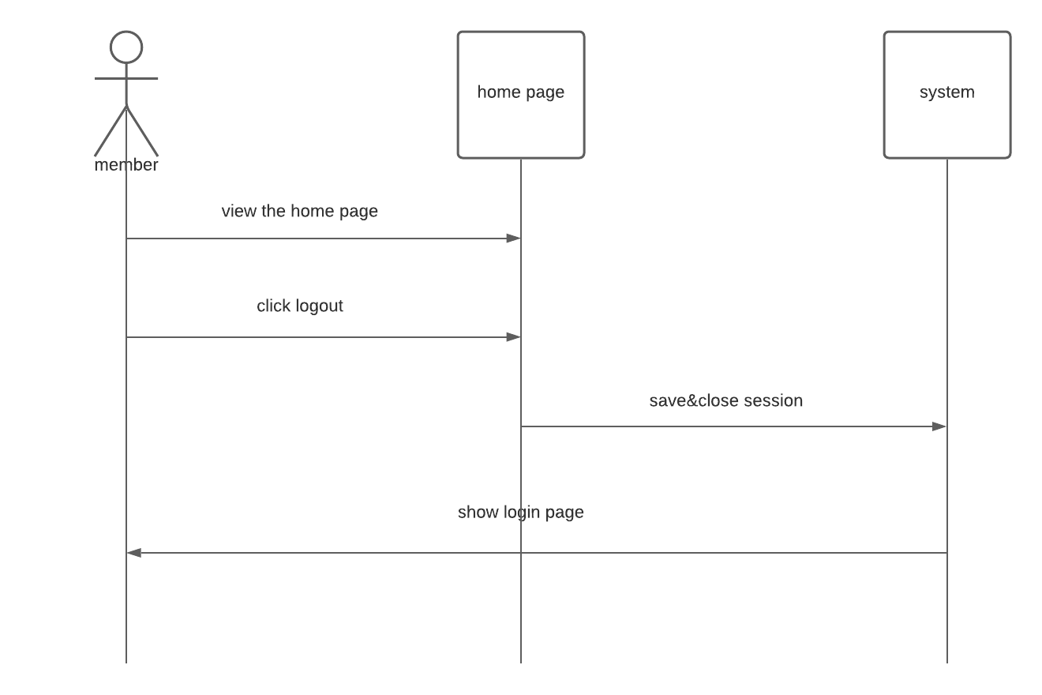

Class - Sequence Usage Table

Class Name | Sequence Diagrams | Overall used methods
member | 1 | Login ()
member | 2 | Manage the packages ()
member | 3 | Manage member details ()
member | 4 | Choosing trainer ()
trainer | 5 | View attendance ()
member | 6 | Payment ()
member | 7 | Giving feedback ()
Member | 8 | Logout ()

III. Physical Entity-Relationship Diagram
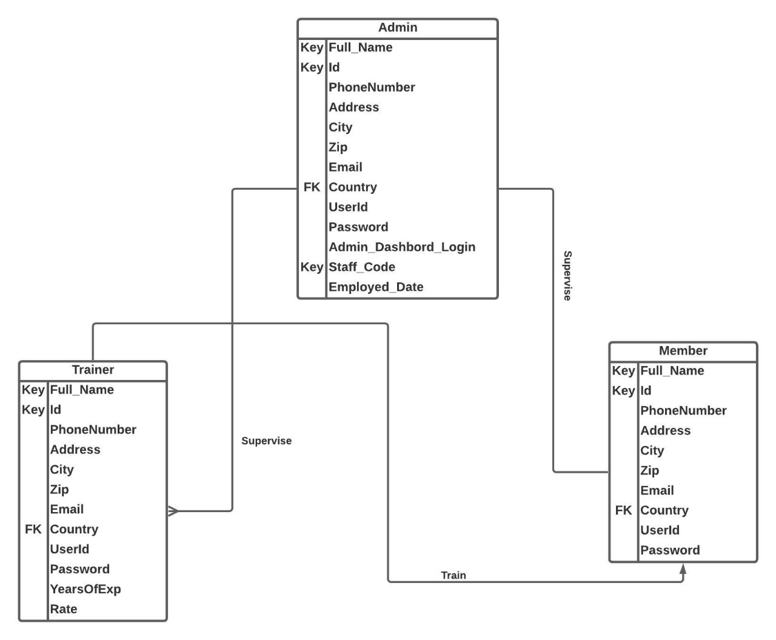

IV. User Interface Design 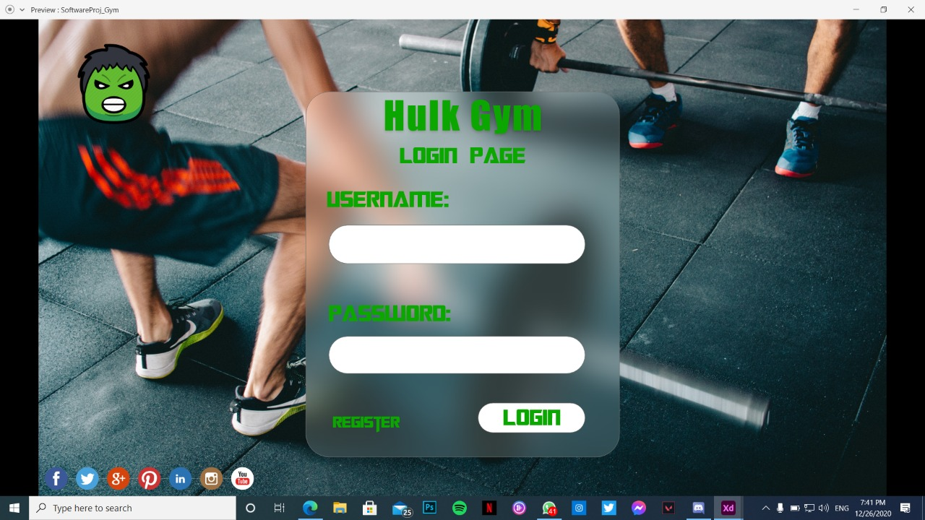
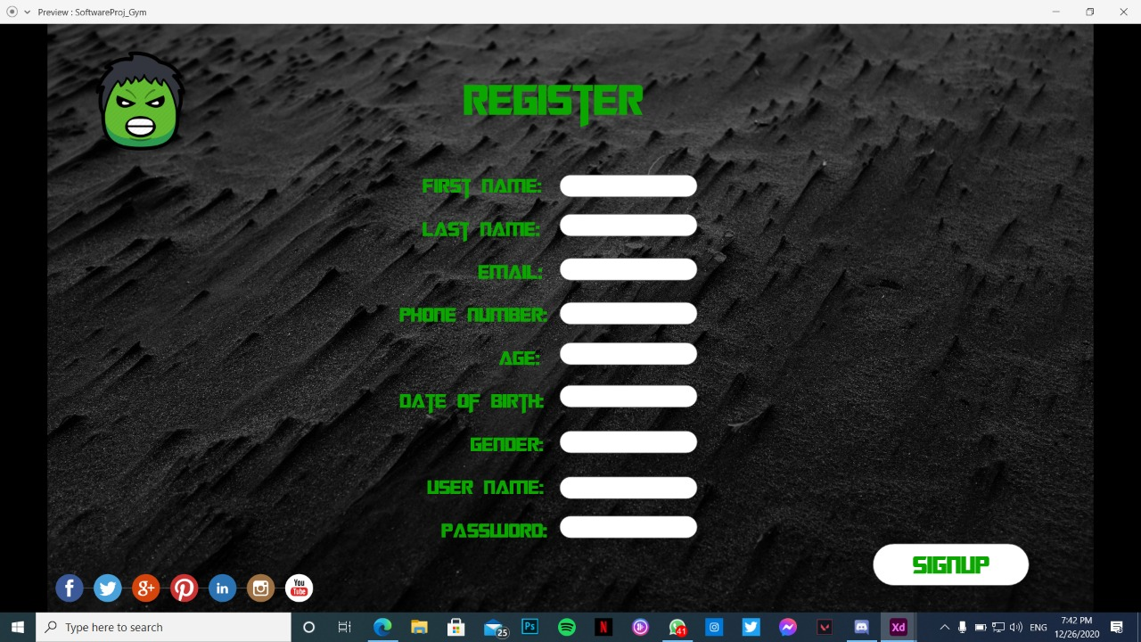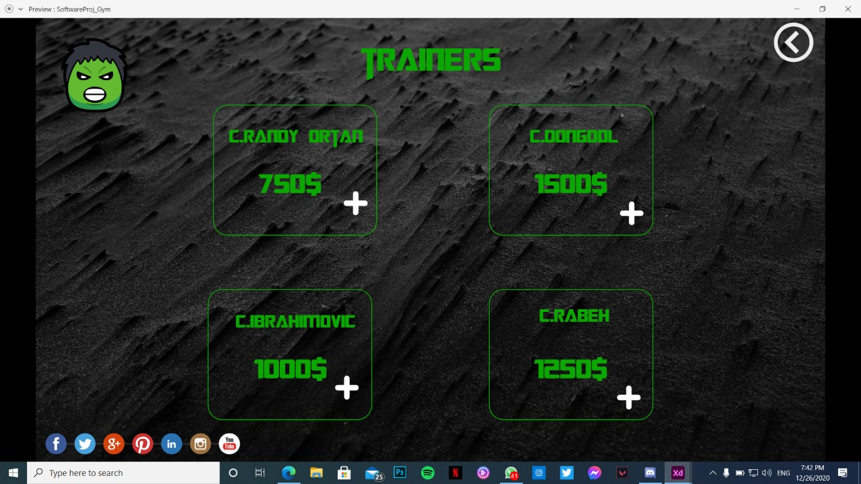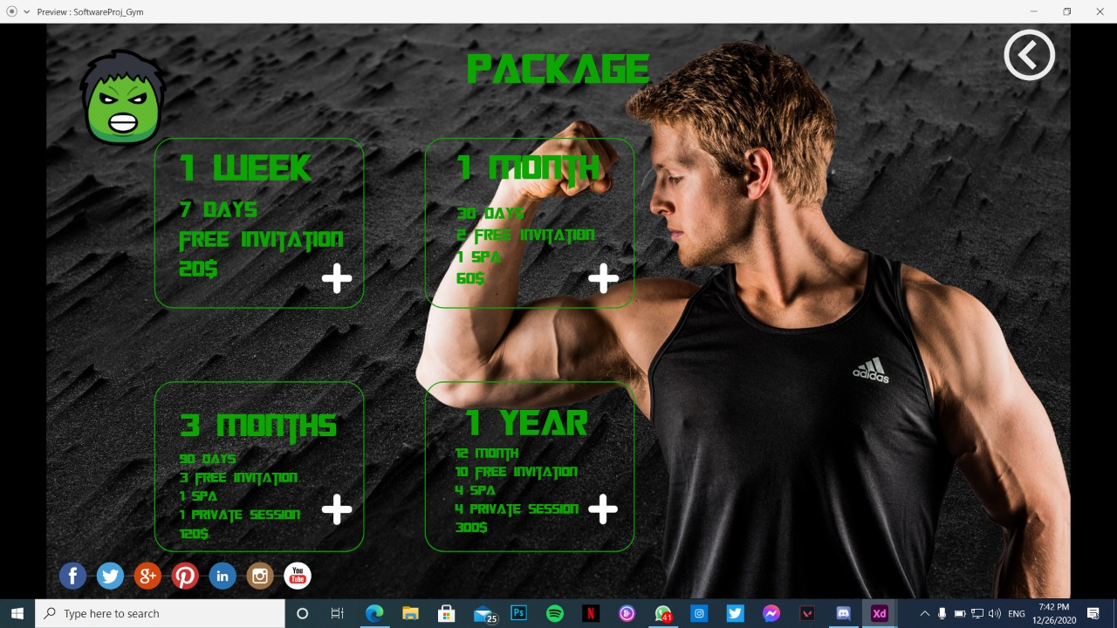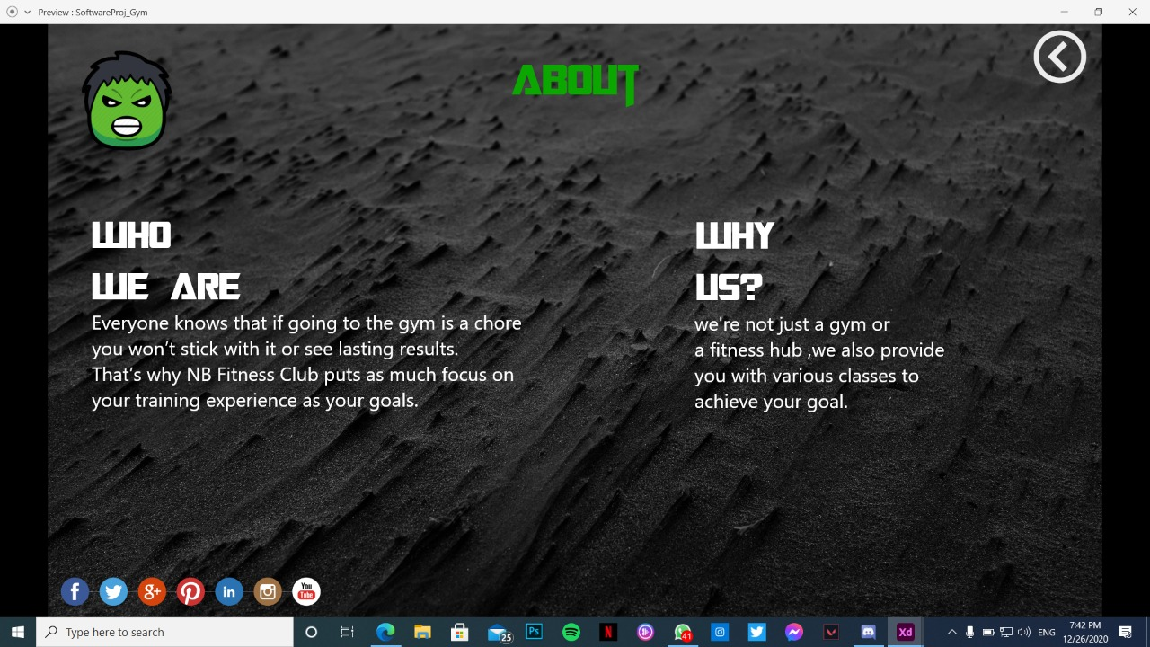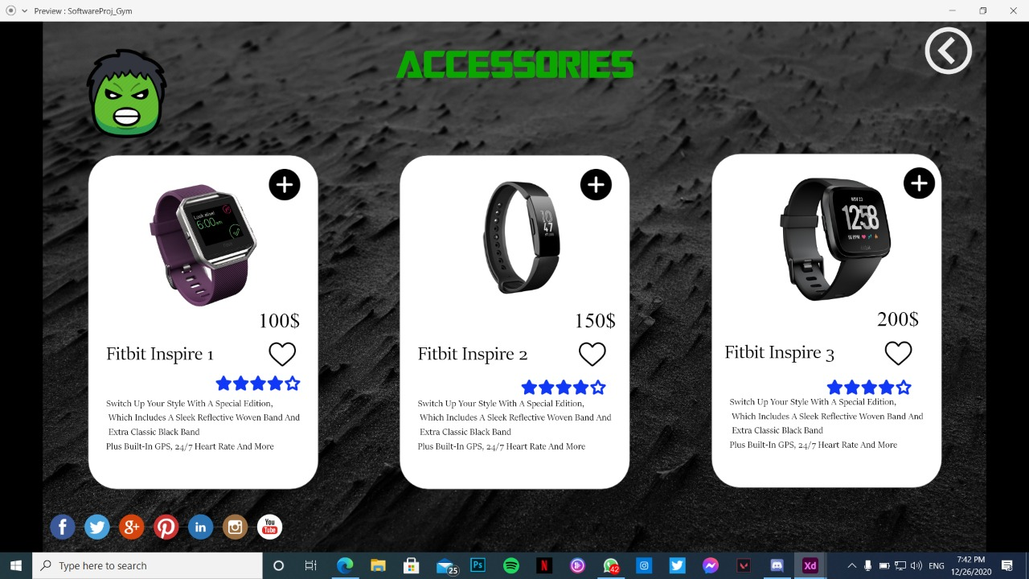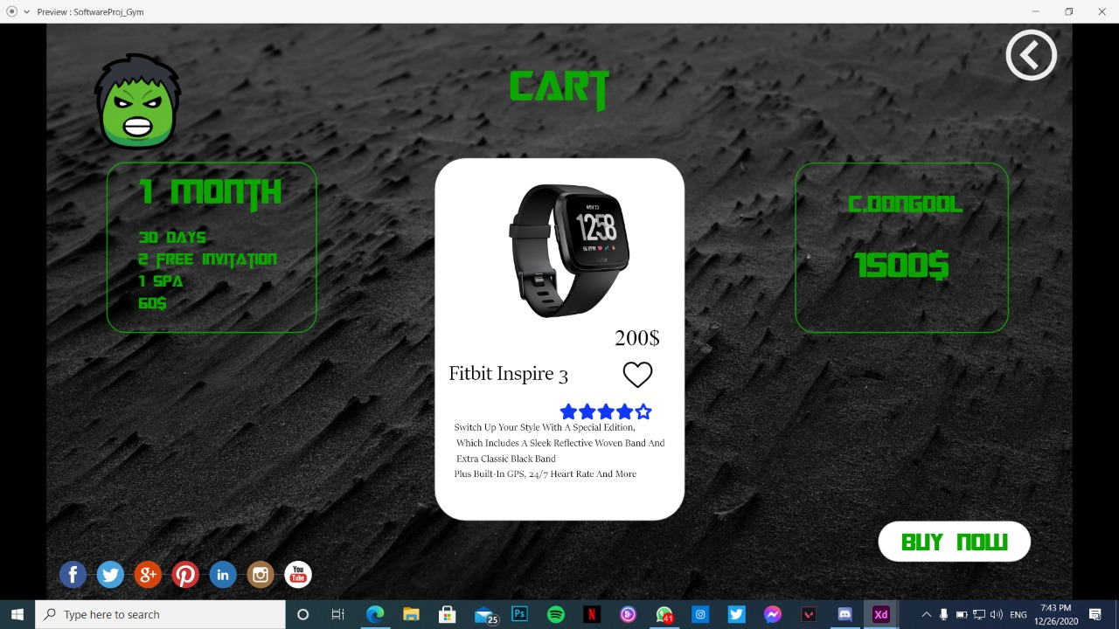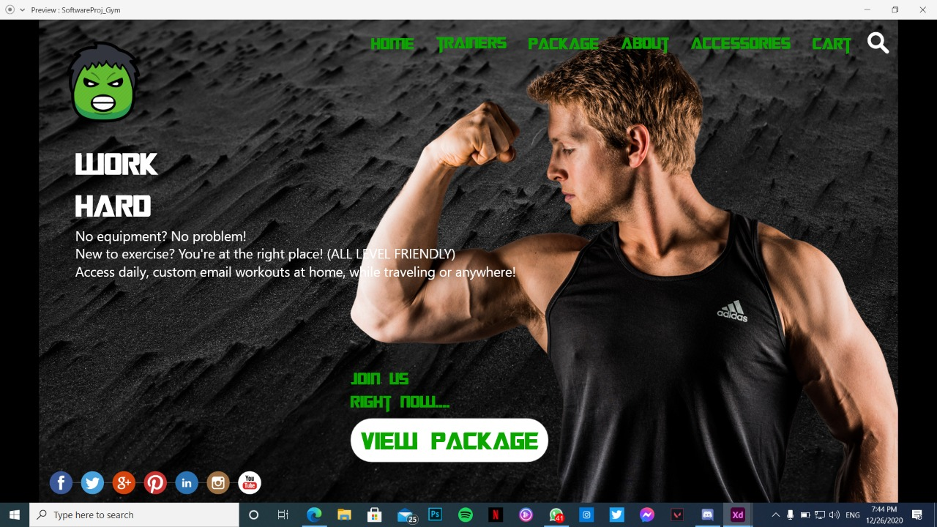

Dataflow diagram (DFD)

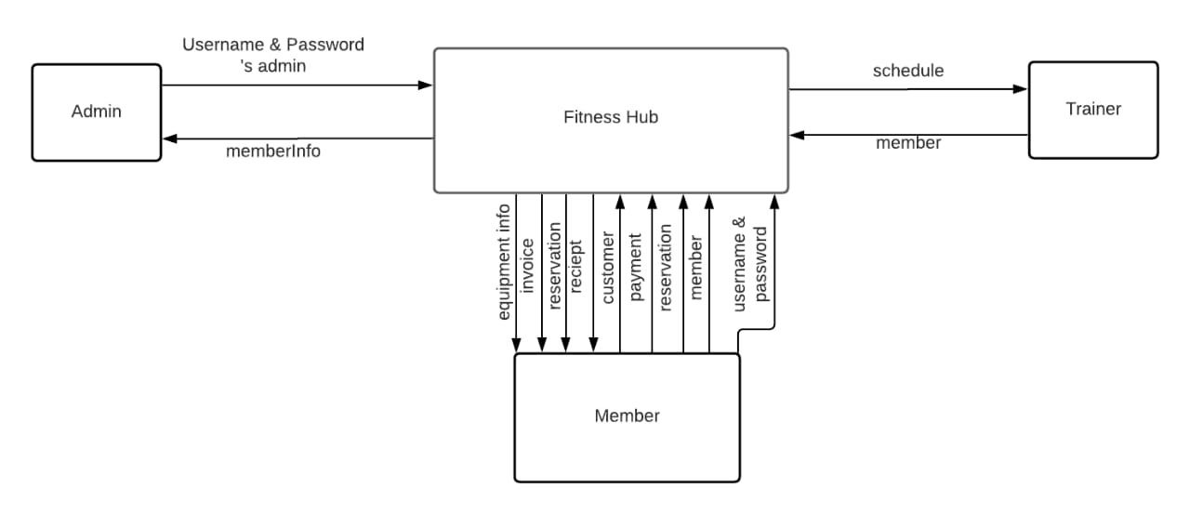

Algorithms and Data Structures

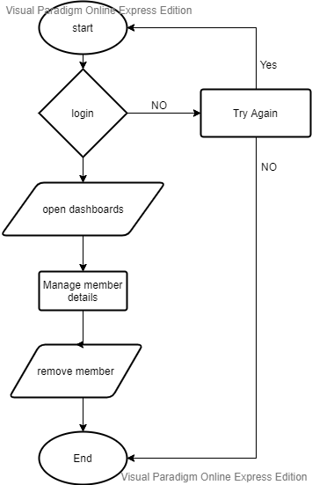
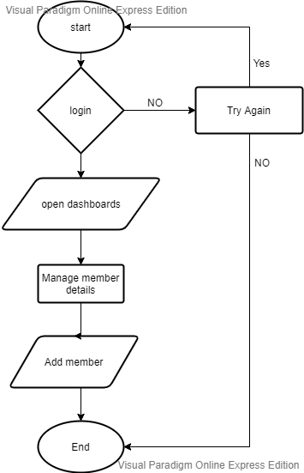

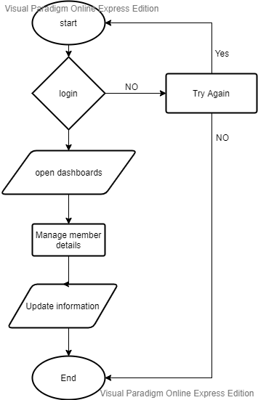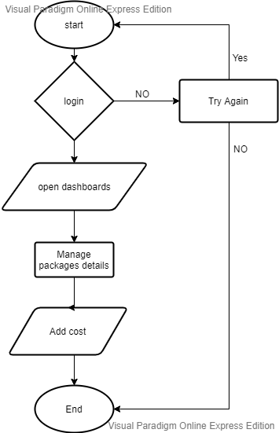

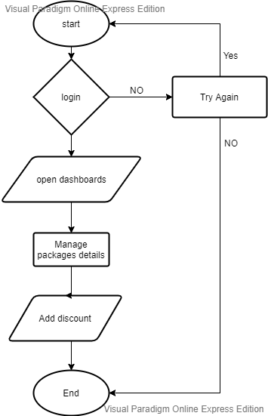

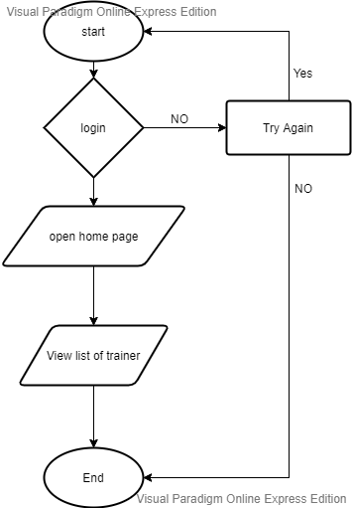
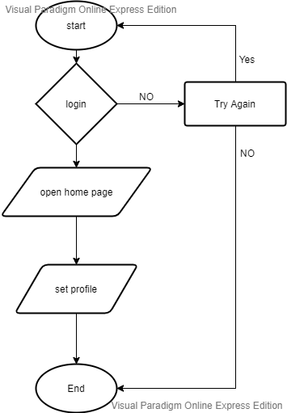

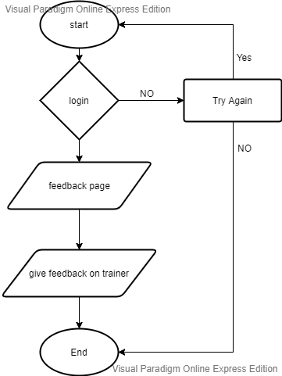

Ownership Report

Item | Owners
none | none
none | none

Github
https://github.com/Dongooll/Hulk-Gym

