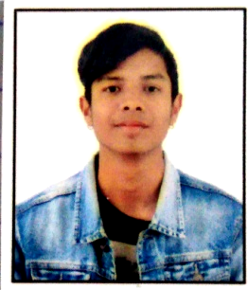 **CURRICULUM VITAE**

**Binod Tharu**

**Email:** [dongzbinod701@gmail.com](mailto:dongzbinod701@gmail.com)

**Phone:** 9811587319

**PERSONAL STATEMENT**

Pursuing career in a challenging environment that could provide an opportunity for learning and professional advancement to work will full dedication and honestly for my organization and devote my potential for the progress of the organization.

**Education background**

* SEE pass out at 2076 BS
* +2 pass out at 2078 BS

**Language**

* Nepali (Excellent in speaking, reading, writing and listening)
* Hindi(Excellent in speaking, reading, writing and listening)
* English(Good in speaking, reading, writing and listening)

**WORK EXPERIENCE:**

* Worked as sub engineer (Tejasvi computer support)
* Worked as computer operator (Birtamode municipality)

**PERSONAL INFORMATION**

* **Passports no:**
* **Citizenship no:** 37-02-76-04413
* **Date of Birth:** 2059/04/25
* **Nationality:** Nepali
* **Religion:** Hindu
* **Marital Status:** single