AERO1005 MATLAB Coursework 2

Author: Dongqi YAO
Student ID: 20720155
Date of report: 04/25/2026

LED indicator circuit construction
The temperature sensor and resistors are connected to the Arduino Uno on the breadboard. The sensor output is connected to analogue pin A0, while power and ground lines are properly routed to ensure stable signal acquisition.
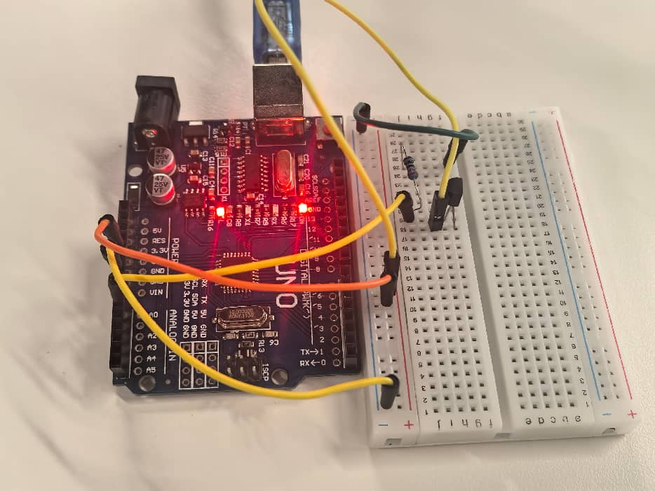
The three-colour LED system (green, yellow, red) is wired with current-limiting resistors to digital pins D3, D5, and D7 respectively. This forms the visual feedback interface for temperature monitoring.
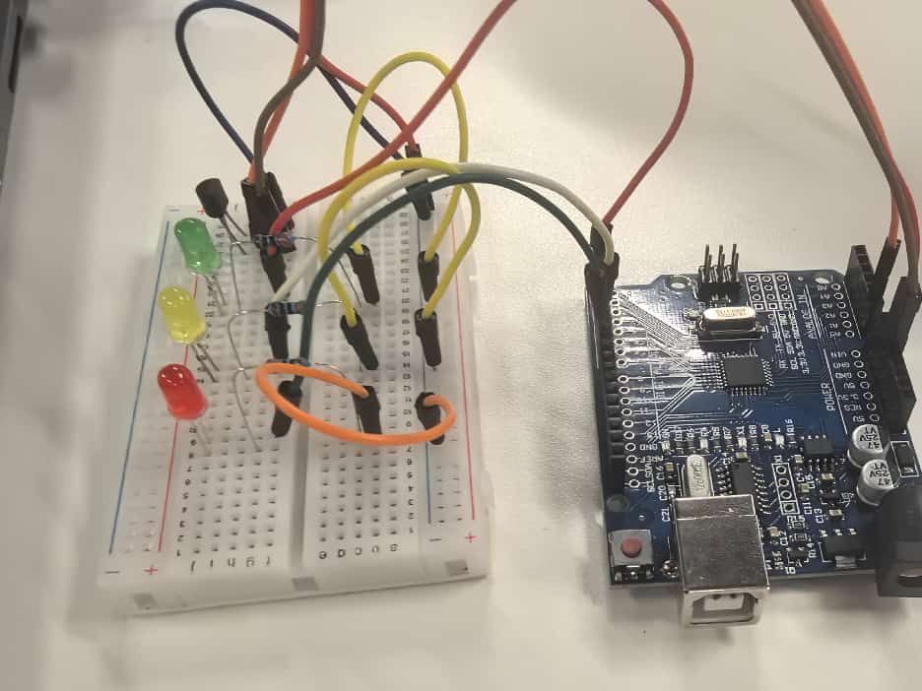
When the measured temperature is below 18°C, the yellow LED activates, indicating the low-temperature warning state. The real-time temperature plot in MATLAB shows stable readings.
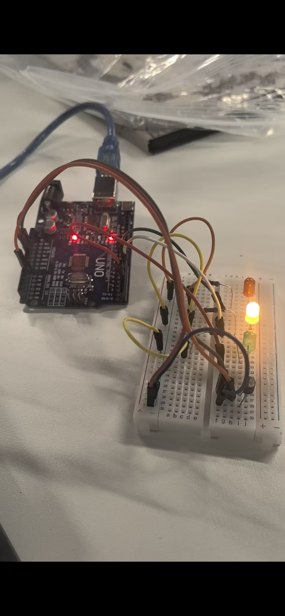
As the temperature rises above 24°C, the red LED lights up as a high-temperature alert. The rate of temperature change is also calculated and printed in the MATLAB command window.
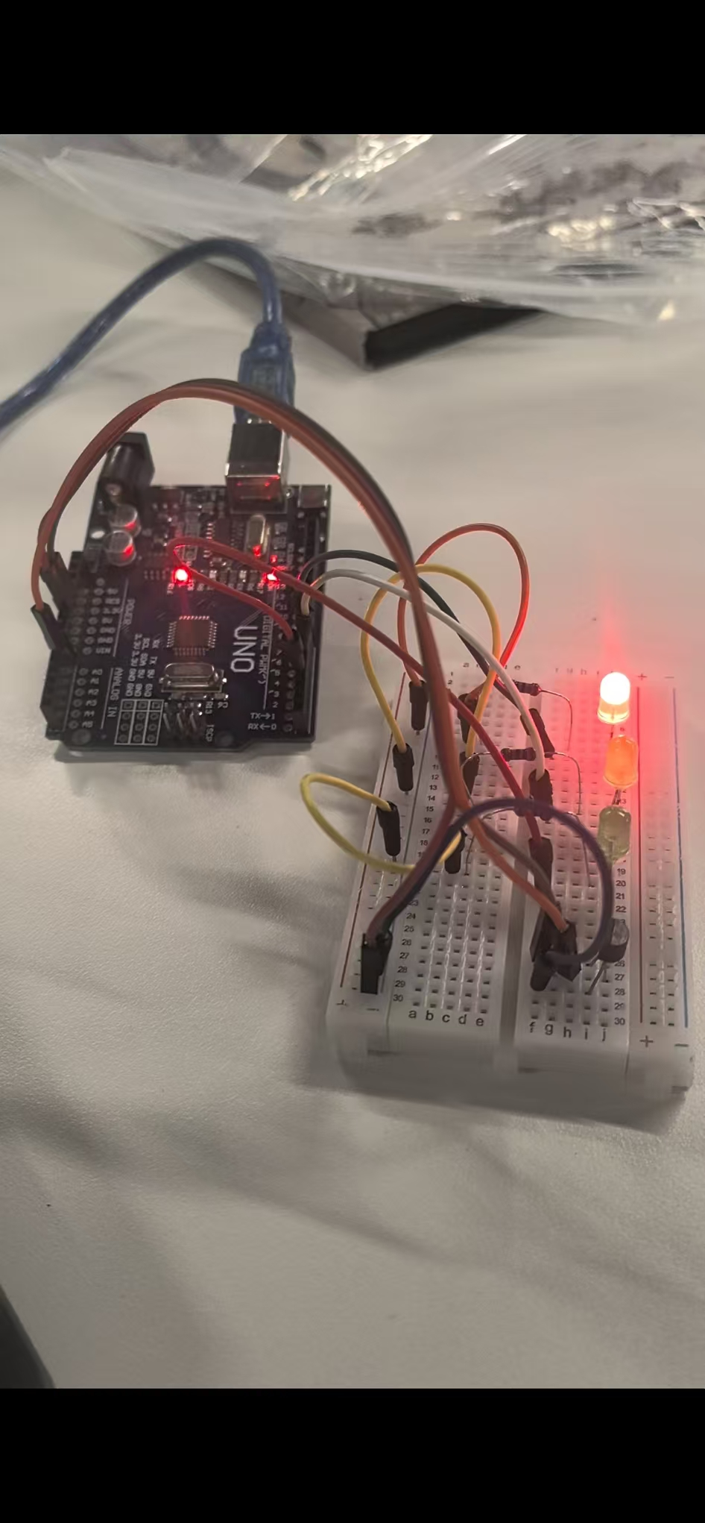
When the temperature stabilises within the 18–24°C comfort zone, the green LED remains constantly on, confirming normal cabin environmental conditions.
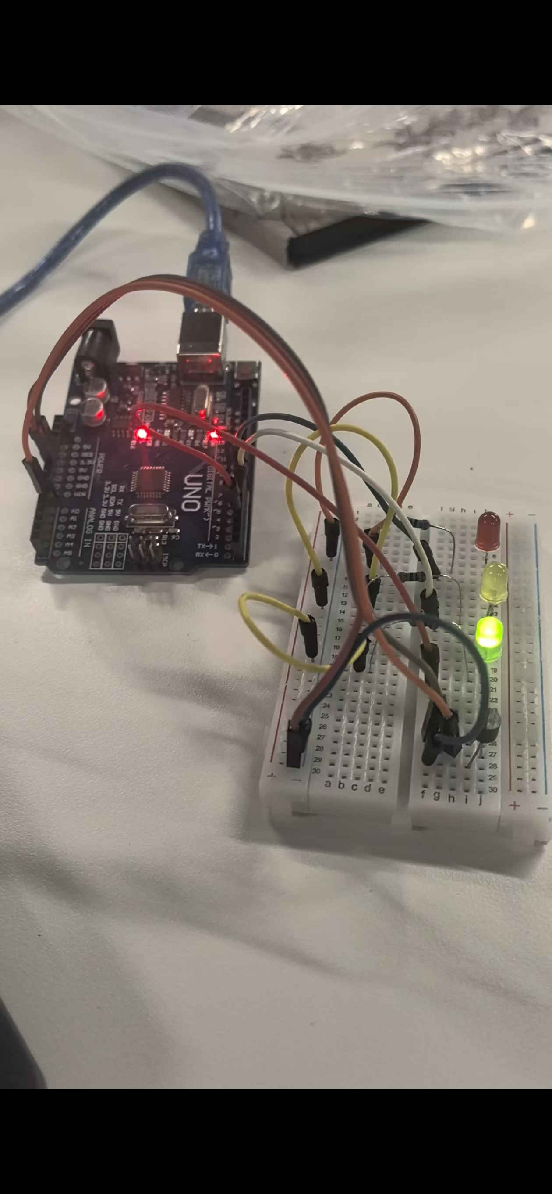
Flowchart
This diagram outlines the initial design of the temperature monitoring function. It begins with variable initialisation, followed by an infinite while loop for continuous monitoring. Inside the loop, the system reads the sensor voltage, converts it to temperature, records the data, and updates a real-time plot. A central decision point branches into three temperature ranges:
18–24 °C → Green LED constant ON
Below 18 °C → Yellow LED blinking
Above 24 °C → Red LED fast blinking
After LED control, a short delay ensures stable timing before the loop repeats.
Flowchart 1

This flowchart reflects the actual MATLAB implementation. After initialising the Arduino connection and data arrays, the infinite loop reads the analogue voltage from pin A0 and converts it using the formula temp = (V - 0.5)/0.01. It then updates the time_list and temp_list arrays and refreshes the real-time plot. The decision logic is explicitly structured as a multi-condition if-elseif-else statement:
• 18–24 °C → Green LED ON (others OFF)
• Below 18 °C → Yellow LED (D5) blinks at 0.5 s intervals
• Above 24 °C → Red LED (D7) blinks at 0.25 s intervals
The timing of the pause function is synchronised with the LED cycles and plot updates.
Flowchart 2
This flowchart describes the temp_prediction function. After initialising LEDs and data buffers, an infinite loop continuously reads and converts temperature data. The system then calculates the temperature change rate (°C/s) using the derivative of recent samples, and predicts the temperature after 5 minutes assuming a constant rate. The current temperature, rate, and predicted value are printed to the console.
A multi-way decision point controls the LEDs:
• Temperature within 18–24 °C → Green LED ON
• Rate > +4 °C/min → Red LED ON (fast heating warning)
• Rate < −4 °C/min → Yellow LED ON (fast cooling warning)
A short delay maintains the sampling cycle before repeating.

Flowchart 3

Plot
This graph presents the temperature variation recorded over a 10‑minute period by the Task 2 system. The x‑axis represents time in seconds, and the y‑axis shows temperature in degrees Celsius. The data demonstrates stable operation within the comfort range of 22.3 °C to 23.4 °C, with most readings staying near 22.8 °C. The sharp vertical spikes visible in the plot correspond to brief fluctuations caused by environmental disturbances or sensor noise, such as contact with the sensor. Despite these short‑term variations, the overall temperature trend remains steady within the predefined comfort zone (18–24 °C), confirming that the green LED indicator would remain active throughout the test.
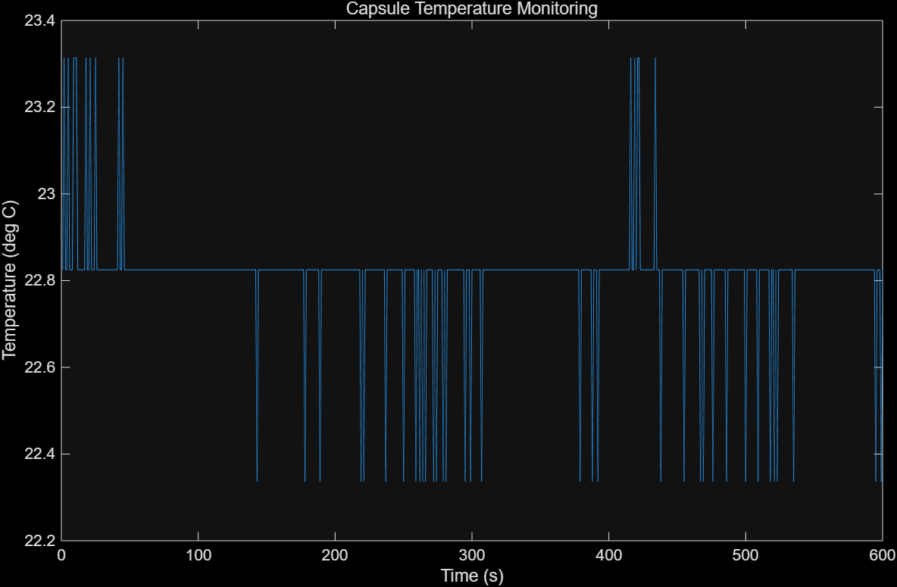
Figure:Real‑time capsule temperature monitoring results

Reflective Statement
This temperature monitoring and prediction project successfully implemented real-time cabin temperature detection, LED indication and temperature trend prediction using Arduino and MATLAB. Throughout the development process, several practical challenges were encountered. The primary difficulty was hardware instability, including loose circuit connections and noisy sensor readings, which caused inconsistent temperature data and delayed LED response. Additionally, configuring Git file uploading and MATLAB source control created operational obstacles during file submission.
The project has clear strengths. The modular function design separates different tasks independently, ensuring readable, structured and reusable code. The system achieves real-time monitoring, change rate calculation and five-minute temperature prediction, with visual LED feedback for rapid temperature fluctuations. The moving average filter effectively reduces sensor noise, improving system stability.
Nevertheless, the system has noticeable limitations. The temperature prediction assumes a constant changing rate, which cannot fully simulate real complex cabin environments. Moreover, basic LED indication provides limited alarm information, and manual testing restricts experimental consistency.
For future improvements, additional sensors can be integrated to collect multi-environment data. Advanced prediction algorithms can replace linear estimation to enhance accuracy. Furthermore, adding data logging files and graphical user interfaces can make monitoring results more intuitive and improve the system’s practicality for capsule cabin control.

