Office Hours:

Monday 10-5 pm

Tuesday 12-5pm

Wednesday 10-5 pm

Thursday 12-5 pm

Friday 10-5 pm

Saturday 12-3 pm

Sunday –Closed—

1. In the about us section it should say orthopaedic physical therapy clinic** erase facility please.
2. In the about section, In the third sentence, it should say “we aim to develop a relationship”
3. In meet our physical therapist.. my name should come altogether not separated as it shows in the mobile website
4. I have the facebook and instagram pages
5. Where do i go to give you the links for them?
6. Instagram Page link [www.instagram.com/angeltouchpt](http://www.instagram.com/angeltouchpt)
7. Facebook page link <https://www.facebook.com/AngeltouchDPT/>



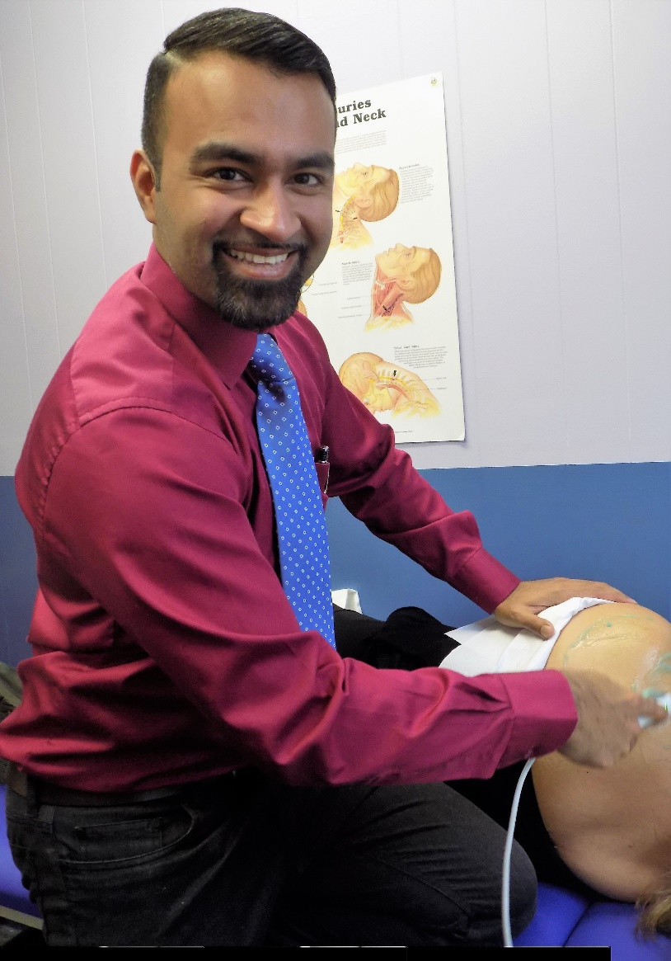

**Please add a testimonial**

**“Dedication to caring, discipline to recovery and the eventual path to wellness are the attributes that I experience at Angel Touch Physical Therapy (ATPT). The professionalism exhibited by Waqar A. Muhammad, DPT and his team has led me to think that, Angel Touch Physical Therapy will be a great asset to the community…”**

**John Pratt**

**Elmont, New York**