3 Policy Gradients
1. Small batch experiments
(nothing)
(rtg)
(na)
(rtg & na)
Actor loss
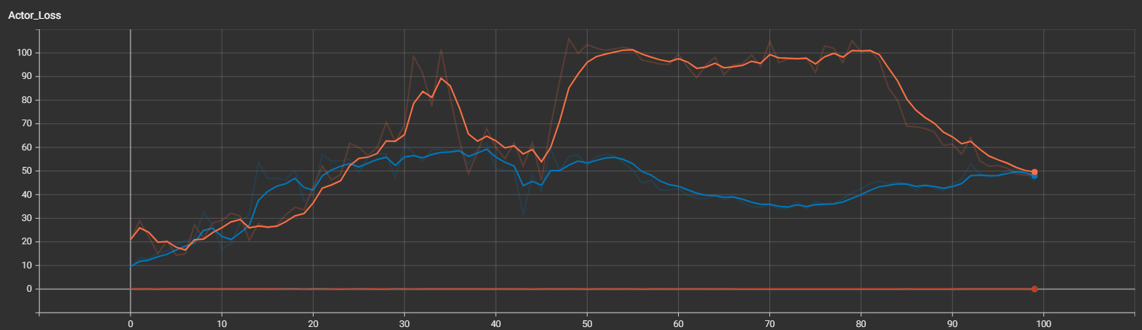

Eval Average Retrun
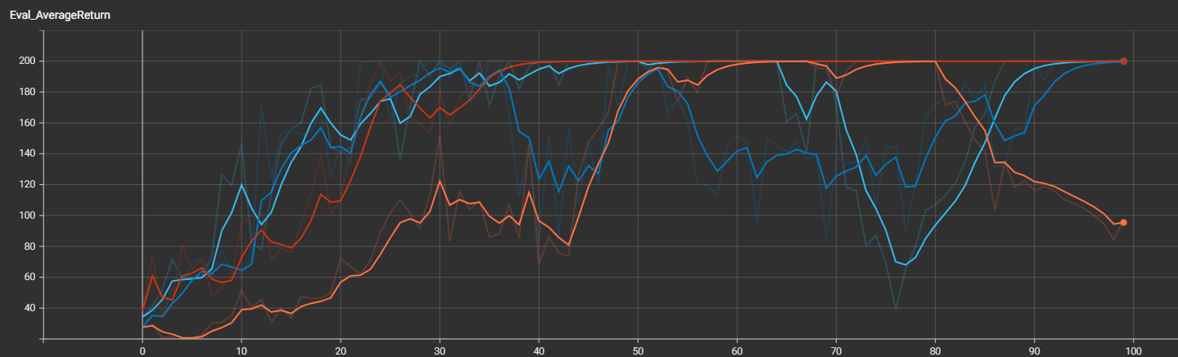

2. Large batch experimetns (large batch vs small batch)

2.1 none
(lb when none)
(sb when none)

Actor loss
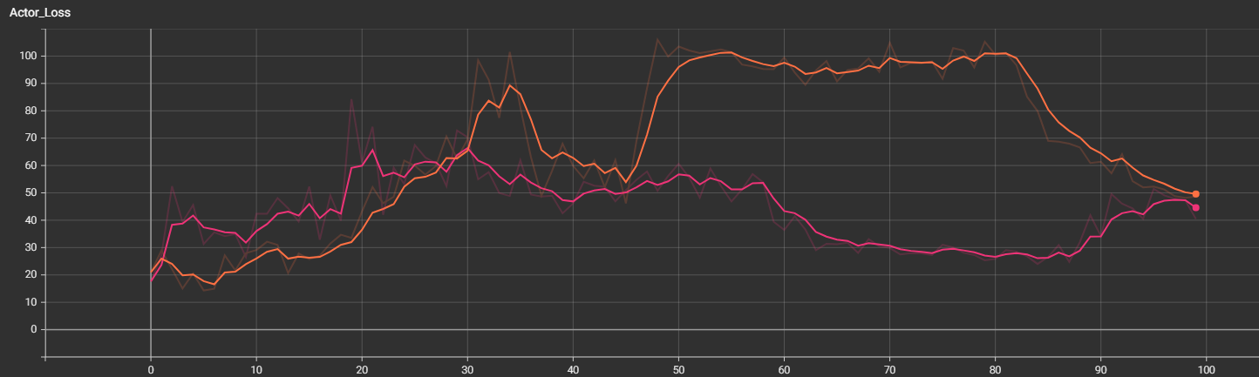
Eval Average Return
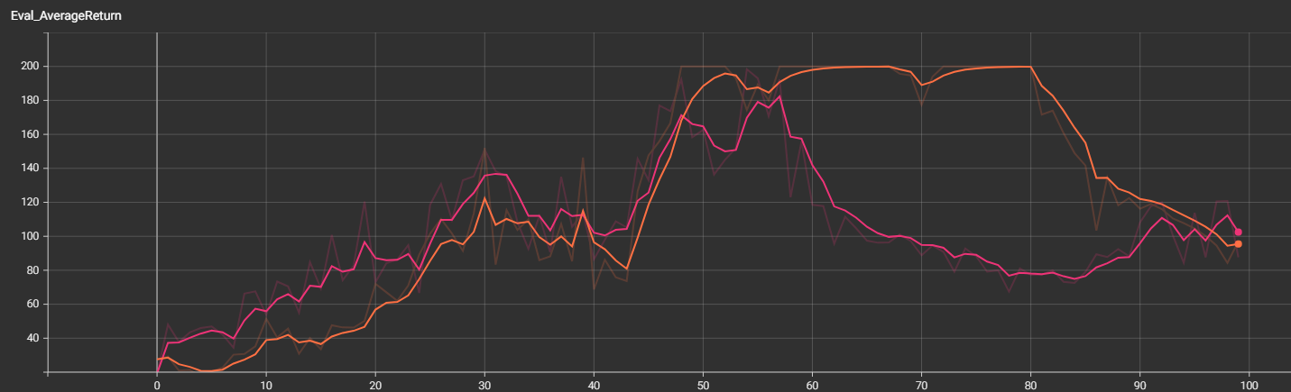

2.2 rtg
(lb when rtg)
(sb when rtg)

Actor loss
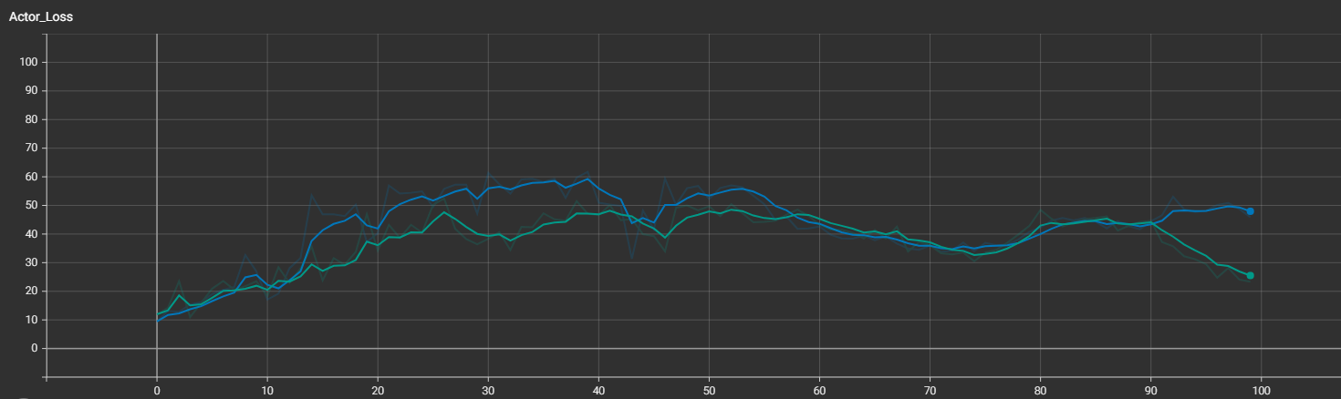
Eval Average Return
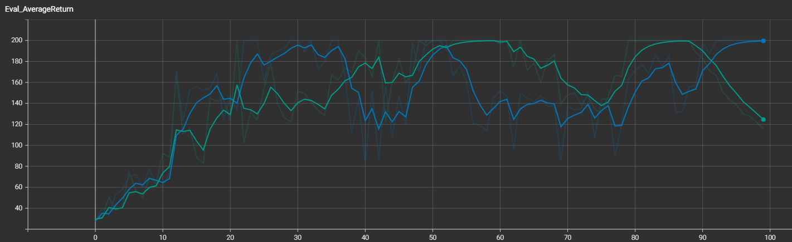

2.3 na
(lb when na)
(sb when na)

Actor loss
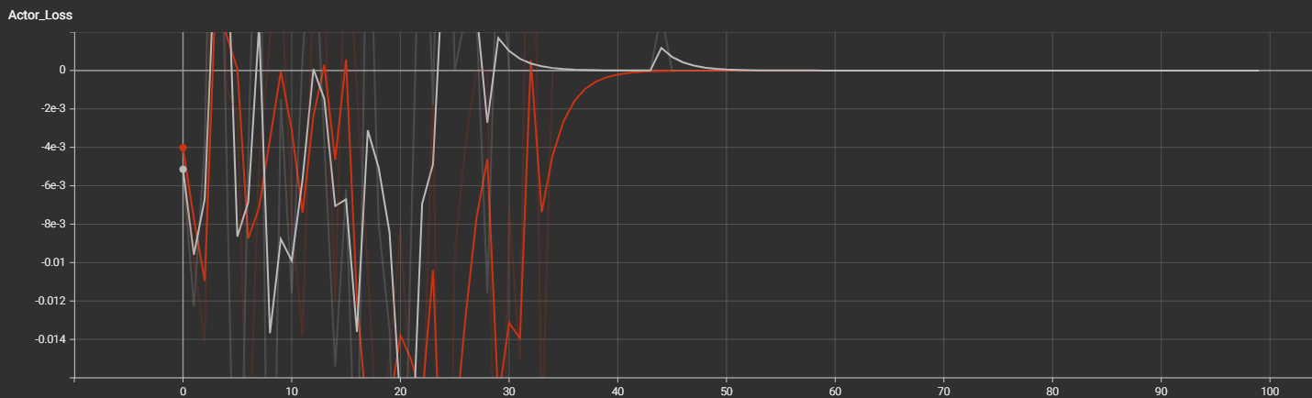
Eval Average Reutrn
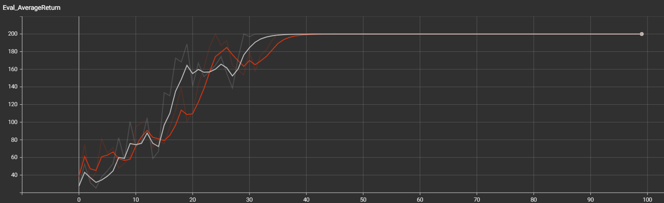

2.4 rtg & na
(lb when rtg & na)
 (sb when rtg & na)

Actor loss
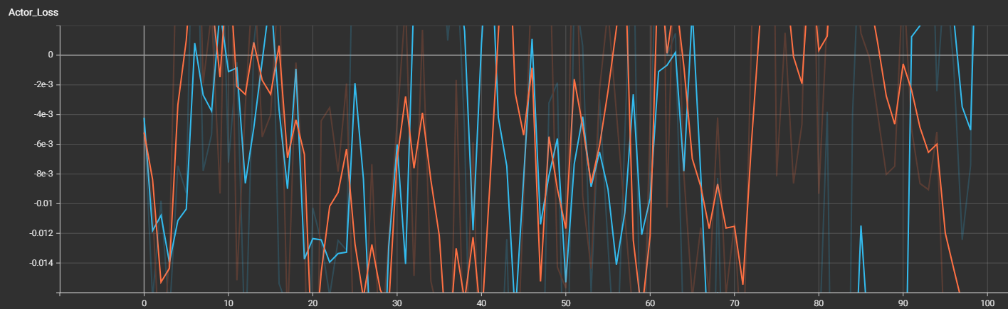
Eval Average Return
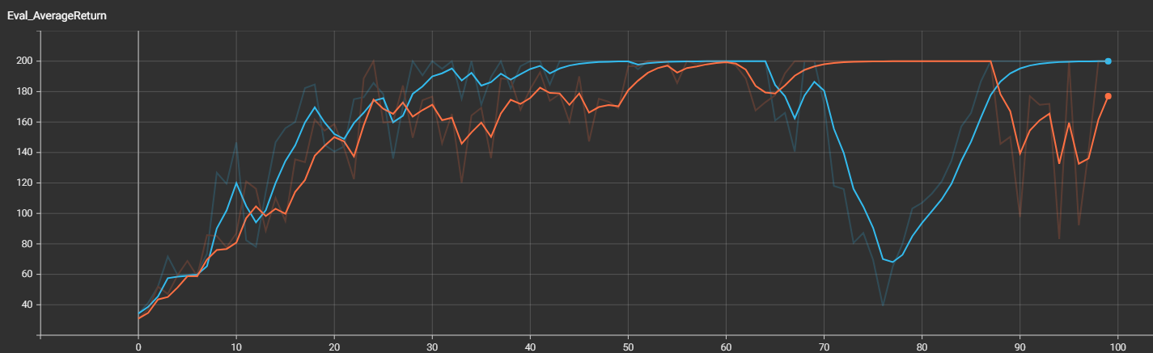

3. Answer the following questions briefly
Q: Which value estimator has better performance without advantage normalization: the trajectorycentric one, or the one using reward-to-go?
A: Using reward-to-go.

Q: Did advantage normalization help?
A: Yes.

Q: Did the batch size make an impact?
A: Not really.

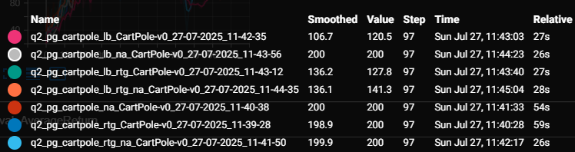

python cs285/scripts/run_hw1.py --expert_policy_file cs285/policies/experts/Ant.pkl --env_name Ant-v4 --exp_name bc_ant_video --n_iter 1 --expert_data cs285/expert_data/expert_data_Ant-v4.pkl --ep_len 1000 --eval_batch_size 5000 --video_log_freq 1 --n_layers 2 --size 64

- Eval_AverageReturn : 1552.6072998046875
- Eval_StdReturn : 292.062255859375
- Eval_MaxReturn : 2147.45068359375
- Eval_MinReturn : 1278.1318359375
- Eval_AverageEpLen : 896.1666666666666
- Train_AverageReturn : 4681.891673935816
- Train_StdReturn : 30.70862278765526
- Train_MaxReturn : 4712.600296723471
- Train_MinReturn : 4651.18305114816
- Train_AverageEpLen : 1000.0
- Training Loss : 0.03868953138589859
- Train_EnvstepsSoFar : 0
- TimeSinceStart : 30.320274114608765
- Initial_DataCollection_AverageReturn : 4681.891673935816

python cs285/scripts/run_hw1.py --expert_policy_file cs285/policies/experts/Hopper.pkl --env_name Hopper-v4 --exp_name bc_hopper_video --n_iter 1 --expert_data cs285/expert_data/expert_data_Hopper-v4.pkl --ep_len 1000 --eval_batch_size 5000 --video_log_freq 1 --n_layers 2 --size 64

- Eval_AverageReturn : 1006.6049194335938
- Eval_StdReturn : 315.4906005859375
- Eval_MaxReturn : 1974.660400390625
- Eval_MinReturn : 405.4320068359375
- Eval_AverageEpLen : 302.2352941176471
- Train_AverageReturn : 3717.5129936182307
- Train_StdReturn : 0.3530361779417035
- Train_MaxReturn : 3717.8660297961724
- Train_MinReturn : 3717.159957440289
- Train_AverageEpLen : 1000.0
- Training Loss : 0.03620936721563339
- Train_EnvstepsSoFar : 0
- TimeSinceStart : 11.099523305892944
- Initial_DataCollection_AverageReturn : 3717.5129936182307
Eval_AverageReturn
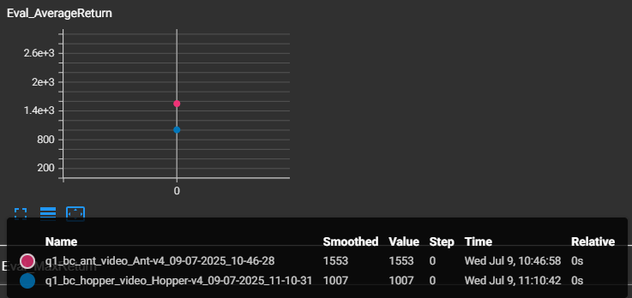
Eval_StdReturn
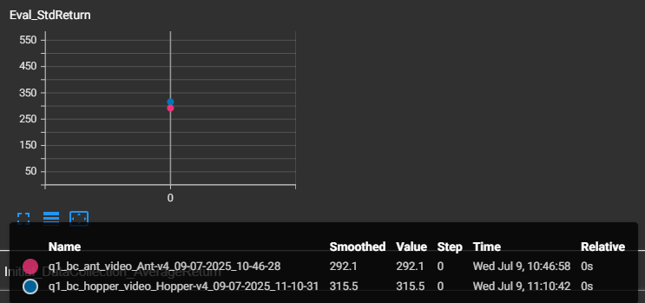

2. Experiment with one set of hyperparameters that affects the performance of the behavioral cloning agent, such as the amount of training steps, the amount of expert data provided, or something that you come up with yourself. For one of the tasks used in the previous question, show a graph of how the BC agent’s performance varies with the value of this hyperparameter. In the caption for the graph, state the hyperparameter and a brief rationale for why you chose it.

python cs285/scripts/run_hw1.py --expert_policy_file cs285/policies/experts/Ant.pkl --env_name Ant-v4 --exp_name bc_ant_video --n_iter 1 --expert_data cs285/expert_data/expert_data_Ant-v4.pkl --ep_len 1000 --eval_batch_size 5000 --video_log_freq 1 --n_layers 2 --size 64

- Eval_AverageReturn : 1552.6072998046875
- Eval_StdReturn : 292.062255859375
- Eval_MaxReturn : 2147.45068359375
- Eval_MinReturn : 1278.1318359375
- Eval_AverageEpLen : 896.1666666666666
- Train_AverageReturn : 4681.891673935816
- Train_StdReturn : 30.70862278765526
- Train_MaxReturn : 4712.600296723471
- Train_MinReturn : 4651.18305114816
- Train_AverageEpLen : 1000.0
- Training Loss : 0.03868953138589859
- Train_EnvstepsSoFar : 0
- TimeSinceStart : 30.320274114608765
- Initial_DataCollection_AverageReturn : 4681.891673935816
… --n_layers 4 --size 128

- Eval_AverageReturn : 1277.498291015625
- Eval_StdReturn : 362.19354248046875
- Eval_MaxReturn : 1998.316650390625
- Eval_MinReturn : 870.1470336914062
- Eval_AverageEpLen : 998.5
- Train_AverageReturn : 4681.891673935816
- Train_StdReturn : 30.70862278765526
- Train_MaxReturn : 4712.600296723471
- Train_MinReturn : 4651.18305114816
- Train_AverageEpLen : 1000.0
- Training Loss : 0.03484756872057915
- Train_EnvstepsSoFar : 0
- TimeSinceStart : 33.58611559867859
- Initial_DataCollection_AverageReturn : 4681.891673935816

… --n_layers 1 --size 32

- Eval_AverageReturn : 612.7852783203125
- Eval_StdReturn : 90.59205627441406
- Eval_MaxReturn : 790.5887451171875
- Eval_MinReturn : 546.1014404296875
- Eval_AverageEpLen : 1000.0
- Train_AverageReturn : 4681.891673935816
- Train_StdReturn : 30.70862278765526
- Train_MaxReturn : 4712.600296723471
- Train_MinReturn : 4651.18305114816
- Train_AverageEpLen : 1000.0
- Training Loss : 0.03733008727431297
- Train_EnvstepsSoFar : 0
- TimeSinceStart : 28.81749987602234
- Initial_DataCollection_AverageReturn : 4681.891673935816

Eval_AverageReturn
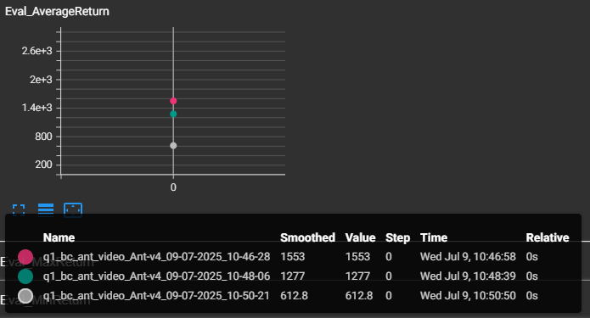
Eval_StdReturn
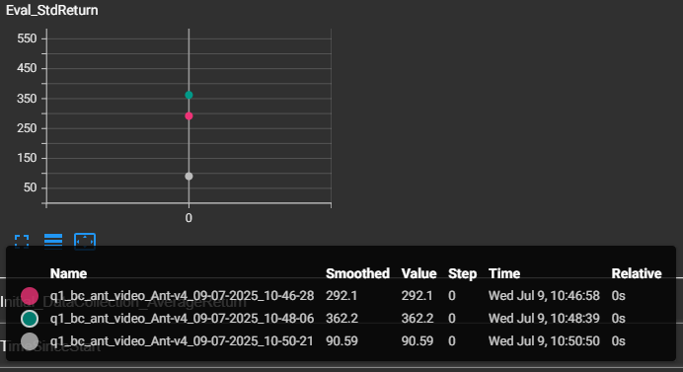

4 Dagger
1. Using the same code, you should be able to run DAgger by modifying the runtime parameters as follows:
python cs285/scripts/run_hw1.py --expert_policy_file cs285/policies/experts/Ant.pkl --env_name Ant-v4 --exp_name dagger_ant_video --n_iter 10 --do_dagger --expert_data cs285/expert_data/expert_data_Ant-v4.pkl --ep_len 1000 --eval_batch_size 5000 --video_log_freq 1 --n_layers 2 --size 64

2. Run DAgger and report results on the two tasks you tested previously with behavioral cloning. Report your results in the form of a learning curve, plotting the number of DAgger iterations vs. the policy’s mean return, with error bars to show the standard deviation. Include the performance of the expert policy and the behavioral cloning agent on the same plot (as horizontal lines that go across the plot). In the caption, state which task you used, and any details regarding network architecture, amount of data, etc. (as in the previous section).
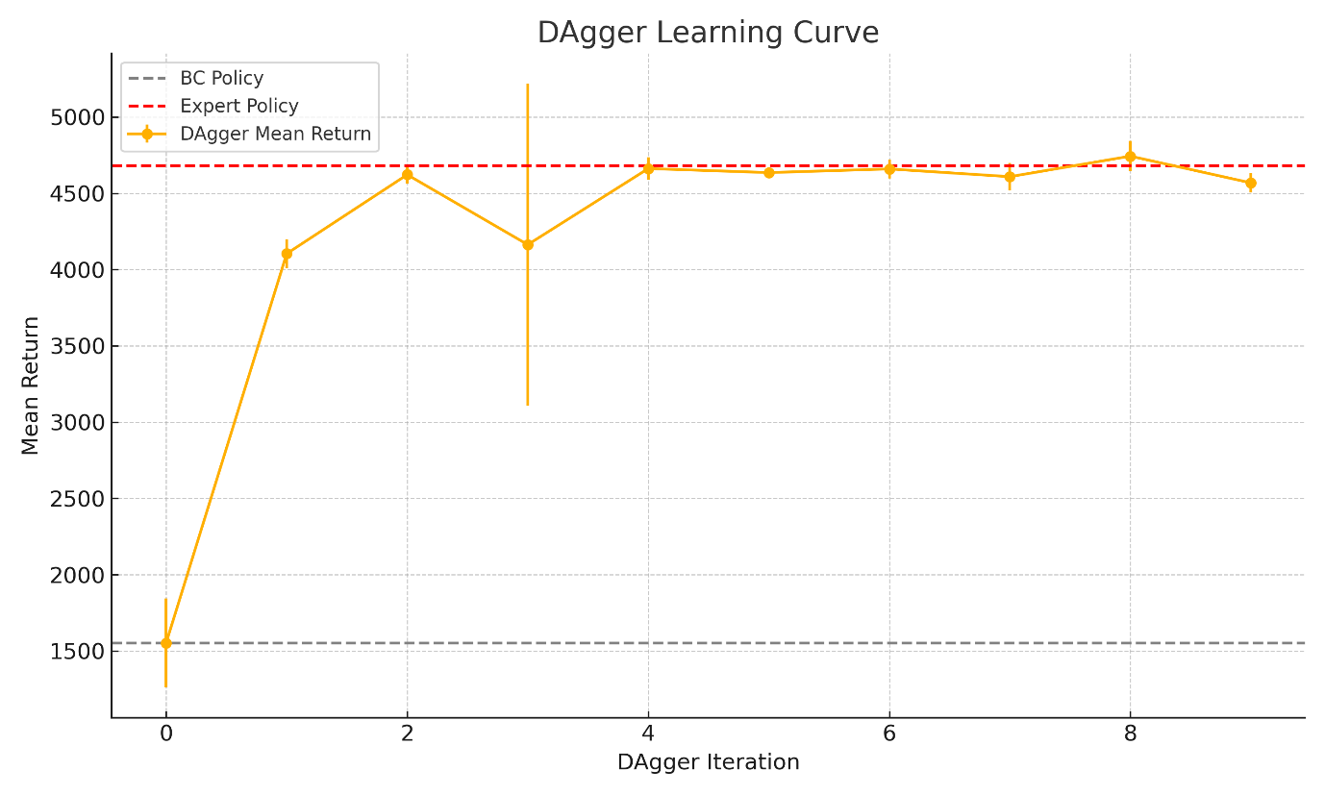

Environment (Task): Ant-v4
Expert Policy File: Ant.pkl (used to imitate expert behavior)
Learning Method: DAgger (Dataset Aggregation)
- Executed with the --do_dagger flag
Number of Iterations: --n_iter 10 → DAgger was run for 10 iterations
Episode Length: --ep_len 1000 → Each episode consists of 1000 steps
Policy Network Architecture:
- Number of hidden layers: --n_layers 2
- Size of each hidden layer: --size 64
Evaluation Batch Size: --eval_batch_size 5000 → Each evaluation is performed using 5000 steps

5 Discussion

1. How much time did you spend on each part of this assignment.
Analysis | 1h
Editing Code | 2h
Behavioral Cloning | 2h
DAgger | 2h

2. Any additional feedback?

