電通二乙微處理器實驗 實驗結報

實驗名稱 | Lab04
組別 |  | 組員 | 林東頤

- 實驗目的

了解七段顯示器的原理
共陰極與共陽極七段顯示器的不同
如何讓7段顯示器顯示 0-F
如何控制四合一7段顯示器
如何讓四合一7段顯示器顯示四位數字

- 實驗步驟

將Arduino與7段顯示器連接後,寫入題目所需之程式。

- 程式碼

<一>

#include "SevSeg.h"
SevSeg sevseg; //Instantiate a seven segment controller object
static unsigned long timer = millis();
static int deciSeconds = 0;
byte a=0;
byte i;
byte b=0;
void setup() {
byte numDigits = 4;
byte digitPins[] = {5,4,3,2};
byte segmentPins[] = { 8, 9, 10, 11, 12, 13,14,15};
bool resistorsOnSegments = false; // 'false' means resistors are on digit pins
byte hardwareConfig = COMMON_CATHODE; // See README.md for options
bool updateWithDelays = false; // Default. Recommended
bool leadingZeros = false; // Use 'true' if you'd like to keep the leading zeros
pinMode(6, INPUT);
sevseg.begin(hardwareConfig, numDigits, digitPins, segmentPins, resistorsOnSegments, updateWithDelays, leadingZeros);
sevseg.setBrightness(90);
Serial.begin(9600);
}

void loop() {
if (millis() - timer >= 100) {
timer += 100;
deciSeconds++; // 100 milliSeconds is equal to 1 deciSecond

b=deciSeconds%100;
if (b % 60 == 0)
{
a++;
deciSeconds=0;
Serial.println(a);
for(i=0;i<a;i++)
deciSeconds+=100;
}
if (deciSeconds == 2359) { // Reset to 0 after counting for 1000 seconds.
deciSeconds=0;
}
sevseg.setNumber(deciSeconds);
}

sevseg.refreshDisplay(); // Must run repeatedly
}

<二>

#include "SevSeg.h"
SevSeg sevseg; //Instantiate a seven segment controller object
static unsigned long timer = millis();
static int deciSeconds = 0;
byte a=0;
byte i;
byte b=0;
void setup() {
byte numDigits = 4;
byte digitPins[] = {5,4,3,2};
byte segmentPins[] = { 8, 9, 10, 11, 12, 13,14,15};
bool resistorsOnSegments = false; // 'false' means resistors are on digit pins
byte hardwareConfig = COMMON_CATHODE; // See README.md for options
bool updateWithDelays = false; // Default. Recommended
bool leadingZeros = false; // Use 'true' if you'd like to keep the leading zeros
pinMode(6, INPUT);
sevseg.begin(hardwareConfig, numDigits, digitPins, segmentPins, resistorsOnSegments, updateWithDelays, leadingZeros);
sevseg.setBrightness(90);
Serial.begin(9600);
}

void loop() {
if (6 == LOW) b = a = 0;

if (millis() - timer >= 100) {
timer += 100;
deciSeconds++; // 100 milliSeconds is equal to 1 deciSecond

b=deciSeconds%100;
if (b % 60 == 0)
{
a++;
deciSeconds=0;
Serial.println(a);
for(i=0;i<a;i++)
deciSeconds+=100;
}
if (deciSeconds == 2359) { // Reset to 0 after counting for 1000 seconds.
deciSeconds=0;
}
sevseg.setNumber(deciSeconds);
}

sevseg.refreshDisplay(); // Must run repeatedly
}

<三>

#include "SevSeg.h"
SevSeg sevseg;
int Hour = 0;
int Min = 0;

void setup() {
byte numDigits = 4;
byte digitPins[] = {5, 4, 3, 2};
byte segmentPins[] = {8, 9, 10, 11, 12, 13, 14, 15};
sevseg.begin(COMMON_CATHODE, numDigits, digitPins, segmentPins);
pinMode(6, INPUT);
pinMode(16, INPUT);
}

void loop() {
if (digitalRead(6) == 1)
{
Min = 0;
Hour = 0;
}
if (digitalRead(16) == 1)
{
sevseg.setNumber(Hour * 100 + Min, 4);
Min = Min - 1;
if (Min == 0)
{
Min = 59;
if (Hour == 0)
Hour = 23;
else
Hour--;
}
}
else
{
sevseg.setNumber(Hour * 100 + Min, 4);
Min = Min + 1;
if (Min == 60)
{
Min = 0;
if (Hour == 23)
Hour = 0;
else
Hour++;
}
}
for (int i = 0; i < 1000000; i++)
sevseg.refreshDisplay();
}
- 實驗結果及分析
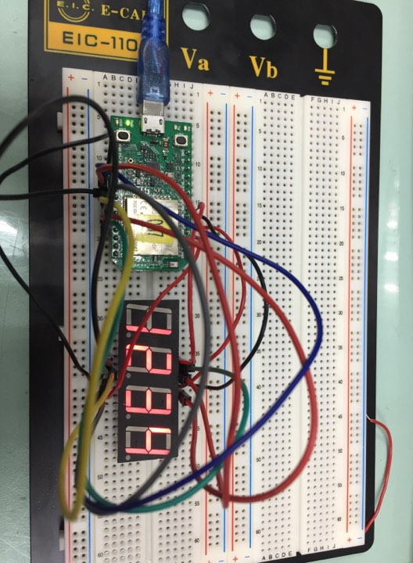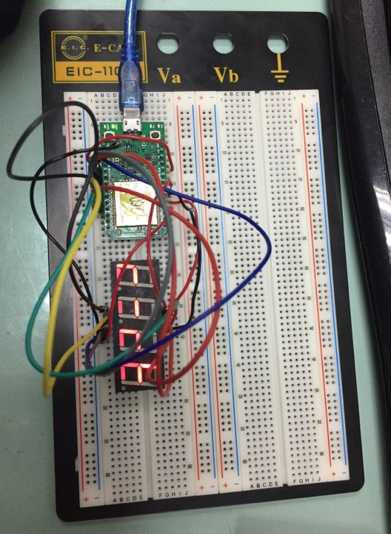

- 心得討論

因為跳啦啦而錯失檢查機會，現在努力補回來
- 修正電路圖
- 修正程式碼

