 | Dongyoung Kim, Ph.D.  Artificial intelligence for engineering and industry  Date of birth: 1987.05.26  AI professional @ Data Analytics Laboratory,  Samsung Life Insurance, Seoul, Republic of Korea  Mobile: 010-6616-9430  E-mail: dongyoung.kim@me.com / Portfolio: http://www.dykim.net

EXPERIENCES
2020 – Current | Samsung Life Insurance /Seoul, South Korea  AI professional at Data Analytics Laboratory.
2017 – 2019 | Institute for Basic Science / Ulsan, South Korea  Research Fellow at Center for Soft and Living Matter
2012 – 2016 | Texas A&M University / College Station, Texas, U.S.A.  Research Assistant
2010 – 2012 | The University of Southwestern medical center / Dallas, Texas, U.S.A.  (Research Assistant
2010 – 2012 | The University of Texas at Dallas / Dallas, Texas, U.S.A.  Research Assistant
2009 – 2010 | Embedded Software Research Center / Deagu, South Korea  Research Assistant
2010 – 2010 | EOS Australia / Sydney, Australia  Internship

EDUCATION
2012 – 2016 |  | Texas A&M University, Ph.D. in Biomedical Engineering  College station, Texas, USA
2010 – 2012 |  | The University of Texas at Dallas, B.S. Electrical Engineering and Computer Sciences  Richardson, Texas, USA
2006 – 2012 |  | Kyungpook National University , B.S. Electrical Engineering and Computer Sciences  Daegu, South Korea
PROJECTS
2020 – 2020 | End-to-end Deep learning based Optical Character Recognition (Deep OCR) framework  - A framework converting optically acquired image data to character using a series of deep learning models.  - Sets of deep learning models were designed and developed for image to text conversion using a variety of deep learning techniques, i.e., convolutional neural network, generative adversarial network, graph convolutional network, recurrent neural network, attention network.  - An image preprocessing model was developed to remove noise and to correct optical conditions (Korea patent under review).  - An language model was developed to understand unstructured text data and to translate to a structured database (Korea patent under review).  - Deep learning based data simulator to train and test deep learning models (Korea patent filed, see details in Deep learning based optical image acquisition simulator engine below).  - Deliver the Front-End service from trained models via RESTful API and redis/celery.  Related Awards  - ICDAR SROIE leaderboard text localization 1st place (2020/12)  https://rrc.cvc.uab.es/?ch=13&com=evaluation&task=1  - ICDAR SROIE leaderboard text recognition 1st place (2020/12)  https://rrc.cvc.uab.es/?ch=13&com=evaluation&task=2  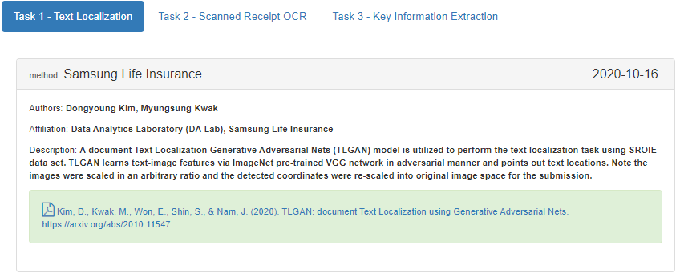 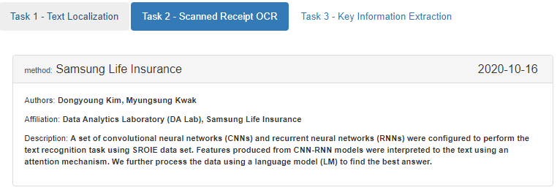  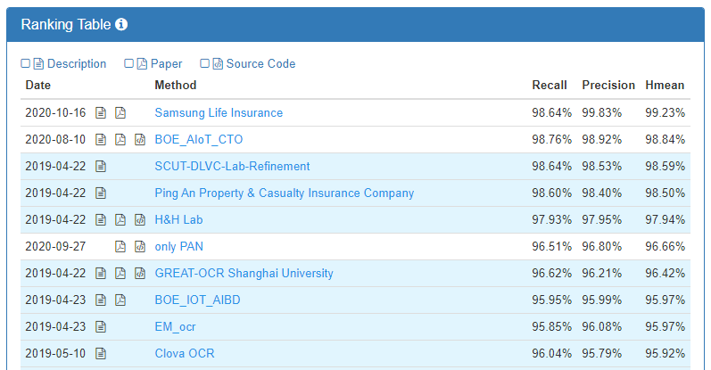 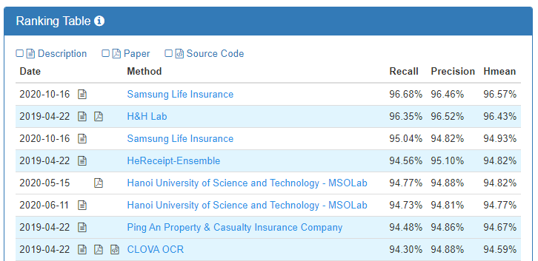  Related Patents  - Dongyoung Kim, et al. METHOD FOR MANAGING TRAINING DATA FOR OPTICAL CHARACTER RECOGNITION, Korea Patent Filed 1020200059652, 2020.  - Two more Korea patent under review (Image preprocessing approach, Unstructured data understanding)  Related Publications  - Kim, D., Kwak, M., Won, E., Shin, S., & Nam, J. TLGAN: document Text Localization using Generative Adversarial Nets. Arxiv 2010.1154, 2020.  Related News  - The Chosun Ilbo newspaper (조선일보) 2010. 10. 29. 서류 지옥서 구해준 ‘딥러닝 OCR’에 세계가 ‘엄지 척’  https://lnkd.in/gHGEcmr  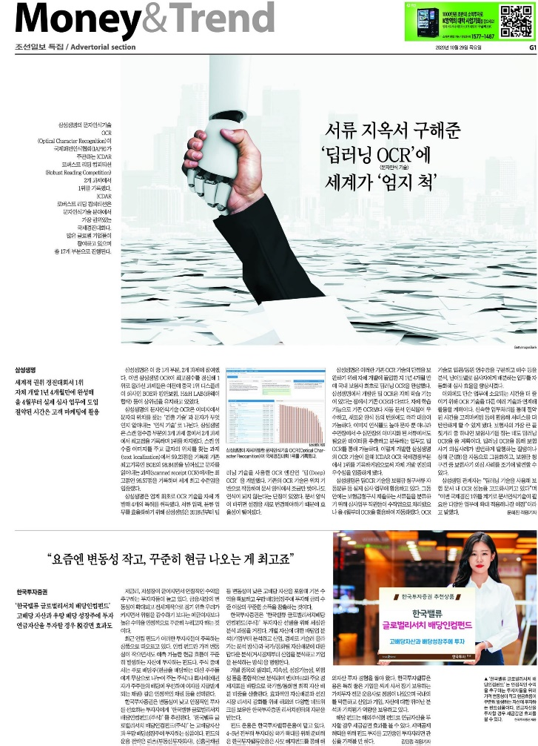
2020 – 2020 | Deep learning based optical image acquisition simulator engine  - Simulating optically acquired images using generative adversarial networks.  - Supporting data simulation and management via light memory database  - Only needs single image to learn the image features and to reproduce similar optical looks.  - Realize the automation in deep OCR model training and testing.  Related Patents  - Dongyoung Kim, et al. METHOD FOR MANAGING TRAINING DATA FOR OPTICAL CHARACTER RECOGNITION, Korea Patent Filed 1020200059652, 2020.
2020 – 2020 | AI data/model management platform  - A Platform to train, to experiment, and to sever deep learning model with data management capability.  - A data management system with rapid and efficient light memory database.  - MLFLOW to mage models and experiments.  - Redis/celery to serve models from experiments.  - Supporting RESTful AP with a web based front service.
2020 – Current | Finance Knowledge Digitalization for AI based QA Engine  - A research to make an AI-usable data foundation of the product manuals and the knowledge management system (KMS).  - Development of the financial knowledge digitalization and search framework (ARK API: artificial intelligent readable knowledge search API).  - A data foundation development supporting RDB and GraphDB.  - A framework design to support in-house models and other programs including IR search (Elastic search and/or IR models: TF-IDF, BM25), MRC (BERT, Electra), GPT, and Graph query models.  - Serving as AI application (AI consultant QA, Chatbot QA, semantic search) and supporting multimodal AI knowledge processes.  - Making pretrain BERT model using the product manuals and the knowledge management system (KMS) with the domain specific vocabulary.
2020 – Current | Finance Knowledge Graph  - Build finance knowledge graph to support QA system.  - Property graph design using Apache TinkerPop and Gremlin.  - Semi-automated conversion of RDB to GraphDB of KMS and product manual defining a higher structure resolution of the documents.  - Graph IR search and Graph semantic search model design.  - Graph multi-hop MRC model development.
2017 – 2019 | AI-powered transmitted light microscopy for functional analysis of live cells  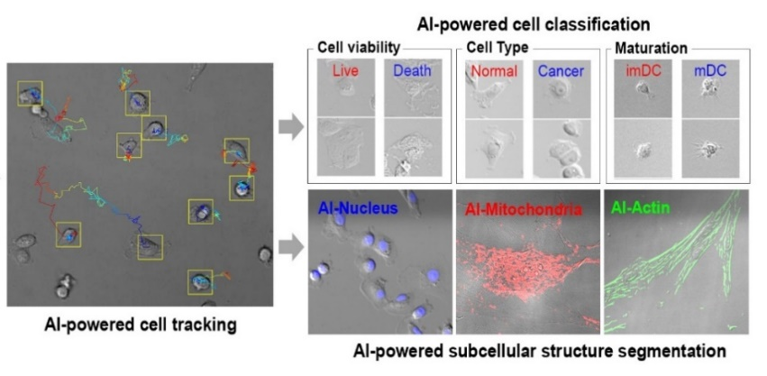  - Transforming a transmitted light microscopy image into a fluorescence microscopy equivalent image (or information) using unsupervised machine learning and supervised semantic segmentation.  - Real-time monitoring of living cell property and status from transmitted light microscopy video using region proposal convolutional neural network and convolutional neural network.  - Living cell tracking in time-lapse video using complementary learning of object shape and colors online.  Related Patents  *Dongyoung Kim, et al. GENERATING METHOD FOR SPECIALIZED MICROSCOPE IMAGES USING ARTIFICIAL NEURAL NETWORK AND IMAGE PROCESSING APPARATUS. Korea Patent 1020846820000, 2020.  *Dongyoung Kim, et al. ANALYSING METHOD FOR CELL IMAGE USING ARTIFICIAL NEURAL NETWORK AND IMAGE PROCESSING APPARATUS FOR CELL IMAGE. Korea Patent 1020846830000, 2020.  Related publications  *Kim, D., Min, Y., Oh, J.M. et al. AI-powered transmitted light microscopy for functional analysis of live cells. Sci Rep 9, 18428 (2019) doi:10.1038/s41598-019-54961-x
2019 – 2020 | Searching extreme rare cancer extracellular vesicle in blood plasma using generative adversarial network  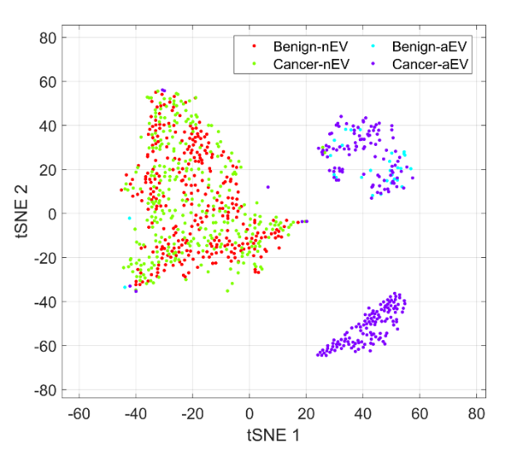  - A deep learning-based approach to detect ultra-rare cancer signal from blood.  *Manuscript under preparation (2020).
2019 – 2020 | In-silico histology staining using generative adversarial network  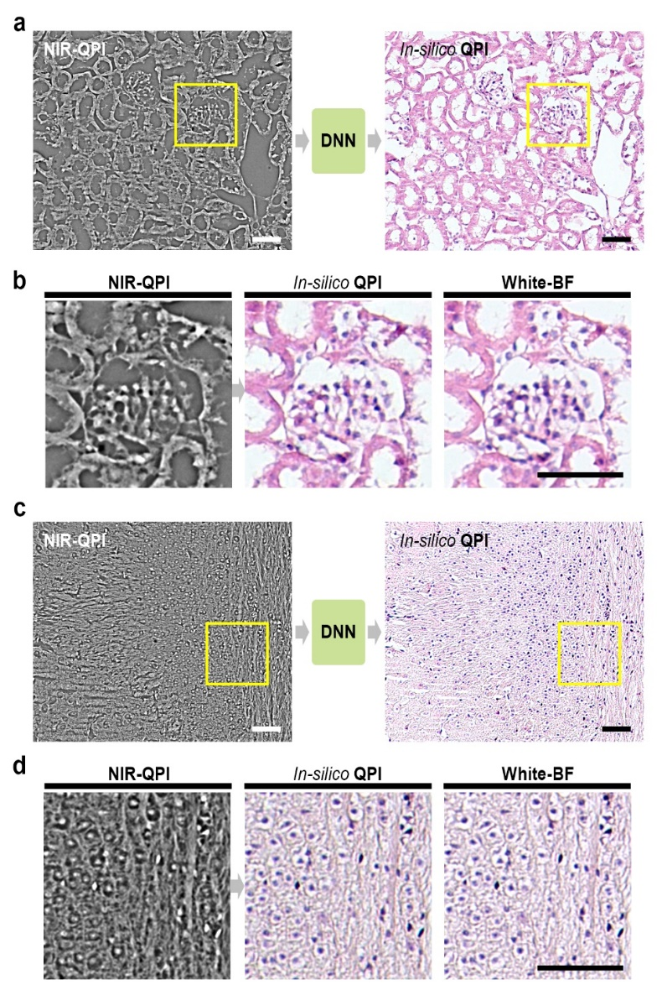  - Generative adversarial network to visualize histology stains from substance’s phase information.  *Manuscript submitted (2020).
2019 – 2020 | Generative adversarial network for high-definition medical image  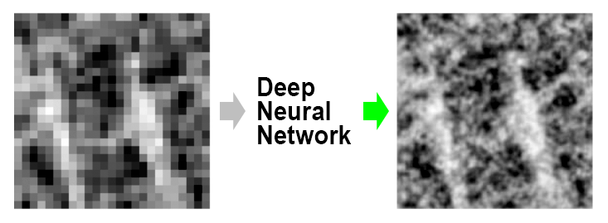  - A modality to enhance resolution of medical tomographic images using generative adversarial network.  *Manuscript under preparation (2020).
2019 – 2020 | Generative adversarial network for rapid medical image acquisition  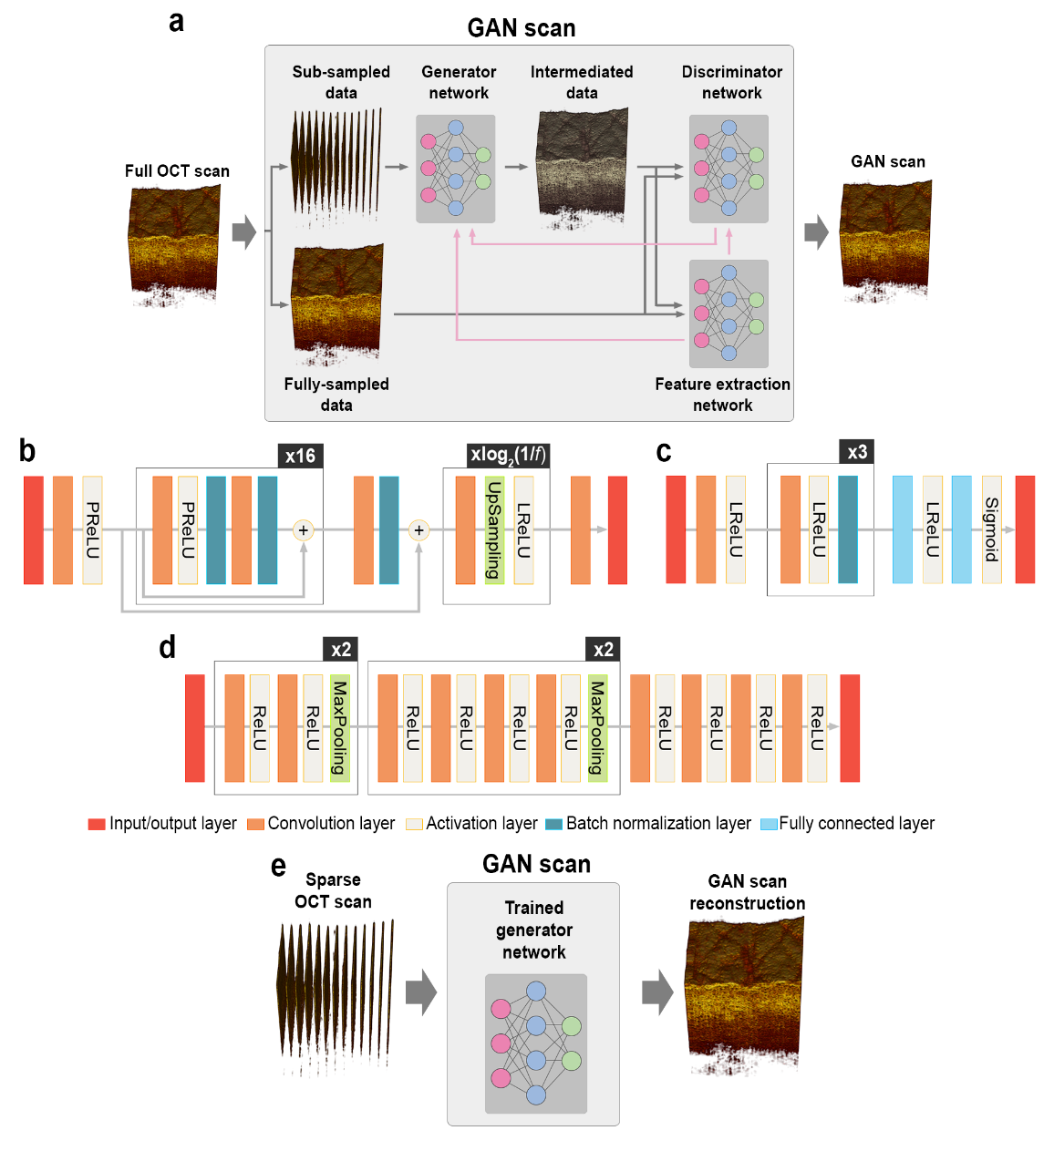  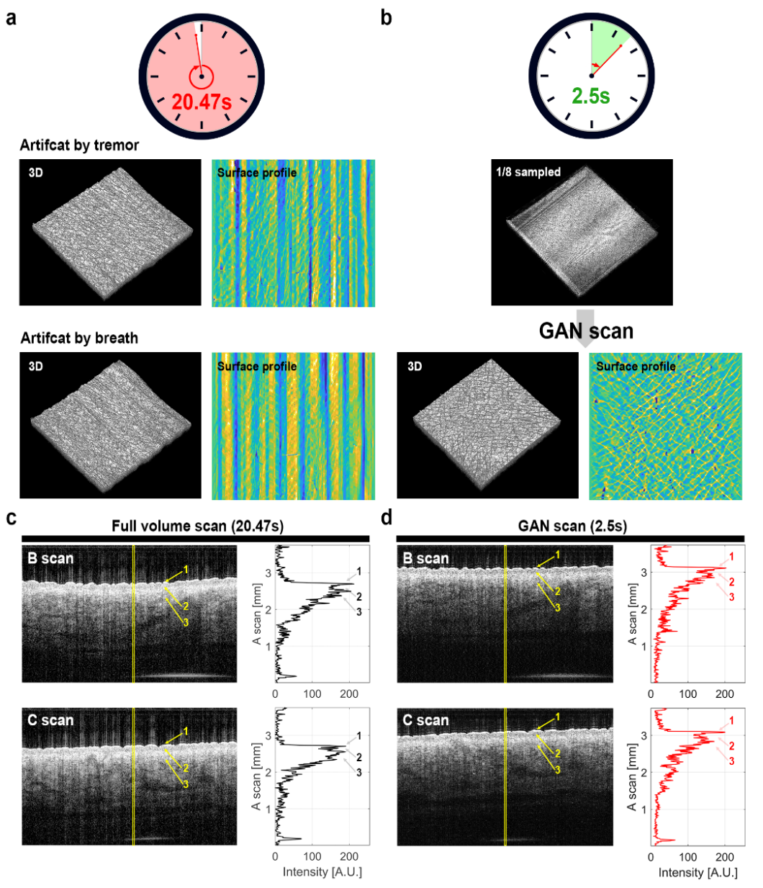  - A modality to reduce medical tomographic imaging time by 1/10 using generative adversarial network.  *Manuscript submitted (2020).
2017 – 2020 | A fidget spinner for the point-of-care diagnosis of urinary tract infection  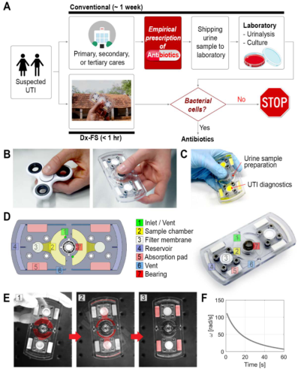  - Hand-powered microfluidic system for bacterial cell enrichment.  - Urinary tract infection diagnosis from a cell phone photograph of a testing kit with machine learning techniques.  Related Patents  - Dongyoung Kim, et al. CENTRIFUGAL FORCE BASED NON-POWERED PARTICLE CONCENTRATION APPARATUS AND METHOD OF PARTICLE CONCENTRATION. Korea Patent 1021037840000, 2020.  - Dongyoung Kim, et al. CENTRIFUGAL FORCE BASED PLATELET ISOLATION AND TESTING SYSTEM. Korea Patent 1020638650000, 2020.  Related Publications  *Kim, D., Michael, I., Gulenko, O., Kumar, S., Kumar, S., Clara, J., … Cho, Y.-K. (2020). A fidget spinner for the point-of-care diagnosis of urinary tract infection. Nature Biomedical Engineering. https://doi.org/10.1038/s41551-020-0557-2  Related News  - Korea MBC News “장난감 원리로 감연진단… 피젯 스피너의 변신” (2020)  - U.S. NewScientist News “Fidget spinner device can diagnose UTIs in under an hour without a lab” (2020)
2017 – 2020 | EV-Ident: Identifying Tumor-Specific Extracellular Vesicles by Size Fractionation and Single-Vesicle Analysis  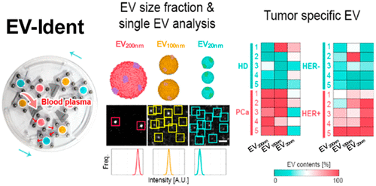  - Early cancer prediction from blood born particle using machine learning techniques.  - Extremely accurate protein marker expression measures by photon counting of particle optical image modeling / localization optimization.  - Identify cancer marker via unsupervised and supervised machine learning.  Related Publications  *Kim, D., Woo, H.-K., Lee, C., Min, Y., Kumar, S., Sunkara, V., … Cho, Y.-K. (2020). EV-Ident: Identifying Tumor-Specific Extracellular Vesicles by Size Fractionation and Single-Vesicle Analysis. Analytical Chemistry, 92(8), 6010–6018. https://doi.org/10.1021/acs.analchem.0c00285
2012 – 2015 | Three-dimensional super resolution microscopy  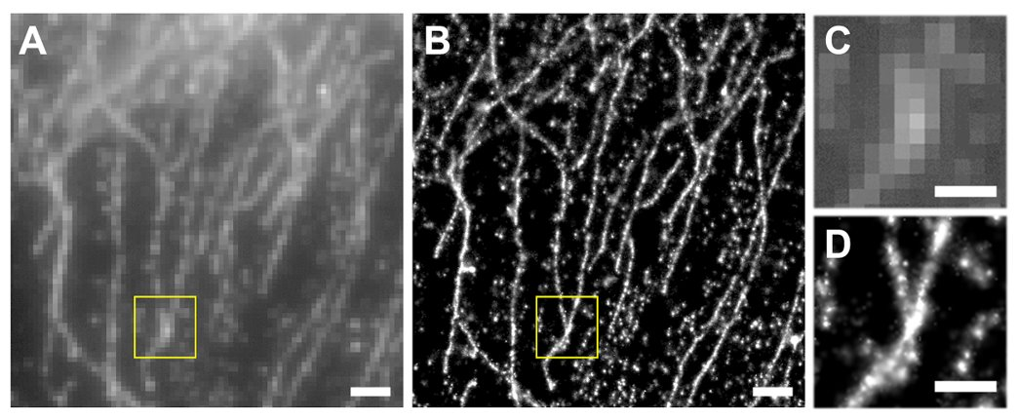  - An optical microscopy technique resolving fluorescently labeled features in ~5 nm resolution.  - Multifocal plane microscopy enables three-dimensional super-resolving imaging/ Multicolor imaging and super-precision chromatic/spatial registration are capable.  Related Publications  *Cohen E. A. K.,. Kim D., Ober R.J, Cramer-Rao Lower Bound for Point Based Image Registration with Heteroscedastic Error Model for Application in Single Molecule Microscopy. IEEE Transactions on Medical Imaging 2015  *Ram S, Kim D, Ober RJ, Ward ES. 3D Single Molecule Tracking with Multifocal Plane Microscopy Reveals Rapid Intercellular Transferrin Transport at Epithelial Cell Barriers. Biophysical Journal 2012
2014 – 2016 | Remote focusing multifocal plane microscopy for the imaging of 3D single molecule dynamics with cellular context  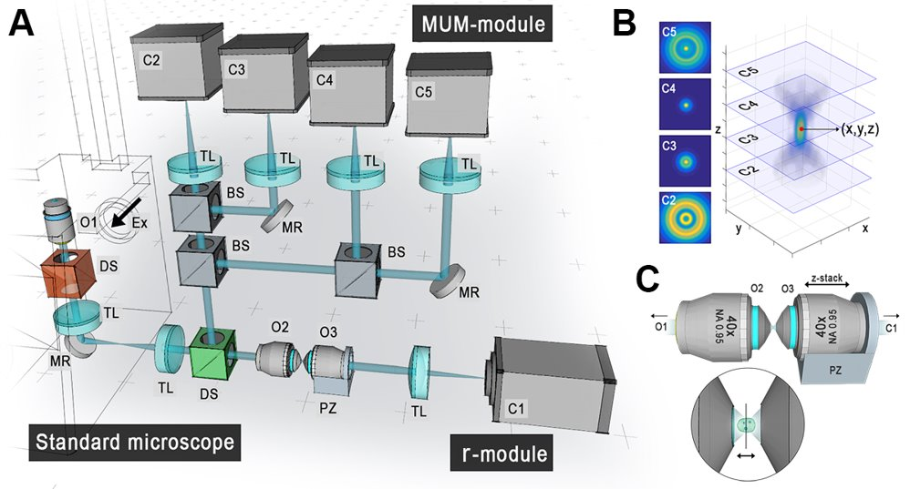  - A microscopy modality to visualize three-dimensional single molecule trajectory in a context of three-dimensional and multicolor cellular structures and compartments over time.  Related patents  - Dongyoung Kim, et al. ADVANCED MULTI-DIMENSIONAL MICROSCOPY SYSTEM FOR SINGLE PARTICLE & STRUCTURE IMAGING. U.S. Patent, 2017.  Related publications  *Kim, D., Chao, J., Velmurugan, R., You, S., Ward, E. S., and Ober, R. J. Remote focusing multifocal plane microscopy for the imaging of 3D single molecule dynamics with cellular context. Proceedings of the SPIE, Three-Dimensional and Multidimensional Microscopy: Image Acquisition and Processing XXIV, 10070: 2017.  *Kim D, You S, Ward E.S., Ober R.J, Imaging of three-dimensional single molecule dynamics with cellular context: Antibody trafficking and interaction with cell membrane and sorting endosomes. ASCB, San Fransisco, CA. 2016.  *Cohen E. A. K.,. Kim D., Ober R.J, Cramer-Rao Lower Bound for Point Based Image Registration with Heteroscedastic Error Model for Application in Single Molecule Microscopy. IEEE Transactions on Medical Imaging 2015

PATENTS
Dongyoung Kim, et al. METHOD FOR MANAGING TRAINING DATA FOR OPTICAL CHARACTER RECOGNITION, Korea Patent Filed 1020200059652, 2020.
Dongyoung Kim, et al. GENERATING METHOD FOR SPECIALIZED MICROSCOPE IMAGES USING ARTIFICIAL NEURAL NETWORK AND IMAGE PROCESSING APPARATUS. Korea Patent 1020846820000, 2020.
Dongyoung Kim, et al. ANALYSING METHOD FOR CELL IMAGE USING ARTIFICIAL NEURAL NETWORK AND IMAGE PROCESSING APPARATUS FOR CELL IMAGE. Korea Patent 1020846830000, 2020.
Dongyoung Kim, et al. CENTRIFUGAL FORCE BASED NON-POWERED PARTICLE CONCENTRATION APPARATUS AND METHOD OF PARTICLE CONCENTRATION. Korea Patent 1021037840000, 2020.
Dongyoung Kim, et al. CENTRIFUGAL FORCE BASED PLATELET ISOLATION AND TESTING SYSTEM. Korea Patent 1020638650000, 2020.
Dongyoung Kim, et al. ADVANCED MULTI-DIMENSIONAL MICROSCOPY SYSTEM FOR SINGLE PARTICLE & STRUCTURE IMAGING. U.S. Patent, 2017.

HONORS & AWARDS
2020 | IEEE ICDAR SROIE text localization task, 1st place  https://rrc.cvc.uab.es/?ch=13&com=evaluation&task=1
2020 | IEEE ICDAR SROIE text recognition task, 1st place  https://rrc.cvc.uab.es/?ch=13&com=evaluation&task=2
2018 | The 22nd International Conference On Miniaturized Systems For Chemistry And Life Sciences, Shark Tank Competition, 1st place
2016 | Swiss SMLMS Challenge (EPFL)  3D single molecule localization microscopy, 1st place
2014 – 2016 | Texas A&M University Research Fellowship
2012 – 2014 | The University of Texas at Dallas Research Fellowship
2011 – 2011 | The University of Texas at Dallas Undergraduate Research Fellowship
2011 – 2011 | The University of Texas at Dallas Senior Design Project, 2nd place
2010 – 2012 | The University of Texas at Dallas Undergraduate scholarship

LANGUAGES
Korean Native, English Fluent

SKILLS
Deep learning | Deep learning-based image processing model developments and service deployment.  Deep learning-based language model developments and service deployment.  Machine learning model management framework design and service.  Deep learning model quantization and distillation.
Programming | Python, MATLAB, C, C++, JAVA, JavaScript, HTML.
Database | SQLite, MongoDB, GraphDB (Gremlin, Tinkerpop, Neo4j)
Library | Tensorflow, Keras, Pytorch, OpenCV  Git, MLFlow, Docker
Control systems | NI LabWindows/CVI (C based control system IDE), NI LabView.
Optical system developments | Zemax based optical system design, Multimodal optical system configuration. Epifluorescence, TIRF microscopy, Confocal microscopy, Single molecule microscopy, super-resolution microscopy, Transmitted/scanning electron microscopy

LECTURES
BME21101 Introduction to biomedical engineering (Introduction to artificial intelligence for biomedical engineering / Introduction to deep learning), 2019, Ulsan National Institute of Science and Technology (UNIST).

PUBLICATIONS
Kim, D., Kwak, M., Won, E., Shin, S., & Nam, J. TLGAN: document Text Localization using Generative Adversarial Nets. Arxiv 2010.1154, 2020.
Kim, D., Woo, H.-K., Lee, C., Min, Y., Kumar, S., Sunkara, V., … Cho, Y.-K.. EV-Ident: Identifying Tumor-Specific Extracellular Vesicles by Size Fractionation and Single-Vesicle Analysis. Analytical Chemistry, 92(8), 6010–6018, 2020.
Kim, D., Michael, I., Gulenko, O., Kumar, S., Kumar, S., Clara, J., … Cho, Y.-K.. A fidget spinner for the point-of-care diagnosis of urinary tract infection. Nature Biomedical Engineering, 2020.
Kim, D., Min, Y., Oh, J.M. et al. AI-powered transmitted light microscopy for functional analysis of live cells. Sci Rep 9, 18428, 2019.
Sunkara, V., Kim C., Park J., Woo H., Kim D., Ha H., Kim M., Son Y., Kim J., Cho Y., Fully automated, label-free isolation of extracellular vesicles from whole blood for cancer diagnosis and monitoring. Theranostics, 2019.
Michael I., Kumar S., Oh J,, Kim D, Kim J., Cho Y. Surface Engineered Paper Hanging Drop Chip for 3D Spheroid Culture and Analysis. ACS applied materials & interfaces, 2018.
Li, R., Chiguru, S., Li, L., Kim, D., Velmurugan, R., Kim, D., Tian, H., Schroit, A., Mason, R., Ober, R. J. and Ward, E. S. Targeting phosphatidylserine with calcium-dependent protein-drug conjugates for the treatment of cancer. Molecular Cancer Therapeutics, 2018.
Devanaboyina, S. C., Khare, P., Challa, Kim, D., Ober, R. J., and Ward, E. S. Engineered clearing agents for the selective depletion of antigen-specific antibodies. Nature Communications, 2017.
Kim, D., Chao, J., Velmurugan, R., You, S., Ward, E. S., and Ober, R. J. Remote focusing multifocal plane microscopy for the imaging of 3D single molecule dynamics with cellular context. Proceedings of the SPIE, Three-Dimensional and Multidimensional Microscopy: Image Acquisition and Processing XXIV, 10070: 2017.
Vahid, M. R., Chao, J., Kim, D., Ward, E. S., and Ober, R. J. State space approach to single molecule localization in fluorescence microscopy. Biomedical Optics Express, 2017
Poovasery J.S., Kang J.C., Kim D, Ober R.J, Ward E.S. Antibody targeting of HER2/HER3 signaling overcomes heregulin-induced resistance to PI3K inhibition in prostate cancer. International Journal of Cancer 2017
Kim D, You S, Ward E.S., Ober R.J, Imaging of three-dimensional single molecule dynamics with cellular context: Antibody trafficking and interaction with cell membrane and sorting endosomes. ASCB, San Fransisco, CA. 2016.
Cohen E. A. K.,. Kim D., Ober R.J, Cramer-Rao Lower Bound for Point Based Image Registration with Heteroscedastic Error Model for Application in Single Molecule Microscopy. IEEE Transactions on Medical Imaging 2015
Ram S, Kim D, Ober RJ, Ward ES. The level of HER2 expression is a predictor of antibody-HER2 trafficking behavior in cancer cells. mAbs 2014
Devanaboyina SC, Lynch SM, Ober RJ, Ram S, Kim D, Puig-Canto A, Breen S, Kasturirangan S, Fowler S, Peng L, et al. The effect of pH dependence of antibody-antigen interactions on subcellular trafficking dynamics. mAbs 2013
Ram S, Kim D, Ober RJ, Ward ES. Microscopy in Polarized Epithelia Reveals a Novel Cellular Process of Intercellular Transfer. Biophysical Journal 2013
Ram S, Kim D, Ober RJ, Ward ES. 3D Single Molecule Tracking with Multifocal Plane Microscopy Reveals Rapid Intercellular Transferrin Transport at Epithelial Cell Barriers. Biophysical Journal 2012
Kim D, Ram S, Ober RJ, Ward ES. 3D single molecule tracking of rapid intracellular trafficking imaged by multifocal plane microscopy Microscopy and Microanalysis 2012.

