Dongyoung Kim, Ph.D.
Artificial intelligence for science and engineering
AI professional @ Data Analytics Laboratory,
Samsung Life Insurance, Seoul, Republic of Korea
E-mail: dongyoung.kim@me.com / Portfolio: http://www.dykim.net

EXPERIENCE
2020 – Current | Samsung Life Insurance, South Korea  AI professional at Data Analytics Laboratory.
2017 – 2019 | Institute for Basic Science, South Korea  Research Fellow, Advisor: Prof. Yoon-Kyung Cho (Ulsan National Institute of Science and Technology).
2012 – 2016 | Texas A&M University, U.S.A.  Research Assistant, Advisor: Raimund Ober (Texas A&M University).
2010 – 2012 | The University of Southwestern medical center, U.S.A.  Research Assistant,
2010 – 2012 | The University of Texas at Dallas, U.S.A.  Research Assistant
2010 – 2010 | EOS Australia, Sydney, Australia  Intern
2009 – 2010 | Embedded software research center, South Korea  Research Assistant

EDUCATION
2012 – 2016 | Ph.D., Biomedical Engineering,  Texas A&M University  College station, Texas, USA
2010 – 2012 | B.S., Electrical engineering and computer science  The University of Texas at Dallas  Richardson, Texas, USA
2006 – 2012 | B.S. Electrical engineering and computer science  Kyungpook National University  Daegu, South Korea

PROJECTS
2020 – 현재 | End-to-End deep learning powered optical character recognition framework  - A set of deep learning models to understand document from document images.  - Models include generative adversarial networks, convolutional networks, recurrent neural networks and others for image conversions, corrections, recognition, context understanding and more.
2020 – 현재 | Deep learning powered data simulator for optical character recognition models.  - Image simulator using generative adversarial network to train (or fake) deep learning models used for optical character recognition.  Patent  - Kim D et al. Method for training data for optical character recognition. Korea Patent Pending, 1020200059652, 2020
2020 – 현재 | AI data/model management framework  - A software framework to manage data and models of deep learning model training/inference.  - Optical data storage and transaction using light memory database.  - Model, experiment management and model production/serving using MLFlow service.
2017– 2019 | AI-powered transmitted light microscopy for functional analysis of live cells.  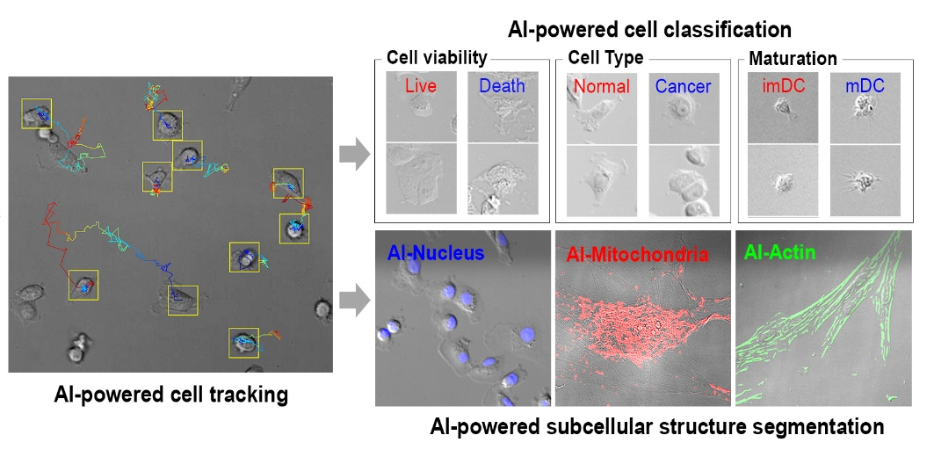  - Transforming a transmitted light microscopy image into a fluorescence microscopy equivalent image (or information) using unsupervised machine learning and supervised semantic segmentation.  - Real-time monitoring of living cell property and status from transmitted light microscopy video using region proposal convolutional neural network and convolutional neural network.  - Living cell tracking in time-lapse video using complementary learning of object shape and colors online.  Patents  - Kim D et al. Generating method for specialized microscope images using artificial neural network and image processing apparatus. Korea Patent, 1020846820000, 2020.  - Kim D et al. Analysing method for cell image using artificial neural network and image processing apparatus for cell image. Korea Patent 1020846830000, 2020.  Publications  - Kim, D., Min, Y., Oh, J.M. et al. AI-powered transmitted light microscopy for functional analysis of live cells. Sci Rep 9, 18428 (2019) doi:10.1038/s41598-019-54961-x
2017 – 2019 | EV-Ident: Identifying Tumor-Specific Extracellular Vesicles by Size Fractionation and Single-Vesicle Analysis  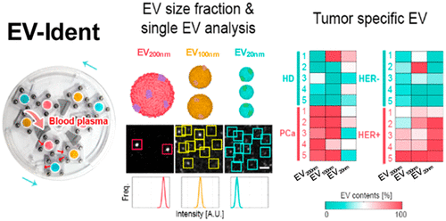  - Early cancer prediction from blood born particle using machine learning techniques.  Publications  - Kim, D., Woo, H.-K., Lee, C., Min, Y., Kumar, S., Sunkara, V., … Cho, Y.-K. (2020). EV-Ident: Identifying Tumor-Specific Extracellular Vesicles by Size Fractionation and Single-Vesicle Analysis. Analytical Chemistry, 92(8), 6010–6018. https://doi.org/10.1021/acs.analchem.0c00285
2017 – 2019 | A fidget spinner for the point-of-care diagnosis of urinary tract infection  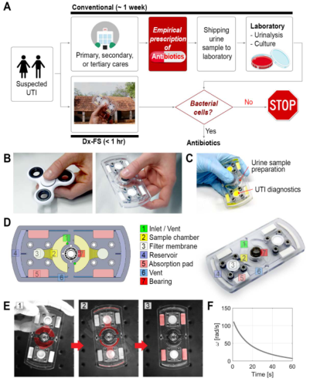  - Hand-powered microfluidic system for bacterial cell enrichment.  - Urinary tract infection diagnosis from a cell phone photograph of a testing kit with machine learning techniques.  Patents  - Kim D et al. Centrifugal force based non-powered particle concentration apparatus and method of particle concentration. Korea Patent 1021037840000, 2020.  - Kim D et al. Centrifugal force based platelet isolation and testing system. Korea Patent 1020638650000, 2020.  Publications  - Kim, D., Michael, I., Gulenko, O., Kumar, S., Kumar, S., Clara, J., … Cho, Y.-K. (2020). A fidget spinner for the point-of-care diagnosis of urinary tract infection. Nature Biomedical Engineering. https://doi.org/10.1038/s41551-020-0557-2
2019 – Current | In-silico fluorescence staining using generative adversarial network.  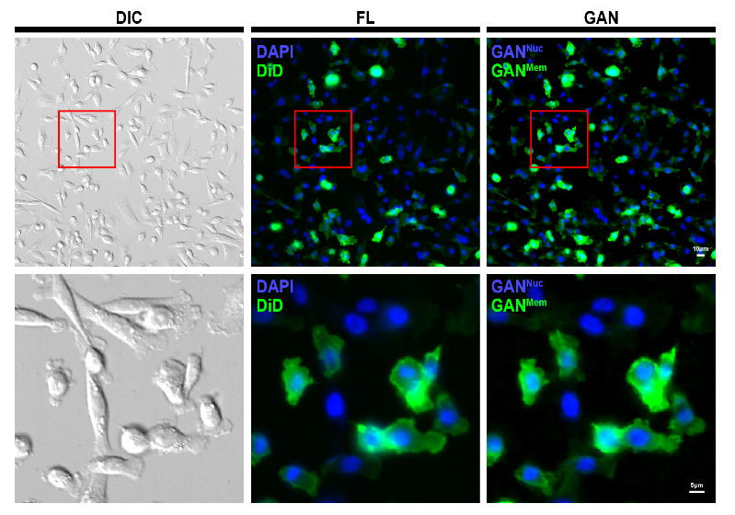  - A deep learning-based approach to create fluorescence stained image from the optical diffraction patterns of the sample.  - Manuscript under preparation.
2019 – Current | In-silico histology staining using generative adversarial network.  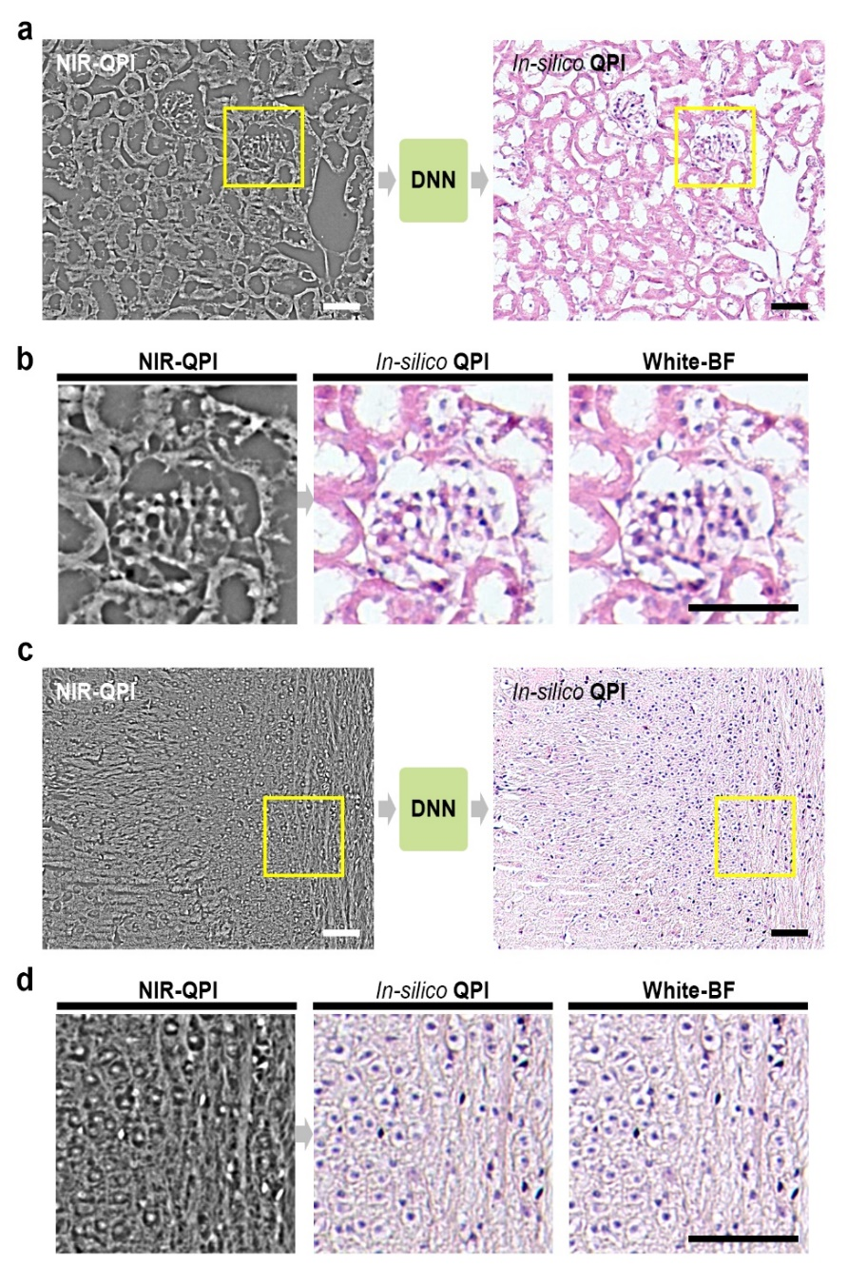  - A deep learning-based approach to create histology stained image from the optical phase information of the unstained slide sample.  - Manuscript under preparation.
2019 – Current | Generative adversarial network for high definition medical image recovery.  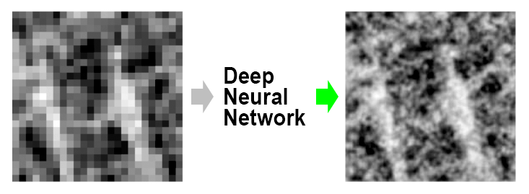  - A deep learning-based approach to create high-resolution tomography images acquired from a low-powered device.  - Manuscript under preparation.
2019 – Current | Generative adversarial network for rapid medical data acquisition.  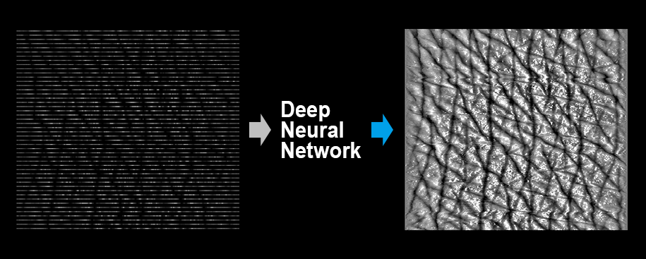  - A deep learning-based approach to make a medical tomography imaging 10 times faster.  - Manuscript under preparation.
2019 – Current | Searching extreme rare cancer extracellular vesicle in blood plasma using generative adversarial network.  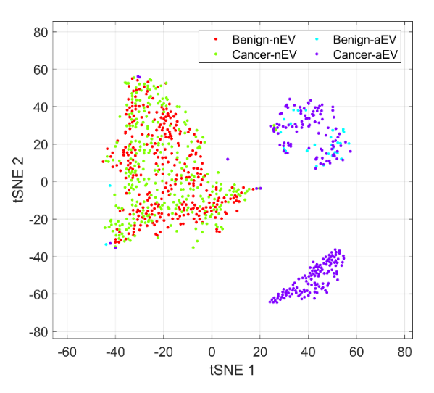  - A deep learning-based approach to detect ultra-rare cancer signal from blood.  - Manuscript under preparation.
2014 – 2016 | Remote focusing multifocal plane microscopy for the imaging of 3D single molecule dynamics with cellular context  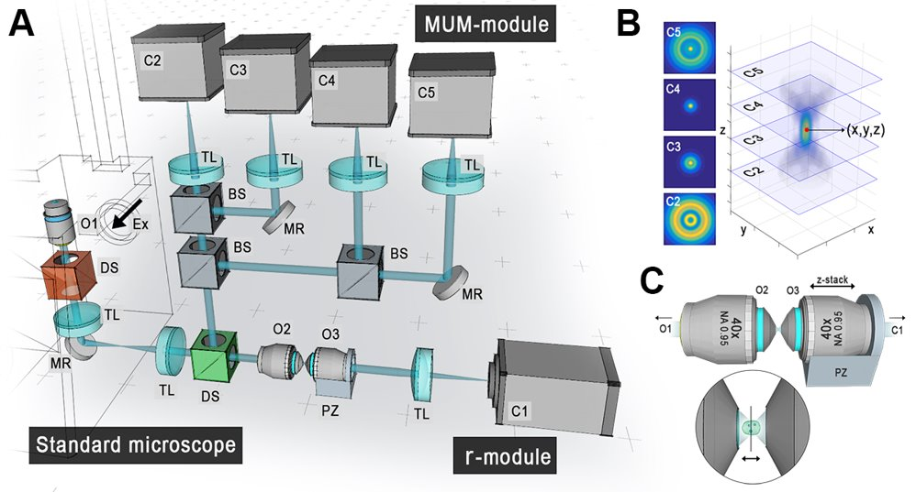  - A microscopy modality to visualize three-dimensional single molecule trajectory in a context of three-dimensional and multicolor cellular structures and compartments over time  - Estimating three-dimensional single molecule location in ~10 nm accuracy.  - Imaging three-dimensional cellular structures from an optical replica using relay optics.  Patents  - Kim D., Ober R.J, Advanced multi-dimensional microscopy system for single particle & structure imaging. U.S. Patent, 2017.)  Publications  - Kim, D., Chao, J., Velmurugan, R., You, S., Ward, E. S., and Ober, R. J. Remote focusing multifocal plane microscopy for the imaging of 3D single molecule dynamics with cellular context. Proceedings of the SPIE, Three-Dimensional and Multidimensional Microscopy: Image Acquisition and Processing XXIV, 10070: 2017.  - Kim D, You S, Ward E.S., Ober R.J, Imaging of three-dimensional single molecule dynamics with cellular context: Antibody trafficking and interaction with cell membrane and sorting endosomes. ASCB, San Fransisco, CA. 2016.
2012 – 2015 | Three-dimensional super resolution microscopy  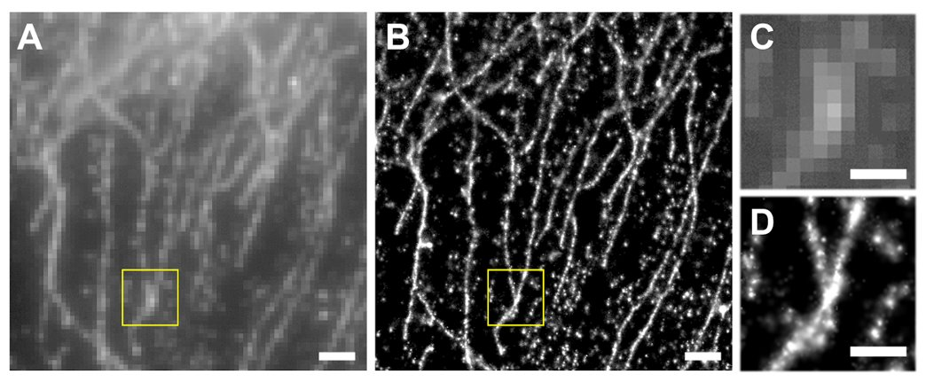  - An optical microscopy technique resolving fluorescently labeled features in ~5 nm resolution.  - Multifocal plane microscopy enables three-dimensional super-resolving imaging.  - Multicolor imaging and super-precision chromatic/spatial registration are capable.  Publications  - Cohen E. A. K.,. Kim D., Ober R.J, Cramer-Rao Lower Bound for Point Based Image Registration with Heteroscedastic Error Model for Application in Single Molecule Microscopy. IEEE Transactions on Medical Imaging 2015  - Ram S, Kim D, Ober RJ, Ward ES. 3D Single Molecule Tracking with Multifocal Plane Microscopy Reveals Rapid Intercellular Transferrin Transport at Epithelial Cell Barriers. Biophysical Journal 2012

PATENTS
Kim D et al. Method for training data for optical character recognition. Korea Patent Pending, 1020200059652, 2020
Kim D et al. Generating method for specialized microscope images using artificial neural network and image processing apparatus. Korea Patent, 1020846820000, 2020.
Kim D et al. Analysing method for cell image using artificial neural network and image processing apparatus for cell image. Korea Patent 1020846830000, 2020.
Kim D et al. Centrifugal force based non-powered particle concentration apparatus and method of particle concentration. Korea Patent 1021037840000, 2020.
Kim D et al. Centrifugal force based platelet isolation and testing system. Korea Patent 1020638650000, 2020.
Kim D., Ober R.J, Advanced multi-dimensional microscopy system for single particle & structure imaging. U.S. Patent, 2017.

HONORS & AWARDS
2018 | 1st place at Shark Tank Competition (Startup company competition).  The 22nd International Conference on Miniaturized Systems For Chemistry And Life Sciences
2016 | 1st place at 3D single molecule localization microscopy  SMLMS Challenge, EPFL, Switzerland.  *Software developed using MATLAB
2014 – 2016 | Scholarship, Texas A&M University, U.S.A.
2012 – 2014 | Scholarship, The University of Texas at Dallas, U.S.A.
2011 – 2011 | Scholarship, The University of Texas at Dallas , U.S.A.
2011 – 2011 | 2nd place for Senior Design Project, The University of Texas at Dallas
2010 – 2012 | Scholarship, The University of Texas at Dallas, U.S.A.

LANGUAGES
English, Korean
SKILLS
Artificial Intelligence | Supervised/unsupervised machine learning, Deep learning model development, Data & modal management framework and platform design.
Programming | MATLAB, Python, C, C++, JAVA.
Data science | Big data analysis, Optimization based data processing.
Electrical system architecture | NI LabWindows/CVI, NI LabView.
Optical system architecture | Zemax based optical system design, Multimodal optical system configuration.
Microscope | Epifluorescence, TIRF microscopy, Confocal microscopy  Super-resolution microscopy  Single molecule microscopy  Transmitted/scanning electron microscopy

LECTURES
BME21101 Introduction to biomedical engineering (Introduction to artificial intelligence for biomedical engineering / Introduction to deep learning), 2019, Ulsan National Institute of Science and Technology (UNIST).

PUBLICATIONS
Kim, D., Min, Y., Oh, J.M. et al. AI-powered transmitted light microscopy for functional analysis of live cells. Sci Rep 9, 18428, 2019
Kim, D., Woo, H.-K., Lee, C., Min, Y., Kumar, S., Sunkara, V., … Cho, Y.-K. (2020). EV-Ident: Identifying Tumor-Specific Extracellular Vesicles by Size Fractionation and Single-Vesicle Analysis. Analytical Chemistry, 92(8), 6010–6018.
Kim, D., Michael, I., Gulenko, O., Kumar, S., Kumar, S., Clara, J., … Cho, Y.-K. (2020). A fidget spinner for the point-of-care diagnosis of urinary tract infection. Nature Biomedical Engineering.
Sunkara, V., Kim C., Park J., Woo H., Kim D., Ha H., Kim M., Son Y., Kim J., Cho Y., Fully automated, label-free isolation of extracellular vesicles from whole blood for cancer diagnosis and monitoring. Theranostics, 2019.
Michael I., Kumar S., Oh J,, Kim D, Kim J., Cho Y. Surface Engineered Paper Hanging Drop Chip for 3D Spheroid Culture and Analysis. ACS applied materials & interfaces, 2018.
Li, R., Chiguru, S., Li, L., Kim, D., Velmurugan, R., Kim, D., Tian, H., Schroit, A., Mason, R., Ober, R. J. and Ward, E. S. Targeting phosphatidylserine with calcium-dependent protein-drug conjugates for the treatment of cancer. Molecular Cancer Therapeutics, 2018.
Devanaboyina, S. C., Khare, P., Challa, Kim, D., Ober, R. J., and Ward, E. S. Engineered clearing agents for the selective depletion of antigen-specific antibodies. Nature Communications, 2017.
Kim, D., Min, Y., Oh, J.M. et al. AI-powered transmitted light microscopy for functional analysis of live cells. Sci Rep 9, 18428, 2019
Kim, D., Woo, H.-K., Lee, C., Min, Y., Kumar, S., Sunkara, V., … Cho, Y.-K. (2020). EV-Ident: Identifying Tumor-Specific Extracellular Vesicles by Size Fractionation and Single-Vesicle Analysis. Analytical Chemistry, 92(8), 6010–6018.
Kim, D., Michael, I., Gulenko, O., Kumar, S., Kumar, S., Clara, J., … Cho, Y.-K. (2020). A fidget spinner for the point-of-care diagnosis of urinary tract infection. Nature Biomedical Engineering.
Sunkara, V., Kim C., Park J., Woo H., Kim D., Ha H., Kim M., Son Y., Kim J., Cho Y., Fully automated, label-free isolation of extracellular vesicles from whole blood for cancer diagnosis and monitoring. Theranostics, 2019.
Michael I., Kumar S., Oh J,, Kim D, Kim J., Cho Y. Surface Engineered Paper Hanging Drop Chip for 3D Spheroid Culture and Analysis. ACS applied materials & interfaces, 2018.
Li, R., Chiguru, S., Li, L., Kim, D., Velmurugan, R., Kim, D., Tian, H., Schroit, A., Mason, R., Ober, R. J. and Ward, E. S. Targeting phosphatidylserine with calcium-dependent protein-drug conjugates for the treatment of cancer. Molecular Cancer Therapeutics, 2018.
Devanaboyina, S. C., Khare, P., Challa, Kim, D., Ober, R. J., and Ward, E. S. Engineered clearing agents for the selective depletion of antigen-specific antibodies. Nature Communications, 2017.
Kim, D., Chao, J., Velmurugan, R., You, S., Ward, E. S., and Ober, R. J. Remote focusing multifocal plane microscopy for the imaging of 3D single molecule dynamics with cellular context. Proceedings of the SPIE, Three-Dimensional and Multidimensional Microscopy: Image Acquisition and Processing XXIV, 10070: 2017.
Vahid, M. R., Chao, J., Kim, D., Ward, E. S., and Ober, R. J. State space approach to single molecule localization in fluorescence microscopy. Biomedical Optics Express, 2017
Poovasery J.S., Kang J.C., Kim D, Ober R.J, Ward E.S. Antibody targeting of HER2/HER3 signaling overcomes heregulin-induced resistance to PI3K inhibition in prostate cancer. International Journal of Cancer 2017
Kim D, You S, Ward E.S., Ober R.J, Imaging of three-dimensional single molecule dynamics with cellular context: Antibody trafficking and interaction with cell membrane and sorting endosomes. ASCB, San Fransisco, CA. 2016.
Cohen E. A. K.,. Kim D., Ober R.J, Cramer-Rao Lower Bound for Point Based Image Registration with Heteroscedastic Error Model for Application in Single Molecule Microscopy. IEEE Transactions on Medical Imaging 2015
Ram S, Kim D, Ober RJ, Ward ES. The level of HER2 expression is a predictor of antibody-HER2 trafficking behavior in cancer cells. mAbs 2014
Devanaboyina SC, Lynch SM, Ober RJ, Ram S, Kim D, Puig-Canto A, Breen S, Kasturirangan S, Fowler S, Peng L, et al. The effect of pH dependence of antibody-antigen interactions on subcellular trafficking dynamics. mAbs 2013
Ram S, Kim D, Ober RJ, Ward ES. Microscopy in Polarized Epithelia Reveals a Novel Cellular Process of Intercellular Transfer. Biophysical Journal 2013
Ram S, Kim D, Ober RJ, Ward ES. 3D Single Molecule Tracking with Multifocal Plane Microscopy Reveals Rapid Intercellular Transferrin Transport at Epithelial Cell Barriers. Biophysical Journal 2012
Kim D, Ram S, Ober RJ, Ward ES. 3D single molecule tracking of rapid intracellular trafficking imaged by multifocal plane microscopy Microscopy and Microanalysis 2012.

