|  |  |
| --- | --- |
|  | TECHNICAL UNIVERSITY OF MOLDOVA  Faculty of Computers, Informatics and Microelectronics  Department: Software Engineering and Automation  Study Program: Software Engineering |

**Formal Languages and Compiler Design**

**Laboratory Work Nr. 2**

**Nondeterministic Finite Automato to Deterministic Finite Automato**

**Executed by: Doni Daniela**

**Group: FAF 193**

**Verified by: Vdovicenco Alexandr**

**Content: Laboratory tasks based on variant-catalog list number**

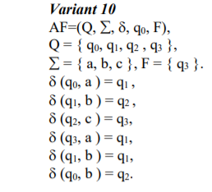

**1. Convert NFA from your variant to DFA on paper, writing all transitions and drawing converted automato.**

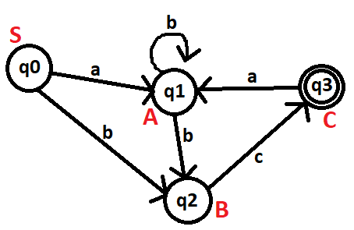

N = {S,A,B,C}

T = {a,b,c}

P = { S-> aA

S->bB

A-> bA

A-> bB

B-> cC

B->c

C-> aA}

|  |  |  |  |
| --- | --- | --- | --- |
|  | **a** | **b** | **c** |
| **q0** | q1 | q2 | **-** |
| **q1** | **-** | q1q2 | **-** |
| **q2** | **-** | **-** | q3 |
| **q3** | q1 | **-** | **-** |

|  |  |  |  |
| --- | --- | --- | --- |
|  | **a** | **b** | **c** |
| **q1q2** | **-** | q1q2 | q3 |

Ilustration of converted automato:

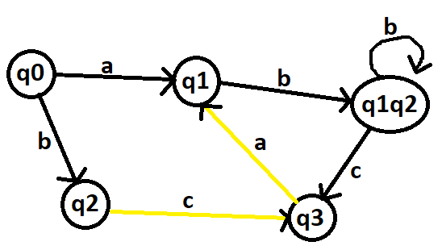

**2. Anexa. Program which converts nondeterministic finite automato (NFA) to deterministic finite automato (DFA)**

https://github.com/DoniDaniela/LFPC_laboratories