|  |  |
| --- | --- |
|  | TECHNICAL UNIVERSITY OF MOLDOVA  Faculty of Computers, Informatics and Microelectronics  Department: Software Engineering and Automation  Study Program: Software Engineering |

**Formal Languages and Compiler Design**

**Laboratory Work Nr. 3**

**Context-free Grammar to Chomsky Normal Form**

**Executed by: Doni Daniela**

**Group: FAF 193**

**Verified by: Vdovicenco Alexandr**

**Content: Laboratory tasks based on variant-catalog list number**

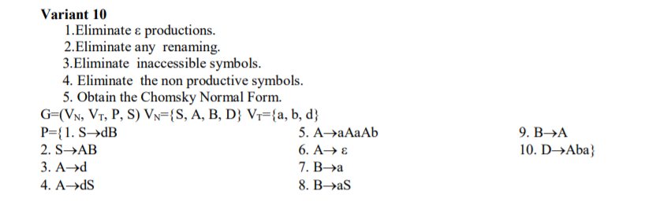

**1. Eliminate ε productions.**

S->dB

S->AB

A->d

A->dS

A->aAaAb

**A->ε**

B->a

B->aS

B->A

D->Aba

**After elimination of ε production:**

S->dB

S->AB

**S->B**

S->d

**S->A**

A->d

A->dS

A->aAaAb

A->aab

A->aAab

A->aaAb

B->a

B->aS

**B->A**

D->Aba

D->ba

**2. Eliminate any renaming.**

S->dB

S->AB

S->a

S->aS

S->dS

S->aAaAb

S->aab

S->aAab

S->aaAb

S->d

A->d

A->dS

A->aAaAb

A->aab

A->aAab

A->aaAb

B->a

B->aS

B->d

B->dS

B->aAaAb

B->aab

B->aAab

B->aaAb

**D->Aba**

**D->ba**

**3. Eliminate inaccessible symbols.**

S->dB

**S->AB**

S->a

S->aS

S->dS

S->aAaAb

S->aab

S->aAab

S->aaAb

S->d

A->d

A->dS

A->aAaAb

A->aab

A->aAab

A->aaAb

B->a

B->aS

B->d

B->dS

B->aAaAb

B->aab

B->aAab

B->aaAb

**4. Eliminate the non productive symbols.**

The non productive symbol is {A}:

S->dB

S->a

S->aS

S->dS

S->aBaBb

S->aab

S->aBab

S->aaBb

S->d

B->a

B->aS

B->d

B->dS

B->aBaBb

B->aab

B->aBab

B->aaBb

**5. Obtain the Chomsky Normal Form.**

S->X1B

S->d

S->a

S->X2X3

S->X1X3

S->X2X4

S->X2Y5

S->X2Z1

S->X2Z2

B->a

B->X2S

B->d

B->X1S

B->X2Y4

B->X2Y5

B->X2Z1

B->X2Z2

X1->d

X2->a

X3->SX4

Y1->b

Y2->BY1

Y3->X2Y2

Y4->BY3

Y5->X2Y1

Z1->BY5

Z2->X2Y2

VN={S,B,X1,X2,X3,X4,X5,Y1,Y2,Y3,Y4,Y5,Z1,Z2}

**6. Anexa.**

Program which converts Context-free Grammar to Chomsky Normal Form.

https://github.com/DoniDaniela/LFPC_laboratories