|  |  |
| --- | --- |
|  | TECHNICAL UNIVERSITY OF MOLDOVA  Faculty of Computers, Informatics and Microelectronics  Department: Software Engineering and Automation  Study Program: Software Engineering |

**Formal Languages and Compiler Design**

**Laboratory Work Nr. 4**

**LL(1) parsing**

**Executed by: Doni Daniela**

**Group: FAF 193**

**Verified by: Vdovicenco Alexandr**

**Content: Laboratory tasks based on variant-catalog list number**

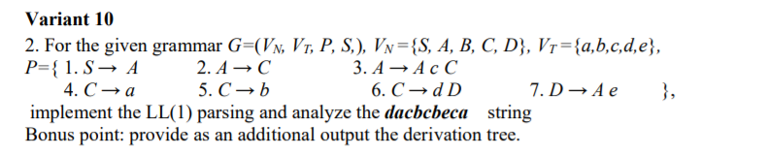

**1. Eliminate Left factoring and left recursion:\**

S->A

A->C

**A->AcC**

C->a

C-> b

C->dD

D->Ae

**Without Left factoring A:**

S->A

A->C

A->A1C

A1->Ac

A1->ε

C->a

C-> b

C->dD

D->Ae

**First Follow Matrix:**

|  |  |  |
| --- | --- | --- |
|  | **First** | **Follow** |
| **S** | **a,b,d,** | **$** |
| **A** | **a,b,d,** | **$** |
| **A1** | **a,b,d,ε** | **c,$** |
| **C** | **a,b,d** | **$** |
| **D** | **a,b,d,** | **e,$** |

**LL1 Predictive Matrix:**

|  |  |  |  |  |  |  |
| --- | --- | --- | --- | --- | --- | --- |
|  | **a** | **b** | **c** | **d** | **e** | **$** |
| **S** | **A** | **A** |  | **A** |  |  |
| **A** | **C** | **C** |  | **A1** |  |  |
| **A1** |  |  | **eps** |  |  | **eps** |
| **C** | **a** | **b** |  | **dD** |  |  |
| **D** | **Ae** | **Ae** |  | **Ae** | **eps** |  |

**Parsing Table:**

**Input: dacbcbeca**

|  |  |  |
| --- | --- | --- |
| **Stack** | **Input** | **Action** |
| **S$**  **A$**  **C$**  **dD$**  **D$**  **Ae$**  **A1Ce$**  **A1ae$**  **A1e$**  **Ace$**  **Ae$**  **A1Ce$**  **A1be$**  **A1e$**  **Ace$**  **Ae$**  **A1Ce$**  **A1be$**  **A1e$**  **A1$**  **Ac$**  **A$**  **C$**  **a$**  **$** | **dacbcbeca$**  **dacbcbeca$**  **dacbcbeca$**  **dacbcbeca$**  **acbcbeca$**  **acbcbeca$**  **acbcbeca$**  **acbcbeca$**  **cbcbeca$**  **cbcbeca$**  **bcbeca$**  **bcbeca$**  **bcbeca$**  **cbeca$**  **cbeca$**  **beca$**  **beca$**  **beca$**  **eca$**  **ca$**  **ca$**  **a$**  **a$**  **a$**  **$** | **A**  **C**  **dD**  **terminal consumed**  **Ae**  **A1Ce**  **A1ae**  **terminal consumed**  **Ace**  **terminal consumed**  **A1Ce**  **A1be**  **terminal consumed**  **Ace**  **terminal consumed**  **A1Ce**  **A1be**  **terminal consumed**  **terminal consumed**  **Ac**  **terminal consumed**  **C**  **a**  **terminal consumed**  **--------------** |

**Anexa.**

Implemented LL(1) parsing:

https://github.com/DoniDaniela/LFPC_laboratories