**Q1**

1. **Total Revenue per Customer with Ranking**: This query calculates the total revenue generated by each customer and ranks them based on their total revenue. It helps identify high-value customers.

select customer_id ,total_revenue , rank() over (order by total_revenue desc ) as top_customer from (

select customer_id , sum(Quantity*price) as total_revenue

from tableRetail

group by customer_id );

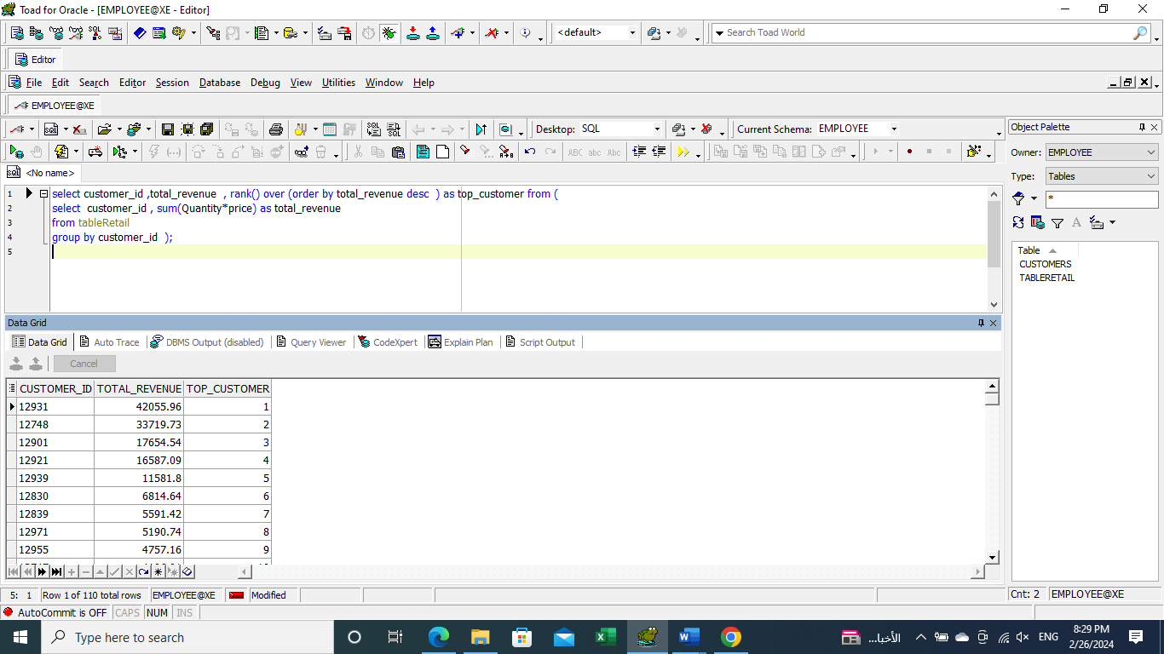

1. **Average Invoice per Customer with Ranking**: This query calculates the average invoice amount for each customer and ranks them based on their average invoice amount. It helps understand spending habits.

select customer_id , avg_invoice, rank() over (order by avg_invoice desc )as top_invocie from (

select customer_id , avg(quantity*price) as avg_invoice

from tableRetail

group by customer_id );

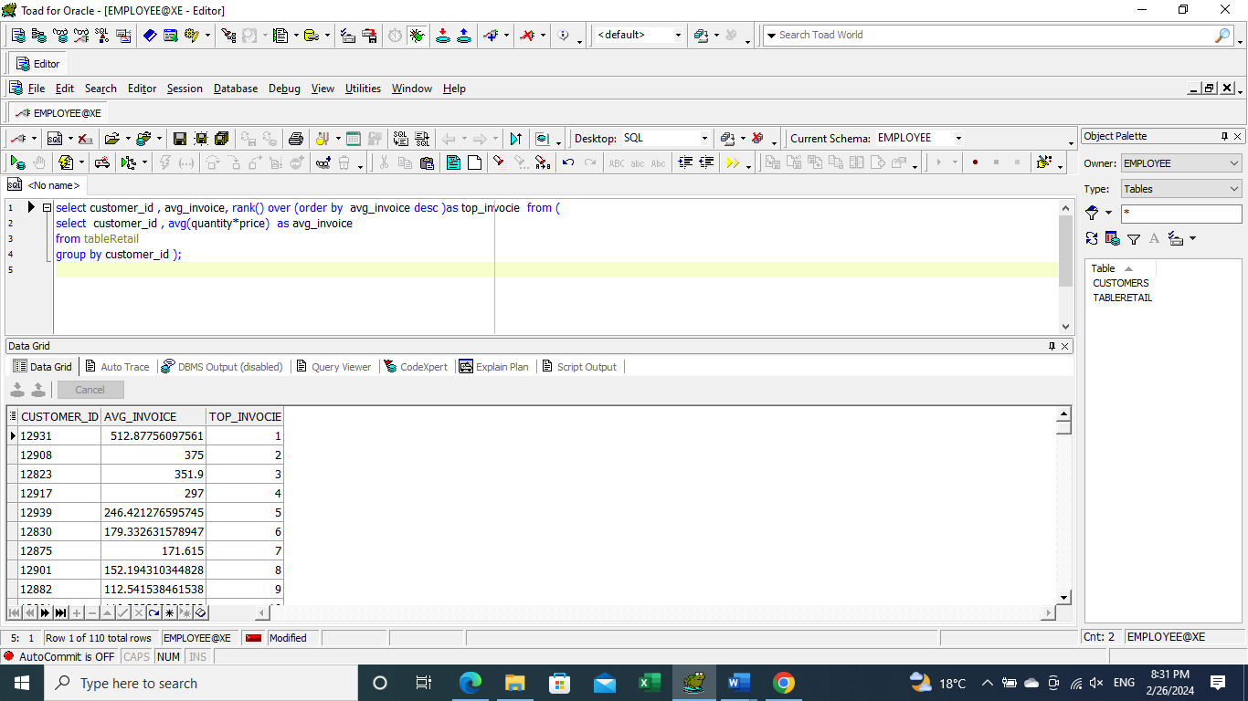

1. **Monthly Revenue**: This query calculates the total revenue for each month, providing insights into revenue trends over time.

SELECT DISTINCT TO_CHAR(TO_DATE(InvoiceDate, 'MM/DD/YYYY HH24:MI'), 'MM/DD/YYYY HH24:MI') AS month,

SUM(quantity * price) OVER (PARTITION BY TO_CHAR(TO_DATE(InvoiceDate, 'MM/DD/YYYY HH24:MI'), 'MM/YYYY')) AS Monthly_Revenue

FROM tableRetail;

\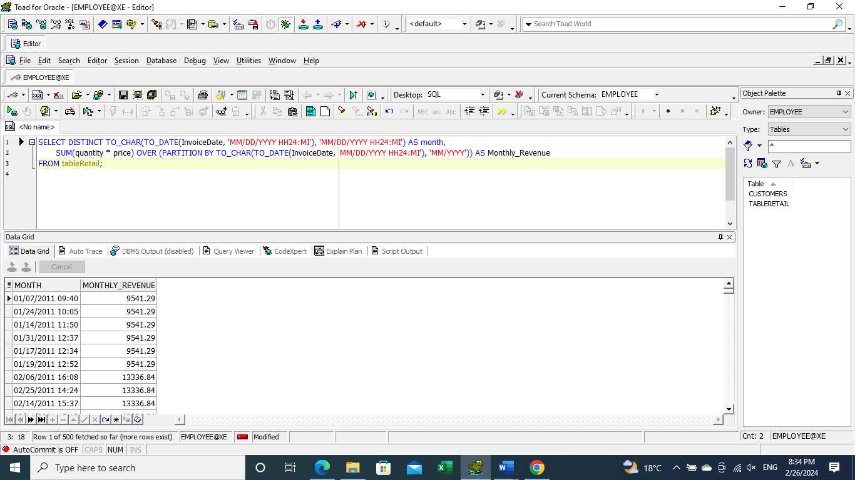

1. **Customer Purchase Frequency**: This query calculates the frequency of purchases for each customer and ranks them based on purchase frequency. It helps identify loyal customers.

with customer_purchase as (

select customer_id , count(invoice) as purchaces from tableretail

group by customer_id ),

ranked_purchase as (

select customer_id , purchaces, dense_rank() over (order by purchaces desc ) as top_purchase

from customer_purchase )

select customer_id , purchaces , top_purchase

from ranked_purchase

where top_purchase = 1 ;

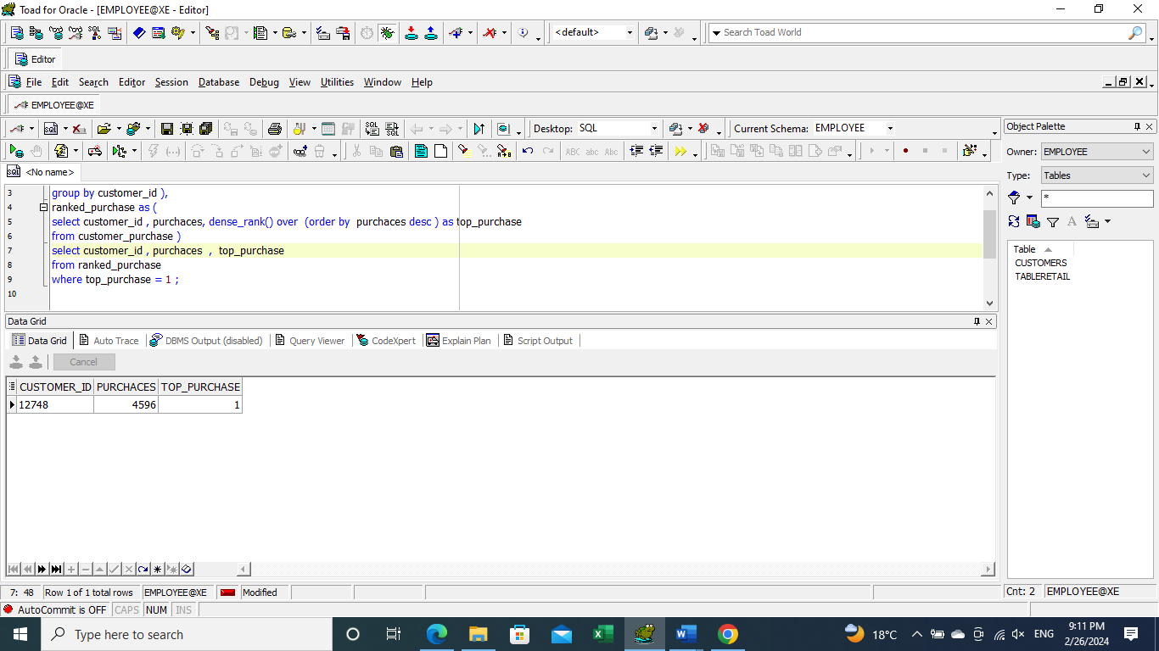

1. **Most Ordered Stock Items**: This query calculates the total quantity of each stock item ordered and ranks them based on total quantity. It helps identify popular products.

select stockcode , total_quantity , rank() over ( order by total_quantity desc ) as most_ordered

from (

select stockcode , sum(quantity) as total_quantity

from tableretail

group by stockcode );

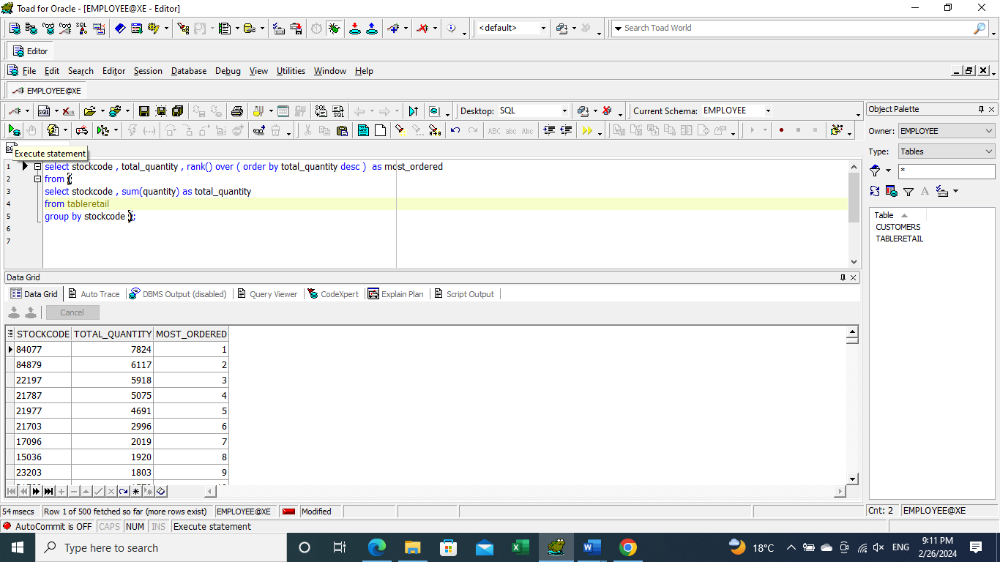

**Q2**

This query is used to calculate the RFM (Recency, Frequency, Monetary) scores for each customer based on their purchasing behavior. RFM analysis is a technique used in marketing to segment customers based on their transaction history. Here's a breakdown of the query and its purpose:

1. **RFMData CTE**: This part of the query calculates the recency, frequency, and monetary values for each customer. Recency is calculated as the difference between the most recent invoice date and the maximum invoice date for each customer. Frequency is the count of invoices for each customer, and monetary is the sum of the quantity multiplied by the price for each invoice.
2. **rfm_score CTE**: This part of the query calculates the RFM scores for each customer by assigning them to quintiles based on their recency, frequency, and monetary values. This helps in ranking customers based on these metrics.
3. **fm_avg CTE**: This part of the query calculates the average of the frequency and monetary scores to get the FM score, which is used for segmentation.
4. **seg_cust CTE**: This part of the query assigns a segment to each customer based on their R_score and FM_score combination. There are several segments defined, such as "Champions," "Loyal Customers," "Potential Loyalists," etc., each representing a different level of customer engagement and loyalty.
5. **Final SELECT**: This part of the query selects the customer ID, recency, frequency, monetary values, R_score, FM_score, and the customer segment for each customer. This information can be used for targeted marketing campaigns, customer retention strategies, and personalized customer engagement based on their segment.

WITH RFMData AS (

SELECT

CUSTOMER_ID,

(SELECT MAX(TO_DATE(INVOICEDATE, 'MM/DD/YYYY HH24:MI')) FROM tableretail) - MAX(TO_DATE(INVOICEDATE, 'MM/DD/YYYY HH24:MI')) AS Recency,

COUNT(INVOICE) AS Frequency,

SUM(QUANTITY * PRICE)AS Monetary

FROM

tableretail

GROUP BY

CUSTOMER_ID

),

rfm_score AS (

SELECT

customer_id,

recency,

Frequency,

Monetary,

NTILE(5) OVER (ORDER BY recency desc ) AS r_score,

NTILE(5) OVER (ORDER BY frequency)AS f_score,

NTILE(5) OVER (ORDER BY monetary) AS m_score

FROM

RFMData

),

fm_avg AS (

SELECT

customer_id,

recency,

Frequency,

Monetary,

r_score,

f_score,

m_score,

round( (F_score + M_score) / 2) AS FM_score

FROM

rfm_score

),

seg_cust AS (

SELECT

customer_id,

recency,

Frequency,

Monetary,

r_score,

f_score,

m_score,

FM_score,

CASE

WHEN R_score = 5 AND FM_score = 5 THEN 'Champions'

WHEN R_score = 5 AND FM_score = 4 THEN 'Champions'

WHEN R_score = 4 AND FM_score = 5 THEN 'Champions'

WHEN R_score = 5 AND FM_score = 2 THEN 'Potential Loyalists'

WHEN R_score = 4 AND FM_score = 2 THEN 'Potential Loyalists'

WHEN R_score = 3 AND FM_score = 3 THEN 'Potential Loyalists'

WHEN R_score = 4 AND FM_score = 3 THEN 'Potential Loyalists'

WHEN R_score = 5 AND FM_score = 3 THEN 'Loyal Customers'

WHEN R_score = 4 AND FM_score = 4 THEN 'Loyal Customers'

WHEN R_score = 3 AND FM_score = 5 THEN 'Loyal Customers'

WHEN R_score = 3 AND FM_score = 4 THEN 'Loyal Customers'

WHEN R_score = 5 AND FM_score = 1 THEN 'Recent Customers'

WHEN R_score = 4 AND FM_score = 1 THEN 'Promising'

WHEN R_score = 3 AND FM_score = 1 THEN 'Promising'

WHEN R_score = 3 AND FM_score = 2 THEN 'Customers Needing Attention'

WHEN R_score = 2 AND FM_score = 3 THEN 'Customers Needing Attention'

WHEN R_score = 2 AND FM_score = 2 THEN 'Customers Needing Attention'

WHEN R_score = 2 AND FM_score = 5 THEN 'At Risk'

WHEN R_score = 2 AND FM_score = 4 THEN 'At Risk'

WHEN R_score = 1 AND FM_score = 3 THEN 'At Risk'

WHEN R_score = 1 AND FM_score = 5 THEN 'Cant Lose Them'

WHEN R_score = 1 AND FM_score = 4 THEN 'Cant Lose Them'

WHEN R_score = 1 AND FM_score = 2 THEN 'Hibernating'

WHEN R_score = 1 AND FM_score = 1 THEN 'Lost'

END AS cust_segment

FROM

fm_avg

)

SELECT

CUSTOMER_ID,

Recency,

Frequency,

Monetary,

R_score,

FM_score,

cust_segment

FROM

seg_cust ;

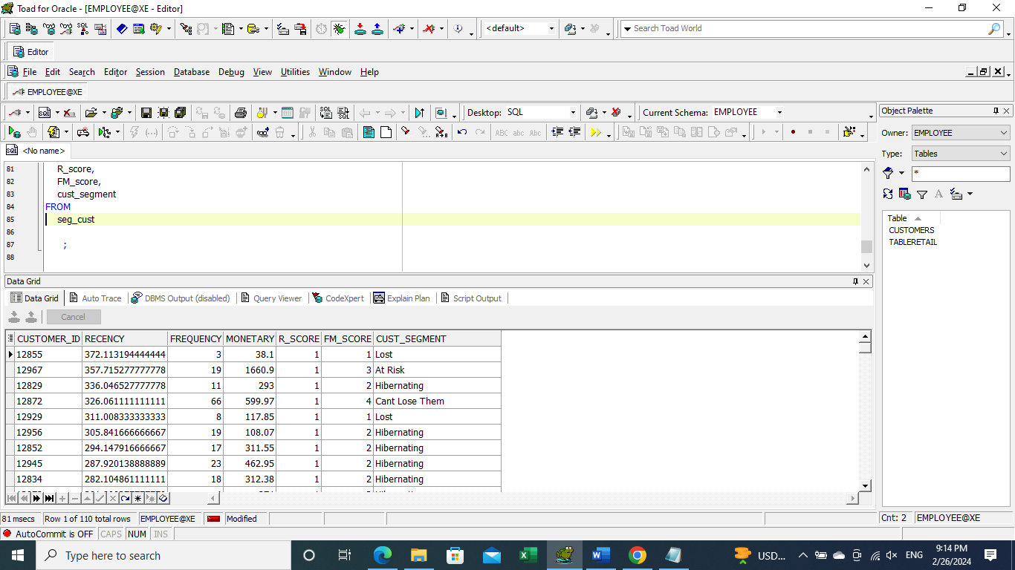

**Q3.A**

This query calculates the maximum number of consecutive days a customer has made purchases. It first assigns a row number to each purchase date for each customer, then calculates the gap in days between each purchase date and its corresponding row number. Finally, it counts the number of consecutive days for each customer and determines the maximum consecutive days for each customer. This information can be useful for understanding customer purchase behavior, identifying regular or frequent purchasers, and tailoring marketing strategies to increase engagement.

with cust_row as (

select cust_id , calendar_dt , row_number() over (partition by cust_id order by calendar_dt ) as rn

from customers ),

cons_days as (

select cust_id , calendar_dt , rn,

calendar_dt - row_number() over (partition by cust_id order by calendar_dt ) as gap_days

from cust_row ) ,

consecutive as (

select cust_id , gap_days , count (*) as consecutive_days

from cons_days

group by cust_id , gap_days)

select cust_id , max(consecutive_days) as max_consecutive_days

from consecutive

group by cust_id ;

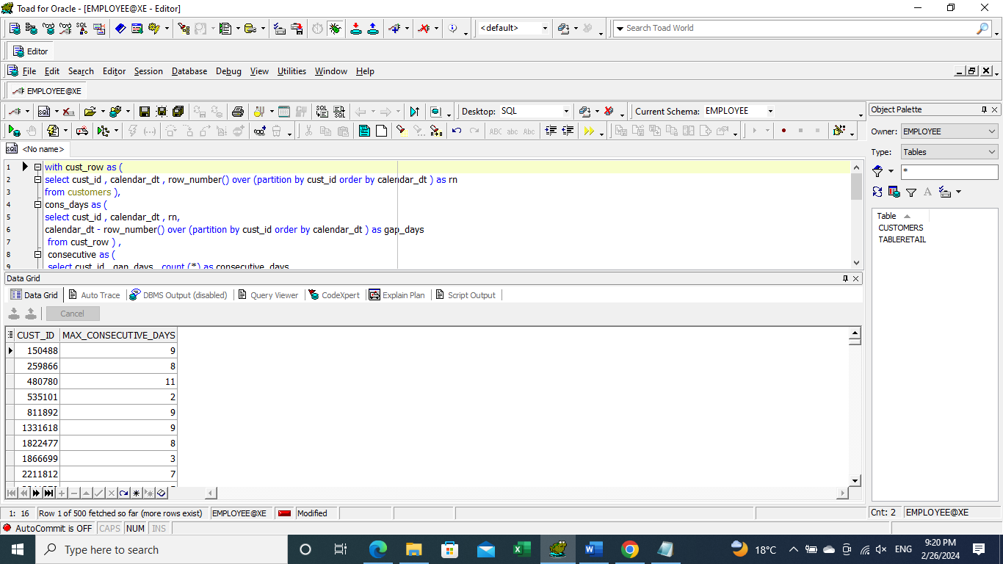

**EXAMPLE:**

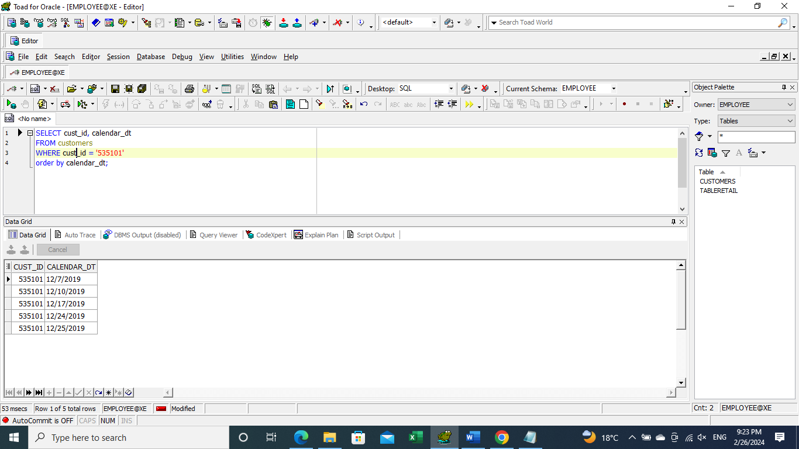

**Q3.B**

This query calculates the average number of days it takes for customers to reach a spending threshold of 250 units of currency. It first calculates the total amount spent by each customer on each day and calculates the cumulative total of their spending. Then, it identifies the first day each customer's spending total exceeds or equals 250 units. Finally, it calculates the average number of days it takes across all customers to reach this threshold. This information can be valuable for understanding customer purchasing behavior and can help in designing targeted marketing campaigns or loyalty programs.

WITH cust_amt AS (

SELECT

cust_id,

calendar_dt,

SUM(amt_le) OVER (PARTITION BY cust_id ORDER BY calendar_dt) AS total,

calendar_dt - FIRST_VALUE(calendar_dt) OVER (PARTITION BY cust_id ORDER BY calendar_dt)

AS total_days

FROM

customers

),

amt_threshold AS (

SELECT

cust_id,

calendar_dt,

total , total_days

FROM

cust_amt

WHERE

total >= 250

) ,

threshold_days as (

SELECT

min(total_days) as total_days_threshold , cust_id

FROM

amt_threshold

group by cust_id )

select

round(avg (total_days_threshold) ) as threshold

from threshold_days ;

