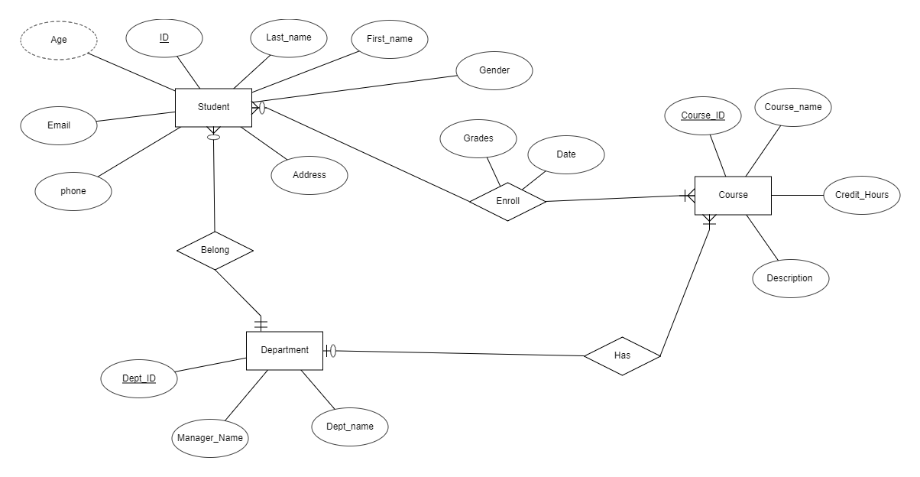

|  |  |  |  |  |  |  |  |  |
| --- | --- | --- | --- | --- | --- | --- | --- | --- |
| Student | Student_id | first_name | Last_name | address | email | Gender | phone | Dept_id(fK) |
| Department | Dept_id | Dept_name | Manager_name |
| course | Course_id | Course_name | description | Credit_hours | Dept_id(fK) |
| Student_course | Student_id | Course_id | date | grades |