**1-**

**Dynamic equations:**

Equation of motion of M1:

M1 X1’’= U- k1X1 - F1X1’ + K2X2 -K2X1

Transfer equation:

(S^2)M1X1(S) = U(S) - F1SX1(S) - K2X1(S) +K2X2(S) - K1X1(S)

Equation of motion of M2:

M2X2’’= K2X1 - F2X2’ - K2X2 -K3X2

Transfer equation:

(S^2)M2X2(S) = K2X1(S) - F2SX2(S) - K2X2(S) - K3X2(S)

Block diagram:

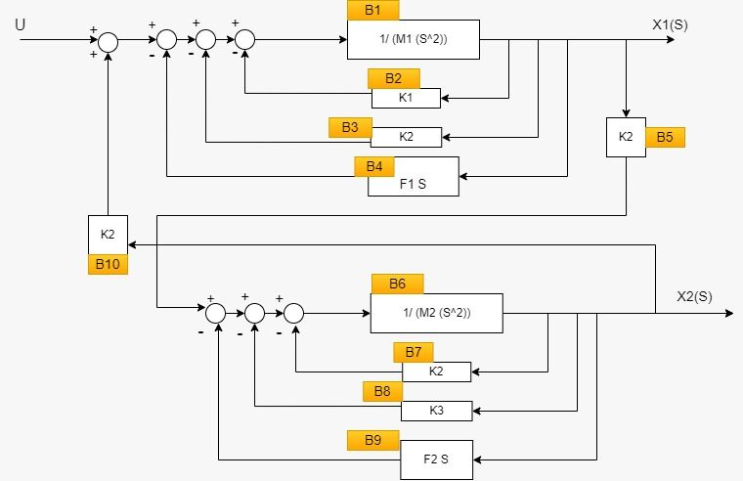

**2-X1/U**

**X2/U**

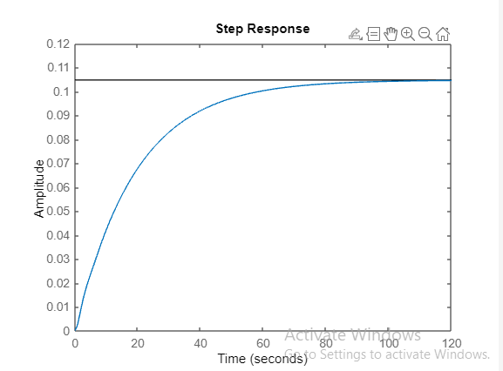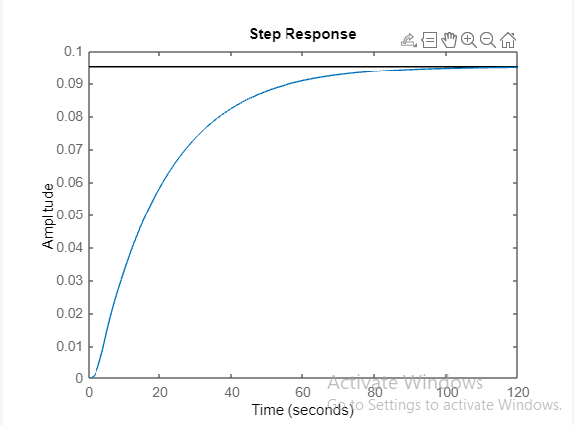

**3-X1 is stable as all poles are in the negative half**

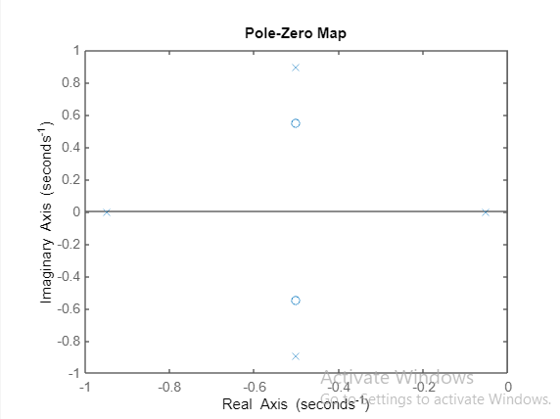

**🡺**function **isstable(sys1)** in Matlab to check stability

**4-**

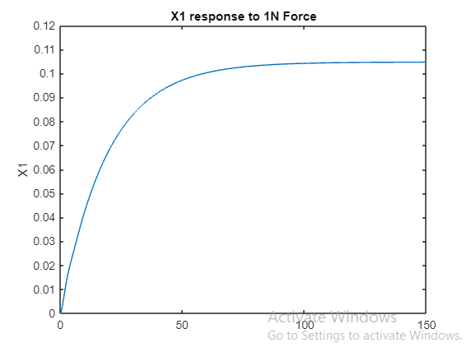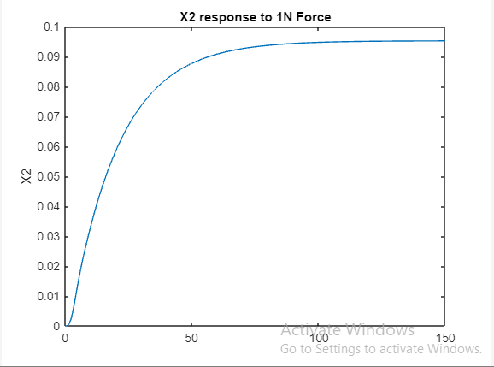

Steady state value of X1 is 0.104701  
Steady state value of X2 is 0.095150

**5-**

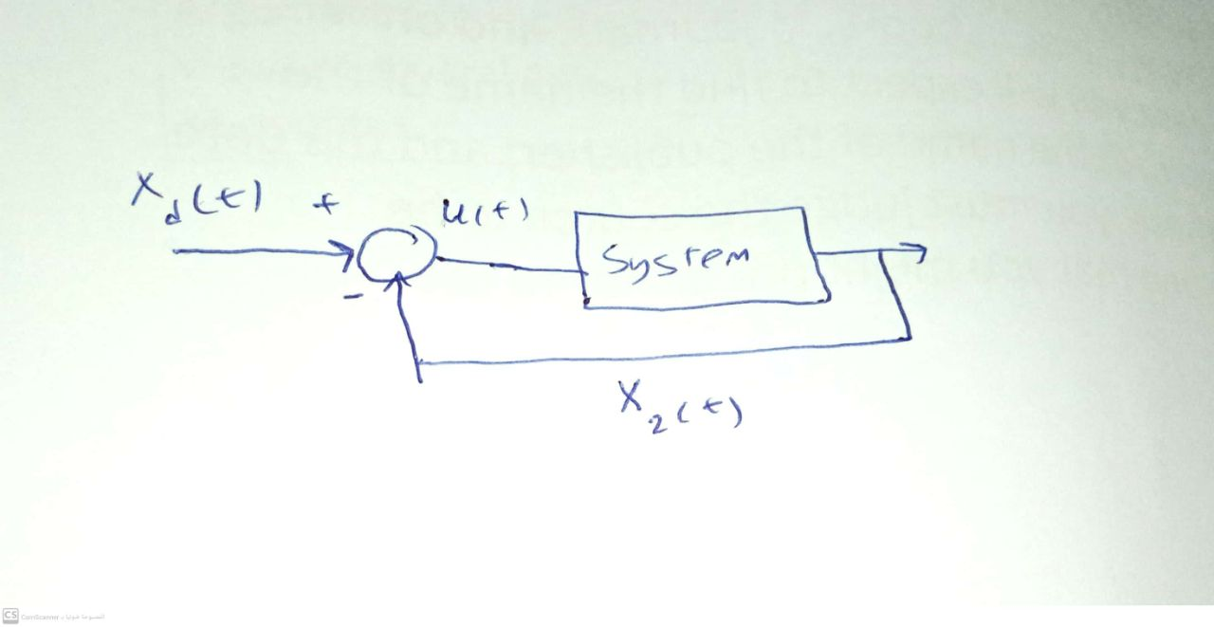

**6-**

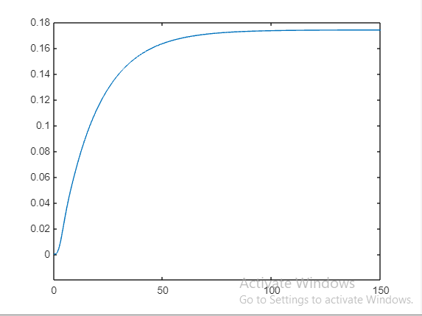

**7-**

Rise time = 37.436246  
Peak time = 150.000000  
Max peak = 0.173883  
Settling time = 68.815786  
Steady state error = 1.826117

**8-**

**For P =1:**   
Rise time of X2 is 37.436246  
Peak time of X2 is 150.000000  
Max peak of X2 is 0.173883  
Settling time of X2 is 68.815786  
Steady state error of X2 is 1.826117  
**For P =10:**  
Rise time of X2 is 18.846006  
Peak time of X2 is 150.000000  
Max peak of X2 is 0.975610  
Settling time of X2 is 35.781356  
Steady state error of X2 is 1.024390

**For P =100:**  
Rise time of X2 is 2.216290  
Peak time of X2 is 6.300000  
Max peak of X2 is 2.683290  
Settling time of X2 is 31.014244  
Steady state error of X2 is 0.190045

**For P =1000:**  
unstable system

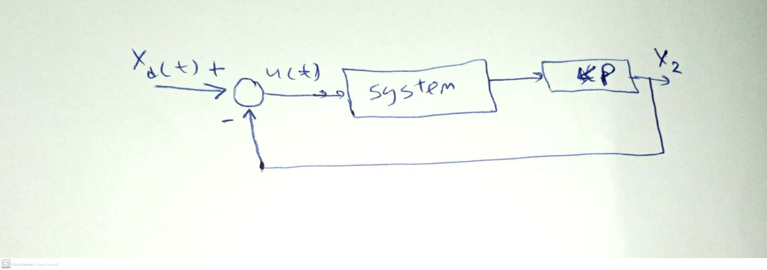

**9-**

**No, because the system becomes unstable (from simulation)**

**P>4189.5 which makes the system unstable**

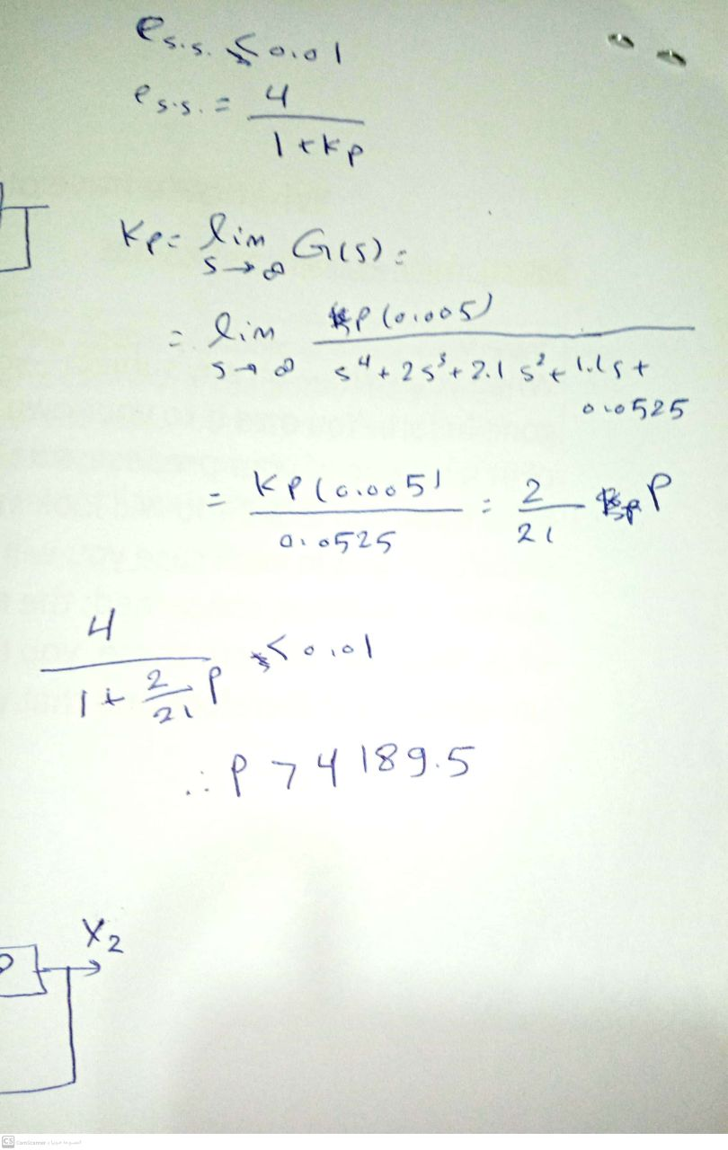

**10-**

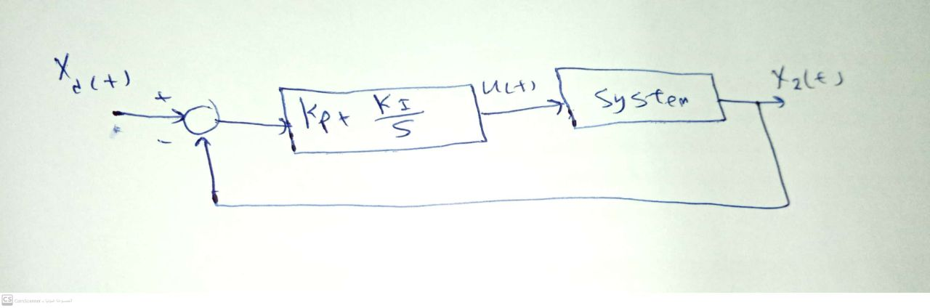

For Kp=100,Ki=10 🡺 Steady state error of X2 is 0.000001

