PROJECT PROPOSAL & REQUIREMENTS DOCUMENT
Synthetic Speech & Voice-Spoofing Detection for Fraud Prevention
An AI × Cybersecurity Semester Project — Full SDLC

Team
Donia Mabrouk
Iheb
Malak
AI Course — Semester Project
September 2026

Table of Contents
1. Executive Summary
2. Problem Statement & Motivation
3. Project Objectives
4. Proposed Solution Overview
5. System Architecture
6. Datasets & Related Grounding
7. Methodology & Experiments
8. Evaluation Metrics
9. SDLC Roadmap (14-Week Plan)
10. Team Roles & Responsibilities
11. Risks & Mitigations
12. Expected Deliverables
13. Conclusion

1. Executive Summary
Voice-cloning fraud — where an attacker uses a few seconds of a real person's voice to synthesize speech and impersonate them over the phone — is one of the fastest-growing social-engineering threats in cybersecurity today. Incidents involving cloned executive voices authorizing fraudulent wire transfers, and synthetic speech bypassing voice-based identity checks, have already caused real financial losses at organizations worldwide.
This project proposes the design, implementation, and evaluation of a synthetic speech / voice-spoofing detection system intended to act as a decision-support security control against this class of attack. Rather than building a generic “deepfake detector,” the project is deliberately framed around a concrete threat model — attacker, attack vector, target, and consequence — which gives the work both academic rigor and direct real-world relevance.
The project will be executed by a three-person team (Donia Mabrouk, Iheb, Malak) across a full Software Development Life Cycle (SDLC): requirements, threat analysis, design, implementation, testing, deployment, and monitoring. The system will be delivered as a containerized REST API with a lightweight analyst-facing dashboard, backed by a machine-learning detector trained and evaluated on established voice-spoofing datasets.
The guiding research question for the project is:
“How reliable is an AI-based voice-spoofing detector when the synthesis method, dataset, or audio channel conditions differ from what it was trained on — and how should that uncertainty be communicated to a security analyst?”
This framing keeps the project intellectually honest: the goal is not to claim deepfakes are “solved,” but to rigorously characterize when and how detection fails, and to design a system that behaves responsibly under that uncertainty.

2. Problem Statement & Motivation

2.1 The real-world problem
Advances in text-to-speech and voice-conversion models have made high-quality voice cloning accessible with only a few seconds of reference audio. This capability is increasingly weaponized in:
- Vishing (voice phishing) and executive impersonation — attackers clone a manager's or family member's voice to authorize payments or extract sensitive information.
- Bypass of voice-based identity verification used by call centers and some financial institutions.
- Erosion of trust in recorded or live audio as evidence, with downstream effects on journalism, legal proceedings, and public discourse.
Unlike many AI course projects that address a hypothetical or purely academic problem, this one maps directly onto an active, documented attack pattern in the cybersecurity threat landscape — which is what gives it both real-world grounding and portfolio credibility.

2.2 Why this is a genuine AI × cybersecurity intersection
The project is not “ML applied to audio” in isolation. It is framed around a security threat model — attacker capability, attack vector, asset at risk, and a detection control — which is what makes it a cybersecurity project rather than only a signal-processing / classification exercise. The figure below summarizes this threat model.
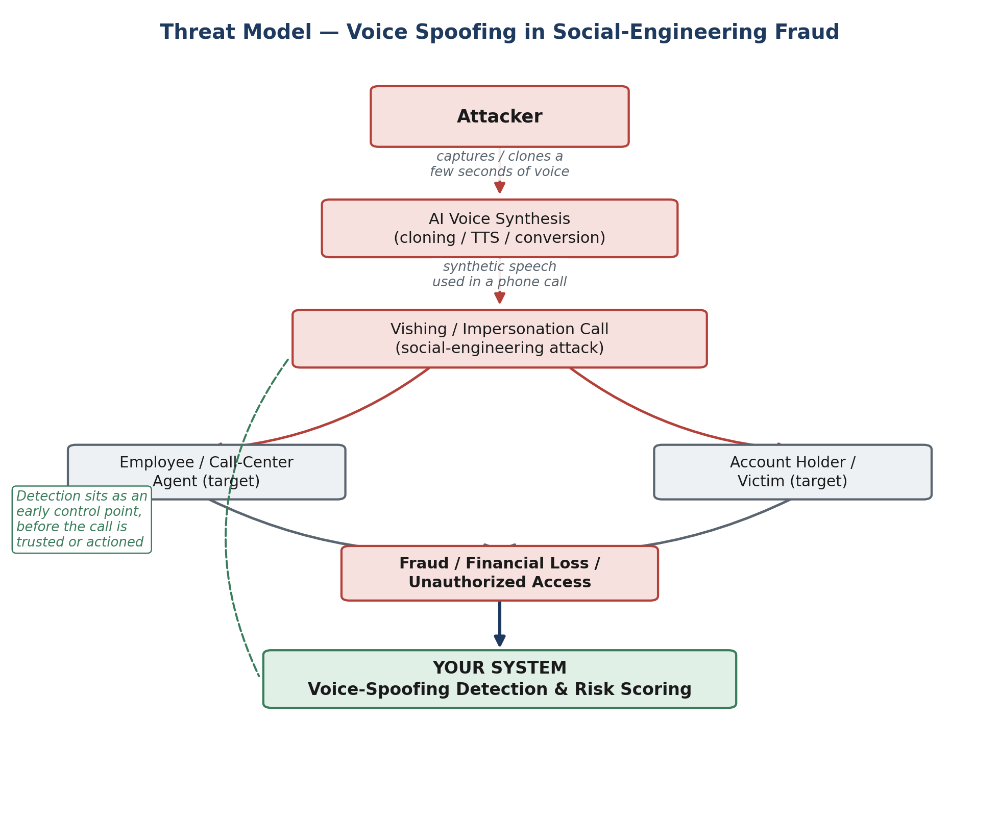
Figure 1 — Threat model: how synthetic speech is weaponized in a social-engineering fraud scenario, and where the detection system intervenes.

2.3 Attacker capability assumptions
A threat model diagram shows the attack path; it does not by itself pin down what the attacker can and cannot do. The project makes these assumptions explicit:
- Attacker can: obtain a short voice sample of the target (public recording, social media, a prior call); generate synthetic speech from it using accessible TTS/voice-conversion tools; transmit that speech through a real phone/recording channel, introducing the codec and compression artifacts the robustness evaluation (Section 7.2) targets.
- Attacker cannot (explicitly out of scope): modify or tamper with the detection service itself; access the model's internals or training data; alter the analyst dashboard or its outputs.
- Noted as a limitation, not implemented: an attacker aware that detection exists could in principle adapt to evade it (adversarial evasion). The project does not implement or defend against adversarial attacks on the detector itself — this is stated as an explicit limitation in the final report rather than left unaddressed.

3. Project Objectives

3.1 Primary objectives
- Design and implement a machine-learning system that classifies short speech segments as authentic, synthetic, or uncertain.
- Ground the system in a realistic fraud-prevention threat model rather than a generic classification framing.
- Rigorously evaluate the system's generalization across datasets and, where feasible, across unseen synthesis/attack methods.
- Deliver the detector as a working software system — REST API, containerized deployment, and a minimal analyst dashboard — not only a notebook.
- Execute the project through a complete, documented SDLC suitable for both course evaluation and a professional portfolio.

3.2 Non-objectives (explicit scope boundaries)
- The system is not a production banking-grade biometric authenticator; it is a decision-support prototype.
- The system does not claim to detect all present or future synthesis methods — its limitations are treated as a first-class deliverable, not an afterthought.
- Real-time / streaming detection is a stretch goal, not a baseline requirement.

4. Proposed Solution Overview
The proposed system, Voice-Spoofing Detection & Risk Scoring, ingests a short audio sample and returns a structured risk assessment rather than a blunt binary verdict. This design choice reflects the project's core stance: the detector is an assistive security control, not an oracle.

4.1 Key design decisions
- Three-way output — authentic / synthetic / uncertain — instead of forced binary classification, so low-confidence cases are routed to manual verification rather than silently misclassified.
- Two-tier modeling — a classical baseline (for a credible, interpretable comparison point) plus a deep model, evaluated against each other rather than reporting the deep model in isolation.
- Generalization as a first-class evaluation axis — cross-dataset testing (train on one spoofing dataset, test on another) is treated as a required experiment, not an optional extra.
- Robustness to realistic degradation — telephone-quality compression, noise, and codec artifacts are tested explicitly, since real fraud calls are rarely pristine studio audio.
- Service-oriented architecture — the model is exposed through a REST API and consumed by a dashboard, giving the team a real software system with clear integration points, rather than logic trapped in a single notebook.

4.2 Terminology note
The project is deliberately named “synthetic speech / voice-spoofing detection” rather than “voice deepfake detection,” since the system is designed to detect both text-to-speech synthesis (represented in the training data) and voice-conversion attacks (represented in the external test set) — “deepfake” alone underspecifies which of these is meant. Using the more precise terminology signals familiarity with the underlying literature and avoids overstating what the datasets represent.

5. System Architecture
The architecture separates an offline training/evaluation pipeline from an online inference service, with a lightweight operations layer for monitoring. This separation keeps the ML research work (datasets, training, generalization experiments) decoupled from the deployable service, which simplifies both development and testing.
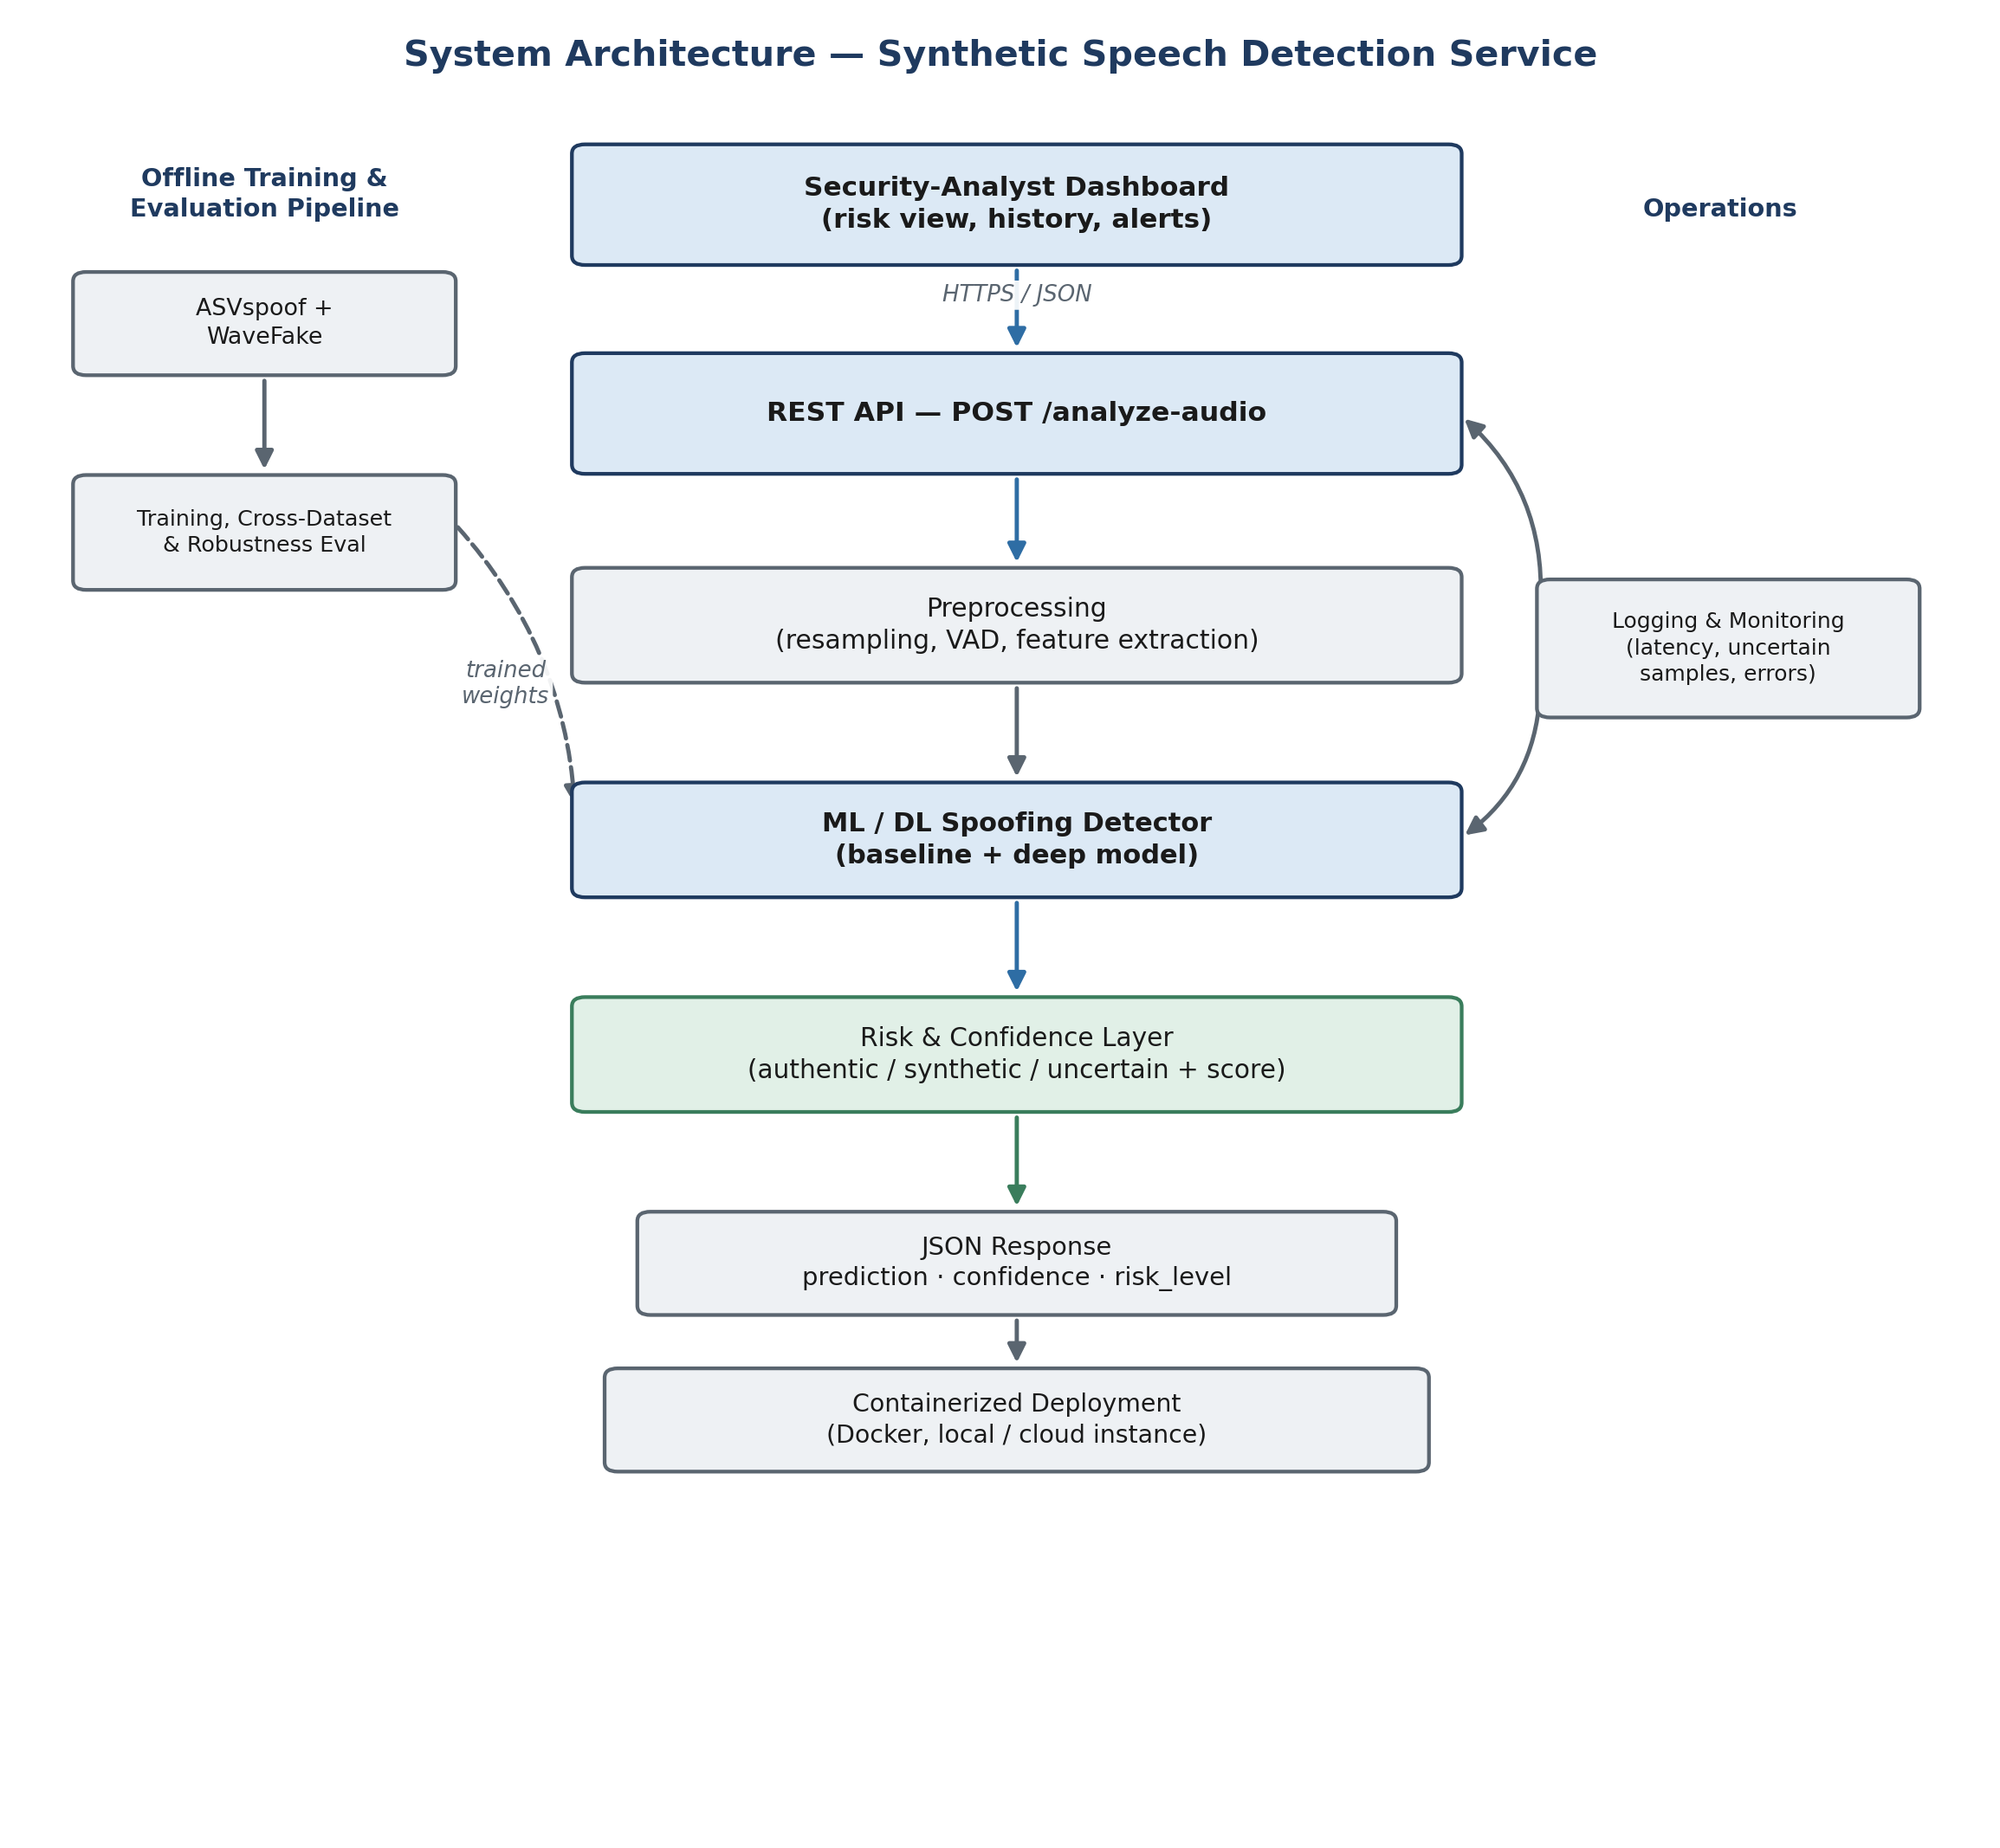
Figure 2 — End-to-end system architecture: offline training/evaluation pipeline (left), the online detection service (center), and operations/monitoring (right).

5.1 Component summary
Component | Responsibility
Preprocessing | Resampling, voice-activity detection, feature extraction (e.g. log-mel spectrogram / raw waveform framing)
ML / DL Detector | Baseline classical model + a deep model (e.g. CNN over spectrograms, or a raw-waveform architecture); ensembled or compared
Risk & Confidence Layer | Converts raw model output into authentic / synthetic / uncertain plus a calibrated confidence score
REST API | POST /analyze-audio — stateless inference endpoint returning prediction, confidence, and risk_level as JSON
Dashboard | Minimal analyst-facing view: submit audio, see risk history and flagged cases
Logging & Monitoring | Tracks predictions, latency, and uncertain/flagged samples for later review

6. Datasets & Related Grounding
- Fake-or-Real (FoR), 2-second version — the training, validation, and in-domain test set. Built from real speech paired with synthetic speech from multiple commercial/research TTS systems (the original FoR release spans engines including Deep Voice 3, Google WaveNet, Google TTS, Microsoft TTS, Amazon Polly, and Baidu TTS), giving the model a broad synthetic-speech training distribution rather than one generator's output. Ready-paired REAL/FAKE clips, standardized to 2 seconds — no separate real-audio sourcing required.
- DEEP-VOICE — used exclusively as a frozen, external generalization test set, never for training or tuning. Contains real speech from eight public figures and Retrieval-based Voice Conversion (RVC) clips converting one person's speech into another's voice — a fundamentally different synthesis paradigm from FoR's TTS-based attacks (voice conversion vs. text-to-speech). This tests whether the detector learns transferable synthetic-speech characteristics or only FoR-specific artifacts.
Both datasets are freely available as ready-to-use packages on Kaggle / Hugging Face — no institutional approval process, no dataset larger than ~1.2 GB. Acquisition fits comfortably in Phase 0, before Week 1 begins, and needs no more than free-tier Google Colab and Drive.
Methodological note: ASVspoof 2019 LA, WaveFake, and In-the-Wild were each evaluated as candidate datasets earlier in the project's planning and are not being used in the current design. ASVspoof was set aside once a smaller, self-contained pairing (FoR-2sec + DEEP-VOICE) was found to deliver an equally rigorous cross-generation-method generalization test — TTS-trained model tested cold on voice-conversion attacks — without ASVspoof's protocol/metric overhead (see the t-DCF note in Section 8). This trade-off is recorded here explicitly rather than left as a silent substitution; all three remain documented options for future work (Section 7.2).

6.1 Dataset audit & leakage-aware split protocol (required before training)
This audit gates all modeling work — it is a required Phase 2 task, time-boxed to a single focused session, not an open-ended investigation. The scientific claim behind the whole project (that FoR → DEEP-VOICE constitutes a meaningful generalization test) depends on it:
- FoR-2sec provenance — confirm which TTS generation methods are actually represented in this specific 2-second Hugging Face/Kaggle packaging, rather than assuming the full diversity of the original FoR release survived repackaging (the original release's dataset card does not fully document this for the 2-second variant).
- Speaker and source-recording distribution — identify whether multiple clips derive from the same underlying recording or speaker, which is a dataset-leakage risk if a naive random split places related clips on both sides of train/val/test.
- Duplicate / near-duplicate detection — check for repeated or highly similar segments that would let the model memorize rather than generalize.
- Group-aware split strategy — if speaker or source-recording metadata is available, split at the group level (not the clip level) so no source leaks across train/validation/test. If the packaging's metadata doesn't support this, document that limitation explicitly rather than proceeding with an ungrounded split.
- DEEP-VOICE class balance — the external test set is heavily skewed toward the spoof class (documented benchmark packaging: 628 bonafide vs. 4,425 spoof); this does not invalidate EER as a threshold-independent metric, but raw accuracy and the confusion matrix must be reported and read with that imbalance stated explicitly.
- License and redistribution terms for both datasets.
The single most important rule this audit protects: DEEP-VOICE is evaluated once, on the final frozen model, after all model selection and threshold tuning is complete on FoR alone. No retraining, re-tuning, or threshold adjustment using DEEP-VOICE results — doing so would silently convert the external test into a second validation set and invalidate the generalization claim.

7. Methodology & Experiments
Given a one-semester timeline and a three-person team, the project is scoped as an MVP core that must be delivered to a high standard, plus exactly two stretch goals — rather than attempting every possible experiment at shallow depth. The guiding rule: one strong, well-evaluated deep model beats three mediocre ones. Breadth is deliberately sacrificed for experimental rigor.

7.1 MVP core (required)
- Dataset audit & leakage-aware split (Section 6.1) — completed and documented before any model is trained.
- Baseline model — MFCC features with a lightweight classical classifier (e.g. SVM), establishing a credible reference point rather than comparing the deep model to nothing.
- One primary deep model — a CNN over log-mel spectrograms, 16kHz preprocessing. This is the single architecture the team commits to and evaluates rigorously. A pretrained front-end (wav2vec2 / WavLM) is explicitly parked as future work (see 7.2) rather than pursued in parallel, to protect delivery of the MVP.
- Cross-dataset generalization experiment — train and validate on FoR-2sec, evaluate in-domain on a held-out FoR test split, then evaluate the frozen final model on DEEP-VOICE as a true external test (never used for training or tuning). This is the project's central research contribution.
- Working REST API and minimal dashboard, containerized with Docker.

7.2 Stretch goals (exactly two, both required if time allows)
- Robustness / audio degradation curve — measure how detection performance (EER) decays as controlled degradation (noise, compression, reduced bandwidth) is progressively applied to clean audio, producing a clean→mild→moderate→severe curve rather than one arbitrary noisy test. This directly ties the ML result back to the fraud scenario: real vishing calls are rarely pristine studio audio.
- Confidence calibration — verify that the model's reported confidence is actually trustworthy (e.g. via temperature/Platt scaling, checked with a reliability diagram / Expected Calibration Error), not just raw softmax output taken at face value. This is what makes the “uncertain” category in the risk layer scientifically meaningful rather than an arbitrarily chosen threshold.
Parking lot — attempt only if both required stretch goals are complete with meaningful time to spare, and never at the expense of them:
- Speaker- or attack-specific held-out evaluation within FoR, if the audited metadata supports it.
- A second independent external dataset (ASVspoof, WaveFake, or In-the-Wild — each evaluated and set aside earlier, still viable as a further generalization check with time to spare).
- Pretrained front-end fine-tuning (wav2vec2 / WavLM) — the highest-ceiling extension, but only once the CNN MVP is solid and evaluated end-to-end.
- Explainability — e.g. spectrogram-based saliency (audio explainability is less mature than image explainability, so this is deliberately deprioritized).

7.3 Why generalization is the centerpiece
Voice-synthesis technology is not static — new generation methods continue to appear after any dataset is collected. This gives the project an intellectually honest and technically mature framing: rather than claiming to have solved detection, the project investigates and quantifies how detection reliability degrades under distribution shift — specifically, shift from TTS-based synthesis (training) to voice-conversion attacks (external test) — and designs the system to communicate that uncertainty rather than hide it. This is directly analogous to concept drift in cybersecurity systems more broadly, and is a legitimate, citable research angle. The claim is deliberately scoped: the project tests generalization to RVC-based voice conversion specifically, not to all possible modern voice-cloning methods — a distinction the final report states explicitly rather than overclaiming.
Framed for a portfolio, the target outcome is not “we built a model that detects fake voices with 96% accuracy,” but: “we evaluated a classical and neural detector trained on TTS-based synthetic speech, measured its generalization to an independent voice-conversion attack dataset, quantified robustness to realistic channel degradation, introduced calibrated uncertainty handling, and deployed the result through a containerized inference API and analyst dashboard.” A model that performs well in-domain but degrades on the external test is not a failed result — documented and explained, it is one of the project's most valuable findings, and a real cybersecurity insight about distribution shift.

8. Evaluation Metrics
Reporting only accuracy would understate both the rigor of this project and the actual security question at stake — for a fraud-prevention system, false negatives (synthetic audio classified as real) and false positives (real audio classified as synthetic) carry different costs, and the report must discuss that trade-off explicitly rather than collapsing it into one number. The following are required:
Metric | Why it matters here
Accuracy / Precision / Recall / F1 | Standard classification metrics — reported alongside the confusion matrix, never as the sole headline number
EER (Equal Error Rate) | Standard in the spoofing-detection literature; threshold-independent, and remains meaningful even on DEEP-VOICE's imbalanced class distribution
ROC-AUC | Threshold-independent view of separability between authentic and synthetic classes
Confusion matrix (incl. “uncertain” bucket) | Shows the false-negative/false-positive trade-off explicitly, and how often the system correctly defers a decision instead of guessing
Calibration (reliability diagram / Expected Calibration Error, stretch goal) | Checks whether reported confidence values are trustworthy, not just high or low
Note: t-DCF (tandem detection cost function) was used in earlier planning when ASVspoof was the primary dataset, since it is defined specifically around ASVspoof's ASV/spoofing protocol. It is not used here — forcing it into a system that no longer uses ASVspoof's experimental setup would suggest the methodology is being copied rather than genuinely fitted to this project's own datasets, which would be less rigorous, not more.

9. SDLC Roadmap (14-Week Plan)
The roadmap below maps the SDLC phases onto a typical 14-week semester, with the MVP core front-loaded so there is buffer time before the final weeks, and stretch goals placed late enough that they can be dropped without damaging the core deliverable if the team runs behind.
Weeks | Phase | Key activities
1 | Requirements & threat modeling | Define stakeholder persona, functional/non-functional requirements, threat model (dataset download happens in Phase 0, before Week 1)
2 | Dataset & preprocessing | Acquire FoR-2sec + DEEP-VOICE; build preprocessing/feature-extraction pipeline; run the 6.1 dataset audit & leakage-aware split protocol
3–4 | Baseline model | Implement and evaluate the classical baseline; set up the evaluation harness (EER/ROC-AUC/F1)
5–7 | Deep model | Design, train, and tune the single primary CNN detector; compare against baseline
8 | Cross-dataset generalization | Evaluate the frozen final model (trained/tuned on FoR-2sec only) on DEEP-VOICE as a true external test; analyze and document the generalization gap
9 | Risk & confidence layer | Implement authentic/synthetic/uncertain output logic and thresholding
10 | API & containerization | Build the REST API, containerize with Docker, integration-test the pipeline
11 | Dashboard | Build the minimal analyst-facing dashboard consuming the API
12 | Stretch goals | Execute the two required stretch experiments: robustness/degradation curve and confidence calibration
13 | Testing & monitoring | Software testing, ML evaluation review, logging/monitoring pass, bug fixing
14 | Documentation & delivery | Final report, architecture documentation, demo preparation, presentation

10. Team Roles & Responsibilities
To avoid the project splintering into three disconnected mini-projects, each member owns a track end-to-end while maintaining shared understanding of the full system through regular sync-ups.
Member | Primary track | Core responsibilities
ML / Research lead | Modeling & evaluation | Literature review, dataset handling, baseline + deep model, all evaluation experiments (generalization, robustness, metrics)
Backend / Security lead | Service & integration | REST API, inference pipeline, logging, containerized deployment, integration testing
Frontend / Systems lead | Interface & documentation | Dashboard, experiment visualization, UX, SDLC documentation, test-case authoring
Team assignment (Donia, Iheb, Malak) to these tracks to be confirmed by the team based on individual strengths and interests.

11. Risks & Mitigations
Risk | Mitigation
FoR-2sec repackaging lacks a full dataset card (unclear which TTS methods/speakers survived into the 2-second version) | Treat diversity claims as unverified until the Section 6.1 audit confirms what's actually present; document exact findings rather than assuming the original FoR release's full diversity
Dataset leakage (same speaker/recording split across train/val/test) | Group-aware split per the Section 6.1 audit; document if metadata doesn't support grouping rather than proceeding blindly
DEEP-VOICE accidentally used for tuning, invalidating the external-test claim | Hard rule: DEEP-VOICE is evaluated once, on the frozen final model, after all FoR-based model selection and threshold tuning is complete — no exceptions
Insufficient compute for the deep model | Confirm available compute early; the CNN + log-mel baseline is deliberately the only required architecture so this stays lightweight
Scope creep across too many architectures or experiments | Exactly one primary deep model and exactly two stretch goals (robustness, calibration); everything else is parking-lot only, attempted after both are done
Over-claiming detection performance or generalization scope | Report EER/accuracy/F1 with the confusion matrix, not accuracy alone; state explicitly that generalization is tested against RVC voice conversion specifically, not all possible voice-cloning methods
Team fragmentation into disconnected sub-projects | Weekly integration sync; each member reviews the full pipeline, not only their own track

12. Expected Deliverables
- Trained baseline and deep synthetic-speech detectors, with full evaluation results (accuracy, precision/recall/F1, EER, ROC-AUC, confusion matrix).
- Cross-dataset generalization analysis (FoR-2sec → DEEP-VOICE, frozen external test) with documented findings.
- Deployed REST API (POST /analyze-audio) and containerized service.
- Minimal security-analyst dashboard consuming the API.
- Full SDLC documentation: requirements, threat model, architecture, test plan, and final technical report.
- A presentation-ready demo suitable for both course evaluation and portfolio use.

13. Conclusion
This project targets a real, currently escalating cybersecurity problem — AI-driven voice fraud — with a scope that is ambitious but achievable for a three-person team over one semester. By centering the work on a concrete threat model, treating generalization and uncertainty as first-class research questions rather than afterthoughts, and delivering a real deployed system rather than only a notebook, the project is designed to satisfy the course's SDLC requirements while producing a genuinely strong, defensible portfolio piece for all three team members.

