DHCP-Lab
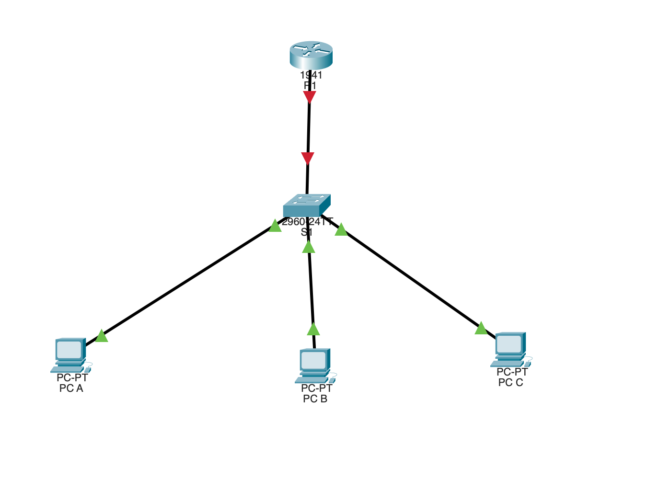
Initial network topology created in Cisco Packet Tracer consisting of one router (R1), one switch (S1), and three client endpoints (PC-A, PC-B, PC-C). Devices are connected using copper straight-through cables to simulate a basic LAN architecture where the router will provide DHCP services for client devices.
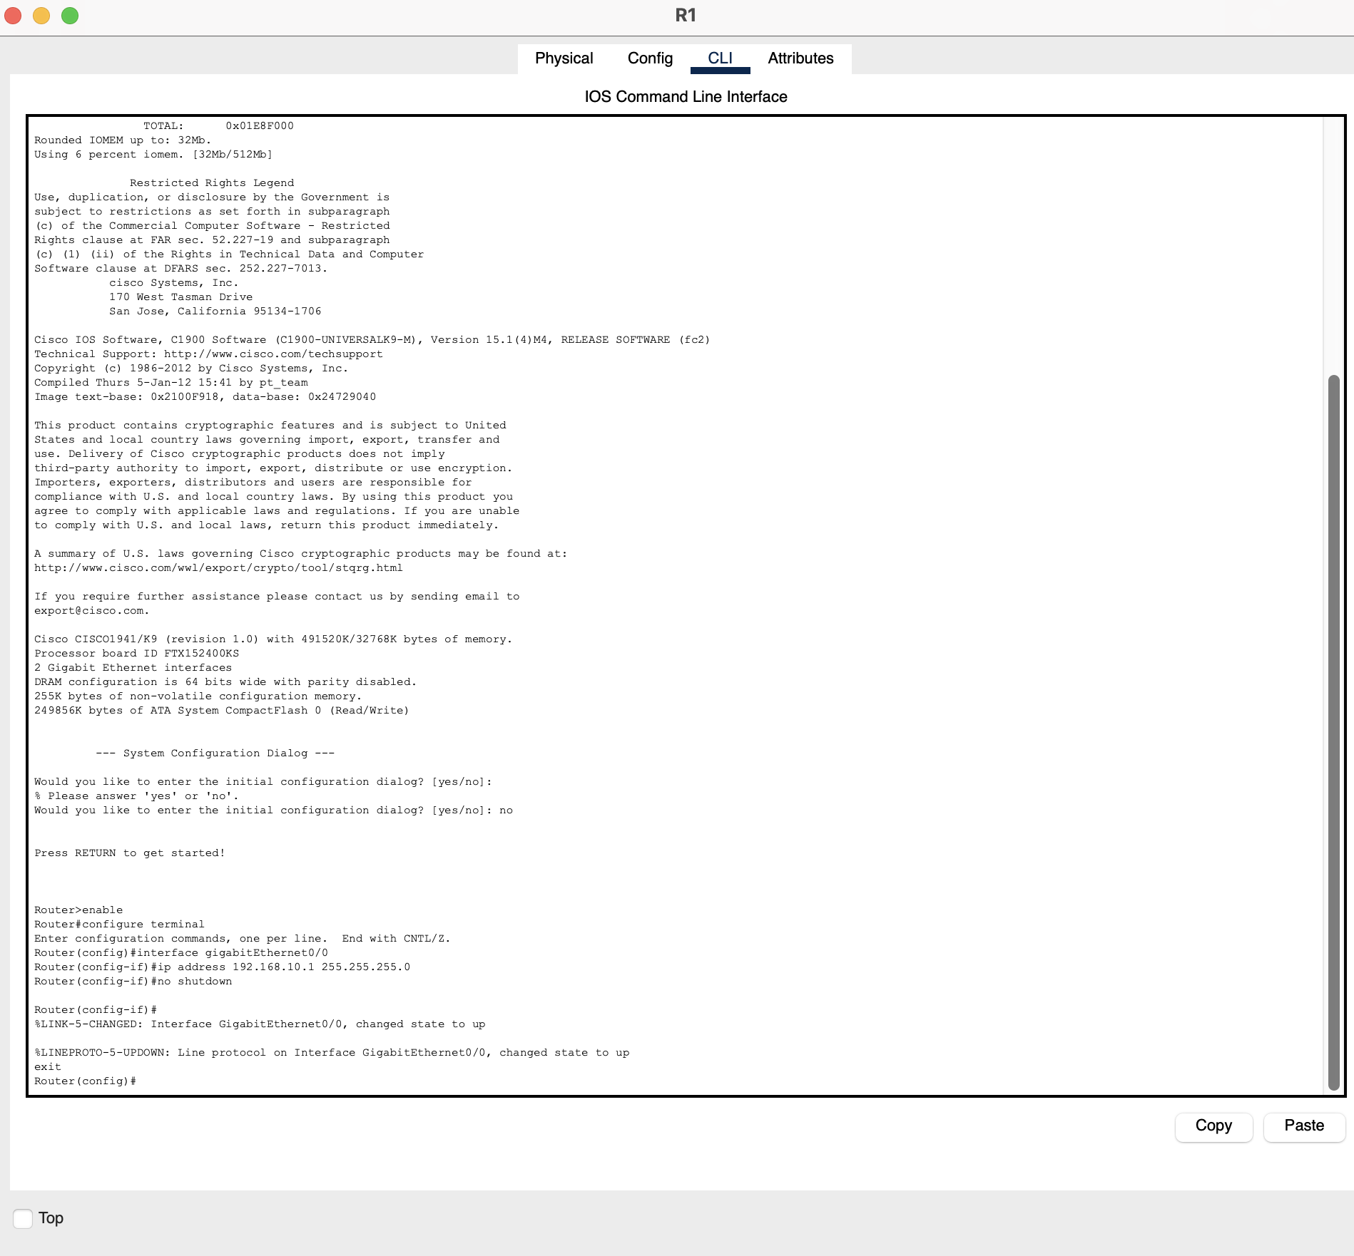
Screenshot 2 – Router Interface Configuration
Configured the router interface GigabitEthernet0/0 with the IP address 192.168.10.1/24, which serves as the default gateway for the network. The interface was enabled using the no shutdown command, bringing the link online and allowing communication between the router and the switch.
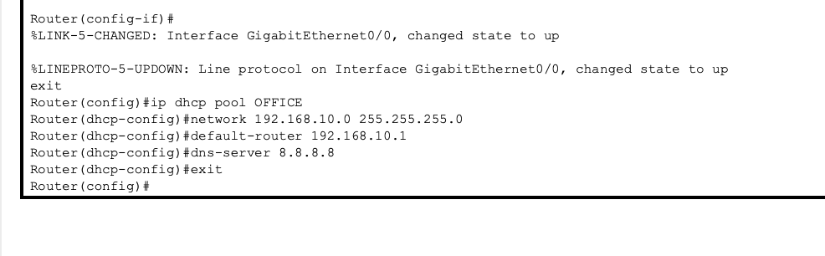Screenshot 3 – DHCP Pool Configuration
Configured a DHCP pool on the router to automatically assign IP addresses to client devices on the network. The pool defines the network range, default gateway, and DNS server that will be distributed to hosts requesting an address.
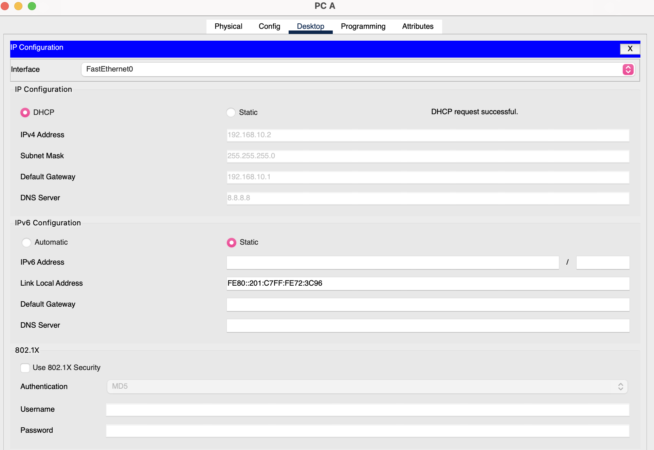
Screenshot 4 – DHCP Address Assignment
Configured the client device to obtain an IP address automatically using DHCP. The router successfully assigned an IP address, subnet mask, default gateway, and DNS server from the configured DHCP pool.
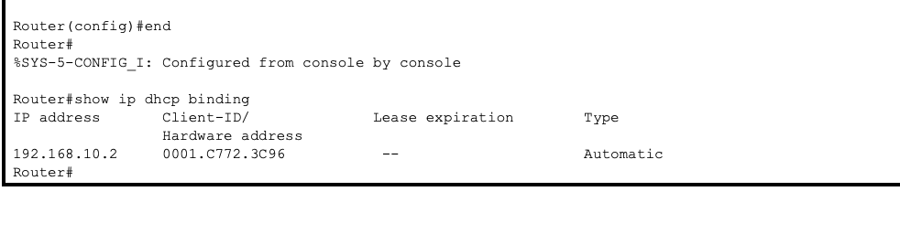
Screenshot 5 – DHCP Lease Verification
Used the show ip dhcp binding command on the router to verify that the DHCP server successfully assigned an IP address to a client device. The output confirms that the client received the address 192.168.10.2 from the configured DHCP pool.
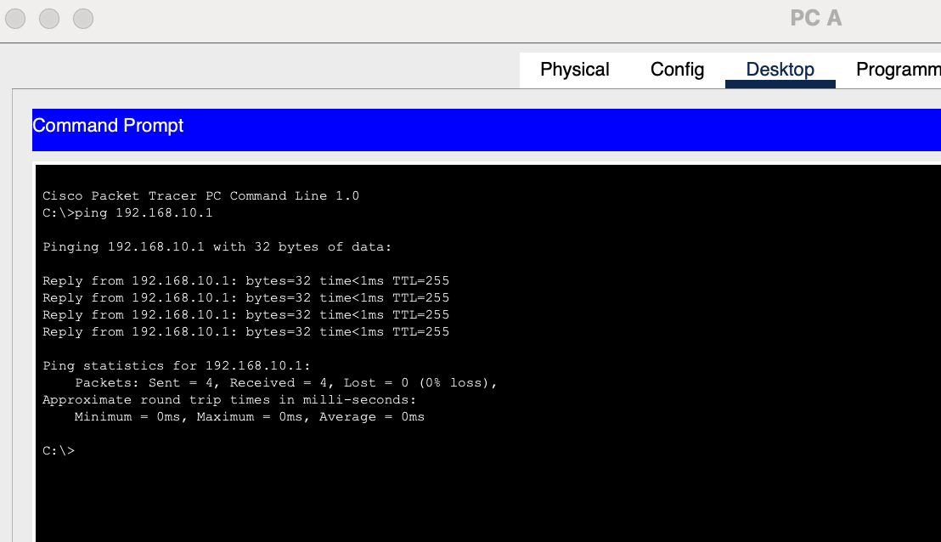
Screenshot 6 – Network Connectivity Test
Tested connectivity between the client device and the router using the ping command. Successful replies confirm that the client can communicate with the default gateway and the network is functioning correctly.
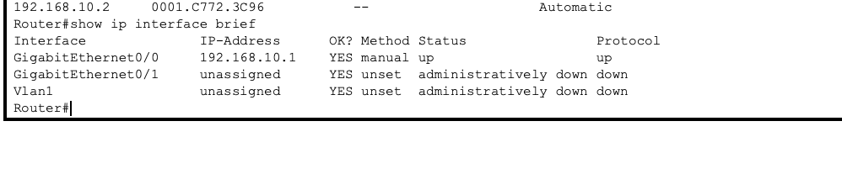
Screenshot 7 – Interface Status Verification
Used the `show ip interface
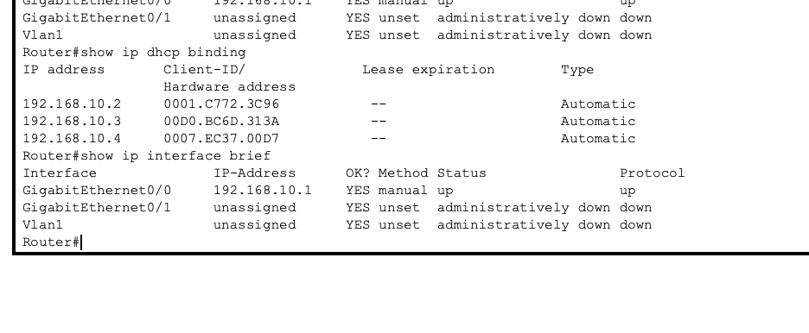
Screenshot 8 – Multiple DHCP Client Leases
Executed the show ip dhcp binding command on the router to verify that the DHCP service successfully assigned addresses to multiple client devices. The output confirms that three hosts received IP addresses dynamically from the configured DHCP pool, demonstrating that the DHCP server is functioning correctly across the network.

