**Program 2**

**Aim:** Perform svd (Singular Value Decomposition) using python.

**Program:**

from numpy import array  
from scipy.linalg import svd

ar = array([[3, 2, 4], [7, 3, 5]])

print(ar)

a, b, c = svd(ar)

print(a)

print(b)

print(c)

**Output:**

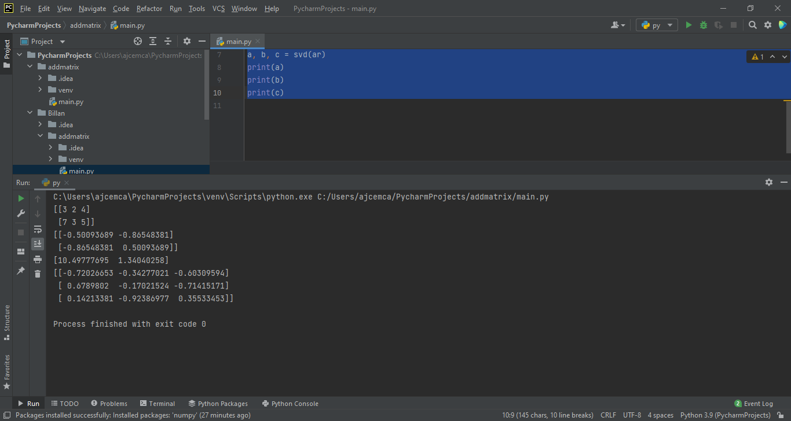

**Program 3**

**Aim:** Program to implement k-NN classification using any standard dataset available in the public domain and find the accuracy of the algorithm.

**Program:**

from sklearn.neighbors import KNeighborsClassifier

from sklearn.model_selection import train_test_split

from sklearn.datasets import load_iris

from sklearn import metrics

irisData = load_iris()

x = irisData.data

y = irisData.target

x_train, x_test, y_train, y_test = train_test_split(x, y, test_size=0.35, random_state=35)

knn = KNeighborsClassifier(n_neighbors=9)

knn.fit(x_train, y_train)

print(knn.predict(x_test))

acc = metrics.accuracy_score(y_test, knn.predict(x_test))

print("Accuracy: ", acc)

**Output:**

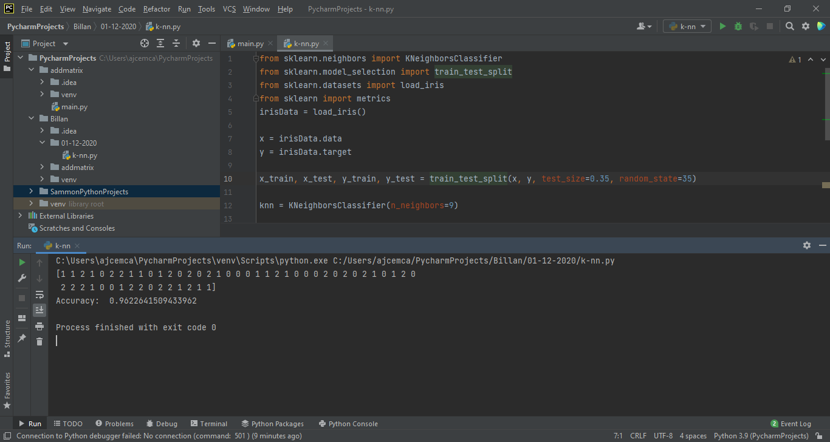

**Program 3**

**Aim:** Program to implement k-NN algorithm using any random dataset without using inbuilt packages.

**Program:**

import math

from math import sqrt

def euclidean_dist(row1, row2):

dist = 0.0

for i in range(len(row1)-1):

dist += (row1[i] - row2[i]) ** 2

return math.sqrt(dist)

def get_neighbors(train, test_row, num_neighbors):

distances = list()

for train_row in train:

dist = euclidean_dist(test_row, train_row)

distances.append([train_row, dist])

distances.sort(key=lambda tup: tup[1])

neighbors = list()

for i in range(num_neighbors):

neighbors.append(distances[i][0])

return neighbors

def predict_classif(train, test_row, num_neighbors):

neighbors = get_neighbors(train, test_row, num_neighbors)

output_val = [row[-1] for row in neighbors]

prediction = max(set(output_val), key=output_val.count)

return prediction

dataset = [[2.78, 2.55, 0],

[1.26, 2.36, 0],

[3.39, 4.40, 0],

[1.38, 1.85, 0],

[5.74, 3.56, 0],

[3.53, 5.67, 1],

[6.24, 3.67, 1],

[2.45, 1.78, 1]]

prediction = predict_classif(dataset, dataset[0], 3)

print("Expected ", dataset[0][-1], " got ", prediction)

**Output**

