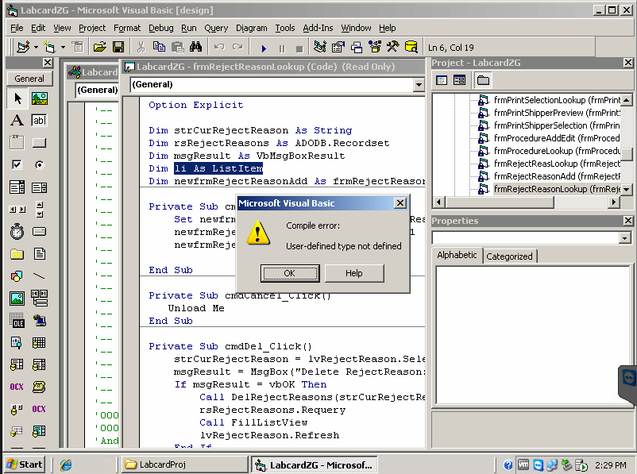

This is the error which we are getting while running the program. It is the issue of missing reference but when we are trying to give the reference it is giving us another error here is the screen shot of it.

Process of giving the reference

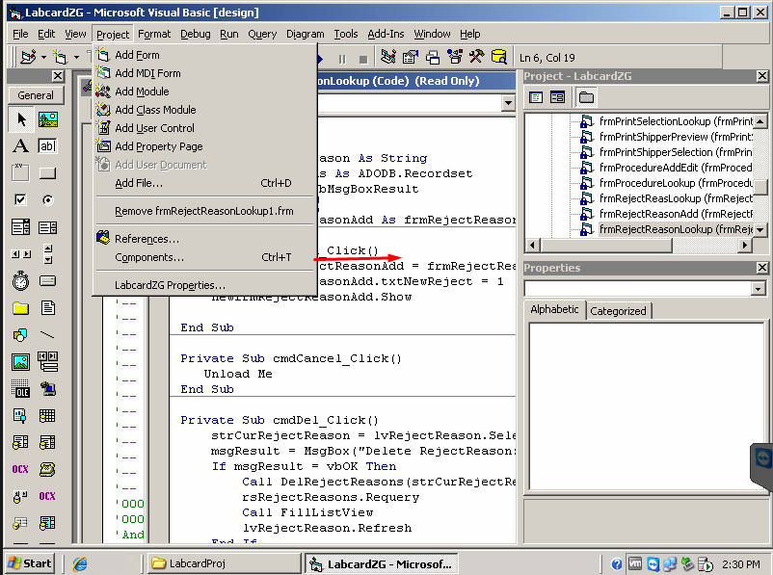

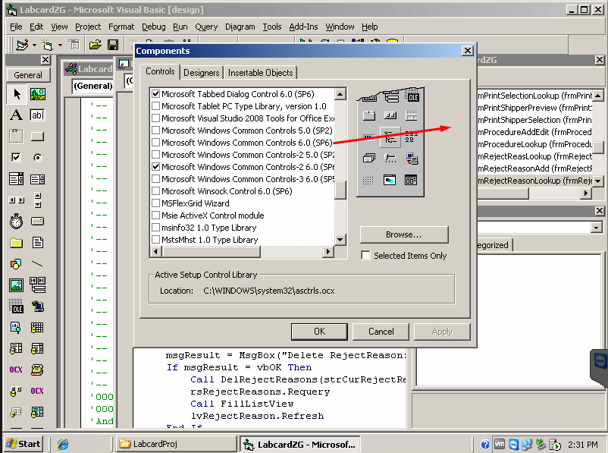

Windows common control 6.0(sp6) has to be added to remove the fist error.

The error screen shot.

